Summary
This lab talks about replacing pages in a page table on ‘Misses’. It takes into account 3 different algorithms, namely, FIFO(First in First out), LRU(Least Recently Used), and OPT(Optimal).
The program compares average number of page faults of each of the algorithms with page reference sequences.

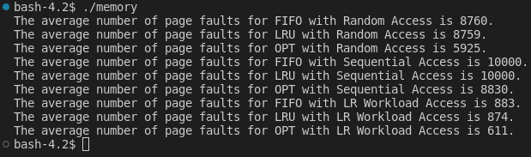
The above is the results which show the average page faults for different algorithms.

