Lab7
Summary:

This lab helps us understand how file systems work in Linux. It talks about different FAT systems over the years, FAT-12, FAT-16, FAT-32 etc.
It then talks about decoding the Boot sector. We do this manually and then convert that into code so that it prints our required output at correct offsets.
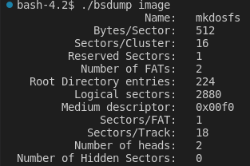

Finally we decode the root directory using the image provided and simulate a result of ‘ls’ for the image.
For this we used indexes in buffer and iterate through it, for the offsets with size 2, we switch the endians, that is we perform an endian swap.
Finally for the last part, fat12ls, the size if twice the size of short, that is 4. For this we need to use another swap that swaps the endian swaps.

This is the result for the last part of the lab.
