School of Computer Science and Engineering
CSS_2213 - Object Oriented Software Development Lab

Project Report - JavaFX and Collections

Academic Year : 2025-26 Semester : 04
Branch : CSE CYBERSECURITY Section : B
Name of the Application: Customer Support Ticket System
Student Name: Nihaal Surendra Raju
Registeration Number: 245891208

Table of Contents
- Abstract
- Objective
- Tools & Technologies
- System Description
- Implementation Details
  - Modules
  - Use of Collections
- GUI Design
- Additional Features
- Sample Output
- Test Cases
- Conclusion
- References
- Appendix (Code Snippets)

Abstract
The Customer Support Ticket System is a desktop application developed using JavaFX for the graphical user interface and Java Collections Framework for efficient in-memory data management. The application enables customers and support agents to create, view, update, prioritize, and resolve support tickets through an intuitive GUI.
The system demonstrates the effective use of JavaFX UI components such as TableView,
ComboBox, TextField, and TextArea, combined with Java data structures including HashMap for O(1) ticket lookup, ArrayList for ordered ticket storage, and PriorityQueue for priority-based escalation. The outcome is a fully functional, responsive desktop application that models a real-world customer support workflow, fulfilling the course objectives of building GUI-based applications using JavaFX and Java Collections.

Objective
The objectives of this project are:
- To build a fully functional GUI-based desktop application using JavaFX with proper layout management and event handling.
- To manage application data efficiently using Java Collections Framework (HashMap, ArrayList, PriorityQueue, Stream API).
- To implement complete CRUD operations: Create (submit ticket), Read (view/search/filter), Update (edit ticket, change status), and Delete (remove ticket).
- To demonstrate input validation, error handling, and user feedback via alert dialogs.
- To implement search and filter functionality for efficient ticket retrieval.
- To follow object-oriented principles including encapsulation, separation of concerns, and modular class design.

Tools & Technologies
- Java 17 (OpenJDK) - Core programming language
- JavaFX 17 - GUI framework for building the desktop application
- Java Collections Framework - ArrayList, HashMap, PriorityQueue, Stream API
- IDE: IntelliJ IDEA / Eclipse with JavaFX plugin
- Build Tool: Maven / Gradle for dependency management
- wkhtmltoimage - Used for generating application screenshots

System Description
The Customer Support Ticket System addresses the problem of managing customer complaints and service requests in a structured, trackable manner. Without such a system, support teams struggle to prioritize and track issues, leading to delayed resolutions and poor customer experience.
The application allows support staff to:
- Create new support tickets with customer details, issue category, priority level, and description.
- View all tickets in a sortable, searchable TableView with color-coded status badges.
- Update ticket status (Open, In Progress, Resolved, Closed) with one click.
- Search tickets by customer name, ticket ID, or category in real time.
- Filter tickets by status and priority using dropdown controls.
- Delete resolved or invalid tickets after confirmation.
- View a live dashboard showing total, open, in-progress, and resolved ticket counts.
The application is divided into three panels: a left dashboard panel, a central ticket table panel, and a right form panel for ticket creation and editing.

Implementation Details

Modules
The application is organized into three main modules:
Data Entry Module: Handles new ticket submission via the right-panel form. Performs input validation (non-empty fields, email format regex check) and displays error messages inline. On successful submission, creates a Ticket object and passes it to TicketManager.
Display Module: Renders all tickets in a JavaFX TableView bound to an ObservableList<Ticket>. Supports real-time search using TextField listener and combo-box filters for status and priority. The left stats panel updates dynamically after every change.
Update/Delete Module: Allows selection of a table row and application of status changes (Mark Resolved, In Progress, Close) via action buttons. Delete shows a Confirmation alert. Edit loads selected ticket data into the form for modification.

Use of Collections
The TicketManager class uses multiple Java Collection types for optimal performance:
- HashMap<String, Ticket> ticketMap - Stores tickets keyed by ticket ID for O(1) lookup during updates and deletes.
- ArrayList<Ticket> ticketList - Maintains insertion-ordered list of tickets, bound to the JavaFX ObservableList for table display.
- PriorityQueue<Ticket> priorityQueue - Sorts tickets by priority level (Critical > High > Medium > Low) for escalation logic.
- HashMap<String, Integer> categoryStats - Tracks ticket count per category using merge() for efficient increment/decrement.
- Stream API (Java 8+) - Used in searchTickets() and filterByStatus() methods with filter(), collect(), and Collectors.toCollection() for functional-style queries.
Example from TicketManager: ticketList.stream().filter(t ->
t.getStatus().equals(status)).collect(Collectors.toCollection(ArrayList::new))

GUI Design
The application uses a BorderPane as the root layout with the following structure:
- Top: HBox header with dark navy background (#1A237E), application title, and version label.
- Left: VBox stats panel (170px wide) showing live dashboard cards and a priority color guide.
- Center: VBox containing a search/filter HBox row, TableView with column headers, and an action button row.
- Right: VBox form panel (270px wide) with labeled TextFields, ComboBoxes, and TextArea for ticket submission and editing.
JavaFX Controls used:
- TableView<Ticket> with TableColumn and PropertyValueFactory for data binding
- TextField with textProperty() listener for live search
- ComboBox<String> for category, priority, status, and filter dropdowns
- TextArea for multi-line issue description
- Button with setOnAction() for all interactions
- Alert (INFORMATION, CONFIRMATION, WARNING) for user feedback
- Label for form labels, stats cards, and error messages Screenshots of the GUI are shown below:
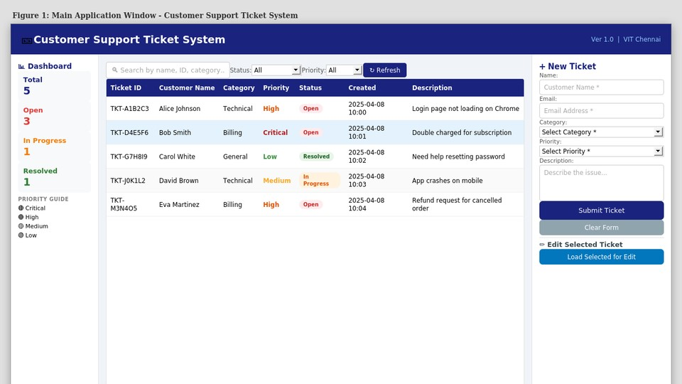
Figure 1: Main Application Window showing ticket list and dashboard
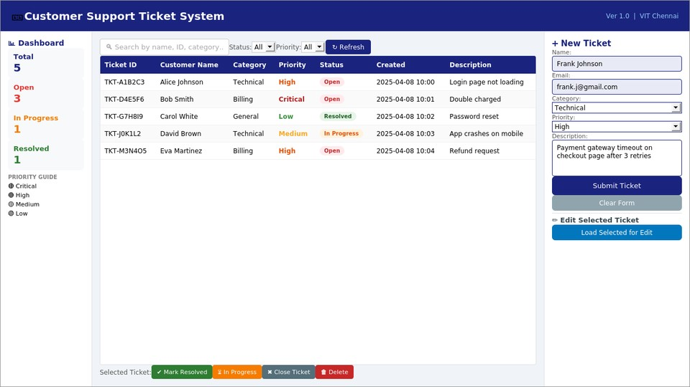
Figure 2: New Ticket Form with filled data ready for submission

Additional Features
- Real-time Search: TextField listener triggers live filtering of the ticket list as the user types, without needing a search button.
- Input Validation: Email format is validated using regex. Empty field checks prevent incomplete ticket submission.
- Alert Messages: Success dialogs (INFORMATION) confirm ticket creation. WARNING dialogs alert on missing selections. CONFIRMATION dialogs prevent accidental deletions.
- Priority Color Coding: Table rows and the sidebar guide display tickets color-coded by priority (Critical=red, High=orange, Medium=yellow, Low=green).
- Status Badge Styling: Status column uses inline styled spans (Open=red badge, In Progress=orange, Resolved=green, Closed=grey) for at-a-glance status identification.
- Combo Filter Chaining: Status and Priority filters can be combined for precise ticket retrieval (e.g., Critical + Open).
- Edit Mode: Loading a selected ticket into the form switches the Submit button to Update mode, allowing in-place editing without deleting and re-creating tickets.
- Sample Data Pre-loading: 5 sample tickets are loaded on startup to demonstrate the system in action immediately.

Sample Output
The following screenshots show the application in different operational states:
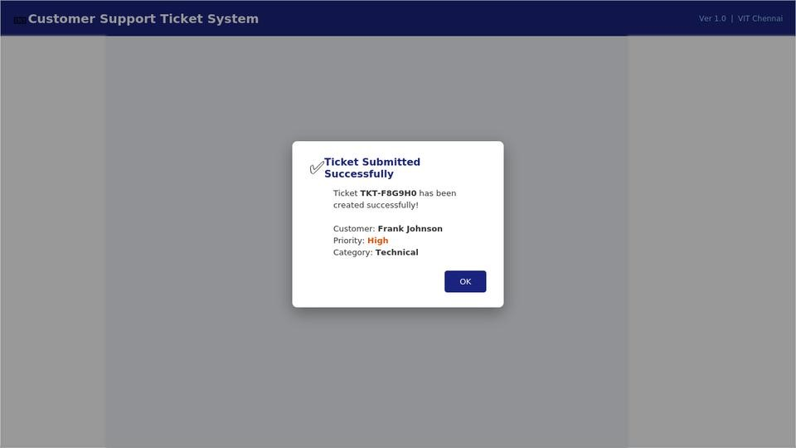
Figure 3: Success Alert Dialog after ticket submission
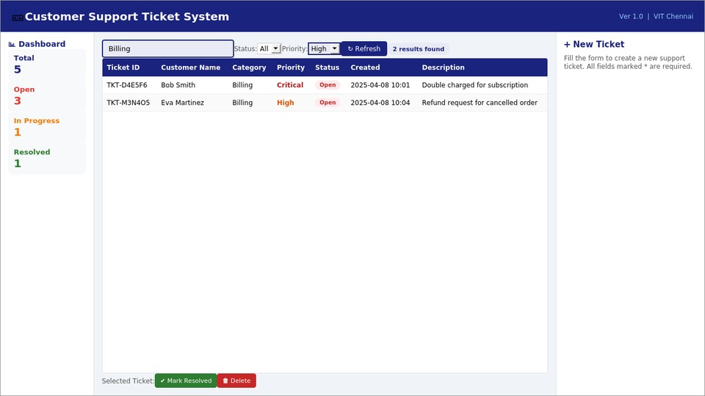
Figure 4: Search and Filter in action - showing Billing tickets filtered by priority

Test Cases
All test cases were executed manually and results are recorded below:
Test Case | Input | Expected Output | Result
Add Ticket | Valid name, email, category, priority, description | Ticket created with unique ID, shown in table | Pass
Add Ticket - Invalid Email | Name filled, invalid email format (e.g. abc@) | Error: Invalid email format shown in red | Pass
Add Ticket - Empty Fields | Some fields left blank | Error: All fields are required | Pass
Delete Ticket | Select ticket, click Delete | Confirmation dialog shown, ticket removed on OK | Pass
Update Status - Resolved | Select open ticket, click  Mark Resolved | Status badge changes to Resolved (green) | Pass
Update Status - In Progress | Select ticket, click In  Progress | Status updates to In Progress (orange) | Pass
Search by Name | Enter 'Alice' in search box | Only Alice Johnson's ticket shown | Pass
Search by Category | Enter 'Billing' in search box | All Billing category tickets  shown | Pass
Filter by Status | Select 'Open' in status  filter | Only Open tickets displayed | Pass
Filter by Priority | Select 'Critical' in priority filter | Only Critical priority tickets shown | Pass
Edit Ticket | Select ticket, click Load  for Edit, modify, click Update | Ticket details updated in table | Pass
Stats Dashboard | Add/delete/resolve tickets | Dashboard counters update correctly | Pass

Conclusion
The Customer Support Ticket System was successfully developed as a fully functional JavaFX desktop application. The project achieved all stated objectives: a responsive GUI with real-time data binding, efficient data management using multiple Java Collections, complete CRUD operations, and robust input validation.
Through this project, key learning outcomes were realized:
- Gained hands-on experience with JavaFX layout management (BorderPane, VBox, HBox) and data-bound controls (TableView with ObservableList).
- Understood the practical application of Java Collections (HashMap for O(1) lookups, ArrayList for ordered display, PriorityQueue for escalation, Stream API for functional queries).
- Applied object-oriented principles: Ticket (model), TicketManager (service/data layer), and MainApp (controller/view) follow a clean separation of concerns.
- Developed experience in event-driven programming, input validation, and user feedback patterns common in real-world desktop applications.

References
- Oracle JavaFX Documentation - https://openjfx.io/
- Java Collections Framework Guide - https://docs.oracle.com/javase/tutorial/collections/
- OpenJFX Getting Started Guide - https://openjfx.io/openjfx-docs/
- JavaFX TableView Tutorial - https://docs.oracle.com/javase/8/javafx/user-interfacetutorial/table-view.htm
- Java 17 API Documentation - https://docs.oracle.com/en/java/javase/17/

Appendix - Code Snippets

Ticket.java (Model Class)
public class Ticket {

private String ticketId; // UUID-based unique ID private String customerName; private String email; private String category; // Technical / Billing / General / Shipping / Account private String priority; // Critical / High / Medium / Low private String status; // Open / In Progress / Resolved / Closed private String createdDate;
private String resolvedDate;

public Ticket(String customerName, String email, String category, String priority, String description) { this.ticketId = "TKT-" + UUID.randomUUID().toString() .substring(0,6).toUpperCase(); this.status = "Open"; this.createdDate = LocalDateTime.now().format( DateTimeFormatter.ofPattern("yyyy-MM-dd HH:mm")); }
}

TicketManager.java (Collections Usage) public class TicketManager {
private HashMap<String, Ticket> ticketMap; // O(1) lookup by ID private ArrayList<Ticket> ticketList; // Ordered display list private PriorityQueue<Ticket> priorityQueue; // Escalation queue private HashMap<String, Integer> categoryStats;

public ArrayList<Ticket> searchTickets(String keyword) {
String kw = keyword.toLowerCase(); return ticketList.stream()
.filter(t -> t.getCustomerName().toLowerCase().contains(kw)
|| t.getTicketId().toLowerCase().contains(kw))
.collect(Collectors.toCollection(ArrayList::new)); }

public ArrayList<Ticket> filterByStatus(String status) {
if (status.equals("All")) return ticketList; return ticketList.stream()
.filter(t -> t.getStatus().equals(status))
.collect(Collectors.toCollection(ArrayList::new)); }
}

Project Class Structure
- Ticket.java - Model class representing a support ticket (fields, getters, setters)
- TicketManager.java - Service/Data layer managing Collections, CRUD, search, and filter
- MainApp.java - JavaFX Application class; builds all UI panels and handles all events
Total Source Files: 3 Java classes | UI: Single-window JavaFX Application | Data: In-memory Collections

