**Subject:** Internet of Things

**Project:** Wireless Switching Circuit

**Instructor:** Ms. Khanim Pashayeva

**Student:** Nihat Rushanov, Alakbarov Dadash,

Aslanzade Ali, Agayev Eldar

**Group:** E27-24

**Table of Contents**

1. Introduction
2. Objectives of the Project
3. System Design and Setup
4. Arduino Code
5. Future Improvements
6. Conclusion

**Introduction**

This project is a demonstration of an **automatic light control system** using an Arduino Uno, a photoresistor (LDR), and an LED. The system is designed to measure the ambient light levels using the photoresistor and respond accordingly by turning the LED on or off. This practical implementation highlights the following features:

1. **Light Sensing**: The photoresistor reads the intensity of the surrounding light, converting it into an analog value.
2. **Threshold-Based Control**: The system uses a predefined threshold value to determine whether the light level is low (dark) or sufficient (bright).
3. **Automated Response**:
   * If the light level falls below the threshold, the LED turns on, indicating darkness.
   * If the light level is above the threshold, the LED remains off, conserving energy.

The project is an effective demonstration of using sensor data for automation, which is widely applicable in real-world scenarios such as street lighting, home automation, and energy conservation systems. The system's behavior can be monitored in real-time via the Arduino Serial Monitor, where it displays light level readings and system status updates.

**Objectives of the Project**

The primary objectives of this project are as follows:

1. **To Design an Automated Light Control System**
   * Develop a system capable of detecting ambient light levels using a photoresistor (LDR) and controlling an LED based on those levels.
2. **To Implement Threshold-Based Automation**
   * Use a predefined threshold to determine when the LED should turn on (low light) or off (sufficient light), simulating a real-world scenario of energy-efficient lighting.
3. **To Understand and Apply Sensor Integration with Arduino**
   * Integrate and utilize the photoresistor (LDR) with Arduino Uno to measure and process analog data effectively.
4. **To Enhance Energy Efficiency Awareness**
   * Demonstrate the importance of automated systems in saving energy by turning lights on only when necessary.
5. **To Provide Real-Time Monitoring**
   * Display real-time light intensity values and system actions through the Serial Monitor, enabling clear visualization of the system's operation.
6. **To Develop Skills in Embedded Systems and Programming**
   * Gain hands-on experience in Arduino programming, circuit design, and sensor-based automation, contributing to foundational knowledge in embedded systems.

**System Design and Setup**

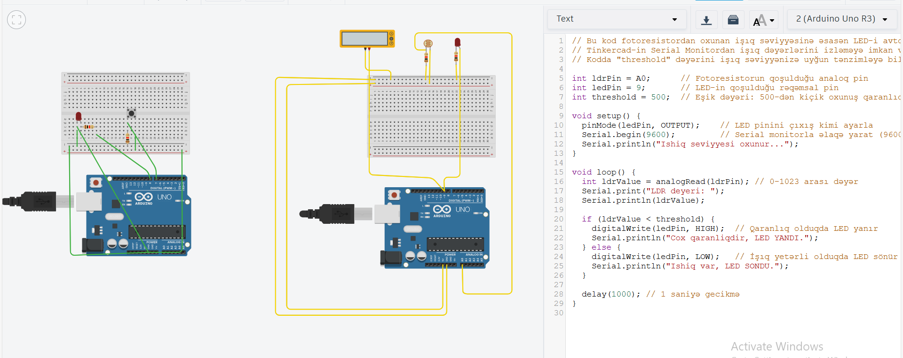

**Arduino Code**

**// Bu kod fotoresistordan oxunan işıq səviyyəsinə əsasən LED-i avtomatik idarə edir.**

**// Tinkercad-in Serial Monitordan işıq dəyərlərini izləməyə imkan verdiyini unutmayın.**

**// Kodda "threshold" dəyərini işıq səviyyənizə uyğun tənzimləyə bilərsiniz.**

**int ldrPin = A0; // Fotoresistorun qoşulduğu analoq pin**

**int ledPin = 9; // LED-in qoşulduğu rəqəmsal pin**

**int threshold = 500; // Eşik dəyəri: 500-dən kiçik oxunuş qaranlıq sayılır (misal üçün)**

**void setup() {**

**pinMode(ledPin, OUTPUT); // LED pinini çıxış kimi ayarla**

**Serial.begin(9600); // Serial monitorla əlaqə yarat (9600 baud)**

**Serial.println("Ishiq seviyyesi oxunur...");**

**}**

**void loop() {**

**int ldrValue = analogRead(ldrPin); // 0-1023 arası dəyər**

**Serial.print("LDR deyeri: ");**

**Serial.println(ldrValue);**

**if (ldrValue < threshold) {**

**digitalWrite(ledPin, HIGH); // Qaranlıq olduqda LED yanır**

**Serial.println("Cox qaranliqdir, LED YANDI.");**

**} else {**

**digitalWrite(ledPin, LOW); // İşıq yetərli olduqda LED sönür**

**Serial.println("Ishiq var, LED SONDU.");**

**}**

**delay(1000); // 1 saniyə gecikmə**

**}**

**Future Improvements**

Adjustable Threshold

Add a knob (potentiometer) to easily change the light sensitivity without changing the code.

Wireless Control

Include Wi-Fi or Bluetooth to control and monitor the system remotely with a phone or app.

Data Logging

Save light data on an SD card or cloud to analyze usage over time.

Smart Home Integration

* Make the system work with smart home devices like Alexa or Google Home.

**Conclusion**

This project successfully demonstrates an automated light control system using an Arduino Uno, a photoresistor, and an LED. It highlights the efficient use of sensors to detect ambient light levels and respond accordingly. The system is simple, cost-effective, and can be further improved with features like wireless control and smart home integration. This project showcases the potential of automation to save energy and improve daily life.