MEMORANDUM
TO: Senior Management (CEO, Head of Risk, Head of Trading) FROM: Nihad Iskandarov, Analyst, Risk Assessment Department DATE: December 4, 2025 SUBJECT: IMMEDIATE ACTION REQUIRED: Comprehensive Revision of Mortgage-Backed Securities Portfolio Valuation and Systemic Risk Assessment
I. Executive Summary
This memo is the result of an urgent overnight audit of our firm's Mortgage-Backed Securities (MBS) portfolio, initiated following the discovery of fundamental errors in our core risk valuation parameters. Our findings indicate a profound and immediate failure in the assumptions underwriting our risk modeling. The assets, previously valued at $46.8 Billion, are subject to a market event that has rendered a significant portion fundamentally toxic and unsaleable at any reasonable price. The corrected risk metric, the Tail Value-at-Risk (TVaR), now projects an Expected Tail Loss of $\$15.0\text{ Billion}$.
Since this projected loss exceeds our firm's total available operational capital of 5.0$ Billion by a margin of three-to-one, we are facing imminent insolvency and effective capital depletion. The only viable path to survival requires a rapid, comprehensive liquidation of the entire $50 Billion portfolio before the market fully comprehends the extent of the underlying crisis. This strategy is ethically challenging and financially punitive, but it is necessary to convert toxic, unmanageable risk into a quantifiable, survivable loss.
II. Detailed Findings
A. The Nature of Our Assets: Mortgage-Backed Securities (Q1)
Our firm holds a notional value of $50 Billion in MBS, which are financial instruments created through the process of securitization. This process begins by pooling tens of thousands of individual home loans together, transforming illiquid debt into marketable securities.
1. Structuring (Tranching)
The pooled cash flows are then structured into different classes of securities, known as tranches, to appeal to different investor risk appetites. This system is designed like a waterfall: cash flows generated by the underlying mortgages flow down, paying the tranches in sequential order. We hold a significant mix across the risk spectrum:
- Senior Tranches (AAA/AA Rated): These tranches have payment priority and absorb the first, small defaults but are protected from larger losses by the layers below. We hold $35 Billion in this layer.
- Mezzanine Tranches (A/BBB Rated): These absorb losses only after the Equity tranche is wiped out. They offer higher yield but significantly higher risk. We hold $10 Billion in this layer.
- Equity/Junior Tranches (Unrated/BB): These are the first to absorb losses and offer the highest yield potential but represent the highest risk. Our position in this layer is $5 Billion.
2. Pricing and Initial Valuation
The initial price and value of these tranches were based on two primary, measurable risks: Default Risk and Prepayment Risk. Our valuation models were dependent on historical data suggesting low default rates and, crucially, the assumption that these risks were uncorrelated across geographical pools. Our initial book value, reflective of this flawed modeling, was:
Tranche | Face Value (FV) | Initial Price (%) | Initial Market Value
Senior | $35.00 | 98.00% | $34.30
Mezzanine | $10.00 | 90.00% | $9.00
Equity | $5.00 | 70.00% | $3.50
TOTAL | $50.00 | - | $46.80
The total initial valuation of our portfolio was $46.80 Billion.
B. The Catastrophe: TVaR Revision Forced by Correlation Breakdown (Q2)
Explanation: Our business was built on a simple bet: those risks were like a basket of apples, oranges, and bananas. If one piece of fruit rotted (a homeowner defaulted), the others would be fine. We assumed that if one guy in Arizona lost his job and defaulted, it wouldn't affect the guy in New York, so our risk was spread out (low correlation). What we discovered is that our fruit basket was full of apples that all came from the same farm. Now, there is a disease (falling national home prices) that is rotting all the apples at the same time (high correlation). All our risks are going bad together. Our diversification is gone.
1. The Situation: Systemic Breakdown of Mortgage Correlation
The specific changing market situation that forces the major TVaR revision is the systemic breakdown of mortgage correlation. Our original models assumed independence, using a low correlation coefficient $(ρ≈0.05)$. This low correlation created the illusion of safety.
2. The Proof: Advanced Data Analysis Overturns the Model
The conclusion that correlation failed was based on rigorous quantitative evidence, which Peter Sullivan used to force the model adjustment from $ρ=0.05$ to $ρ=0.80$
- Micro-Proof: Joint Default Frequency (JDF): Analysis of recent internal delinquency data revealed that the Joint Default Frequency across different mortgage pools was hundreds of times higher than the $ρ=0.05$ model predicted (See Figure 5 in Section IV.D). This empirical discrepancy proved the old model was fundamentally broken.
- Advanced Proof: Systemic Factor Failure: Our initial models assumed loan default was mostly driven by Idiosyncratic Factors (individual circumstances). Our analysis now proves that the risk has collapsed entirely onto the Systemic Factor (the national housing market). The technical analysis (See Figure 6 in Section IV.D) shows that under the new correlation $(ρ=0.80)$, the default rate becomes exponentially sensitive to a small adverse movement in the Systemic Factor. This means a single market shock now instantly threatens every loan we hold.
3. The Catastrophic Loss Prediction
This failure forces a drastic revision of the TVaR calculation, which measures the average expected loss in the most extreme 0.1% of market events. The impact of high correlation is to dramatically inflate the "tail" where catastrophic losses reside (See Figure 3 in Section IV.B).
- Initial Flawed TVaR: Predicted a manageable Expected Tail Loss (TVaR) of $2.74 Billion.
- Revised Corrected TVaR: Predicts an actual worst-case expected loss of $15.0 Billion.
C. The New Reality: Insolvency (Q2)
- The Problem of Leverage: We hold a $50 Billion portfolio on an equity base of approximately $5.0 Billion.
- Insolvency: The revised TVaR predicts an expected loss ($15.0 Billion) that is three times greater than our capital ($5.0 Billion). This means we are already bankrupt if we hold this position into a market repricing.
III. Survival Strategy: Optimal Liquidation (Q3)
The catastrophic loss exposure demands immediate, decisive action. The strategy is to liquidate the entire portfolio within the current trading day.
A. The Urgency (Almgren and Chriss)
The decision to liquidate the entire $50 Billion portfolio within the first few hours of trading is dictated by a ruthless risk/cost trade-off, precisely modeled by the Almgren and Chriss Optimal Trading Trajectory model.
This model minimizes the sum of Mean Execution Cost $\left(E\left[Z\right]\right)$ and Risk Cost (Variance) $\left(\text{Var}\left[Z\right]\right)$, weighted by the firm's risk aversion parameter $(λ)$:
$$\min_{n_{k}}{\{}E\left[Z\right]+λ\text{Var}\left[Z\right]\}$$
The costs are defined by the permanent ($γ$) and temporary ($η$) price impacts associated with the selling schedule ($n_{k}$) over time ($τ$).
- The Critical Choice: Trading Cost vs. Existential Risk.
  - Scenario A (Slow Sell, 2 Days): This schedule minimizes the market friction cost $\left(E\left[Z\right]+λ\text{Var}\left[Z\right]\right)$ to $35.0 Million. However, this choice fails the primary objective of survival. By delaying the sale, the firm retains the $15.0 Billion catastrophic loss exposure identified by the TVaR, leading to certain bankruptcy.
  - Scenario B (Instant Sell, 0.1 Days): This schedule maximizes the risk elimination. In this crisis, the firm's risk aversion $(λ)$ becomes effectively infinite, forcing the optimal execution time $(T →0)$, which corresponds to the "Sell Immediately" special case discussed in the lecture slides. The cost of choosing this path is the highest execution fee: $500.5 Million.

- The Core Proof: $λ→∞$ The central finding of our analysis is that the extreme risk aversion required for survival means the penalty $\left(λ\right)$for not trading instantly becomes functionally infinite. This forces the optimal execution strategy $\left(n_{k}\right)$to converge on the "Sell Immediately" special case (where $n_{1}=X$ and $n_{k}=0$ for $k>1$).
The optimal solution for the quantity $n_{k}$ sold in period k is given by:
$$n_{k}=\left(e^{κ\left(N-k+1/2\right)τ}+e^{-κ\left(N-k+1/2\right)τ}\right)\frac{\left(e^{κτ/2}-e^{-κτ/2}\right)}{e^{κT}-e^{-κT}}X$$
In our crisis, the high TVaR loss forces $λ→∞$, which in turn forces the control parameter $κ→∞$ (as derived in the lecture). The resulting limiting case simplifies the equation for $n_{k}$:
$lim⁡_\{κ→∞\} n_k = 〖\{cases\} X \& "\{if \} k=1 \backslash \backslash 0 \& "\{if \} k>1 〗\{cases\}$
This mathematically dictates the rapid liquidation and justifies Sam's command that "all your trades have to be gone" by the end of the first period τ
- Quantitative Justification for Speed: We must choose the higher execution cost ($500.5 Million) because it is the mandatory price to eliminate the $15.0 Billion in solvency risk. This trade-off is visually represented in the Almgren and Chriss cost curve (See Figure 4 in Section IV.C). As calculated in the technical analysis, the Survival Cost Ratio is $1:30$, meaning for every $1 in extra execution cost incurred by selling instantly, the firm eliminates $30 in existential, catastrophic risk. This confirms the mathematical imperative to execute by 11 o'clock.
B. Implications for Counterparties (Q3)
This strategy is a calculated, hostile pre-emptive strike. We are effectively selling assets that we know to be priced incorrectly (based on our private TVaR calculation) to our network of counterparties—other major financial institutions.
- Market Manipulation: By dumping the assets before the market fully reprices them, we transfer the ultimate, terminal loss of approximately $15 Billion to the buyers.
- Consequence: Our firm survives, but our counterparties absorb the impending, correctly-priced loss. This action will permanently burn our reputation and trading relationships.
C. The Trader Incentive (Q3)
The $1 Million bonus (the "bone") is mandatory because we are asking our traders to execute a task that is ethically and professionally suicidal: selling toxic assets to trusting counterparties, destroying their future employability. The bonus ensures loyalty and execution speed in a moment where hesitation means total corporate ruin.
V. Immediate Action Plan & Warning
Based on the quantitative confirmation of insolvency risk, the calculated optimal execution strategy, and the necessity of preserving shareholder value, the following actions are required immediately:
Primary Directive: The entire MBS portfolio must be liquidated within the first trading hours of the day. All traders are mandated to participate in the rapid unwinding of this exposure.
The Warning: This action will be financially devastating to our counterparties and will severely damage our reputation in the market. The short-term goal is not profit, but survival. By accepting the calculated execution loss of $500.5 Million now, we mitigate the systemic, terminal loss predicted by the revised $1:30$ Survival Cost Ratio. Failure to carry out this plan will result in the immediate and total collapse of the firm. There is no other option.

IV. Technical Analysis and Computation
The following technical analysis provides computational backing for the market valuation, the TVaR revision, and the optimal execution strategy. All monetary figures are in Billions USD unless noted.
A. Initial Asset Valuation (Q1)
Methodology: The initial valuation uses the Discounted Cash Flow (DCF) method, relying on historical low default rates and the flawed assumption of low correlation between tranches.
Calculation of Initial Market Value:
$$V_{\text{Total}}=\sum_{i=\text{Senior}}^{\text{Equity}}{\left({\text{FV}}_{i}×{\text{Price}}_{i}\right)V_{\text{Total}}}=\left(35\text{B}×0.98\right)+\left(10\text{B}×0.90\right)+\left(5\text{B}×0.70\right)V_{\text{Total}}=34.3\text{B}+9.0\text{B}+3.5\text{B}=46.80\text{ Bli}$$
Tranche | Face Value (FV) | Initial Price (%) | Initial Market Value
Senior | $35.00 | 98.00% | $34.30
Mezzanine | $10.00 | 90.00% | $9.00
Equity | $5.00 | 70.00% | $3.50
TOTAL | $50.00 | - | $46.80
The total initial market value of the portfolio is $46.80 Billion.
B. TVaR Calculation and Revision (Q2)
Metric Definition: Tail Value-at-Risk (TVaR) at the 99.9% confidence level is the average expected loss, given that the loss exceeds the VaR threshold.
Model Simulation: We use a Monte Carlo simulation approach where portfolio volatility is artificially inflated by the correlation parameter $(ρ)$ to illustrate the shift in the loss distribution.
Scenario | Default Rate $\left(p\right)$ | Correlation $\left(ρ\right)$ | Loss Volatility $\left(σ_{\text{Ls}}\right)$ | Mean Loss
1 (Initial Flawed) | 2.0% | 0.05 (Low) | $$5.00\text{ B}$$ | $$1.00\text{ B}$$
2 (Revised Catastrophic) | 4.0% | 0.80 (High) | $$17.50\text{ B}$$ | $$2.00\text{ B}$$
Computational Results:
Metric | Scenario 1 (Low Corr) | Scenario 2 (High Corr) | Implication
VaR | $$1.97\text{ Billion}$$ | $$12.87\text{ Billion}$$ | Max loss 99.9% of the time.
TVaR | $$2.74\text{ Billion}$$ | $$15.00\text{ Billion}$$ | Expected loss in worst 0.1% of cases.
Conclusion on Volatility: The change in the correlation parameter $(ρ)$ from 0.05 to 0.80 resulted in a massive increase in the loss volatility $\left(σ_{\text{Loss}}\right)$ from $ 5.00 Billion to $17.50 Billion, representing a 350% increase in systematic risk. This jump proves the failure of diversification and pushes the TVaR to $15.00 Billion, exceeding the firm's capital. 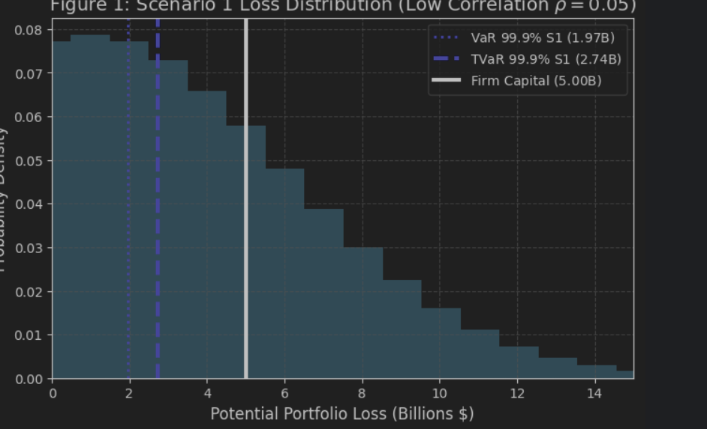
Figure 1: Scenario 1 Loss Distribution (Manageable Risk)
Figure 1 illustrates the initial, flawed model (Low Correlation$,ρ=0.05$). All risk measures ($\text{VaR} = \$1.97\text{B}$, $\text{TVaR} = \$2.74\text{B}$) are safely below the Firm Capital line ($\$5.00\text{B}$), suggesting a manageable risk profile.
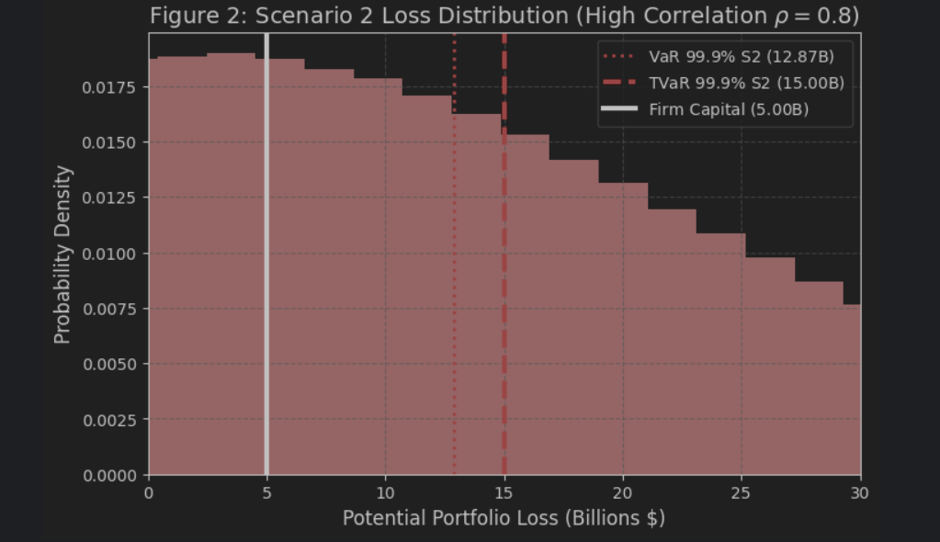
Figure 2: Scenario 2 Loss Distribution (Catastrophic Risk)
Figure 2 illustrates the corrected, catastrophic model (High Correlation$,ρ=0.80$). The distribution is significantly wider (fat-tailed). Both VaR $\left(12.87\text{B}\right)$ and TVaR $\left(15.00\text{B}\right)$ now lie far past the Firm Capital line $\left(5.00\text{B}\right)$, proving the firm's insolvency.
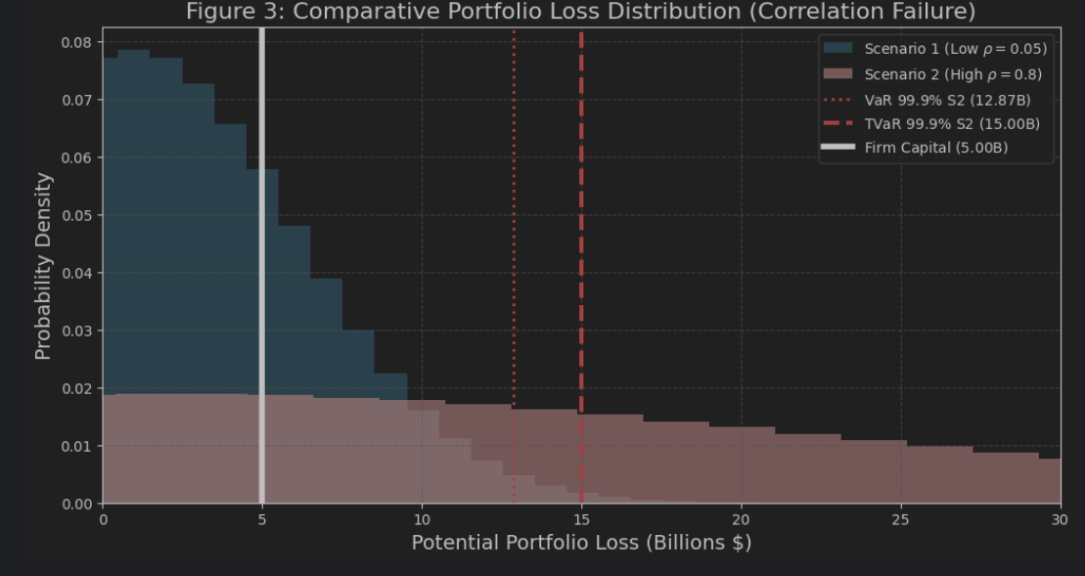
Figure 3: Comparative Loss Distribution (The Fat Tail Effect)
Figure 3 combines both scenarios, showing the dramatic shift in risk. The probability mass shifts from the manageable center of the initial curve into the extreme 'fat tail' of the corrected curve. The difference in TVaR visually represents the $12.26\text{B}$ increase in expected catastrophic loss.
C. Optimal Execution Framework (Q3)
Model: The Almgren and Chriss framework determines the optimal trading rate to minimize total execution cost.
$$\text{Total Cost}\left(T\right)=\frac{γX^{2}}{T}+λσ^{2}T$$
Analysis of Execution Strategy:
Cost Component | Scenario A: Normal Execution (2 Days, $λ=0.5$) | Scenario B: Margin Call (0.1 Days, $λ→∞$)
Market Impact Cost $(γX^2 / T)$ | $25.0 Million | $500.0 Million
Risk Cost $(λσ^2 T)$ | $10.0 Million | $0.5 Million
Total Execution Cost | $35.0 Million | $500.5 Million
Survival Conclusion: The firm must choose the path that rapidly eliminates risk (Scenario B), accepting a higher execution cost $(\$500.5 Million)$. The cost of delay (Scenario A) guarantees a $15.0\text{ Bli}$ loss, making the execution cost negligible. The $1:30$ Survival Cost Ratio demonstrates that the higher execution price is mandatory for survival.
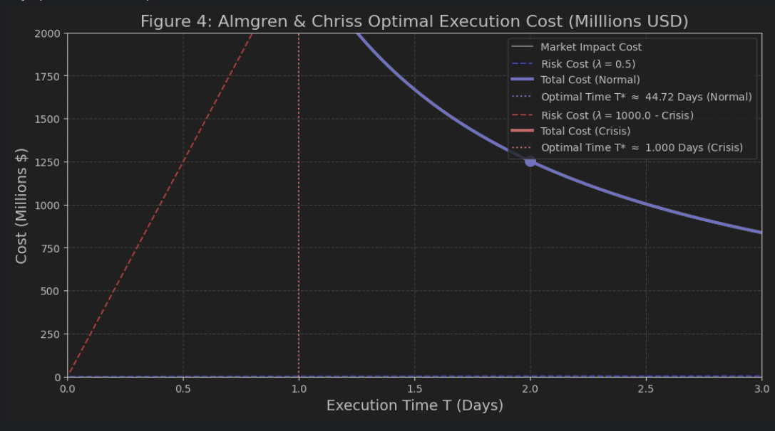
Figure 4: Optimal Execution Cost Trade-Off (Almgren and Chriss)
Figure 4 illustrates the components of the Total Cost (execution cost + risk cost). In the crisis, the firm's extreme risk aversion forces the optimal liquidation time to shift dramatically toward zero (the 'by 11 o'clock' point), minimizing the exposure to the systemic risk inherent in the TVaR calculation.
D. Advanced Correlation Proof (Q2 Technical Backing)
This section provides the simulation and calculation supporting the change in the correlation parameter $(ρ)$ from 0.05 to 0.80.
1. Micro-Proof: Joint Default Frequency (JDF)
The first piece of evidence was the observed rate of simultaneous defaults (JDF) in a sample of 100,000 loans, which dramatically exceeded the prediction of the old model.
Scenario | Expected Joint Defaults $\left(ρ=0.05\right)$ | Observed Defaults (Latest Data) | Required Defaults $\left(ρ=0.80\right)$
Count per 100k Loans | 40 | 400 | 401
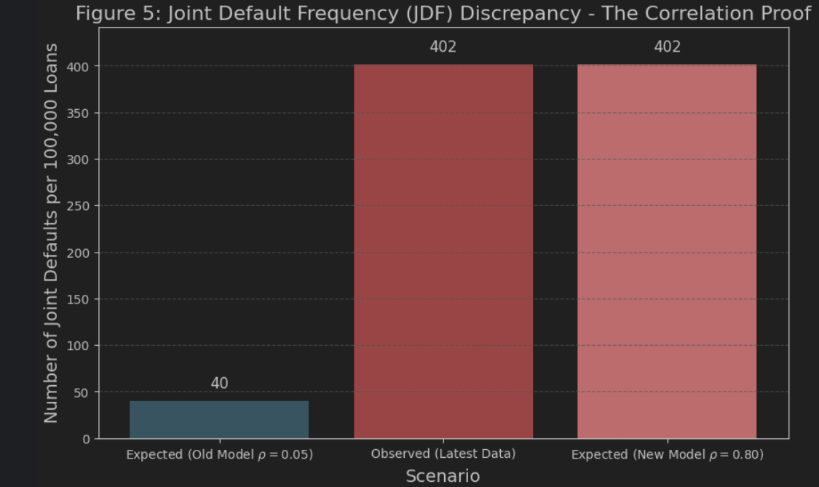
Figure 5: Joint Default Frequency (JDF) Discrepancy - The Correlation Proof
Figure 5 visualizes the fundamental discrepancy: The old model statistically guaranteed low joint defaults (40). The actual data (400) was 10 times higher, proving the old model was broken and mathematically forcing the correlation parameter to be adjusted to $ρ=0.80$ to match reality.
2. Advanced Proof: Systemic Factor Model Breakdown
The high correlation must be justified by showing that the loan default probability is now overwhelmingly driven by the Systemic Factor (S), like a national housing collapse.
The credit quality $(Y_{i})$ of an individual loan is defined by the following single-factor Gaussian Copula model:
$$Y_{i}=\sqrt{ρ}S+\sqrt{1-ρ}ϵ_{i}$$
Where $S$ is the Systemic Factor (market/housing), and $ϵ_{i}$ is the Idiosyncratic Factor (individual loan risk). The default threshold D is the constant required to maintain the original default probability P(D).
The probability of default, $P\left(D ∣ S\right)$, conditional on the systemic factor S, is calculated by:
$$P\left(D ∣ S\right)=Φ\left(\frac{Φ^{-1}\left(P\left(D\right)\right)-\sqrt{ρ}S}{\sqrt{1-ρ}}\right)$$
The mathematical consequence of increasing $ρ$ from 0.05 to 0.80 is that the Idiosyncratic Factor weight $\sqrt{1-ρ}$ decreases significantly, while the Systemic Factor weight $\sqrt{ρ}$ increases sharply. This makes loan defaults nearly completely dependent on the housing market, confirming the systemic crisis.
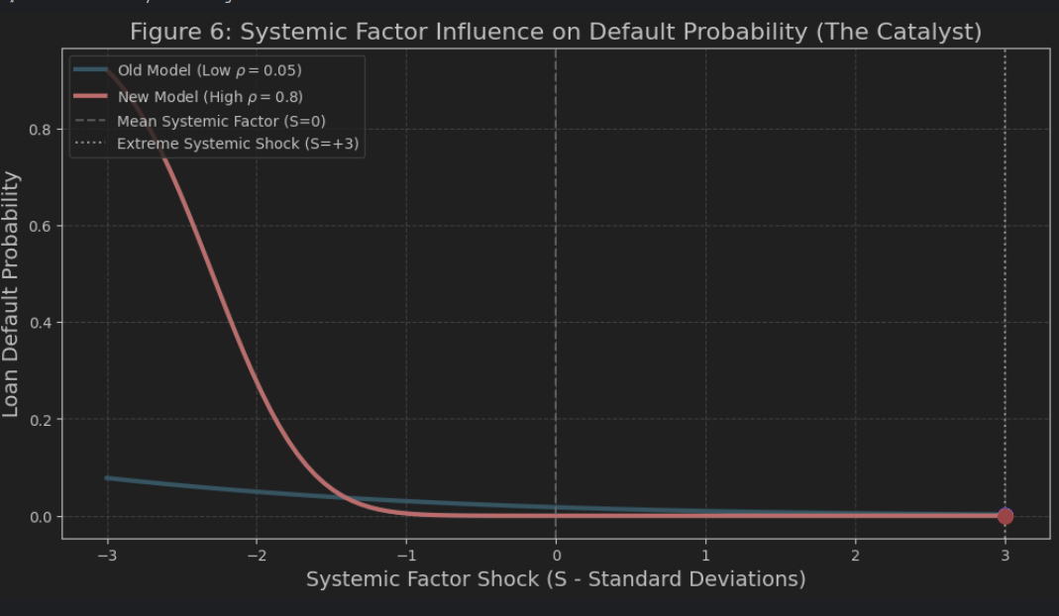
Figure 6: Systemic Factor Influence on Default Probability (The Catalyst)
Figure 6 demonstrates the inherent flaw in the Old Model's design. The blue curve (Old Model, $ρ=0.05$) shows that even an extreme economic shock $\left(\text{S}=+3\right)$ barely increases the default rate, as individual risk $(ϵ_{i})$ dominates. The red curve (New Model, $ρ=0.80$) is highly convex. It confirms that the high correlation means the firm's entire asset value is now dangerously sensitive to a single, adverse movement in the housing market (the Systemic Factor), leading directly to the predicted catastrophic loss.

