Network driver

https://opensourceforu.com/?s=network+driver
write my first linux network driver
https://linuxgazette.net/156/jangir.html
http://www.tldp.org/LDP/LG/issue93/bhaskaran.html
https://bootlin.com/doc/legacy/network-drivers/network-drivers-lab.pdf
http://www.xml.com/ldd/chapter/book/ch14.html
https://www.freertos.org/FreeRTOS-Plus/FreeRTOS_Plus_TCP/networking_basics.html
http://www.dauniv.ac.in/downloads/EmbsysRevEd_PPTs/Chap_3Lesson17EmsysNew.pdf

//////////////////////////////////////////////////////////////////////////////////////////////////////////////////////////////////////

Tasklets and Bottom-Half Processing
https://www.safaribooksonline.com/library/view/linux-device-drivers/0596000081/ch09s05.html
http://linuxforthenew.blogspot.in/2011/07/top-bottom-halfs-in-linux-isr.html
https://notes.shichao.io/lkd/ch8/
how to write top half and bottom half driver code??

/////////////////////////////////////////////////////////////////////////////////////////////////////////////////////////////////////
Block device driver
for new pendrive : linux created these files
sdb
sdb1
sg2

but for android phone it just created a link to /dev/usb/001/...

how to copy a file from ubuntu system to pendrive using terminal
https://askubuntu.com/questions/895733/copying-files-to-a-usb-drive

irqno for usb block device driver
http://www.infradead.org/~mchehab/kernel_docs/driver-api/usb/writing_usb_driver.html
http://linux-hotplug.sourceforge.net/
https://www.cse.iitb.ac.in/~bestin/btech-proj/slip/x113.html

interrupt handling in linux usb block device driver
irqnumber for usb block device in linux

////////////////////////////////////////////////////////////////////////////////////////////////////////////////////////////

interrupt handling

(Interrupt Request)

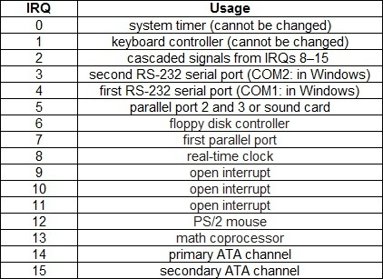

http://geek-university.com/linux/irq-interrupt-request/

http://www.cs.columbia.edu/~krj/os/lectures/L07-LinuxEvents.pdf
http://www.infradead.org/~mchehab/kernel_docs/unsorted/IRQ.html
https://www.linuxquestions.org/questions/linux-newbie-8/command-to-display-irq-dma-etc-125356/

Chapter 7. Interrupts and Interrupt Handlers
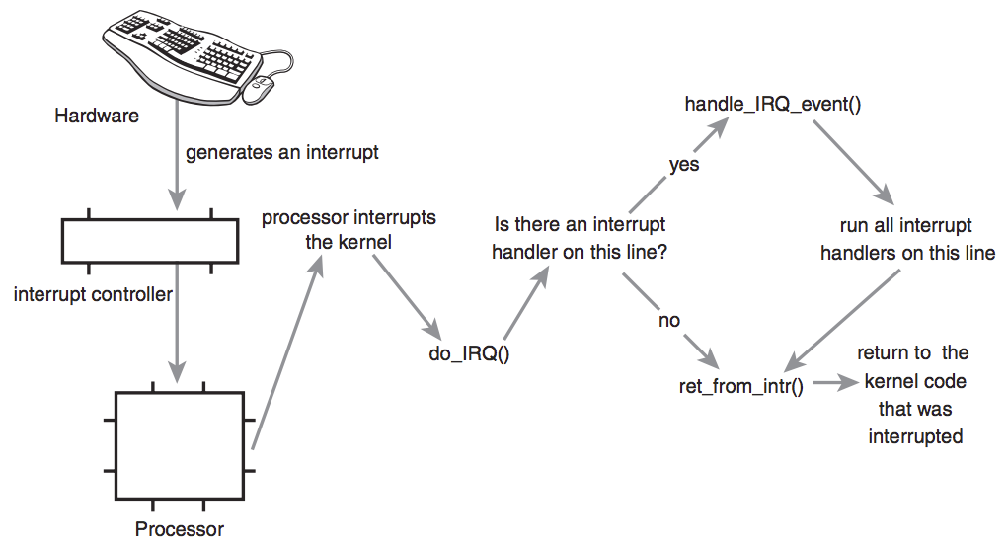
https://notes.shichao.io/lkd/ch7/
https://www.cyberciti.biz/faq/howto-display-iros-under-linux/
https://unix.stackexchange.com/questions/25203/how-can-i-know-which-irq-is-responsible-of-high-cpu-usage
usb interrupt numbers in linux
https://stackoverflow.com/questions/16625921/how-to-determine-the-irq-number-for-a-usb-device

*****
https://opensourceforu.com/page/2/?s=drivers

Linux Device Drivers Series

https://opensourceforu.com/tag/linux-device-drivers-series/

Writing USB Device Drivers
http://www.infradead.org/~mchehab/kernel_docs/driver-api/usb/writing_usb_driver.html

open source

An Introduction to Device Drivers in the Linux Kernel
https://opensourceforu.com/2014/10/an-introduction-to-device-drivers-in-the-linux-kernel/

https://opensourceforu.com/2010/11/understanding-linux-device-drivers/ : fri

Device Drivers, Part 11: USB Drivers in Linux

https://opensourceforu.com/2011/10/usb-drivers-in-linux-1/

Device Drivers, Part 13: Data Transfer to and from USB Devices

https://opensourceforu.com/2011/12/data-transfers-to-from-usb-devices/

https://sysplay.in/blog/linux-device-drivers/2014/02/usb-drivers-in-linux-data-transfer-to-from-usb-devices/

Device Drivers, Part 12: USB Drivers in Linux Continued
https://opensourceforu.com/2011/11/usb-drivers-in-linux-2/
http://static.lwn.net/images/pdf/LDD3/ch10.pdf

How does the Linux kernel handle shared IRQs?

https://unix.stackexchange.com/questions/47306/how-does-the-linux-kernel-handle-shared-irqs

Chapter 13. USB Drivers

https://www.safaribooksonline.com/library/view/linux-device-drivers/0596005903/ch13.html

interrupt handling
https://www.safaribooksonline.com/library/view/understanding-the-linux/0596005652/ch04s06.html

The Linux-USB Host Side API

Introduction to USB on Linux
https://kernel.readthedocs.io/en/sphinx-samples/usb.html

USB driver for talking to the Microchip PIC18 boot loader

https://lwn.net/Articles/263417/

From where we stoped:

>irq for PS2 keyboard and mouse

what irq number should i use to access usb keyboard in linux??
https://superuser.com/questions/456459/computer-architecture-are-usb-keyboards-less-responsive-due-to-narrow-irq-range

Here is a statement I just thought of. Can anyone tell me whether, and why, it is true?
Statement: Because USB keyboards rely on a USB generic driver and architecture that has only access to lower IRQ level(s), it cannot give the keyboard access to an IRQ as priority-high as another (say PS2) controller would.
Does this (if it is true) mean that USB keyboards would have lower priority (in terms of availability more than speed) than keyboards plugged onto another port type (like PS2)?
Take for instance a USB keyboard mapped to a medium priority IRQ, on a faulty system that is stuck on another medium priority interrupt routine. Due to its relatively equal priority, keyboard events would be ignored and you won't be able to send Ctrl-Alt-del or any other emergency keystroke. If the keyboard had a higher priority, the system could enter the keystroke Interrupt routine.
Or does the USB controller have enough IRQ range (be it continuous priority-wise or not) for it to give your keyboard the priority it needs (basically just below power failure)?
And what about virtual keyboards, mapped through network connection on a remote desktop session?
EDIT: My question is not much about speed (see comments): the main question is: does a PS2 keyboard have more chances to speak to a CPU that is stuck somewhere on an interrupt priority higher than USB and lower than keyboard?

>>
It’s not about IRQ range, it’s about three main factors:
- Amount of bus crowding
- Amount of data
- Length of data path
In the past, keyboards and mice would have a dedicated IRQ (IRQ1 for keyboards, IRQ12 for PS/2 mice).
This meant that when a key was pressed, it had an almost direct line to the CPU (via the PIC; but still, only one jump away). This allowed for keyboard events to be processed very fast in hardware, particularly since it had IRQ1. (Of course this is all about normal keyboard usage and ignores the reset line that goes from the keyboard controller directly to the CPU.)
USB devices on the other hand all share the same bus and the USB controller’s IRQ (which is usually one of the IRQ-steering ones that is shared with other devices like NICs, video-cards and such). As such, with a USB keyboard, events go from the keyboard controller, through the USB bus into the USB host controller, from there, to the secondary PIC, then to the master PIC, then to either the drivers in the OS or the BIOS, then onto the CPU. Moreover, there is error-checking data added to data transferred over USB.
In other words, there is simply more going on with a USB keyboard than with an AT or PS/2 keyboard. The data path is longer and there is more data, and it may even have to go through software. Even though the USB bandwidth is sufficiently large, having other devices on the same port causes collisions and delays (you can add a hub, but all ports on it are still the same port on the controller). So there is a lot more waiting going on.
In addition, having its own (IRQ meant that an older keyboard could interrupt the CPU’s processing whenever it needed to. With USB, the keyboard has no such mechanism and can only send some data and wait/hope for the USB controller to interrupt the CPU at some point.
Virtual keyboards are even worse because they definitely go through software which of course cannot compete with a hardware line.
Here is a simple visualization of the difference between an AT or PS/2 keyboard and a USB keyboard:
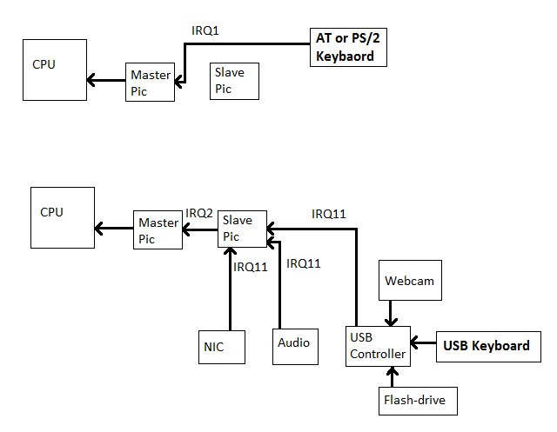

/////////////////////////////////////////////////////////////////////////////////////////////////////////////////////////////////////////////

An Introduction to the Linux Kernel
https://opensourceforu.com/2015/06/an-introduction-to-the-linux-kernel/

An Introduction to Device Drivers in the Linux Kernel
https://opensourceforu.com/2014/10/an-introduction-to-device-drivers-in-the-linux-kernel/

Linux Device Drivers Series

https://opensourceforu.com/tag/linux-device-drivers-series/

Waiting and Blocking in a Linux Driver
https://opensourceforu.com/2016/03/waiting-and-blocking-in-a-linux-driver-2/

Waiting and Blocking in a Linux Driver
https://opensourceforu.com/2016/02/waiting-and-blocking-in-a-linux-driver/

An Introduction to Distributed Replicated Block Device (DRBD)
https://opensourceforu.com/2015/12/an-introduction-to-distributed-replicated-block-device-drbd/

Using Parallel Ports to Control Devices
https://opensourceforu.com/2015/06/using-parallel-ports-to-control-devices/

Writing a Basic Framebuffer Driver
https://opensourceforu.com/2015/05/writing-a-basic-framebuffer-driver/

How to Cross Compile the Linux Kernel with Device Tree Support
https://opensourceforu.com/2014/10/how-to-cross-compile-the-linux-kernel-with-device-tree-support/

Writing an RTC Driver Based on the SPI Bus
https://opensourceforu.com/2014/09/writing-an-rtc-driver-based-on-the-spi-bus/

Working with MTD Devices
https://opensourceforu.com/2012/01/working-with-mtd-devices/

Linux to get heterogeneous memory management to boost machine learning
https://opensourceforu.com/2017/06/linux-heterogeneous-memory-management-boost-machine-learning/

The Xenomai Project, a Linux Based RTOS
https://opensourceforu.com/2015/10/the-xenomai-project-a-linux-based-rtos/

Talking to the Kernel through Sysfs
https://opensourceforu.com/2015/05/talking-to-the-kernel-through-sysfs/

Writing I2C Clients in Linux
https://opensourceforu.com/2015/01/writing-i2c-clients-in-linux/

Compile a GPIO Control Application and Test It On the Raspberry Pi
https://opensourceforu.com/2014/10/compile-a-gpio-control-application-and-test-it-on-the-raspberry-pi/

Building the Android Platform: Compile the Kernel
https://opensourceforu.com/2014/09/building-the-android-platform-compile-the-kernel/

What is Linux Kernel Porting?
https://opensourceforu.com/2014/09/what-is-linux-kernel-porting/

Code Sport
https://opensourceforu.com/2013/12/code-sport-3/

The Semester Project-IV File Systems: Formatting a Pen Drive
https://opensourceforu.com/2013/03/the-semester-project-iv-file-systems-formatting-a-pen-drive/

File Systems A Semester Project-II, Part-19
https://opensourceforu.com/2013/01/file-systems-a-semester-project-ii-part-19/

Some Nifty udev Rules and Examples
https://opensourceforu.com/2012/06/some-nifty-udev-rules-and-examples/

IT Pays To Be a Linux Expert
https://opensourceforu.com/2012/05/it-pays-to-be-a-linux-expert/

Yocto Project : Incubating Linux-based systems
https://opensourceforu.com/2014/09/yocto-project-incubating-linux-based-systems/

Kernel Development & Debugging Using the Eclipse IDE

Debugging the Linux Kernel with debugfs

FOSSTIVAL 2009: Hackers for Hackers
Develop image processing embedded systems using Python

