Steps & Results

1. Take the streaming tweets from the Twitter which are the output of the search results of the “covid19” word.
2. After sentiment analysis, we can see that there are most of the neutral tweets and next majority are positive tweets and the least ones are the negative tweets.
3. As we see at certain point of time, the number of tweets spiked around 9:30 pm, the similar trend is seen, and the neutral tweets are the highest but both the positive and negative are of same count.

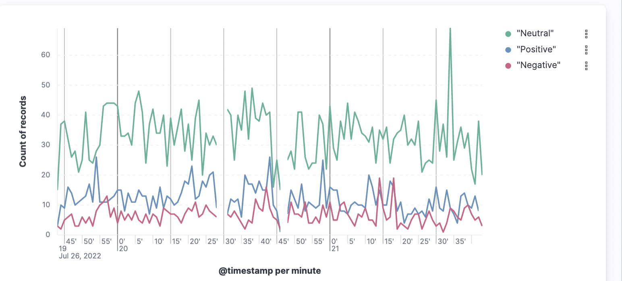

The last two graphs show the counts of the negative, positive and neutral tweets count overall until that particular instance of time.