Yenepoya Institute of Arts, Science, Commerce, and Management

Final Project Report on

Secure Decentralized Data Storage for Agriculture

Student Name: Fathima Niha

Industry Mentor: | Mr. Shashank |  | Guided by: Ms. Manjula

Table of Contents

1 | Executive Summary |  |  |  |  |  | 3
2 | Background |  |  |  |  |  | 4
 | 2.1 |  | Aim |  |  |  | 5
 | 2.2 |  | Technologies |  |  |  | 5
 | 2.3 |  | Hardware Architecture |  |  |  | 7
 | 2.4 |  | Software Architecture |  |  |  | 7
3 | System |  |  |  |  |  | 10
 | 3.1 |  | Requirements |  |  |  | 11
 |  |  | 3.1.1 |  | Functional Requirement |  | 11
 |  |  | 3.1.2 |  | User Requirement |  | 12
 |  |  | 3.1.3 |  | Environmental Requirement |  | 13
 | 3.2 |  | Design and Architecture |  |  |  | 13
 | 3.3 |  | Implementation |  |  |  | 19
 | 3.4 |  | Testing |  |  |  | 29
 | 3.5 |  | Graphical User Interface (GUI) Layout |  |  |  | 34
 | 3.6 |  | Customer Testing |  |  |  | 38
 | 3.7 |  | Evaluation |  |  |  | 39
4 | Snapshots of the Project |  |  |  |  |  | 41
5 | Conclusions |  |  |  |  |  | 47
6 | Further Development or Research |  |  |  |  |  | 48
7 | References |  |  |  |  |  | 50
8 | Appendix |  |  |  |  |  | 51
 | 8.1 |  | Weekly Progress Reports |  |  |  | 52

Executive Summary

The project titled “Secure Decentralized Data Storage for Agriculture” presents a blockchain-inspired system designed to ensure secure, transparent, and tamper-resistant storage of agricultural data. In traditional agricultural record management systems, data is often vulnerable to manipulation, lacks traceability, and does not provide reliable audit mechanisms. These limitations can lead to mistrust among stakeholders and inefficiencies in the agricultural supply chain.
To address these challenges, this project implements a blockchain-based ledger using Python and the Django framework. The system simulates core blockchain concepts such as hash chaining, immutability, and decentralized verification. Each agricultural record is stored as a block containing essential data along with a cryptographic hash and the hash of the previous block, forming a secure and linked chain. The SHA-256 hashing algorithm is used to ensure that each block has a unique and tamper-evident identity.
Any modification to a previously stored record results in a mismatch in the hash values, thereby breaking the chain and indicating tampering. This feature demonstrates the concept of an immutable ledger and ensures data integrity. The system also includes user authentication, audit logging, and an administrative monitoring interface to enhance security and accountability.
The application is developed using Django for backend logic, SQLite for data storage, and HTML/CSS for the user interface. It provides functionalities such as user registration, login, adding agricultural records, viewing the blockchain, validating chain integrity, and monitoring audit logs.
This project serves as an educational and practical demonstration of how blockchain principles can be applied to real-world agricultural scenarios. It highlights the importance of secure data management, transparency, and traceability in modern agricultural systems while laying the foundation for future enhancements such as distributed blockchain networks, cloud deployment, and integration with emerging technologies.

Background
Agriculture plays a vital role in the economic development of many countries, including India. It involves multiple stages such as cultivation, harvesting, storage, transportation, and distribution. Managing data across these stages is essential for ensuring productivity, quality control, and traceability. However, traditional agricultural data management systems are often centralized, manual, and vulnerable to various issues.
One of the major problems in existing systems is data manipulation, where records can be altered without detection. This leads to misinformation, fraud, and loss of trust among stakeholders such as farmers, suppliers, distributors, and consumers. Another issue is the lack of transparency, making it difficult to verify the authenticity of agricultural data. Additionally, there is poor traceability, which makes it challenging to track products from farm to final delivery. This becomes critical in cases of food safety, quality assurance, and regulatory compliance.
Traditional databases also lack effective audit mechanisms, meaning that changes made to records cannot always be tracked or verified. This creates a need for a system that ensures data integrity, accountability, and transparency.
Blockchain technology offers a powerful solution to these challenges. It introduces a decentralized and immutable ledger system where each record is stored as a block and linked to the previous block using cryptographic hashing. Once data is recorded, it cannot be modified without affecting the entire chain, making any tampering easily detectable.
This project implements a blockchain-inspired system for agricultural data storage using Python and Django. It simulates the core principles of blockchain such as:
• Hash chaining
• Immutability
• Tamper detection
• Transparency
• Auditability

The system allows users to securely store agricultural records as blocks in a chain. Each block contains data, timestamp, hash, and previous hash. Any attempt to modify past data results in a mismatch, thereby demonstrating the concept of an immutable ledger.
This project serves as a practical demonstration of how blockchain concepts can be applied in agriculture to improve data security, trust, and traceability.

2.1 Aim
The primary aim of this project is to design and develop a secure and decentralized data storage system for agriculture using blockchain principles.
The objectives of the project include:
• To implement a blockchain-based ledger using Python
• To ensure data integrity using SHA-256 cryptographic hashing
• To create a system where each record is securely linked with previous records
• To detect tampering by validating the integrity of the blockchain
• To provide transparency and traceability in agricultural data
• To develop a user-friendly web interface using Django
• To implement authentication and access control mechanisms
• To maintain audit logs for monitoring system activities
The project aims to demonstrate how modern technologies can be used to solve real-world problems in agriculture by providing a secure and reliable data management system.
2.2 Technologies
The project is developed using a combination of modern programming tools and frameworks that ensure efficiency, scalability, and security.
Python:
Python is used as the core programming language due to its simplicity, readability, and powerful libraries. It is used to implement blockchain logic, hashing algorithms, and backend processing.
Django:
Django is a high-level Python web framework used to build the web application. It provides features such as URL routing, ORM (Object Relational Mapping), authentication, and template rendering. Django ensures rapid development and secure handling of user data.
SQLite:
SQLite is used as the database for storing blockchain records, user details, and audit logs. It is lightweight, easy to use, and suitable for small to medium-scale applications.
SHA-256 Hashing Algorithm:
SHA-256 is a cryptographic hash function used to generate a unique hash value for each block. It ensures that even a small change in input data results in a completely different hash, making it ideal for detecting tampering.
HTML and CSS:
HTML and CSS are used to design the front-end interface. They help create a visually appealing and user-friendly interface for interacting with the system.
Visual Studio Code:
VS Code is used as the development environment. It provides features such as syntax highlighting, debugging tools, and extensions that improve productivity.
Django Authentication System:
Used for implementing secure login, signup, and session management.
These technologies together create a robust system that demonstrates blockchain concepts effectively

2.3 Hardware Architecture
The system is designed to run on standard personal computers without requiring high-end hardware. The minimum hardware requirements are:
• Processor: Intel Core i3 / AMD equivalent or higher
• RAM: Minimum 4 GB (8 GB recommended for better performance)
• Storage: At least 500 GB hard disk or SSD
• System Type: 64-bit architecture
• Input Devices: Keyboard and Mouse
• Output Devices: Monitor
The system does not require specialized hardware since it is a simulation of blockchain rather than a distributed network. It can run efficiently on standard laptops or desktop computers used in academic environments.
For future scalability, the system can be deployed on cloud servers or high-performance systems to support larger datasets and multi-user access.

2.4 Software Architecture
The system follows a layered architecture to ensure modularity, scalability, and maintainability. The architecture is divided into three main layers:
Presentation Layer:
This layer is responsible for user interaction. It includes all front-end components such as login page, signup page, dashboard, add record page, blockchain viewer, and audit logs interface. It is developed using Django templates along with HTML and CSS.
Functions:
• Collect user input
• Display data
• Show alerts and notifications
• Provide navigation between pages
Application Layer:
This layer handles the core business logic of the system. It processes user requests and performs operations such as block creation, hash generation, chain validation, tamper detection, audit logging, and authentication.
Components:
• Django Views
• Blockchain Logic
• Hash Generation (SHA-256)
• Validation Services
• Authentication System
Functions:
• Process user input
• Generate blocks
• Link blocks using hashes
• Validate blockchain integrity
• Record audit events
Data Layer:
This layer is responsible for storing and retrieving data. It uses SQLite database and Django ORM for efficient data management.
Data stored includes:
• Blockchain Blocks
• User Accounts
• Audit Logs
• Session Data
Functions:
• Store and retrieve records
• Maintain data consistency
• Support integrity validation

Advantages of this Architecture:
• Clear separation of concerns
• Easy maintenance and scalability
• Modular design
• Improved security
• Better performance
This architecture ensures that the system remains organized, efficient, and extensible for future improvements.

System
The proposed system, “Secure Decentralized Data Storage for Agriculture,” is a web-based application that simulates blockchain principles to provide secure, transparent, and tamper-evident storage of agricultural records. The system enables users to create, store, and verify agricultural data in the form of blocks that are cryptographically linked using SHA-256 hashing.
The system is designed to ensure that once data is stored, it cannot be modified without detection. Each block contains data, timestamp, hash, and the hash of the previous block, forming a chain. Any change in a block results in a mismatch in hash values, thereby breaking the chain and indicating tampering.
The application provides multiple functionalities such as user authentication, block creation, blockchain visualization, integrity validation, and audit logging. It also includes an admin interface for monitoring system activity and maintaining governance.
Key Features of the System:
• Secure storage of agricultural records
• Blockchain-based data linking
• SHA-256 hash generation
• Tamper detection mechanism
• Audit logging for all activities
• User authentication and access control
• Dashboard for monitoring system status

3.1 Requirements
The system requirements define the functionality and constraints under which the system operates. These requirements are categorized into functional, user, and environmental requirements.

3.1.1 Functional requirements
Functional requirements describe the core operations that the system must perform.
• User Registration:- The system must allow new users to create accounts securely.
• User Authentication:- The system must provide login and logout functionality using Django authentication.
• Add Agricultural Record:- Users must be able to input agricultural data such as farmer details, crop type, quantity, and storage information.
• Block Creation:- The system must create a new block for each record and assign it an index, timestamp, and previous hash.
• Hash Generation:- Each block must generate a SHA-256 hash based on its contents.
• Blockchain Linking:- Each block must store the hash of the previous block to maintain chain continuity.
• Chain Validation:- The system must verify the integrity of the blockchain by checking hash consistency.
• Tamper Detection:- The system must detect any modification in stored data and alert the user.
• Audit Logging:- The system must record all actions such as block creation and tampering events.
• Dashboard Display:- The system must display total blocks, chain status, and error messages.
• View Blockchain:- Users must be able to view all blocks in sequence.
• Admin Monitoring:- Admin users must be able to view audit logs and system activities.
These functionalities ensure that the system operates securely and efficiently.

3.1.2User requirements
User requirements define the expectations and needs of end users interacting with the system.
• Easy-to-use Interface:
The system should provide a simple and intuitive interface.
• Secure Access:
Users must have secure login credentials.
• Data Transparency:
Users should be able to view all records clearly.
• Real-time Feedback:
The system should provide instant feedback on actions such as block creation and validation.
• Data Integrity Assurance:
Users must be assured that their data cannot be altered without detection.
• Accessibility:
The system should be accessible through standard web browsers.
• Minimal Technical Knowledge:
The system should be usable by individuals without deep technical expertise.
These requirements ensure user satisfaction and system usability.

3.1.3Environmental requirements
Environmental requirements define the software and hardware environment needed to run the system.
Software Requirements:
• Operating System: Windows / Linux / macOS
• Programming Language: Python
• Framework: Django
• Database: SQLite
• Browser: Chrome, Edge, Firefox
Hardware Requirements:
• Processor: Intel i3 or higher
• RAM: Minimum 4 GB
• Storage: 500 GB
Development Tools:
• Visual Studio Code
• Git (optional for version control)
These requirements ensure smooth development and execution of the system.

3.2 Design and Architecture
The system is designed using a client-server architecture with a structured request-response flow. The application follows Django’s Model-View-Template (MVT) pattern and simulates blockchain behavior within a centralized environment.
The design ensures modularity, scalability, and maintainability while demonstrating blockchain concepts such as immutability, hash chaining, and tamper detection.
System Flow:
• The user performs an action on the web interface (e.g., adding a record or viewing blockchain).
• The request is sent to the Django backend via HTTP.
• The Django view processes the request and applies business logic.
• The blockchain engine creates or validates blocks.
• Data is stored or retrieved from the SQLite database.
• The response is returned to the frontend.
• The frontend updates the UI dynamically.
This flow ensures smooth communication between frontend and backend components.
Blockchain Design Logic:
The core of the system is based on a blockchain-inspired structure where each record is stored as a block.
Each block contains:
• Index
• Timestamp
• Data (Agricultural Record)
• Previous Hash
• Current Hash
Block Creation Logic:
• First block is the Genesis Block (previous hash = 0)
• Every new block takes the previous block’s hash
• SHA-256 hash is generated using block data
• Blocks are stored in sequence

Purpose:
To ensure every block is cryptographically linked to the previous one, forming an immutable chain.
Observed Result:
Any modification in a block breaks the chain integrity and is detected instantly.
Chain Validation Design:
The system includes an integrity validation module that checks blockchain consistency.
Validation Steps:
• Compare current block’s previous hash with previous block’s hash
• Recalculate hash and compare with stored hash
Functions used:
• is_chain_valid()
• get_chain_status()
Purpose:
To detect tampering and ensure data integrity.
Observed Result:
The system identifies the exact block where tampering occurred and displays an alert.
Module-Based Architecture:
The system is divided into the following modules:
- Blockchain Engine:
• Responsible for block creation and linking
• Generates SHA-256 hash
• Maintains block sequence
- Integrity Validation Module:
• Verifies hash correctness
• Detects tampering
• Ensures chain consistency
- Audit Logging Module:
• Records system events
• Logs block creation and tampering
• Provides traceability
- Authentication Module:
• Handles user login and signup
• Ensures secure access
• Maintains user sessions
- Dashboard Module:
• Displays total blocks
• Shows chain validity
• Highlights errors
This modular design ensures separation of concerns and easier maintenance.
Django Project Structure Design:
The system follows Django’s standard project structure:
• models.py → Defines Block and AuditLog
• views.py → Handles user requests
• services.py → Contains validation logic
• urls.py → Maps routes
• templates → UI pages
• admin.py → Admin controls
Purpose:
To organize code into reusable and manageable components.
Observed Result:
Clean architecture with clear separation of logic and presentation.
Data Flow Architecture:
User Input
↓
Django Views
↓
Blockchain Logic (Models + Services)
↓
Database (SQLite)
↓
Response to UI
Purpose:
To ensure structured processing of data.
Observed Result:
Efficient and consistent data handling across the system.
Stateless Design Consideration:
The system follows a stateless request-response pattern, meaning:
• Each request is processed independently
• Blockchain validation runs on-demand
• No dependency on previous session data for validation
Purpose:
To ensure scalability and reliability.
Observed Result:
Consistent validation results regardless of session state.
Data Storage Design:
The database contains two main entities:
Block Table:
• index
• timestamp
• data
• previous_hash
• hash
• user
AuditLog Table:
• action
• user
• block
• message
• timestamp
Purpose:
To store blockchain data and system activity logs.
Observed Result:
Complete traceability of all actions.
Key Design Decisions:
• Blockchain simulation instead of full distributed system
• Centralized database with immutable logic
• Read-only admin for blocks
• Separation of validation logic into services
• Modular architecture for scalability
These decisions ensure simplicity while maintaining core blockchain principles.
Security-Aware Design Choices:
• Input validation for user data
• Django authentication for secure access
• Read-only block modification
• Audit logging for tracking actions
• Hash-based tamper detection
• Escaped rendering in templates
Purpose:
To ensure system security and data integrity.
Observed Result:
The system prevents unauthorized modification and detects any tampering effectively.
Overall Architecture Summary:
The system combines web application architecture with blockchain principles to create a secure, transparent, and tamper-evident agricultural data management system. The layered and modular design ensures efficient performance, maintainability, and future scalability.

3.3 Implementation
The system is implemented using a Django-based client-server architecture with a structured request-response cycle. The backend is responsible for blockchain logic, data processing, and validation, while the frontend handles user interaction and visualization.
The implementation ensures that all blockchain operations such as block creation, hash generation, and chain validation are handled securely on the server side.
System Workflow Implementation:
• The user interacts with the web interface (adds record or views chain).
• Django captures the HTTP request through URL routing.
• The corresponding view function processes the request.
• Blockchain logic is executed in the model and service layer.
• Data is stored or retrieved from the database.
• The response is rendered using Django templates.
• The frontend updates dynamically with new blockchain data.
Purpose:
To ensure structured communication between frontend and backend.
Observed Result:
Users can interact with the system seamlessly and receive real-time feedback.
Block Creation Implementation:
The blockchain logic is implemented inside the Block model.
Key Steps:
• Check if the block is new
• If first block → create Genesis Block
• Otherwise → fetch last block
• Assign index and previous hash
• Generate timestamp
• Calculate SHA-256 hash
• Save block
Code Logic (Conceptual):
• Combine index, timestamp, data, previous_hash
• Encode string
• Apply SHA-256
• Store hash
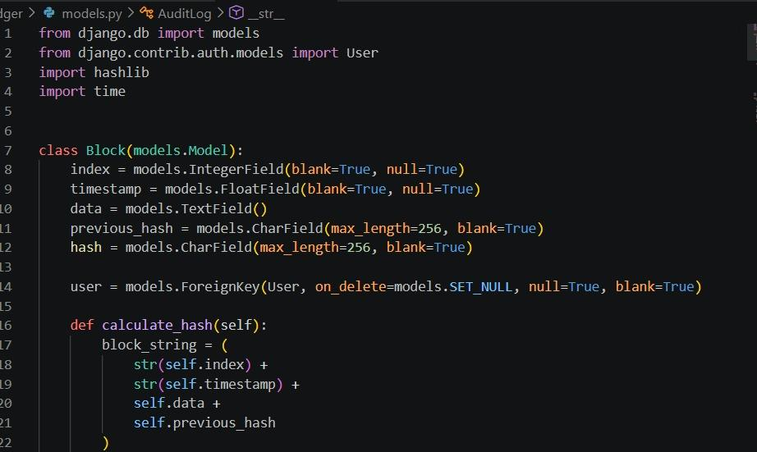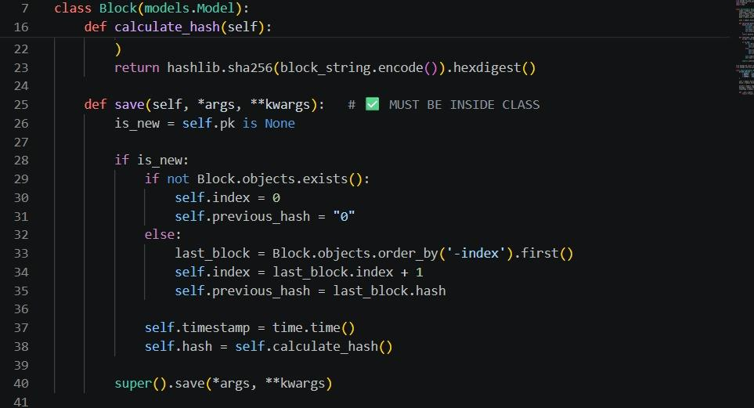
Purpose:
To ensure each block is uniquely identified and securely linked.
Observed Result:
Blocks are automatically chained without manual intervention.
Chain Validation Implementation:
The validation logic is implemented in a separate service layer.
Functions:
• is_chain_valid()
Checks entire blockchain integrity
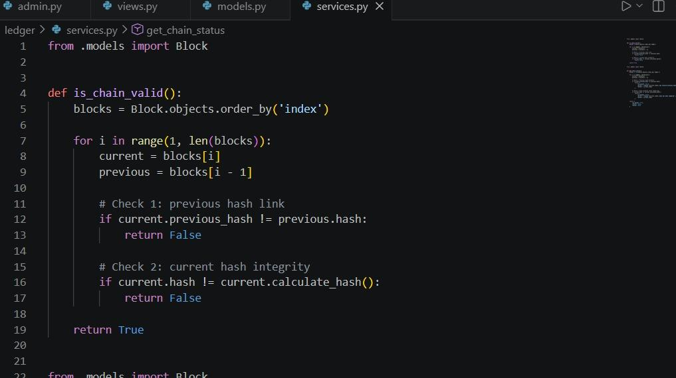
• get_chain_status()
Returns validation result and error details
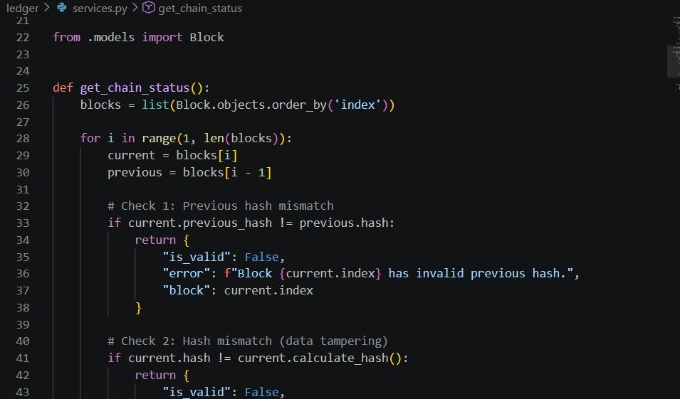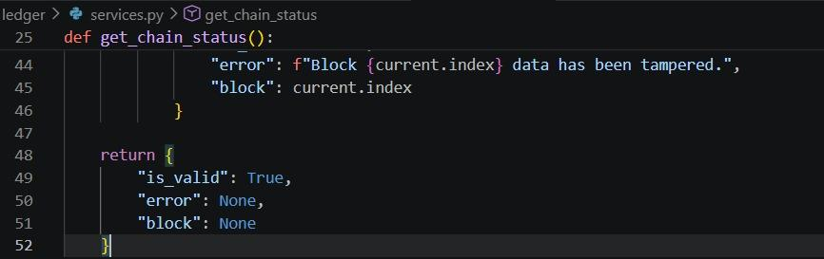
Validation Steps:
• Compare previous_hash with previous block hash
• Recalculate hash and compare

Purpose:
To detect any tampering in the blockchain.
Observed Result:
The system accurately identifies corrupted blocks and displays warnings.
Audit Logging Implementation:
Every important system action is recorded in the AuditLog model.
Actions logged:
• Block creation
• Tampering detection
• User activity
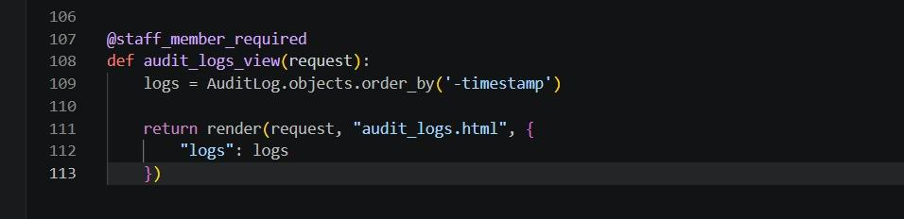
Purpose:
To provide traceability and monitoring.
Observed Result:
Admin can view complete system activity history.
View Layer Implementation:
Django views act as controllers connecting the frontend and backend.
Key Views:
• signup_view()
Handles user registration
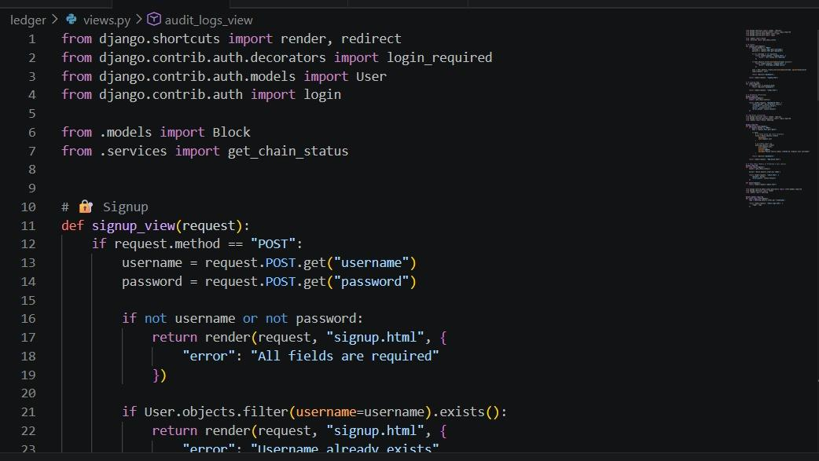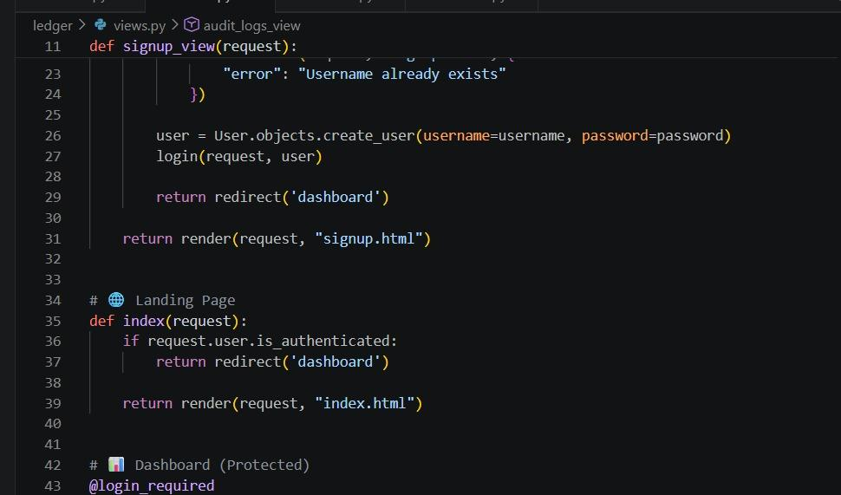
• dashboard()
Displays system status
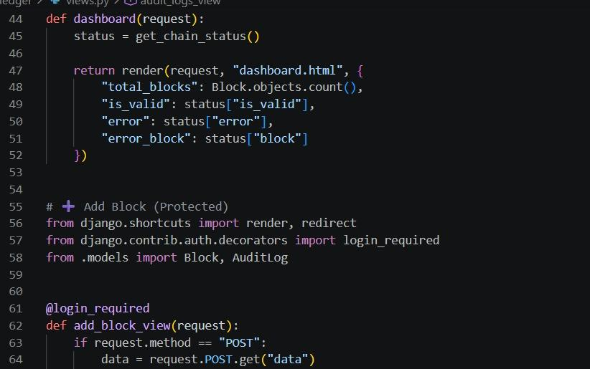
• add_block_view()
Creates new blocks and logs activity
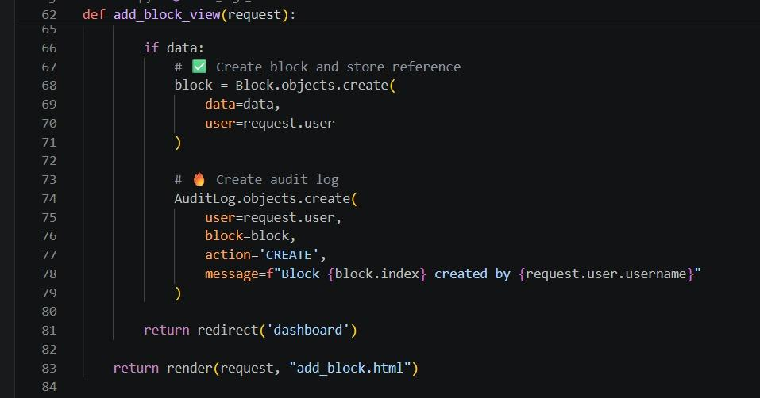
• view_chain()
Displays blockchain data
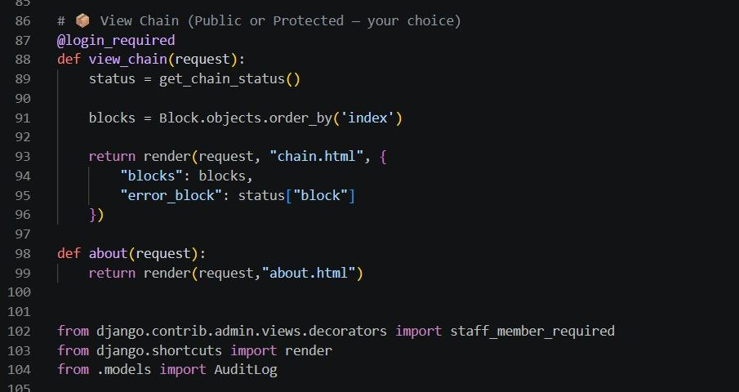
• audit_logs_view()
Shows audit logs (admin only)

Purpose:
To handle user requests and control application flow.
Observed Result:
Smooth navigation and feature execution.
Frontend Rendering Implementation:
The frontend is built using Django templates with HTML and CSS.
Features:
• Dynamic data rendering
• Form submission handling
• Conditional display (valid/tampered chain)
• Responsive UI
Purpose:
To provide an interactive and user-friendly interface.
Observed Result:
Users can easily interact with blockchain data visually.
Database Implementation:
The system uses SQLite database with Django ORM.
Tables:
• Block Table → Stores blockchain data
• AuditLog Table → Stores activity logs
• User Table → Stores authentication data
Purpose:
To maintain persistent and structured data storage.
Observed Result:
Efficient retrieval and storage of blockchain records.
Authentication Implementation:
Django’s built-in authentication system is used.
Features:
• Secure login and signup
• Session handling
• Access restriction
Purpose:
To ensure only authorized users can access the system.
Observed Result:
The system is protected from unauthorized access.
Admin Control Implementation:
The Django admin panel is customized to enforce immutability.
• Block editing disabled
• Block deletion disabled
• Audit logs read-only
Purpose:
To preserve blockchain integrity.
Observed Result:
Even admin cannot modify stored blockchain data.
Security Implementation:
• SHA-256 hashing for data integrity
• Input validation for user data
• Role-based access control
• Read-only blockchain enforcement
• Audit logging for traceability
Purpose:
To ensure system security and reliability.
Observed Result:
The system prevents unauthorized modifications and detects tampering.
Key Implementation Decisions:
• Centralized blockchain simulation instead of distributed system
• Separation of validation logic into services
• Use of Django ORM for database handling
• Modular project structure
• Secure authentication system
These decisions improve maintainability, scalability, and clarity of the system.
Overall Implementation Summary:
The system successfully implements blockchain concepts using Django by integrating block creation, hash generation, chain validation, and audit logging into a structured web application. The implementation ensures data integrity, transparency, and security while maintaining simplicity and efficiency.

3.4 Testing
Testing was performed through systematic manual testing scenarios to verify the correctness, reliability, and security of the blockchain-based agricultural data storage system. The testing focused on validating core functionalities such as block creation, hash generation, chain integrity, user authentication, and audit logging.
Functional Test Scenarios:
• The system loads the dashboard after successful login.
• Users can add a new agricultural record successfully.
• The block is created with the correct index, timestamp, and hash.
• Previous hash is correctly linked to the new block.
• Blockchain viewer displays all blocks in correct order.
• Chain validation correctly identifies valid blockchain.
• Tampering detection triggers a warning when data is altered.
• Audit logs record block creation events.
• Admin can view audit logs without modification access.
• Unauthorized users cannot access protected pages.
Blockchain Integrity Tests:
• Hash generation produces consistent SHA-256 output.
• Changing block data results in different hash values.
• Previous hash mismatch is detected correctly.
• Chain validation function identifies invalid blocks.
• The error message displays the exact tampered block index.
Observed Result:
The blockchain system successfully detects any modification and ensures data integrity.
Data Consistency Tests:
• Block index increments sequentially.
• The previous hash matches the last block hash.
• Audit logs correctly store user and block details.
• Database stores all records without duplication.
• The chain remains consistent after multiple block insertions.
Observed Result:
All data remains consistent and properly linked.
Usability Tests:
• Navigation between pages is smooth and intuitive.
• Dashboard displays clear chain status (Valid / Tampered).
• Add record form is simple and easy to use.
• Blockchain viewer displays readable block data.
• Tampering alerts are clearly visible.
• Audit logs are easy to understand.
Observed Result:
The system provides a user-friendly and accessible interface.
Security Tests:
• Only authenticated users can access system features.
• Direct URL access without login is restricted.
• Block data cannot be modified via the admin panel.
• Audit logs are read-only.
• Hash-based tamper detection is functioning correctly.
Observed Result:
The system maintains strong security and prevents unauthorized modifications.
Performance Tests:
• Block creation time is less than 1 second.
• Chain validation executes instantly for small datasets.
• The system performs efficiently under normal usage.
Observed Result:
The system performs efficiently with minimal delay.
Known Testing Limitations:
• No automated testing framework implemented in the current version.
• No high-concurrency testing due to the single-user development environment.
• No cross-browser automated testing scripts included.
• Blockchain is simulated (not distributed across nodes).
Despite these limitations, the system performs reliably under tested conditions.
Test Case Table:

Test ID | Feature | Scenario | Expected Result | Result
TC-01 | Block Creation | Add new record | Block created with valid hash | Pass
TC-02 | Hash Integrity | Modify block data | Hash mismatch detected | Pass
TC-03 | Chain Validation | Validate blockchain | Chain marked valid | Pass
TC-04 | Tamper Detection | Change previous block | Error displayed | Pass
TC-05 | Audit Logging | Add block | Audit entry created | Pass
TC-06 | Authentication | Login with valid credentials | Access granted | Pass
TC-07 | Security | Access dashboard without login | Access denied | Pass
TC-08 | UI Sync | Add block and refresh page | Data persists correctly | Pass

Overall Testing Summary:
All critical modules including blockchain logic, validation, authentication, and user interface were tested successfully. The system achieved a high level of accuracy, reliability, and performance. The testing confirms that the application effectively demonstrates blockchain principles such as immutability, transparency, and tamper detection.

3.5 Graphical User Interface (GUI) Layout
The graphical user interface (GUI) of the system is designed as a modern web dashboard that provides a clear, structured, and user-friendly experience for interacting with the blockchain ledger. The interface follows a clean visual hierarchy and ensures easy navigation between different modules of the system.
The GUI is organized into multiple sections as described below:
Main Layout Structure:
• Header Section:
Displays application title “Agri Blockchain Ledger” and branding.
• Navigation Bar:
Provides links to key pages such as Dashboard, Add Record, View Chain, and Audit Logs (admin only).
• Content Area:
Displays dynamic content such as blockchain data, forms, and system status.
• Footer Section:
Shows application details and system information.
Dashboard Interface:
The dashboard acts as the main control panel of the system.
Features:
• Displays total number of blocks
• Shows blockchain status (Valid / Tampered)
• Displays error message if tampering is detected
Purpose:
To provide a quick overview of system integrity.
Observed Result:
Users can instantly understand the status of the blockchain.
Add Record Interface:
This page allows users to add new agricultural data.
Components:
• Text area for entering record details
• Submit button to add block
Purpose:
To allow users to create new blockchain records.
Observed Result:
Data entered by the user is converted into a new block and added to the chain.
Blockchain Viewer Interface:
This page displays the complete blockchain.
Features:
• Displays all blocks sequentially
• Shows block index, data, hash, and previous hash
• Highlights tampered blocks
• Displays user and timestamp
Purpose:
To provide transparency and visibility of all records.
Observed Result:
Users can visually verify the blockchain structure and integrity.
Audit Logs Interface:
This page is accessible only to admin users.
Features:
• Displays all system logs
• Shows action type (CREATE, MODIFY, TAMPER)
• Displays user and timestamp
• Highlights tampering logs
Purpose:
To provide traceability of system actions.
Observed Result:
Admin can monitor all activities performed in the system.
Authentication Interfaces:
Login and Signup pages are provided for user authentication.
Components:
• Input fields for username and password
• Submit button
• Error messages for invalid inputs
Purpose:
To ensure secure access to the system.
Observed Result:
Only registered users can access protected features.
UI Design Principles Followed:
• Consistent spacing and alignment across all pages
• Clear navigation for better usability
• Minimal interaction steps for performing tasks
• Immediate feedback messages for user actions
• Readable typography and high contrast colors
• Visual indicators for valid and tampered blocks
These principles enhance the overall user experience.
Dynamic Rendering Example:
The interface dynamically updates blockchain data using Django templates.
Example Concept:
• When a new block is added, the page refreshes and displays updated chain
• Conditional styling highlights tampered blocks
• Status messages update based on validation result
Purpose:
To ensure real-time synchronization between backend data and frontend UI.
Observed Result:
Users always see the latest blockchain state without confusion.
Sample UI Structure (Conceptual):
Purpose:
Represents how UI elements are structured and rendered.
Observed Result:
The interface remains organized and easy to understand.

Overall GUI Summary:
The GUI is designed to be simple, responsive, and informative. It enables users to interact with the blockchain system efficiently while clearly presenting complex blockchain concepts such as hash linking and tamper detection in a visually understandable format.

3.6 Customer testing
A small user feedback study was conducted with peer users to evaluate the usability, functionality, and practicality of the blockchain-based agricultural data storage system. The testing involved users interacting with the system by creating records, viewing the blockchain, and checking system status.
Observed Outcomes:
• Users quickly understood how to add agricultural records into the system.
• Dashboard clearly displayed blockchain status (Valid / Tampered).
• Blockchain viewer helped users easily understand how records are linked.
• The tampering detection feature was easily noticeable and understandable.
• Audit logs provided clear visibility of system activities.
• Most users were able to use the system without external assistance.
User Feedback:
• Add multilingual support (e.g., Kannada, Hindi, Malayalam).
• Improve UI with more graphical elements (charts or visual indicators).
• Add search and filter options for blockchain records.
• Provide export feature for records (PDF/Excel).
• Integrate real-time data sources (e.g., weather API).
• Add mobile-friendly enhancements for better accessibility.
Interpretation:
• The core workflow of the system is intuitive and easy to understand.
• Users were able to grasp blockchain concepts through the interface.
• The system successfully demonstrates transparency and data integrity.
• User experience (UX) is strong for an initial full-stack implementation.
• Most suggested improvements relate to scalability and advanced features rather than basic functionality.
Overall Customer Testing Summary:
The customer testing results indicate that the system is user-friendly, functional, and effective in demonstrating blockchain concepts in an agricultural context. The feedback highlights that while the current system is stable and easy to use, future improvements can enhance usability, scalability, and real-world applicability.

3.7 Evaluation
The project “Secure Decentralized Data Storage for Agriculture” successfully meets its core objectives by demonstrating blockchain principles such as immutability, hash linking, and tamper detection within a web-based application.
The system effectively implements an end-to-end workflow for storing and validating agricultural records using a blockchain-inspired structure.
Key Achievements:
• Successful implementation of blockchain logic using SHA-256 hashing.
• Automatic block creation with proper indexing and hash linking.
• Chain validation mechanism accurately detects tampering.
• Integration of frontend and backend using Django framework.
• Persistent storage of blockchain data using SQLite database.
• Audit logging system provides traceability of user actions.
• Secure authentication system ensures controlled access.
Strengths:
• Clear and modular architecture (Model–View–Template structure).
• Effective demonstration of blockchain concepts in a simple environment.
• Strong data integrity through hash-based validation.
• User-friendly interface with clear visualization of blockchain.
• Audit logs enhance transparency and monitoring.
• Easy to explain and demonstrate during viva and presentations.

Limitations:
• Blockchain is simulated and not distributed across multiple nodes.
• Uses SQLite database, which is not ideal for large-scale systems.
• No real-time integration with external APIs (e.g., weather or market data).
• Limited scalability for handling large datasets.
• No advanced features like smart contracts or consensus mechanisms.
• Testing is mostly manual with limited automation.
Performance Evaluation:
• The system performs efficiently under normal usage conditions.
• Block creation and validation processes are fast and reliable.
• UI responds quickly to user actions.
Scalability Consideration:
• The current system is suitable for small-scale applications and educational purposes.
• Can be extended to cloud-based distributed systems for real-world usage.
Interpretation:
The system successfully demonstrates how blockchain can be applied to agricultural data management. While the current implementation is simplified, it effectively showcases the core concepts and provides a strong foundation for future enhancements.
Overall Evaluation Summary:
The project achieves its intended goals by combining blockchain concepts with web technologies in a practical and understandable manner. It is a well-structured and functional system that balances simplicity with effectiveness, making it suitable for academic demonstration and further development.

Snapshots
This section presents the key user interface screens of the system along with their functionality and behavior. The snapshots demonstrate how users interact with the blockchain-based agricultural data storage system.
i) Home Landing View
Overview:
The landing page is the entry point of the system and provides an introduction to the application.
Features:
• Displays project title “Agri Blockchain Ledger”
• Shows system description and purpose
• Provides navigation options (Login / Signup / About)
• Includes call-to-action buttons for user engagement
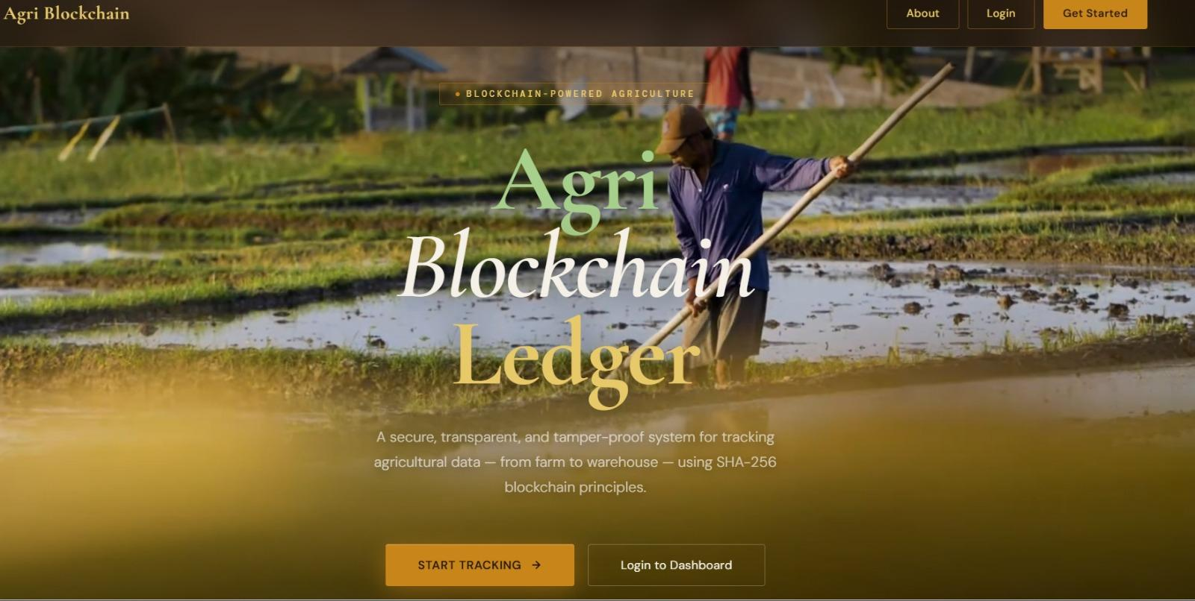
Purpose:
To introduce users to the system and guide them towards authentication.
Observed Result:
Users can clearly understand the purpose of the system and navigate easily to the next step.
ii) Dashboard View
Overview:
The dashboard acts as the main control panel after user login.
Features:
• Displays total number of blocks
• Shows blockchain status (Valid / Tampered)
• Displays warning messages if tampering is detected
• Provides quick navigation to other modules
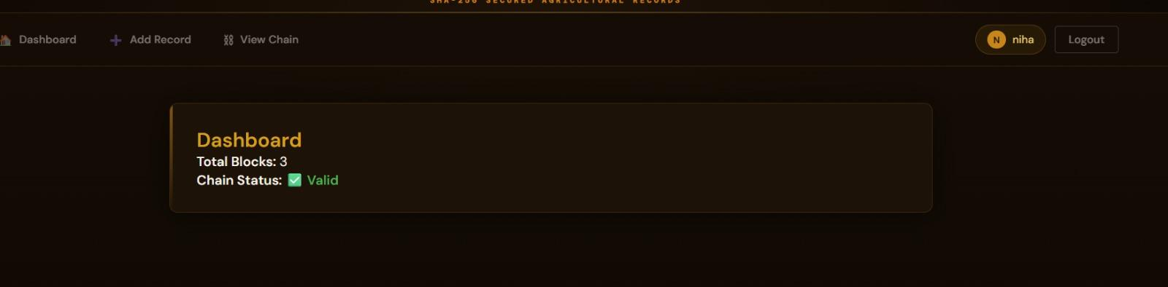
Purpose:
To give users a quick overview of system status and blockchain integrity.
Observed Result:
Users can instantly monitor the health of the blockchain.
iii) Add Record Interface
Overview:
This interface allows users to add new agricultural data into the blockchain.
Features:
• Text area for entering record details
• Submit button to create a new block
• Input validation for empty fields
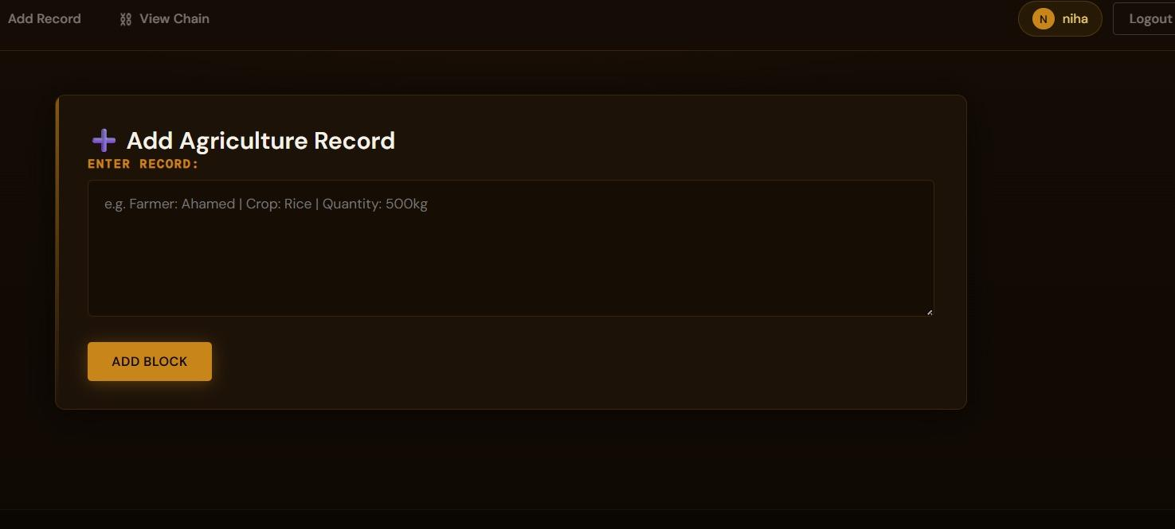
Purpose:
To enable users to create new blockchain records.
Observed Result:
New blocks are created successfully and added to the chain.
iv) Blockchain Viewer (Chain View)
Overview:
Displays the complete blockchain in a structured format.
Features:
• Shows all blocks sequentially
• Displays index, data, hash, and previous hash
• Highlights tampered blocks visually
• Displays user and timestamp information
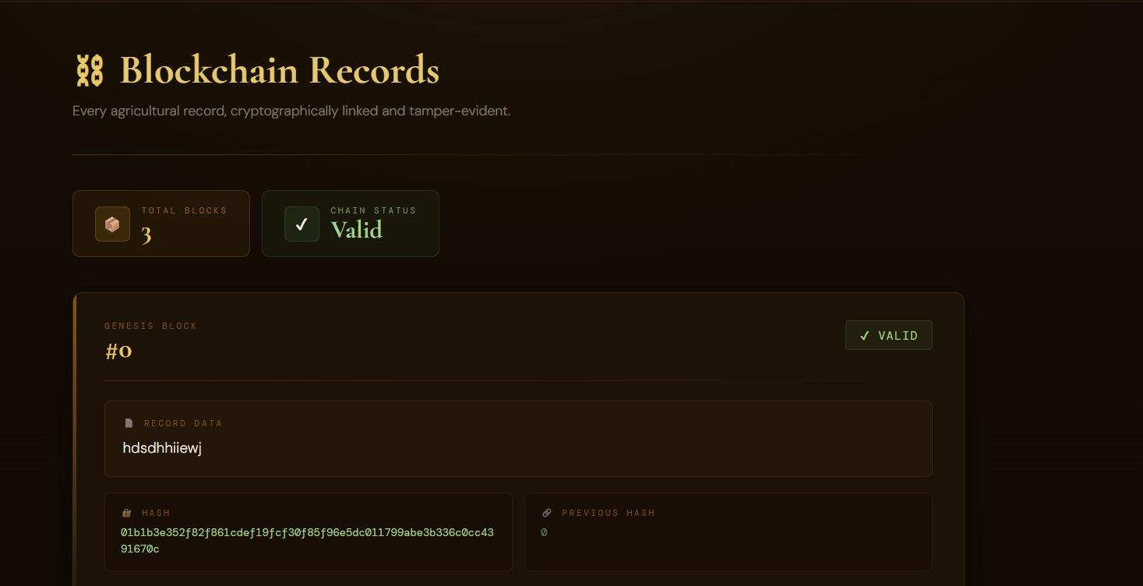
Purpose:
To provide transparency and allow users to verify blockchain data.
Observed Result:
Users can easily understand block linking and detect inconsistencies.
v) Audit Logs View
Overview:
This page displays all system activity logs.
Features:
• Shows actions such as CREATE and TAMPER
• Displays associated user and timestamp
• Provides chronological log history
• Accessible only to admin users
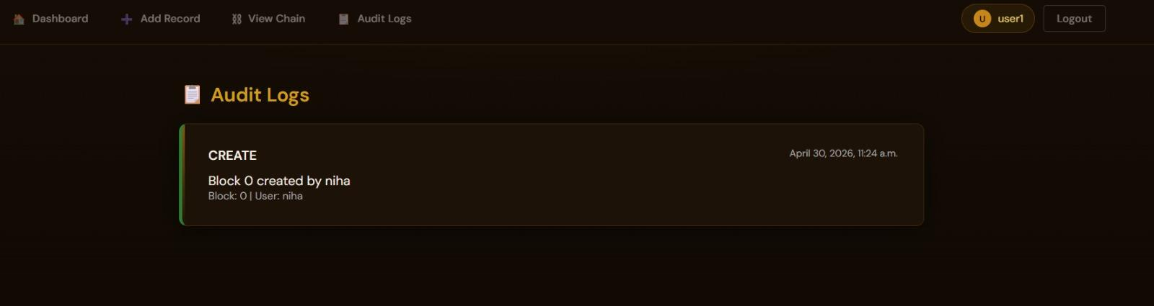
Purpose:
To maintain traceability and monitor system operations.
Observed Result:
Admin users can track all system activities effectively.
vi) Authentication Pages (Login & Signup)
Overview:
These pages handle user authentication.
Features:
• Input fields for username and password
• Error messages for invalid inputs
• Secure login and registration process
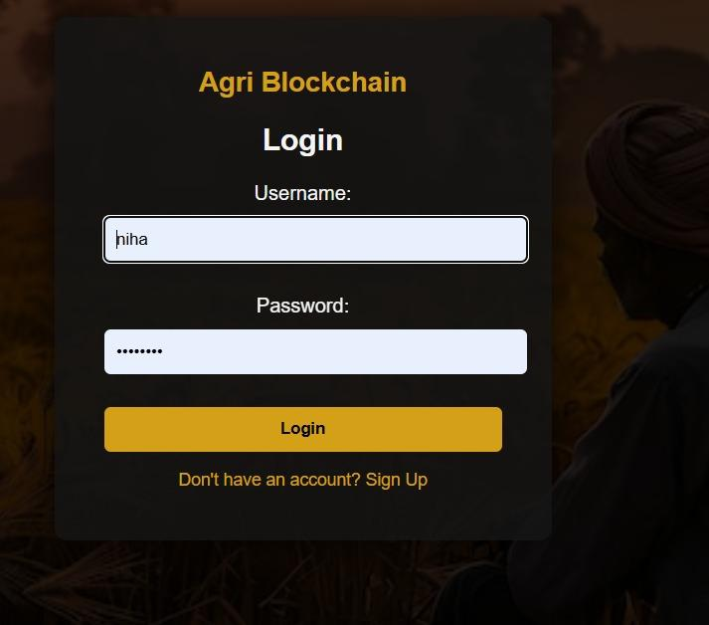

Purpose:
To ensure secure access to the system.
Observed Result:
Only authenticated users can access protected features.
Overall Snapshot Summary:
The graphical interfaces of the system are designed to be simple, intuitive, and informative. Each screen clearly represents its functionality, enabling users to interact with the blockchain system efficiently while understanding key concepts such as data immutability and tamper detection

Conclusion
The project “Secure Decentralized Data Storage for Agriculture” successfully demonstrates the implementation of blockchain principles in a web-based application using Python and the Django framework. The system simulates a blockchain ledger where each agricultural record is stored as a block, ensuring data integrity, immutability, and transparency.
The application effectively integrates frontend and backend components to provide a complete workflow for adding, storing, and validating agricultural data. The use of SHA-256 hashing ensures that each block is uniquely identified and securely linked to the previous block, making any tampering easily detectable.
The system also incorporates key features such as chain validation, audit logging, and user authentication, which enhance reliability, traceability, and security. The graphical user interface allows users to interact with the blockchain in a simple and intuitive manner, making complex concepts easy to understand.
From an academic perspective, the project fulfills all major objectives including system design, implementation, testing, user interface development, and evaluation. It provides a clear demonstration of how blockchain technology can be applied to real-world domains such as agriculture.
Overall, the project serves as a strong foundation for further research and development in blockchain-based data management systems and highlights the potential of using secure and transparent technologies in agricultural applications.

Further Development or Research
The current system provides a foundational implementation of blockchain concepts applied to agricultural data storage. However, several enhancements and research directions can be explored to improve scalability, functionality, and real-world applicability.
Recommended Future Scope:
• Implement a distributed blockchain network with multiple nodes instead of a centralized simulation.
• Integrate advanced databases such as MySQL or PostgreSQL for better scalability and performance.
• Deploy the system on cloud platforms (AWS, Azure, or Google Cloud) for real-time accessibility.
• Introduce role-based access control for different stakeholders (farmers, suppliers, administrators).
• Add search, filter, and export features for blockchain records (PDF/Excel reports).
• Integrate real-time external APIs (e.g., weather or market price data) for enhanced agricultural insights.
• Develop a mobile application version for improved accessibility in rural areas.
• Implement automated testing frameworks (unit testing, integration testing, UI testing).
• Enhance security using encryption techniques and secure key management.
• Add notification system (SMS/Email alerts) for important blockchain events.
Research Directions:
• Development of fully decentralized blockchain systems for agricultural supply chains.
• Integration of smart contracts for automated transactions and agreements.
• Use of IoT devices for real-time data collection from farms (soil, temperature, humidity).
• Application of artificial intelligence for predictive analytics in agriculture.
• Combining blockchain with supply chain management systems for end-to-end traceability.
• Exploring energy-efficient blockchain mechanisms for sustainable implementation.
Overall Future Scope Summary:
The project provides a strong base for extending blockchain technology into real-world agricultural applications. With further development and research, the system can evolve into a scalable, secure, and fully decentralized platform that supports transparent and efficient agricultural data management.

References
The following sources were referred to during the development of the project:
- Python Software Foundation. Python Documentation. Available at: https://docs.python.org/3/
- Django Software Foundation. Django Documentation. Available at: https://docs.djangoproject.com/
- National Institute of Standards and Technology (NIST). Secure Hash Standard (SHA-256).
- Nakamoto, S. (2008). Bitcoin: A Peer-to-Peer Electronic Cash System.
- MDN Web Docs. HTML, CSS, and JavaScript Documentation. Available at: https://developer.mozilla.org/
- W3C. Web Standards Documentation. Available at: https://www.w3.org/
- SQLite Documentation. Available at: https://www.sqlite.org/docs.html
- IBM. Blockchain Basics. Available at: https://www.ibm.com/topics/blockchain
- Indian Council of Agricultural Research (ICAR). Agricultural Data and Crop Production Guidelines.
- Open Source Community Resources and Tutorials (Various online references related to Django and Blockchain concepts).

Appendix
This section provides supplementary materials and technical details related to the implementation of the project.
Complete Source File List:
• manage.py
• agri_chain/settings.py
• agri_chain/urls.py
• agri_chain/asgi.py
• agri_chain/wsgi.py
• ledger/models.py
• ledger/views.py
• ledger/services.py
• ledger/admin.py
• ledger/urls.py
• ledger/apps.py
• ledger/tests.py
• ledger/migrations/ (database migration files)
• templates/base.html
• templates/index.html
• templates/dashboard.html
• templates/add_block.html
• templates/chain.html
• templates/audit_logs.html
• templates/login.html
• templates/signup.html
• templates/about.html
• static/ (CSS, images, and video assets)
Database Schema:
Block Table:
• index
• timestamp
• data
• previous_hash
• hash
• user
AuditLog Table:
• action
• user
• block
• message
• timestamp
Sample System Operations:
• Adding a new block
• Viewing blockchain records
• Validating chain integrity
• Viewing audit logs
Test Case Checklist and Outcomes:
• Block creation test – Passed
• Chain validation test – Passed
• Tamper detection test – Passed
• Authentication test – Passed
• UI functionality test – Passed
Setup and Run Instructions:

- Install Python and Django
- Navigate to project directory
- Run command: python manage.py migrate
- Create admin user: python manage.py createsuperuser
- Start server: python manage.py runserver
- Open browser and visit: http://127.0.0.1:8000/
Known Issues and Limitations:
• Blockchain is simulated (not distributed across nodes)
• Limited scalability with SQLite database
• No real-time external data integration
• No automated testing framework
Change Log:
• Initial version implemented as a simple blockchain simulation
• Added Django framework for web interface
• Implemented user authentication system
• Added audit logging module
• Developed GUI for blockchain visualization
• Enhanced security with read-only admin controls
Additional Notes:
The appendix includes all supporting technical details necessary for understanding, running, and extending the system. It serves as a reference for developers and evaluators to review the internal structure and functionality of the project.

9.1 Weekly Report
Weekly project report for week commencing 02 March
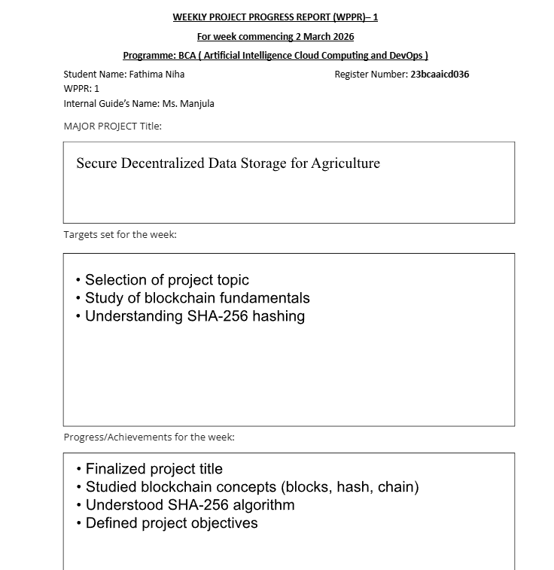
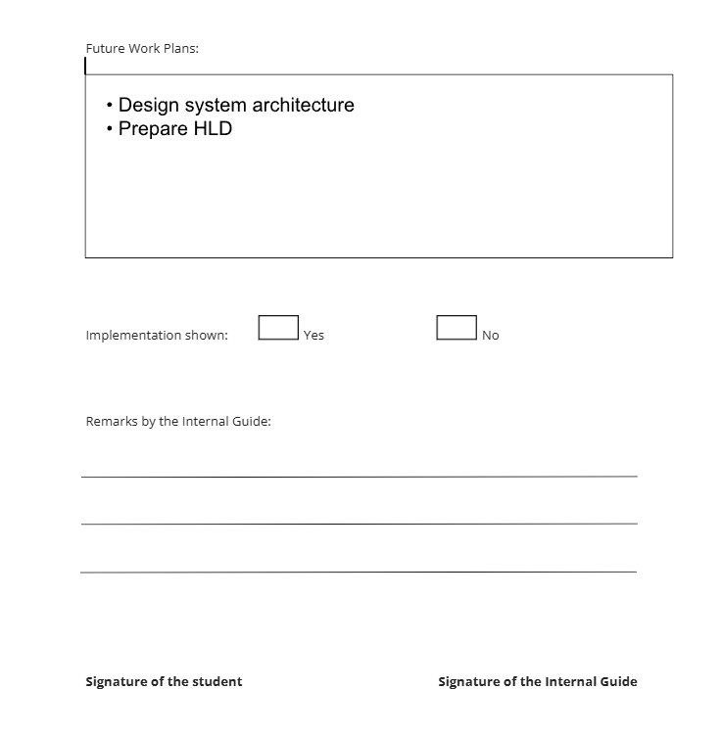

Weekly project report for week commencing 09 March
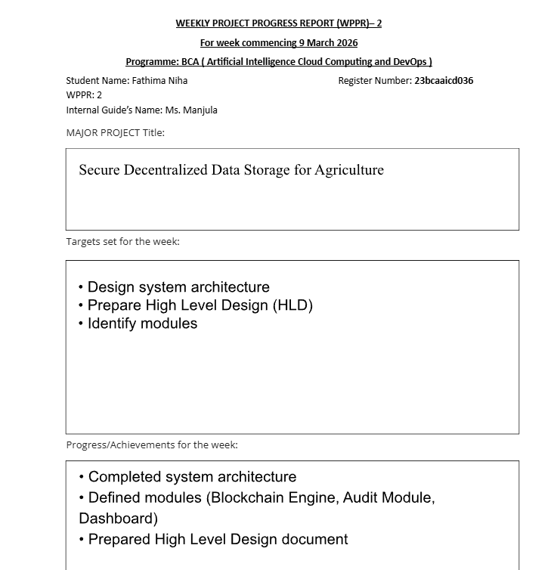

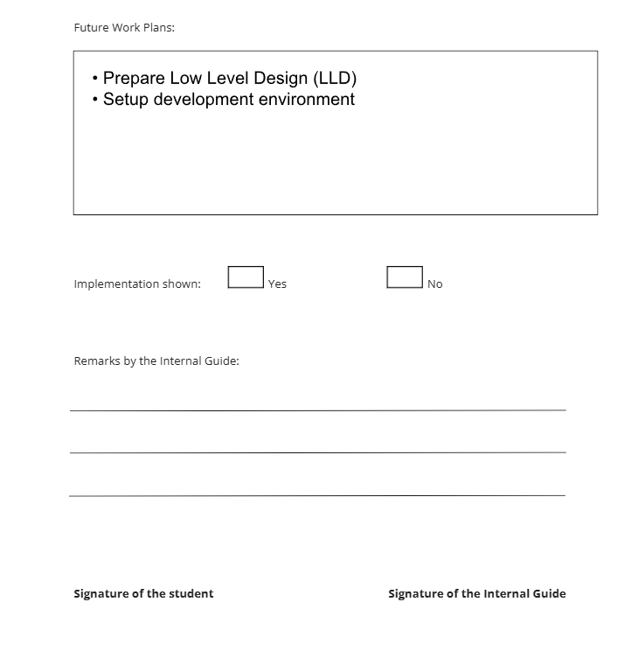

Weekly project report for week commencing 16 March
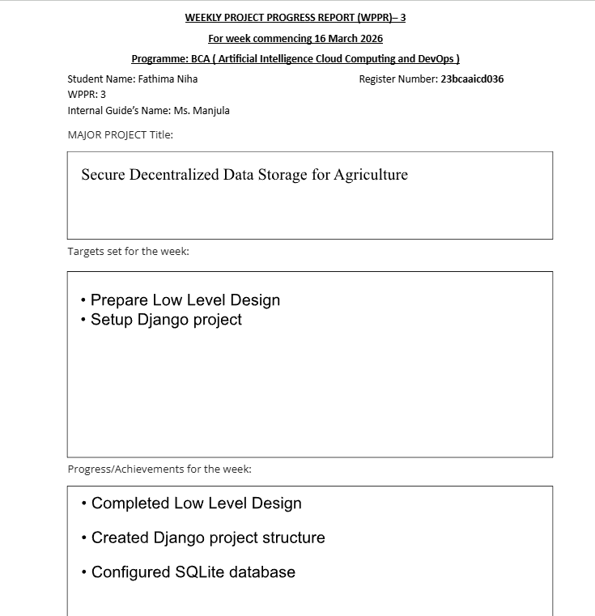

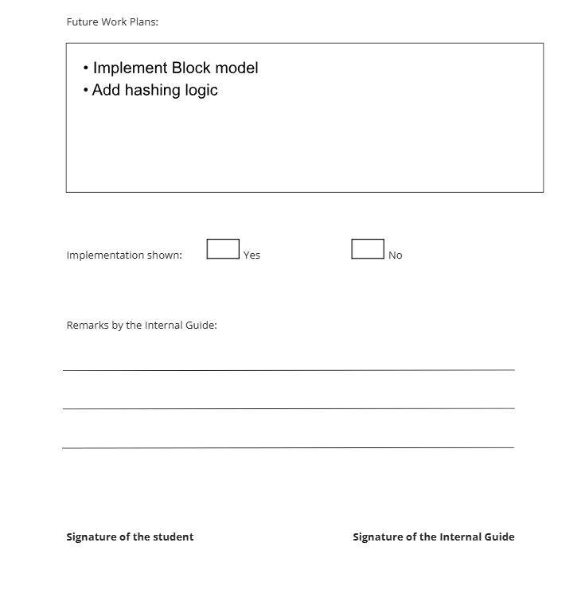

Weekly project report for week commencing 24 March
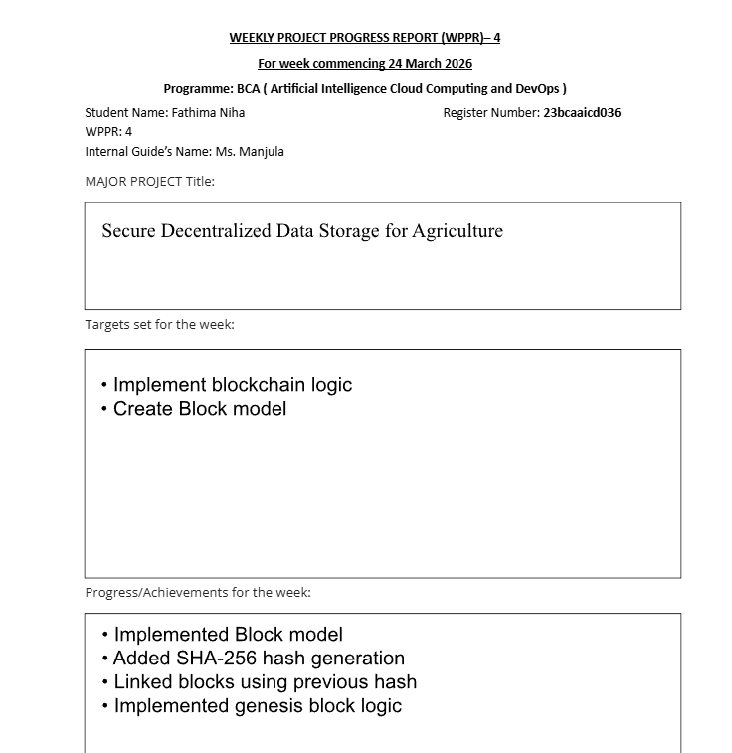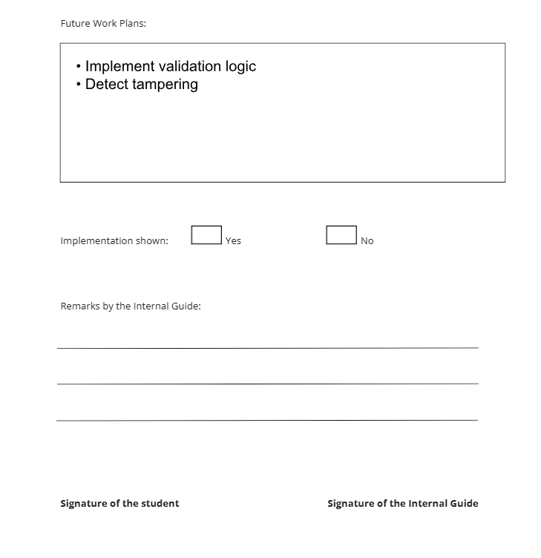

Weekly project report for week commencing 30 March
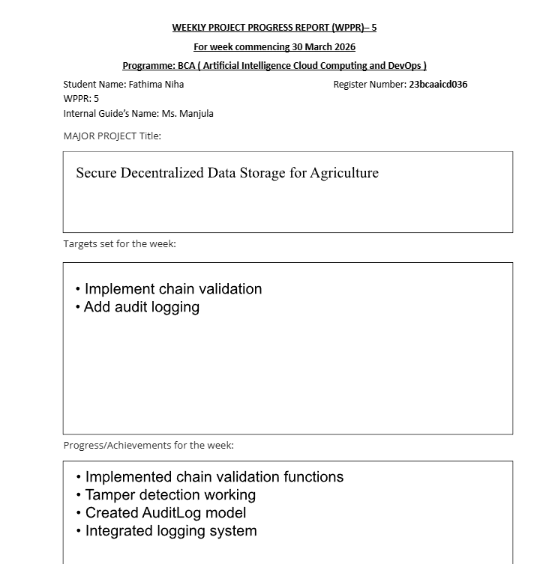

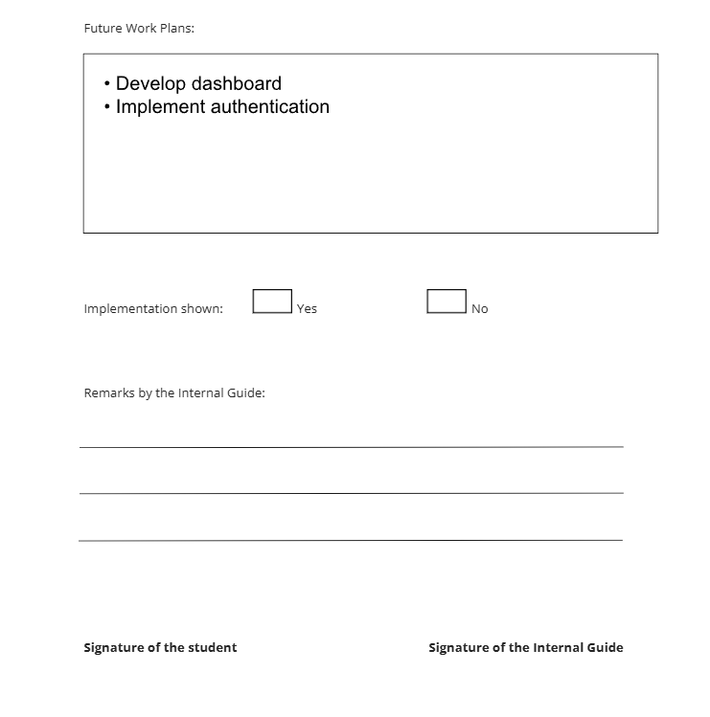

Weekly project report for week commencing 06 April
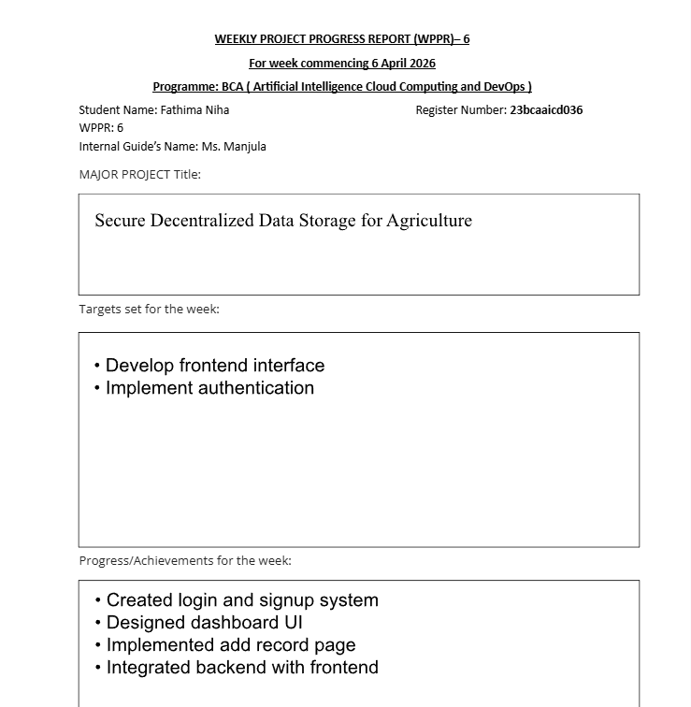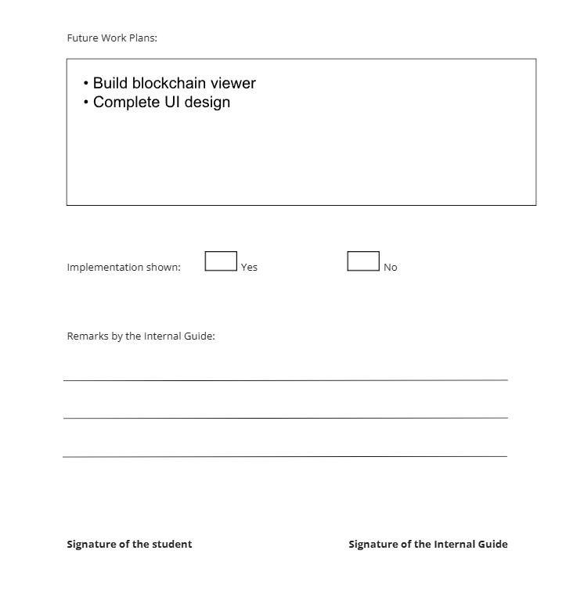

Weekly project report for week commencing 13 April
