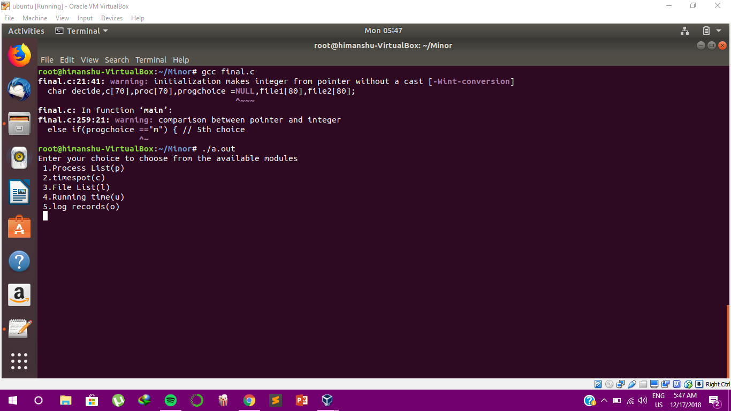
User Interface with the various options for the user to select.
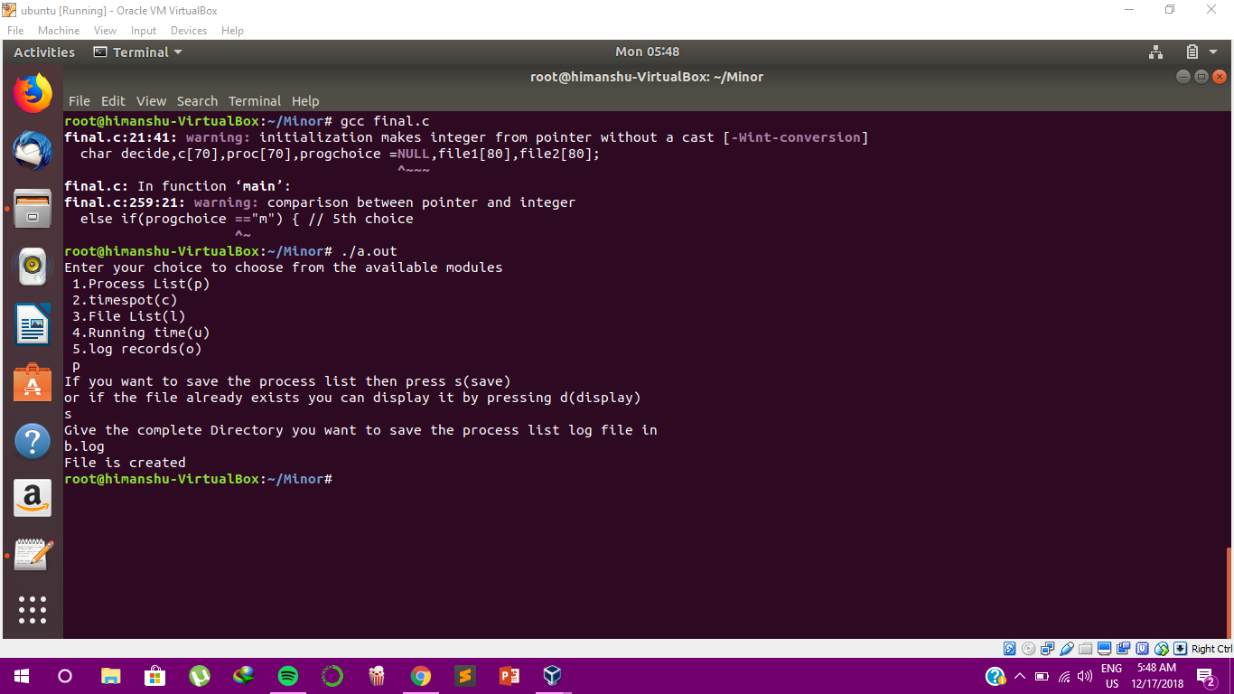
Showing the list of the processes that are currently running.

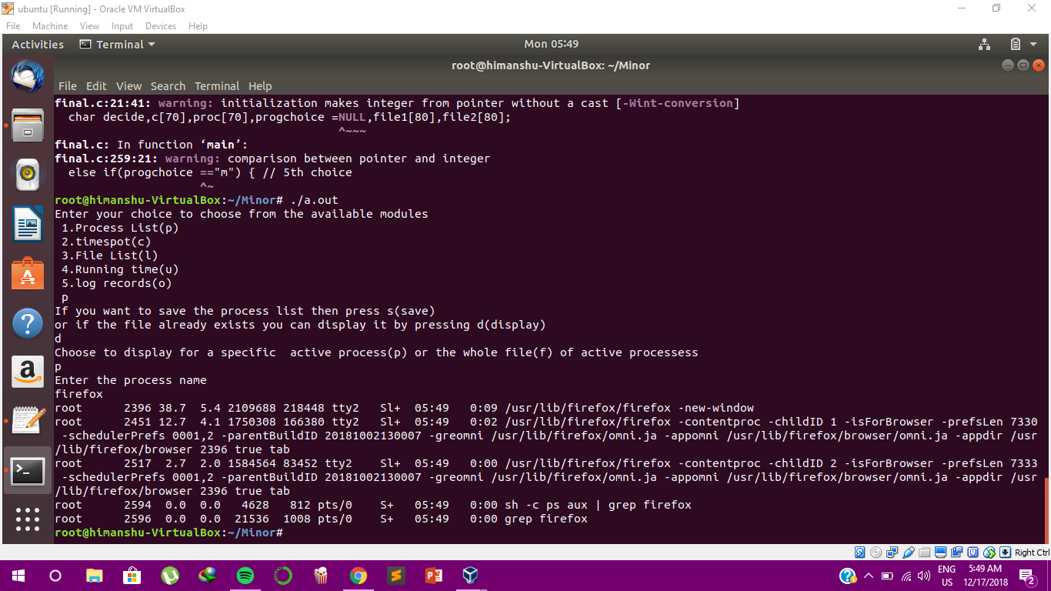
Further detailed execution and output of the process list command.

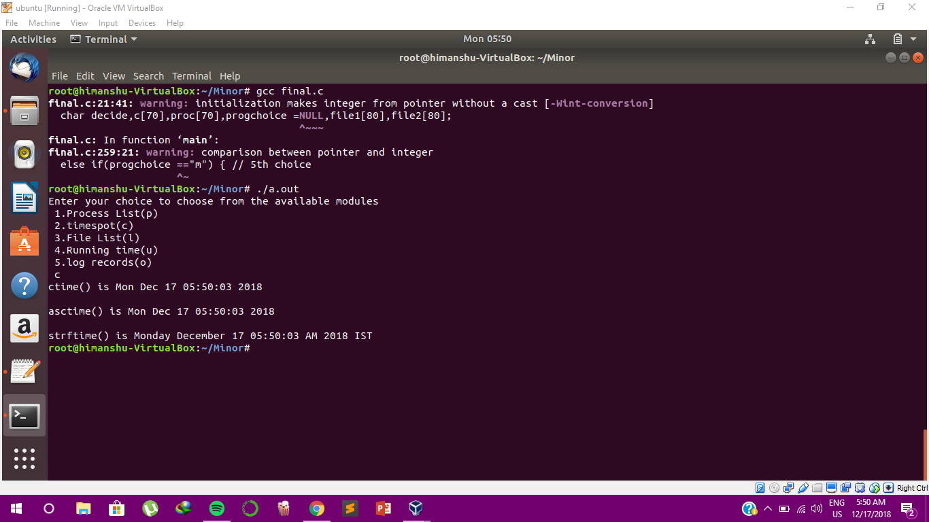
User selecting the timespot command and getting the output.

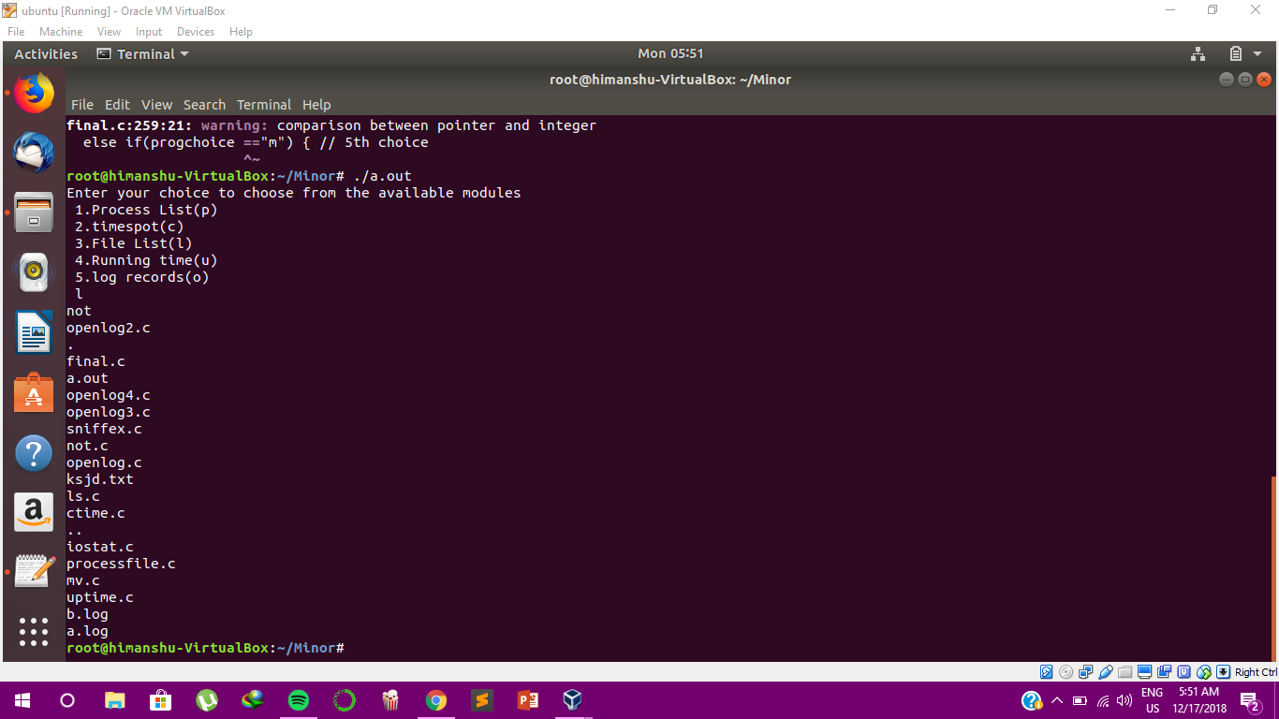
User selecting the File list command and getting all the files in the directory as output.

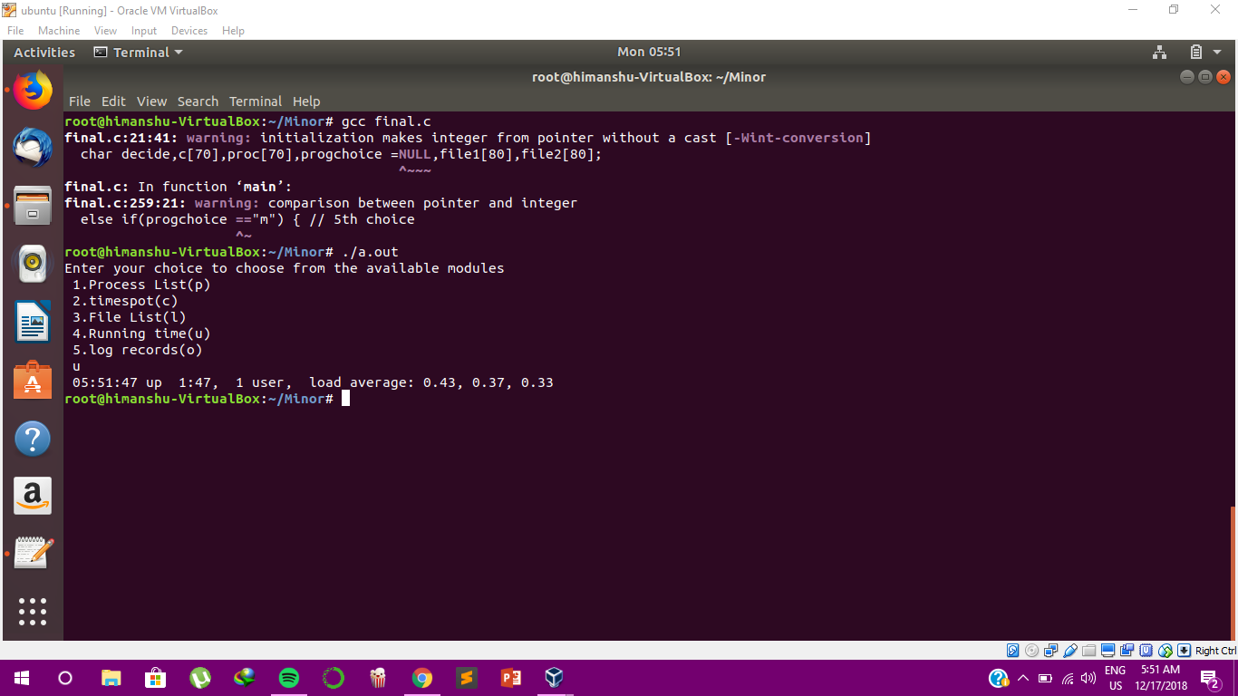
Selection of the Running time command and getting the CPU utilization as output.

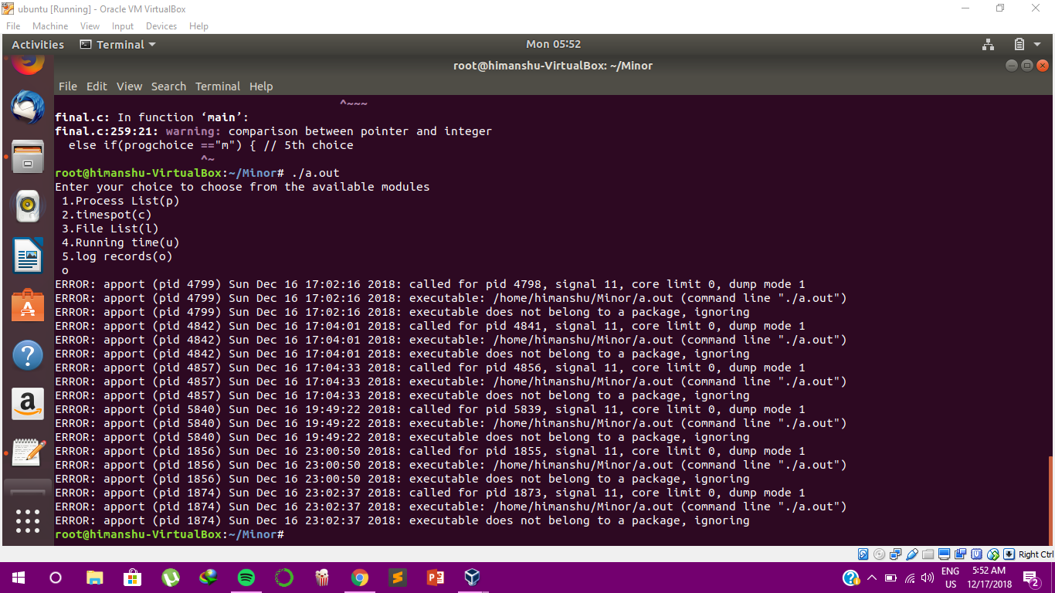
Selecting the log records option and displaying the contents of the accessed log record.

