Chapter

Native 1-Bit Diffusion: Preventing Collapse in 1-Bit Diffusion

Nihal Gazi¹, Ayushman Bhattacharya², Aditya K. Biswas³, Saubhagya Kunti³, Aihik Basu⁴
¹ Department of Computer Science Engineering and Artificial Intelligence & Machine Learning, Institute of Engineering and Management, Kolkata, West Bengal, India
² Department of Computer Science Engineering and Artificial Intelligence & Machine Learning, JIS University, Kolkata, West Bengal, India
³ Department of Computer Science & Business Systems, Institute of Engineering and Management, Kolkata, West Bengal, India
⁴ Department of Computer Science Engineering, Institute of Engineering and Management, Kolkata, West Bengal, India

Abstract

Deploying generative diffusion models on resource-constrained edge devices is severely bottlenecked by the memory and computational costs of floating-point arithmetic. While extreme 1-bit weight quantization offers an optimal solution, current literature asserts that reducing informational bandwidth to this degree inevitably causes catastrophic manifold collapse. We challenge this consensus. In this paper, we demonstrate that manifold collapse is not an inherent hardware penalty, but a fatal artifact of the standard Post-Training Quantization (PTQ) paradigm. We introduce Native Binarization, a framework that trains diffusion models entirely from scratch using 1-bit weights, mean-centered scaling, and pre-activation structures. Through a strict W1A16 hardware ablation, we prove that while standard float-to-binary adaptation completely destroys the generative topology (producing abstract noise with an FID of 381.79 and 0.00% legibility), our natively grown binary model maintains strict topological stability. It achieves functional parity with the unquantized FP16 baseline (FID: 24.22, 89.92% legibility). Our findings establish that 1-bit diffusion manifolds are structurally sound when initialized natively, unlocking a 32x memory reduction and 58x computational speedup without sacrificing semantic utility.

Keywords: 1-Bit Quantization, Diffusion Models, Generative AI, Model Compression, Topology, ResUNet, Edge AI

Introduction

The unprecedented generative potential of these models has ushered in a paradigm shift in artificial intelligence. However, the utilization of these models is still fundamentally dependent on high-performance hardware. As the necessity for edge computing and on-device AI integration increases, the thermodynamic constraints of traditional hardware become a major hurdle. For the utilization of these models on mobile or IoT devices, extreme compression is a necessity.
While the theoretical extreme-case scenario of binarization, where 16-bit or 32-bit floating-point weights are compressed into a mere 1-bit precision, promises the possibility of massive compression ratios, the general consensus among the recent literature is that such extreme quantization is fundamentally incompatible with the complex data distributions required for the diffusion approach. Indeed, the latest state-of-the-art research on the topic, which was published at NeurIPS 2024 under the title "Binarized Diffusion Model" (BiDM), concluded that 1-bit binarization causes the generative manifold to catastrophically collapse.
We contest this narrative. Instead, we contend that the topological destruction we see is not an inherent property of the 1-bit hardware boundary but rather a critical flaw in the current paradigm of Post-Training Quantization (PTQ). Currently, the PTQ paradigm views binarization as a compression problem. It takes a finely tuned and pre-trained FP16 diffusion model and suddenly truncates its weights to discrete binarized states. This "Train-then-Quantize" paradigm suddenly lobotomizes the finely tuned manifold and causes the predictable destruction of structure and creation of abstract noise.
In this paper, we propose a paradigm shift from PTQ to Native Binarization. By reframing binarization as a representation problem rather than a compression problem, we hypothesize that a functional binary manifold can be grown if the network is initialized and trained strictly within those binary constraints. Instead of adapting a pre-trained floating-point teacher, our architecture is trained entirely from scratch with 1-bit weights, utilizing mean-centered weight scaling and pre-activation structures (BN-SiLU-Conv) to maintain gradient flow.
To rigorously validate this, we provide a strict hardware ablation study, fixing the activation precision to a constant (W1A16), to isolate the effects of the binarization methodology. Our results definitively prove that, unlike the standard PTQ adaptation, which collapses completely when 1-bit constraints are applied, Native Binarization achieves functional and topological parity with the FP16 baseline. This approach successfully removes 95% of the model's informational bandwidth, creating a diffusion architecture that is 32x smaller, 58x faster, and eliminates the problem of manifold collapse.

Related Work

Diffusion Models for Edge AI

Post-Training Quantization (PTQ) and its Limits

The 1-Bit Binarization Bottleneck

The Binarization Problem: Compression vs Representation

The Mechanics of Manifold Collapse

Binarization as a Native Representation Problem

Methodology: Native 1-Bit Diffusion Architecture

Pre-Activation Block Structure

Mean-Centered Weight Binarization

Gradient Approximation via Straight-Through Estimator (STE)

Experimental Set-up

Model Architectures and Initialization

The W1A16 Isolation Strategy

Evaluation Metrics

Results and Analysis

Quantitative Parity and Topological Stability

Visual Evidence of Manifold Collapse

Hardware Efficiency Gains

Mobile Learning Literature Review in Medical Education

The recent influx of mobile technologies such as smart phones and tablet computers has profoundly influenced people’s daily activities. As mobile devices continue to diminish in size, their computing capacity is expanding at unprecedented rates providing users with increased on-the-go access, powerful information processing capabilities, and social opportunities. This mobility and instant connectivity phenomenon changes not only how people interact and share information but also presents educational opportunities across fields and academic levels—hence the coining of the term mobile learning.

Pushed Reminders For Knowledge Learning And Behavior Change
Pushed information or reminders using simple text messages were found to be effective in enhancing medical learners’ knowledge acquisition and retention (Chuang and Tsao, 2013; Diedhiou et al., 2015; Walter et al., 2014; Alipour, Jannat and Hosseini, 2014).
In a study in nursing education, students provided with SMS learning resources two times a day showed higher scores in a medical knowledge test than those without SMS observed at one week, two weeks, and four weeks after the intervention (Chuang and Tsao, 2013). Simple text messaging was an effective on-the-job training process for healthcare learners for their continuing education without disrupting their patient care work routine (Diedhiou et al., 2015; Alipour, Jannat and Hosseini, 2014). Most studies attributed the positive effect to spaced education principle and feasibility of mobile learning process to support the pedagogy (Chuang and Tsao, 2013; Diedhiou et al., 2015).

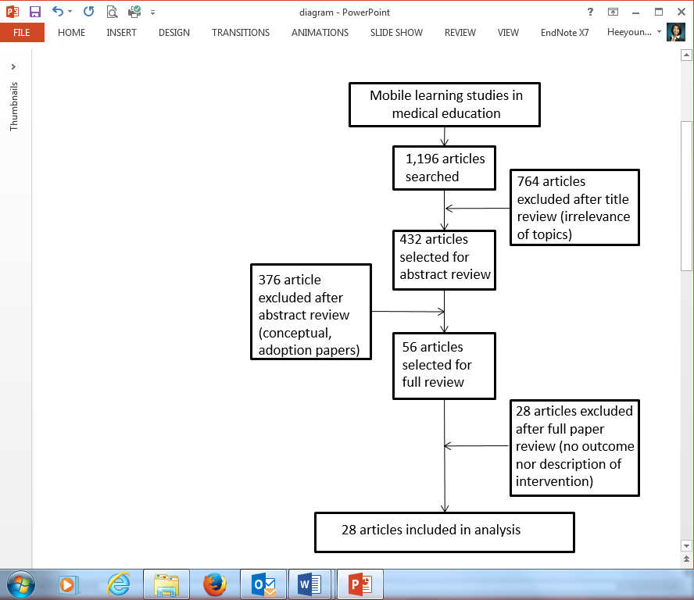
Figure 1. Inclusion and exclusion process.
Visual modeling for performance just in time
Visual modeling for performance just in time is another central instructional approach for effective mobile learning. This instructional strategy often involves reducing extraneous cognitive load on the spot, providing worked examples right before performing a critical task, and visualizing learning object in three dimensional presentations.

There are several limitations in this study. The selection of the database, key words, and years may not include studies available in other databases and journals. Additionally, there may be a selection bias from unpublished studies showing no effects or benefits to mobile learning.
Findings in this study may not represent all possible instructional strategies exhaustively but provided some of the potentials of mobile learning processes. Simply adopting traditional e-learning approaches may not necessarily lead to positive mobile learning experiences as mobile learning leans more toward informal, personal, context-oriented, instant, and opportunistic experiences rather than formal, structured, and media-rich traditional e-learning experiences (Traxler, 2007). More insightful, thoughtful, and innovative design approaches aligned with the mobile learning characteristics should be investigated and studied.

Hawkes et al. (2013) investigated the effect of short visual instruction right before performing newborn intubation and found that this approach was effective for improving both knowledge and procedural skills for novice learners. Medical students performed better with patient encounters in an emergency department setting when they had immediate access to an instructional video right before seeing a patient in the emergency room (Tews et al., 2011). A similar effect was found in another study. According to Noguera et al. (2013), when second year students in physical therapy had access to two- or three-dimensional images of anatomy on their mobile devices during a practice session, their knowledge gain was higher than those who did not have such learning environments. With resources on their mobile devices, the students were able to visualize specific anatomy of knee, ankle, and pelvic zone as they practiced physical therapy. This allowed the participants to deeply engage in learning how physical therapy works in relation to a specific anatomy structure.

Table 1. Summary of included articles

Population | Specialty domain | Intervention  (Mobile Technology) | Conceptual framework / Instructional design features
Undergraduate medical education (UME) | Emergency medicine | Videos delivered on a mobile device | Just-in-time (JIT) learning  Watching the instructional video before entering a patient room
Physician Assistant(PA)/Nursing/Medic/Tech | Military trauma | Learning modules delivered on a mobile device | JIT learning
Nursing | Pharmacology | Short message service (SMS) | Information processing theory  Providing reminders to review the content

Discussion

Findings of the current study suggest several instructional design frameworks of mobile learning. These design approaches are identified and discussed with an educational belief that mobile learning should go beyond a simple techno-centric view that introducing a mobile device technology to instructional activities would automatically provide positive pedagogical effects. As seen in the literature review of this paper, utilizing mobile technology should be perceived as a technological process to design authentic learning experiences (Han, Resch and Kovach, 2013). Thoughtful design of learning experience considering person, time, and place where learning experiences occur is the key for a meaningful mobile learning process.
Mobile learning is a pedagogical process enriched by context-sensitivity of being (location) and doing (activity) of a learner or a teacher. It is a comprehensive process to create meaningful instructional and learning interactions in consideration of where learners and teachers will be and what they will be doing. Simple transferring decontextualized traditional curriculum activities via a mobile device can have limited effectiveness. The mobile leaning pedagogical question is not only about making instructions or guidance available for just-in-time learning, but also about creating an expert presence for a specific individual that facilitates context-based learning and performance in an authentic situation.

Disclaimer

None

References

Alipour S, Jannat F, Hosseini L. Teaching Breast Cancer Screening via Text Messages as Part of Continuing Education for Working Nurses: A Case-control Study. Asian Pac J Cancer P (2014) 15(14):5607-5609.
Baran E. A Review of Research on Mobile Learning in Teacher Education. Educational Technology & Society (2014) 17(4):17-32.
Bearman M, Dawson P. Qualitative synthesis and systematic review in health professions education. Medical Education (2013) 47(3):252-260.
Caffarella RS, Merriam SB. Learning in adulthood: A comprehensive guide. San Francisco, CA: Jossey-Bass; 2012.
Chen C-C, Huang T-C. Learning in a u-Museum: Developing a context-aware ubiquitous learning environment. Computers & Education (2012) 59(3):873-883.
Chu H-C, Hwang G-J, Tsai C-C, et al. A two-tier test approach to developing location-aware mobile learning systems for natural science courses. Computers & Education (2010) 55(4):1618-1627.
Chuang YH, Tsao CW. Enhancing nursing students' medication knowledge: The effect of learning materials delivered by short message service. Computers & Education (2013) 61:168-175.
Cook DA, West CP. Conducting systematic reviews in medical education: a stepwise approach. Medical Education (2012) 46(10):943-952.

