Lab Experiment # 16
OPEN ENDED LAB
To design, simulate and validate a circuit application of applied physics concepts and defend the design through a viva.
Project Title: Smart Medicine Dispenser for Alzheimer's Patients
Group Members
S# | Student Name | Roll No.
01 | Nihal Hyder Shah | 26BSCYS012
02 | Kaleem Ashraf | 26BSCYS030
03 | Sameer Ali | 26BSCYS003
Score: ________ Signature of Lab Tutor: ______________ Date: __________

INTRODUCTION
People with Alzheimer's disease slowly lose their memory, and one of the first things they start forgetting is their daily medicine. Sometimes they miss a dose completely, and sometimes they forget they already took it and take it again. Both are dangerous. The same thing happens with many older people who take more than one medicine a day and have to remember a different time for each one.
Most of the time a family member or caretaker has to keep reminding them, but the caretaker cannot be with the patient all day. And the patient cannot rely on their own memory, because that is exactly the problem.
So we picked this problem for our open ended lab and built a Smart Medicine Dispenser. It keeps the medicine schedule for the patient, rings an alarm when it is time for a dose, shows which medicine to take on a big screen and also says the medicine name out loud. It counts how many pills are left and keeps a record of every dose, so the caretaker can check it later.
Objectives:
- Build a device that reminds the patient at the right time and tells them which medicine to take.
- Keep a count of the pills left and a record of every dose for the caretaker.
- Use the physics concepts from our lab (circuits, Ohm's law, voltage levels and sound) in a real application.
PROJECT DESCRIPTION
The project is made of an Arduino Uno, three push buttons, a buzzer, a breadboard and a laptop. The Arduino is the main controller. It keeps the time, knows when each medicine has to be taken, reads the buttons and rings the buzzer. The laptop works as the screen. The two are connected with a USB cable, which gives power to the Arduino and also carries the data between them.
Right now three medicines are saved in the program: Aspirin at 08:00, Panadol at 14:00 and Vitamin C at 20:00, with 5 pills each. These can be changed from the menu using the buttons.
How it works
When the Arduino is connected, the laptop sends its real time to the Arduino, so the clock is always correct. The screen then shows a menu with three options:
- 1 Dispense: this is the normal mode. The screen shows the next medicine and its time. When the time comes, the buzzer starts ringing, the laptop screen turns red with "TAKE MEDICINE" and the medicine name, and the laptop says the name out loud. After that the pill count goes down by one, the screen turns green and the dose is saved in the log.
- 2 Time Slots: the caretaker can change the time of each medicine using UP and DOWN, and press SET to save.
- 3 Medicines: the caretaker can add or remove pills when refilling the box. If a medicine runs out, the screen and the laptop voice tell the caretaker to refill it.
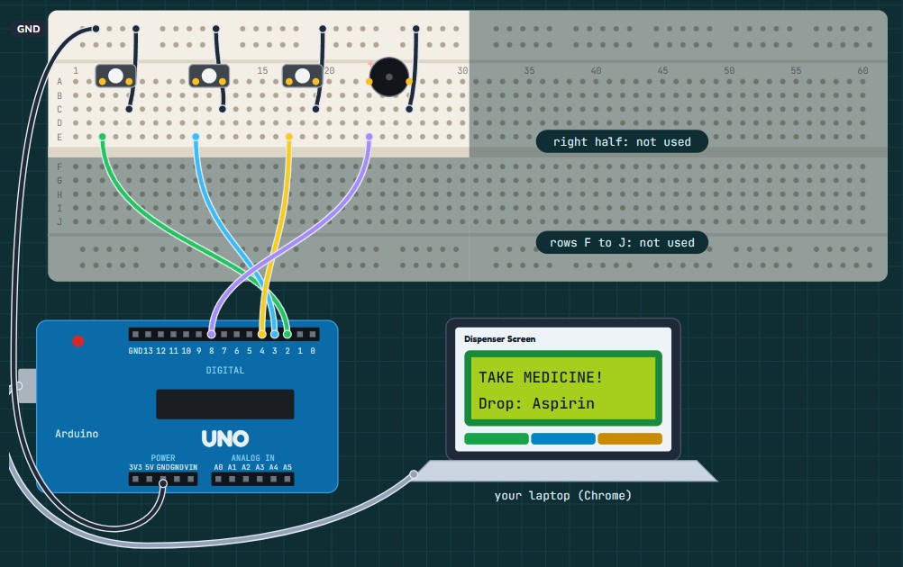
Fig. 1: Circuit diagram of the final project: buttons on pins 2, 3 and 4, buzzer on pin 8, GND line on the breadboard and the laptop connected with USB.
Parts we used and why
# | Part | What it does | Why we used it
1 | Arduino Uno | Runs the program, keeps the time, reads the buttons and controls the buzzer. | Easy to program and works on 5 V, which is safe for all the other parts.
2 | 3 push buttons (SET, UP, DOWN) | Used to move through the menu and change times and pill counts. | Simple to use, even for an older person or a caretaker who is not good with technology.
3 | Buzzer | Rings the alarm at medicine time and beeps when a button is pressed. | A loud sound gets the patient's attention even if they are not looking at the screen.
4 | Laptop (Dispenser Screen page) | Shows the screen, the next medicine, pills left and the log. Says the medicine name out loud. | A big, clear screen is easier to read than a small LCD, and the voice helps patients who cannot read the screen well.
5 | USB cable | Gives 5 V power to the Arduino and sends data between the Arduino and the laptop. | One cable does both jobs, so no battery is needed.
6 | Breadboard and jumper wires | Connect the buttons and buzzer to the Arduino. | No soldering is needed, so parts can be changed easily.

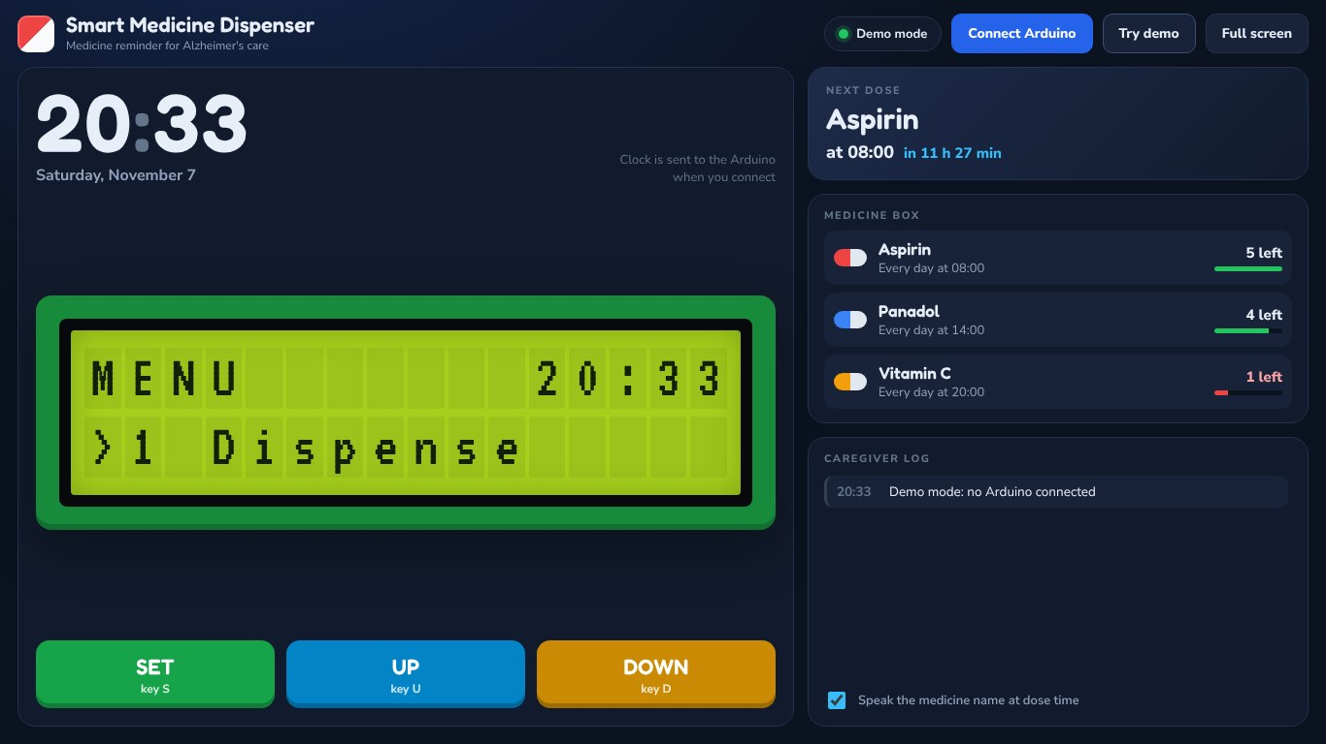
Fig. 2: The Dispenser Screen on the laptop: the menu on the virtual LCD, the next dose, the pills left and the caretaker log.
METHODOLOGY AND RESULTS
Methodology
We built the project step by step and tested every part before adding the next one, so if something went wrong we knew exactly where the problem was.
- Setup: installed the Arduino IDE, selected Arduino Uno and the USB port (COM11), and uploaded a blink program to check the board.
- Ground line: connected the Arduino GND to the top edge line of the breadboard. The minus side of every part goes here.
- Buttons: placed the buttons in holes A3–A5, A10–A12 and A17–A19 and connected them to pins 2, 3 and 4. Tested them with a program that prints which button is pressed.
- Buzzer: placed the buzzer in A23 (+) and A26 and connected it to pin 8. Tested it with a program that plays a different beep for each button.
- Final program and screen: uploaded the full program and connected the laptop screen page in Google Chrome.
Physics used in the circuit
Buttons and Ohm's law: each button pin uses the Arduino's internal pull-up resistor (about 20 kΩ to 50 kΩ). When the button is not pressed, the pin stays at 5 V. When it is pressed, the pin is connected to 0 V and a very small current flows:
I = V / R = 5 V / 20 kΩ = 0.25 mA
This is much less than the 20 mA limit of an Arduino pin, so we did not need any extra resistor.
Buzzer and sound: the buzzer works on the piezoelectric effect. The Arduino sends it a changing voltage, which makes a small disc inside vibrate and make sound at the same frequency. The alarm switches between 880 Hz and 1320 Hz. Using T = 1/f and λ = v/f, with the speed of sound v = 343 m/s:
Frequency f | Period T = 1/f | Wavelength λ = v/f | Used for
600 Hz | 1.67 ms | 0.57 m | DOWN button
880 Hz | 1.14 ms | 0.39 m | Alarm tone 1
1000 Hz | 1.00 ms | 0.34 m | SET button
1320 Hz | 0.76 ms | 0.26 m | Alarm tone 2
1500 Hz | 0.67 ms | 0.23 m | UP button

Data between Arduino and laptop: they talk at 9600 bits per second. Each character takes 10 bits, so about 960 characters are sent every second, which is why the laptop screen updates straight away.
Results
For now the project works as a demo. In real use a patient would wait hours between doses, so for the lab we run the clock 60 times faster (1 second = 1 minute). This way we can set a medicine time a little ahead and show the full alarm in about a minute.
In the demo:
- The buttons move through the menu and the laptop screen changes straight away.
- At the medicine time the buzzer rings, the laptop screen turns red with the medicine name and the laptop says the name out loud.
- After the alarm, the pill count goes down by one and the dose is saved in the caretaker log with the time.
- When a medicine runs out, the screen shows it as empty and asks for a refill.
One problem we faced during the build was an upload error ("not in sync") where the code would not go to the Arduino. Closing and opening the Arduino IDE again fixed it.
APPLICATION
This project can be used at home by Alzheimer's patients and older people who forget to take their medicines. The patient does not have to remember anything. When it is time, the buzzer rings, the screen shows the medicine name in big letters and the laptop says it out loud, so they know exactly which medicine to take.
It also helps the person taking care of them. Every dose is saved in the log with the time, so the caretaker can see which medicine was taken and when. If a medicine runs out, the device tells them to refill it. The caretaker does not have to call or check on the patient again and again.
So it makes daily life easier for both: the patient gets reminded on time, and the caretaker can keep track of everything.
FUTURE WORK
Right now this is a demo that uses a laptop as the screen. In the future we can improve it like this:
- Mobile app for the caretaker: connect the device to an app so the son, daughter or caretaker gets a notification on their phone when it is time for the patient's medicine, and can see which doses were taken or missed.
- Smart watch or wearable: send the reminder to a watch or band the patient wears, so they feel it is time for their medicine even if they are not near the device.
- Full setup in one box: instead of using a laptop as the screen, put the whole setup inside one box with its own screen, so it can be kept on a table at home.
- Simple for the patient: for Alzheimer's patients the device itself can stay very simple, just a buzzer to tell them it is time, while all the details and tracking go to the caretaker's phone.

