**Week-7**

**React**

**9.**

**App.js**

import React from 'react';

function App() {

// Data for List of Players

const players = [

{ name: 'Mr. Jack', score: 50 },

{ name: 'Mr. Michael', score: 70 },

{ name: 'Mr. John', score: 40 },

{ name: 'Mr. Alan', score: 61 },

{ name: 'Mr. Elisabeth', score: 61 },

{ name: 'Mr. Siah', score: 95 },

{ name: 'Mr. Dhoni', score: 100 },

{ name: 'Mr. Virat', score: 104 },

{ name: 'Mr. Jadeja', score: 64 },

{ name: 'Mr. Raina', score: 75 },

{ name: 'Mr. Rohit', score: 80 },

];

// Players with scores less than 70

const playersBelow70 = players.filter(player => player.score < 70);

// Odd/Even Players

const oddPlayers = [

{ label: 'First', name: 'Sachin1' },

{ label: 'Third', name: 'Virat3' },

{ label: 'Fifth', name: 'Yuvraj5' },

];

const evenPlayers = [

{ label: 'Second', name: 'Dhoni2' },

{ label: 'Fourth', name: 'Rohit4' },

{ label: 'Sixth', name: 'Raina6' },

];

const mergedPlayers = [

'Mr. First Player',

'Mr. Second Player',

'Mr. Third Player',

'Mr. Fourth Player',

'Mr. Fifth Player',

'Mr. Sixth Player',

];

return (

<div style={{ margin: '30px' }}>

<h2>List of Players</h2>

<ul>

{players.map((player, idx) => (

<li key={idx}>Mr. {player.name} {player.score}</li>

))}

</ul>

<hr />

<h2>List of Players having Scores Less than 70</h2>

<ul>

{playersBelow70.map((player, idx) => (

<li key={idx}>Mr. {player.name} {player.score}</li>

))}

</ul>

<hr />

<div style={{ marginTop: '30px' }}>

<div>When Flag=false</div>

<h2>Odd Players</h2>

<ul>

{oddPlayers.map((p, i) => (

<li key={i}>{p.label}: {p.name}</li>

))}

</ul>

<h2>Even Players</h2>

<ul>

{evenPlayers.map((p, i) => (

<li key={i}>{p.label}: {p.name}</li>

))}

</ul>

<h2>List of Indian Players Merged:</h2>

<ul>

{mergedPlayers.map((p, i) => (

<li key={i}>{p}</li>

))}

</ul>

</div>

</div>

);

}

export default App;

**IndianPlayer.js**

import React from 'react';

const oddPlayers = [

{ label: 'First', name: 'Sachin1' },

{ label: 'Third', name: 'Virat3' },

{ label: 'Fifth', name: 'Yuvraj5' },

];

const evenPlayers = [

{ label: 'Second', name: 'Dhoni2' },

{ label: 'Fourth', name: 'Rohit4' },

{ label: 'Sixth', name: 'Raina6' },

];

const mergedPlayers = [

'Mr. First Player',

'Mr. Second Player',

'Mr. Third Player',

'Mr. Fourth Player',

'Mr. Fifth Player',

'Mr. Sixth Player',

];

export default function IndianPlayers() {

return (

<div>

<h2>Odd Players</h2>

<ul>

{oddPlayers.map((p, i) => (

<li key={i}>{p.label}: {p.name}</li>

))}

</ul>

<h2>Even Players</h2>

<ul>

{evenPlayers.map((p, i) => (

<li key={i}>{p.label}: {p.name}</li>

))}

</ul>

<h2>List of Indian Players Merged:</h2>

<ul>

{mergedPlayers.map((p, i) => (

<li key={i}>{p}</li>

))}

</ul>

</div>

);

}

**ListOfPlayers.js**

import React from 'react';

const ListofPlayers = () => {

const players = [

{ name: 'Virat Kohli', score: 85 },

{ name: 'Rohit Sharma', score: 45 },

{ name: 'KL Rahul', score: 95 },

{ name: 'Shreyas Iyer', score: 60 },

{ name: 'Rishabh Pant', score: 30 },

{ name: 'Hardik Pandya', score: 72 },

{ name: 'Ravindra Jadeja', score: 50 },

{ name: 'Bhuvneshwar Kumar', score: 40 },

{ name: 'Jasprit Bumrah', score: 15 },

{ name: 'Mohammed Shami', score: 25 },

{ name: 'Yuzvendra Chahal', score: 10 },

];

const filteredPlayers = players.filter(player => player.score < 70);

return (

<div>

<h2>Players with Scores Below 70</h2>

<ul>

{filteredPlayers.map((player, index) => (

<li key={index}>{player.name} - {player.score}</li>

))}

</ul>

</div>

);

};

export default ListofPlayers;

**output**

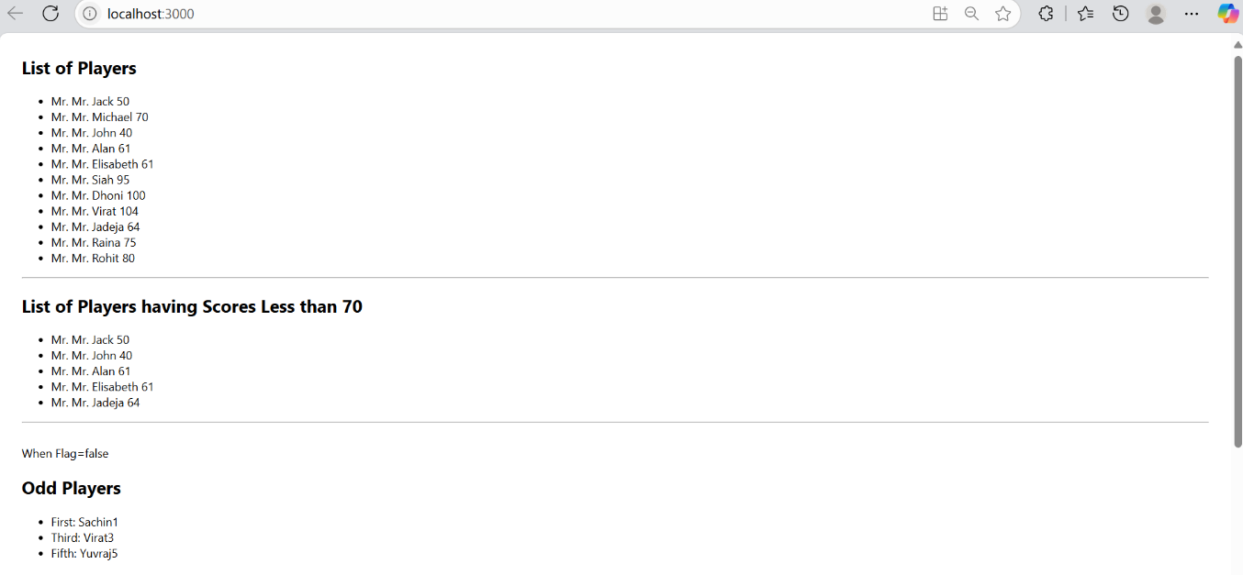

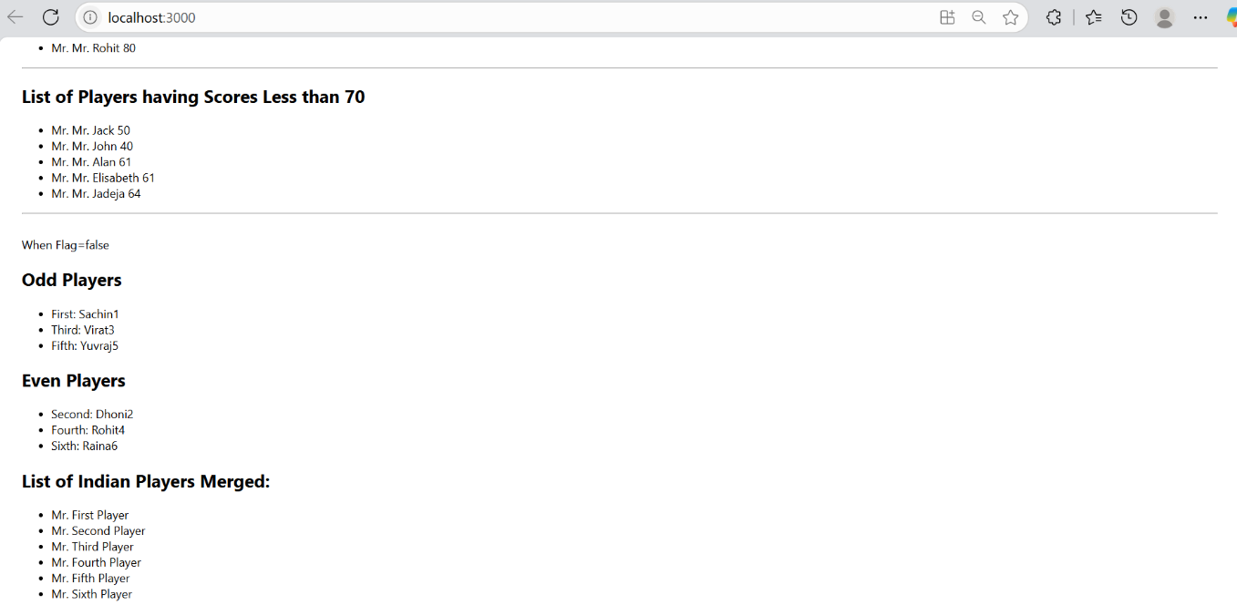

**10.**

**OfficeSpace.js**

import React from 'react';

// Use another realistic office image from Unsplash

const sr = "https://images.unsplash.com/photo-1515378791036-0648a3ef77b2?auto=format&fit=crop&w=600&q=80";

const ItemName = { Name: "DBS", Rent: 50000, Address: "Chennai" };

function OfficeSpace() {

return (

<div style={{ textAlign: 'center', marginTop: '40px' }}>

<h1 style={{ fontWeight: 'bold' }}>Office Space , at Affordable Range</h1>

<img src={sr} width="25%" height="25%" alt="Office Space" style={{ margin: '20px 0' }} />

<div style={{ textAlign: 'left', display: 'inline-block', marginTop: '20px' }}>

<h2><b>Name: {ItemName.Name}</b></h2>

<h3 style={{ color: 'red', margin: 0 }}>Rent: Rs. {ItemName.Rent}</h3>

<h3 style={{ margin: 0 }}>Address: {ItemName.Address}</h3>

</div>

</div>

);

}

export default OfficeSpace;

**App.js**

import React from 'react';

import OfficeSpace from './OfficeSpace';

function App() {

return (

<div className="App">

<OfficeSpace />

</div>

);

}

export default App;

**output:**

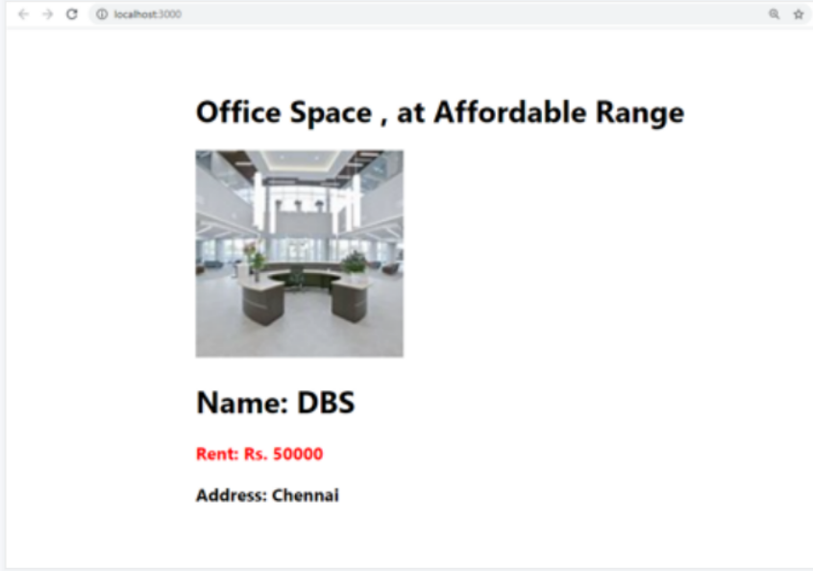

**11.**

**CurrencyConverter.js**

// src/CurrencyConverter.js

import React, { useState } from 'react';

function CurrencyConverter() {

const [rupees, setRupees] = useState('');

const [euro, setEuro] = useState('');

const handleSubmit = (e) => {

e.preventDefault();

const rate = 0.011; // Example: 1 INR = 0.011 EUR

setEuro((rupees * rate).toFixed(2));

};

return (

<div>

<h2>Currency Converter</h2>

<form onSubmit={handleSubmit}>

<input

type="number"

placeholder="Enter INR"

value={rupees}

onChange={(e) => setRupees(e.target.value)}

/>

<button type="submit">Convert</button>

</form>

{euro && <p>Converted to Euro: €{euro}</p>}

</div>

);

}

export default CurrencyConverter;

**app.js**

// src/App.js

import React, { useState } from 'react';

import CurrencyConverter from './CurrencyConverter';

function App() {

const [count, setCount] = useState(0);

const increment = () => {

sayHello();

setCount(prev => prev + 1);

};

const decrement = () => {

setCount(prev => prev - 1);

};

const sayHello = () => {

alert("Hello! This is a static message.");

};

const sayWelcome = (msg) => {

alert(`Message: ${msg}`);

};

const handleClick = (e) => {

alert("I was clicked");

};

return (

<div className="App">

<h1>React Event Handling</h1>

<h2>Counter: {count}</h2>

<button onClick={increment}>Increment</button>

<button onClick={decrement}>Decrement</button>

<br /><br />

<button onClick={() => sayWelcome("Welcome to React!")}>Say Welcome</button>

<br /><br />

<button onClick={(e) => handleClick(e)}>OnPress (Synthetic Event)</button>

<br /><br />

<CurrencyConverter />

</div>

);

}

export default App;

**Output:**

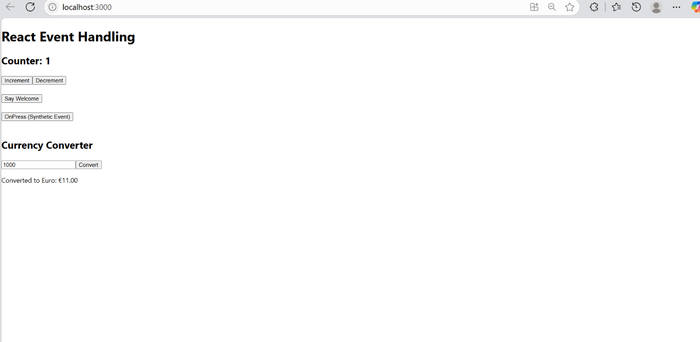

**12.**

**App.js**

import React, { useState } from 'react';

function App() {

const [isLoggedIn, setIsLoggedIn] = useState(false);

const handleLogin = () => {

setIsLoggedIn(true);

};

const handleLogout = () => {

setIsLoggedIn(false);

};

let content;

if (isLoggedIn) {

content = (

<div>

<h1>Welcome back</h1>

<button onClick={handleLogout}>Logout</button>

</div>

);

} else {

content = (

<div>

<h1>Please sign up.</h1>

<button onClick={handleLogin}>Login</button>

</div>

);

}

return (

<div style={{

display: 'flex',

justifyContent: 'center',

alignItems: 'center',

minHeight: '100vh',

textAlign: 'center'

}}>

{content}

</div>

);

}

export default App;

**output:**

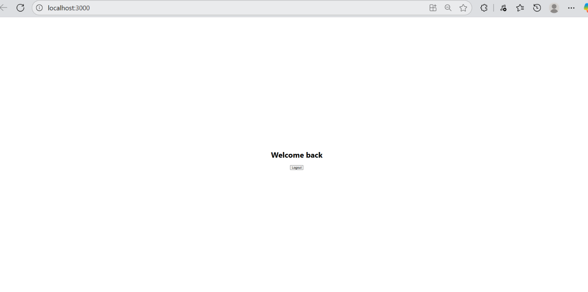

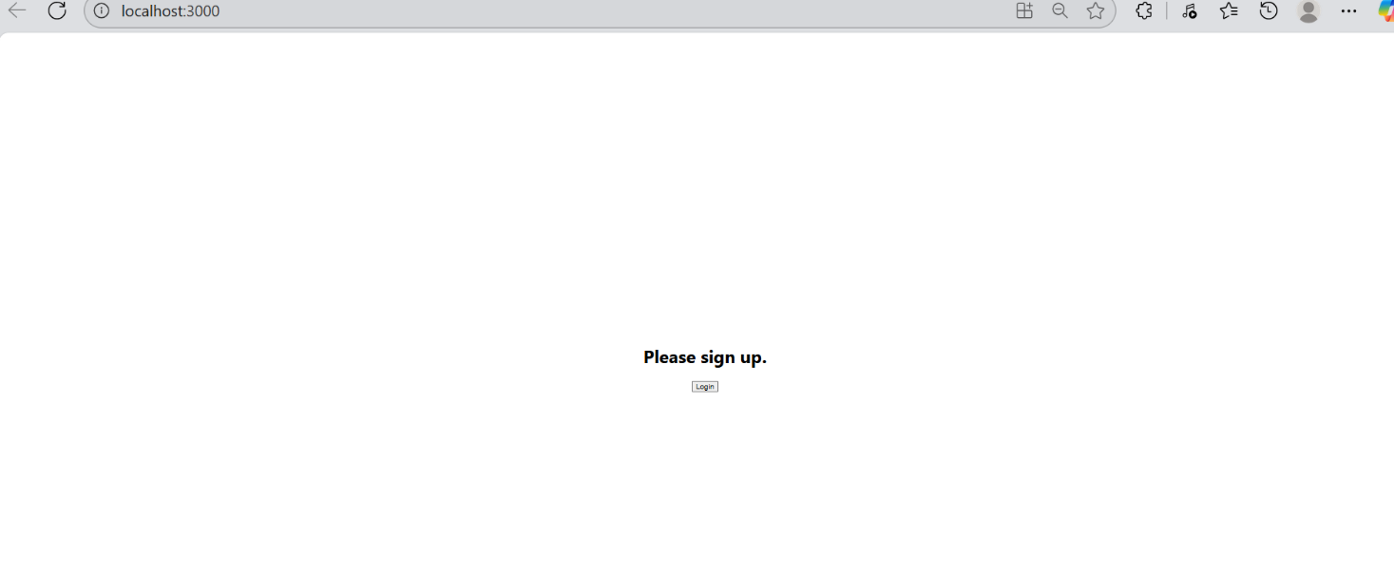

**13.**

**BlogDetails.js**

// src/BlogDetails.js

function BlogDetails() {

return (

<div>

<h2 style={{ fontWeight: 'bold' }}>Blog Details</h2>

<div style={{ fontWeight: 'bold', marginTop: '1em', fontSize: '1.2em' }}>React Learning</div>

<div style={{ fontWeight: 'bold' }}>Stephen Biz</div>

<div>Welcome to learning React!</div>

<div style={{ fontWeight: 'bold', marginTop: '1em', fontSize: '1.1em' }}>Installation</div>

<div style={{ fontWeight: 'bold' }}>Schwezdenier</div>

<div>You can install React from npm.</div>

</div>

);

}

export default BlogDetails;

**BookDetails.js**

// src/BookDetails.js

function BookDetails() {

return (

<div>

<h2 style={{ fontWeight: 'bold' }}>Book Details</h2>

<div style={{ fontWeight: 'bold', marginTop: '1em' }}>Master React</div>

<div>670</div>

<div style={{ fontWeight: 'bold', marginTop: '1em' }}>Deep Dive into Angular 11</div>

<div>800</div>

<div style={{ fontWeight: 'bold', marginTop: '1em' }}>Mongo Essentials</div>

<div>450</div>

</div>

);

}

export default BookDetails;

**CourseDetails.js**

import React from 'react';

function CourseDetails() {

return (

<div>

<h2 style={{ fontWeight: 'bold' }}>Course Details</h2>

<div style={{ fontWeight: 'bold', marginTop: '1em' }}>Angular</div>

<div>4/5/2021</div>

<div style={{ fontWeight: 'bold', marginTop: '1em' }}>React</div>

<div>6/3/20201</div>

</div>

);

}

export default CourseDetails;

**App.js**

// src/App.js

import React, { useState } from 'react';

import BookDetails from './BookDetails';

import BlogDetails from './BlogDetails';

import CourseDetails from './CourseDetails';

function App() {

const [section, setSection] = useState("book");

return (

<div className="App" style={{ display: 'flex', justifyContent: 'center', marginTop: '2em' }}>

<div style={{ display: 'flex', width: '80%', justifyContent: 'space-between' }}>

{/* Course Details */}

<div style={{ flex: 1, textAlign: 'center' }}>

<CourseDetails />

</div>

{/* Divider */}

<div style={{ width: 3, background: 'green', margin: '0 2em' }} />

{/* Book Details */}

<div style={{ flex: 1, textAlign: 'center' }}>

<BookDetails />

</div>

{/* Divider */}

<div style={{ width: 3, background: 'green', margin: '0 2em' }} />

{/* Blog Details */}

<div style={{ flex: 1, textAlign: 'center' }}>

<BlogDetails />

</div>

</div>

</div>

);

}

export default App;

**Output:**

