Project Documentation: A CRM Application for Wholesale Rice Mill

# Table of Contents

1. ***Introduction***
2. ***Project Overview***
3. ***Features and Functionality***

* ***Reporting and Dashboards***
* ***Rollup Summary Field***
* ***Cross-Object Formula Field***
* ***Validation Rules***
* ***Permission Sets and Roles***

1. ***Prerequisites***
2. ***Project Implementation Steps***

* ***Introduction to Salesforce***
* ***Object Creation***
* ***Tabs Creation***
* ***The Lightning App***
* ***Field Creation***
* ***Page Layouts***
* ***Profiles and Roles***
* ***Users and Permission Sets***
* ***Reports and Dashboards***
* ***Apex Development***

1. ***What I Gained from the Project***
2. ***Conclusion***
3. ***Future Enhancements***

# 1. Introduction

This document provides detailed information about the development of the CRM application tailored for a wholesale rice mill.

Running a rice mill is a big job. Every day, you have to handle many tasks—buying raw rice, processing it, managing sales, keeping customers happy, and making sure everything runs smoothly. It’s a lot to manage, especially when you’re trying to grow your business and stay ahead of others.

That’s where **The Rice Mill CRM Application** comes in. We designed this application with one goal in mind: to make life easier for everyone involved in the rice milling process. Whether you're the owner, an employee, or a customer, this tool is here to streamline your day-to-day activities and help you focus on what really matters—producing great rice and getting it to the people who need it.

Think of this CRM application as your all-in-one assistant. It keeps track of everything—from how much rice you sell each day to which customers prefer which types of rice. And the best part? It does all of this in real-time, giving you up-to-the-minute insights that help you make smarter decisions.

No more digging through spreadsheets or guessing what your next move should be. With this application, you’ll have all the information you need right at your fingertips. Want to know how much revenue you generated today? It’s just a click away. Need to see which type of rice is flying off the shelves? The answer is right there in your dashboard.

But it’s not just about numbers and reports. We know that at the heart of every successful rice mill are the relationships you build—with your suppliers, your customers, and your team. This application helps you manage those relationships more effectively, ensuring that everyone gets the attention they deserve.

And the best part? It’s designed to be user-friendly, so you don’t need to be a tech expert to use it. Whether you’re just starting out with digital tools or you’re already tech-savvy, this CRM will fit right into your workflow, making your job easier without any steep learning curve.

As your business grows, this application grows with you. It’s flexible, customizable, and ready to adapt to whatever challenges come your way. So, whether you’re looking to improve efficiency, boost customer satisfaction, or simply get a better handle on your daily operations, the Rice Mill CRM Application is here to help you achieve your goals.

In short, this project is all about giving you the tools you need to run a successful rice mill—one that’s ready for the future and able to thrive in a competitive market.

# 2. Project Overview

The **Rice Mill CRM Application** is designed to be a helpful tool for anyone involved in running a rice mill. Whether you're the owner, a manager, or part of the team, this application makes your daily tasks easier and more organized. At its core, the application is all about simplifying how you manage your rice mill, from tracking how much rice you produce and sell each day to keeping tabs on your customers and their preferences.

### Why This Application Matters

In a busy rice mill, things can get overwhelming quickly. You have to make sure that everything is running smoothly—from making sure there's enough rice to process to ensuring that all sales are recorded accurately. On top of that, you need to keep your customers satisfied and maintain strong relationships with your suppliers. It’s a lot to keep track of, and sometimes important details can slip through the cracks.

This is where the **Rice Mill CRM Application** steps in. It’s like having an extra set of hands (or even a whole team) to help you manage your operations. The application keeps everything in one place, so you don’t have to worry about losing track of important information. Whether you need to see how much rice was sold today or check on a customer’s order history, it’s all there, easy to find and use.

### Key Features

* **Daily Sales Tracking:** The application helps you keep a close eye on your daily sales. You can see at a glance how much rice was sold, which types are most popular, and how much revenue you’ve earned. This real-time information lets you make quick, informed decisions that can improve your business.
* **Customer Management:** Knowing your customers and what they like is key to keeping them coming back. The application stores all your customer information in one place, making it easy to remember who buys what and when. This way, you can provide better service and build stronger relationships.
* **Easy Reporting:** At the end of the day, you need to know how your business is doing. The application makes it simple to generate reports that show your sales, revenue, and other important metrics. These reports are easy to understand and can be shared with your team or used to make decisions about the future.
* **User-Friendly Design:** We know that not everyone is a tech expert, so we designed this application to be straightforward and easy to use. You don’t need special training to get started—just log in, and you’re ready to go.

### Benefits for Your Business

By using the **Rice Mill CRM Application**, you’ll save time and reduce stress. You won’t have to worry about missing important details or spending hours trying to find information. Instead, you can focus on growing your business, making your customers happy, and improving your rice mill’s efficiency.

Plus, as your business grows, this application can grow with you. It’s flexible and can be customized to meet your specific needs, whether that means adding new features or integrating with other systems you use.

# 3. Features and Functionality

### Reporting and Dashboards

The application excels in generating detailed daily reports that cover crucial aspects such as rice sales, total income, popular rice types, and customer purchases. These reports provide valuable insights for the rice mill owners, helping them make informed decisions about resource allocation and future planning. By understanding which rice types are in demand and who the top customers are, the mill can optimize operations and drive growth.

### Rollup Summary Field

A powerful feature of this application is its ability to summarize data from related records and display this information on the parent record. For example, the total amount of rice supplied by each supplier is automatically calculated and displayed on the supplier’s record. This feature ensures that the owners and managers always have up-to-date information on their inventory and supplier contributions, without needing to manually calculate these figures.

### Cross-Object Formula Field

This feature takes automation a step further by allowing calculations that span across different objects within Salesforce. For instance, the application automatically calculates the total payment due from a consumer based on the quantity of rice purchased and the price per kilogram. This eliminates manual calculations, reducing the chances of errors and ensuring that both consumers and the rice mill are always on the same page when it comes to payments.

### Validation Rules

To maintain data integrity, the application includes validation rules that prevent records from being saved with missing or incorrect information. For example, if a required field is left blank, a validation rule using the ISBLANK function will prompt the user with an error message, ensuring that all necessary information is entered correctly. This helps keep the database accurate and reliable, which is crucial for making informed decisions.

### Permission Sets and Roles

The application also features a well-defined system for managing user access through permission sets and roles. Organization-Wide Default (OWD) settings restrict access by default, ensuring data security. Roles such as Owner, Employer, and Worker are defined within the system, with specific access levels: Owners can view all records, Employers can view Worker records, and Workers have more limited access. This hierarchy ensures that sensitive information is only accessible to those with the appropriate permissions, while still allowing users to perform their duties effectively.

## 

## 

# 4. Prerequisites

Before diving into the Rice Mill CRM Application, here’s what you’ll need to get started smoothly:

### 1. Salesforce Developer Account

* **What It Is:** To build and customize the CRM application, you'll need a Salesforce Developer Account. This gives you access to all the tools and resources you need to create and tweak your CRM.
* **How to Get It:** If you don’t have one yet, you can sign up for a free Salesforce Developer Edition account [here](https://developer.salesforce.com/signup). It’s quick and easy!

### 2. Basic Knowledge of Salesforce Admin Concepts

* **Why It Matters:** Knowing a bit about Salesforce administration is crucial. This includes understanding how to set up objects, fields, and relationships, as well as managing permissions.
* **What to Brush Up On:**
  + Creating and managing objects and fields
  + Designing page layouts and record types
  + Setting up permission sets and roles
  + Using validation rules and formula fields

### 3. Web Browsers

* **What You Need:** Make sure you have at least two web browsers on your computer. This helps with accessing Salesforce and testing the application.
* **Recommended Browsers:** Google Chrome, Mozilla Firefox, or Microsoft Edge will work best.

### 4. Good Internet Connectivity

* **Why It’s Important:** A reliable and fast internet connection is essential for working with Salesforce and keeping everything running smoothly.
* **What’s Ideal:** Aim for an internet speed of at least 5 Mbps to avoid any hiccups.

### 5. Basic Understanding of CRM Systems

* **What It Helps With:** Having a general idea of how CRM systems work will make it easier to use and understand the features of our application.
* **Topics to Know:**
  + What CRM systems are and why they’re useful
  + Common features and benefits of CRM tools

### 6. Familiarity with Reporting and Dashboards

* **Why It’s Useful:** Knowing how to create and interpret reports and dashboards will help you get the most out of the application’s data insights.
* **What to Review:**
  + How to create and customize reports
  + Setting up and managing dashboards

### 7. Knowledge of Business Processes in a Rice Mill

* **Why It Helps:** Understanding the day-to-day operations of a rice mill can make the CRM application work better for your specific needs.
* **Key Areas:**
  + Rice procurement and processing
  + Sales and distribution
  + Managing customer relationships

# 5. Project Implementation Steps

### Introduction to SalesforceC:\Users\anuabhav\AppData\Local\Packages\5319275A.WhatsAppDesktop_cv1g1gvanyjgm\TempState\3C565485BBD2C54BB0EBE05C7EC741FC\WhatsApp Image 2024-10-02 at 00.21.28_38057613.jpg

* **Steps:** Creating a developer account and activating it for project use.

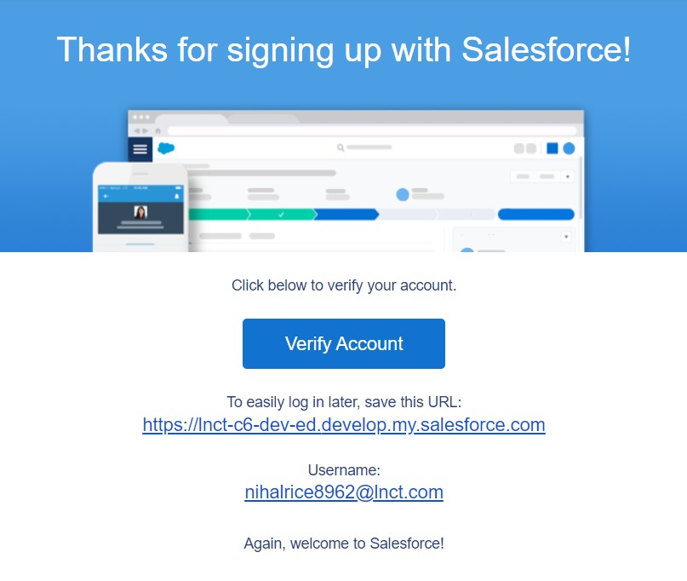

### Object Creation

* **Supplier Object:** Captures details of rice suppliers.
* **Rice Mill Object:** Tracks rice mill operations and inventory.
* **Consumer Object:** Records consumer information.
* **Rice Details Object:** Stores detailed information about rice transactions.

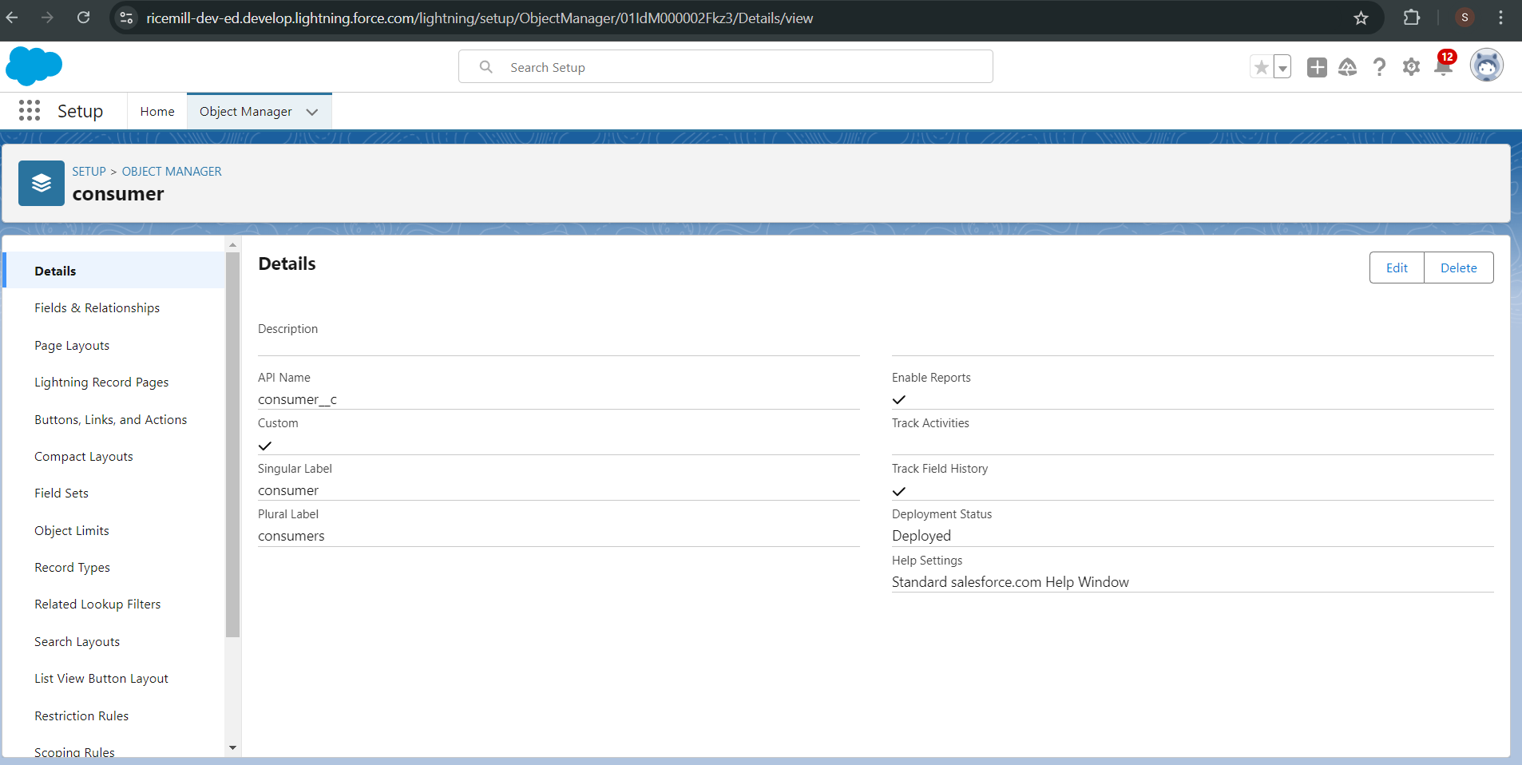

### Tabs Creation

* **Steps:** Creating custom tabs for each object to facilitate easy navigation.

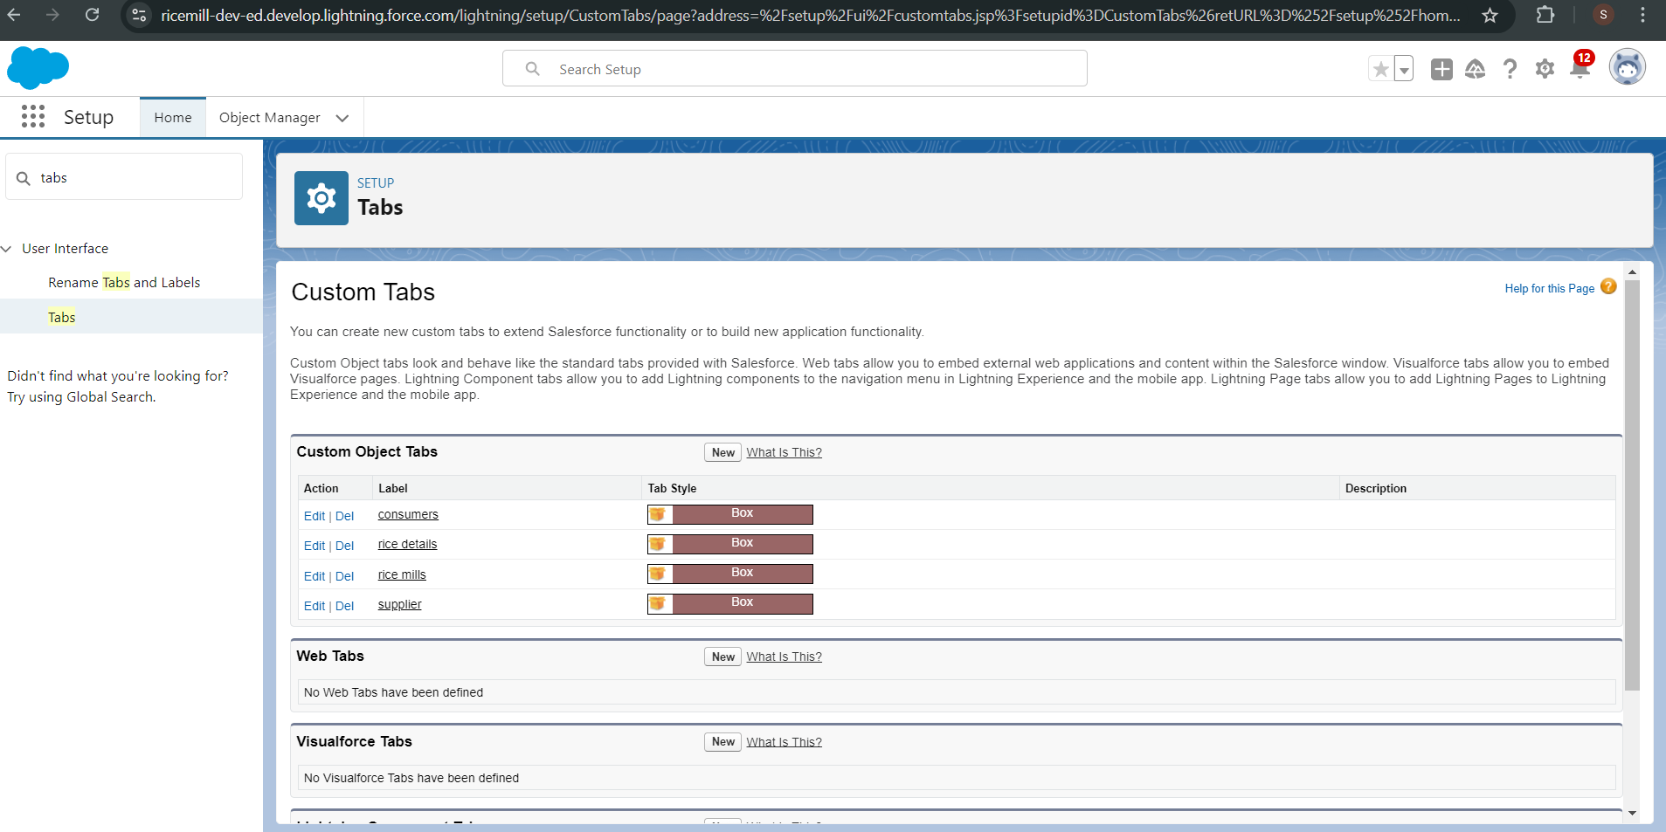

### The Lightning App

* **Steps:** Setting up a Lightning App to organize the Rice Mill CRM and its components.

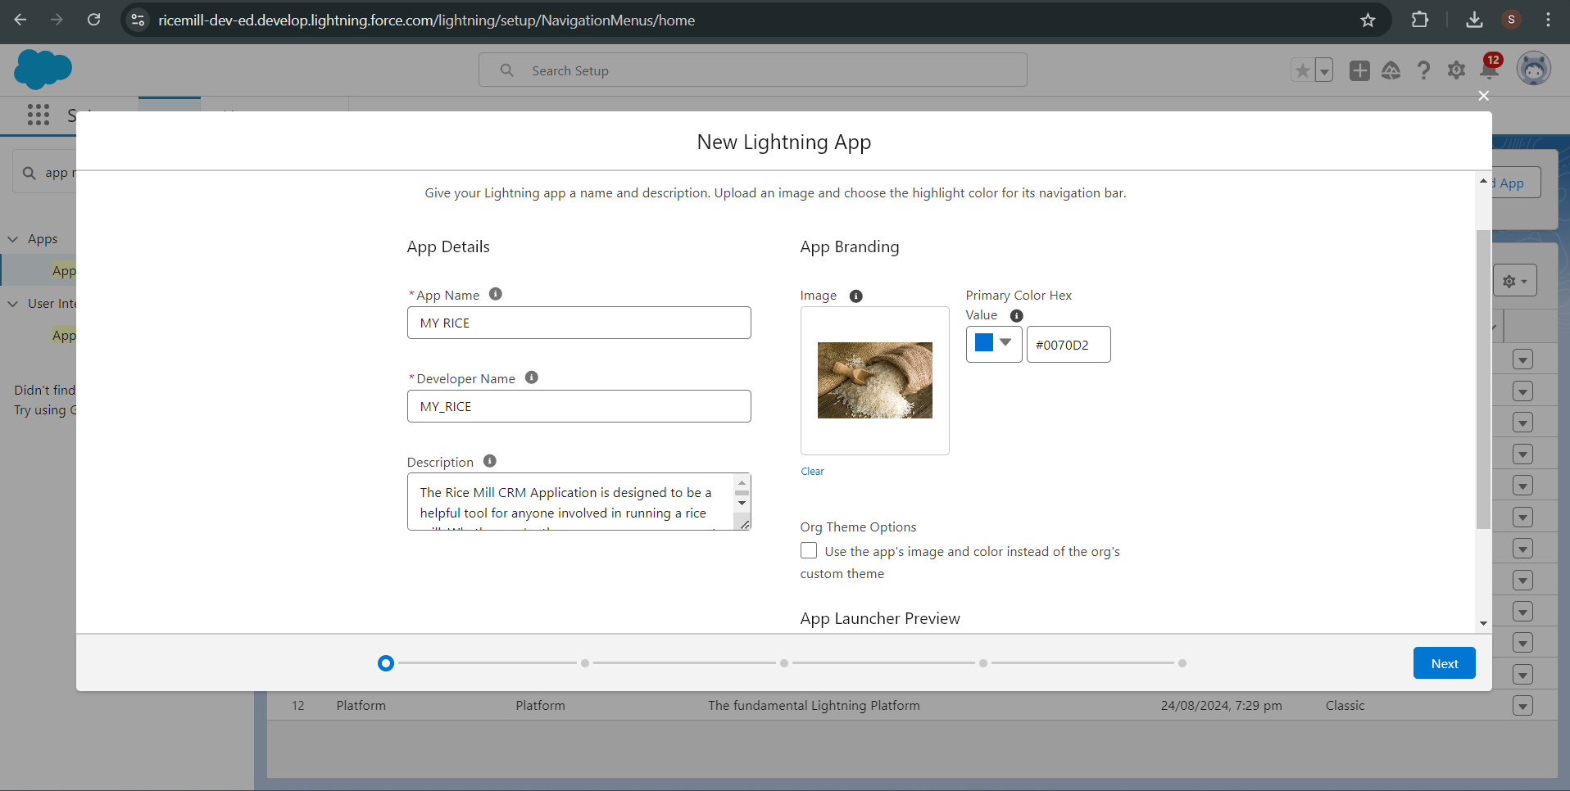

### Field Creation

* **Number Field in Rice Details Object:** Tracks the quantity of rice.
* **Junction Object:** Establishes relationships between Rice Mill and other objects.
* **Master-Detail Relationship:** Links objects like Consumers and Rice Details.
* **Roll-Up Summary:** Aggregates rice quantities from related records.
* **Cross-Object Formula Field:** Calculates payments in Consumer records.
* **Validation Rule:** Ensures required fields are not left blank.

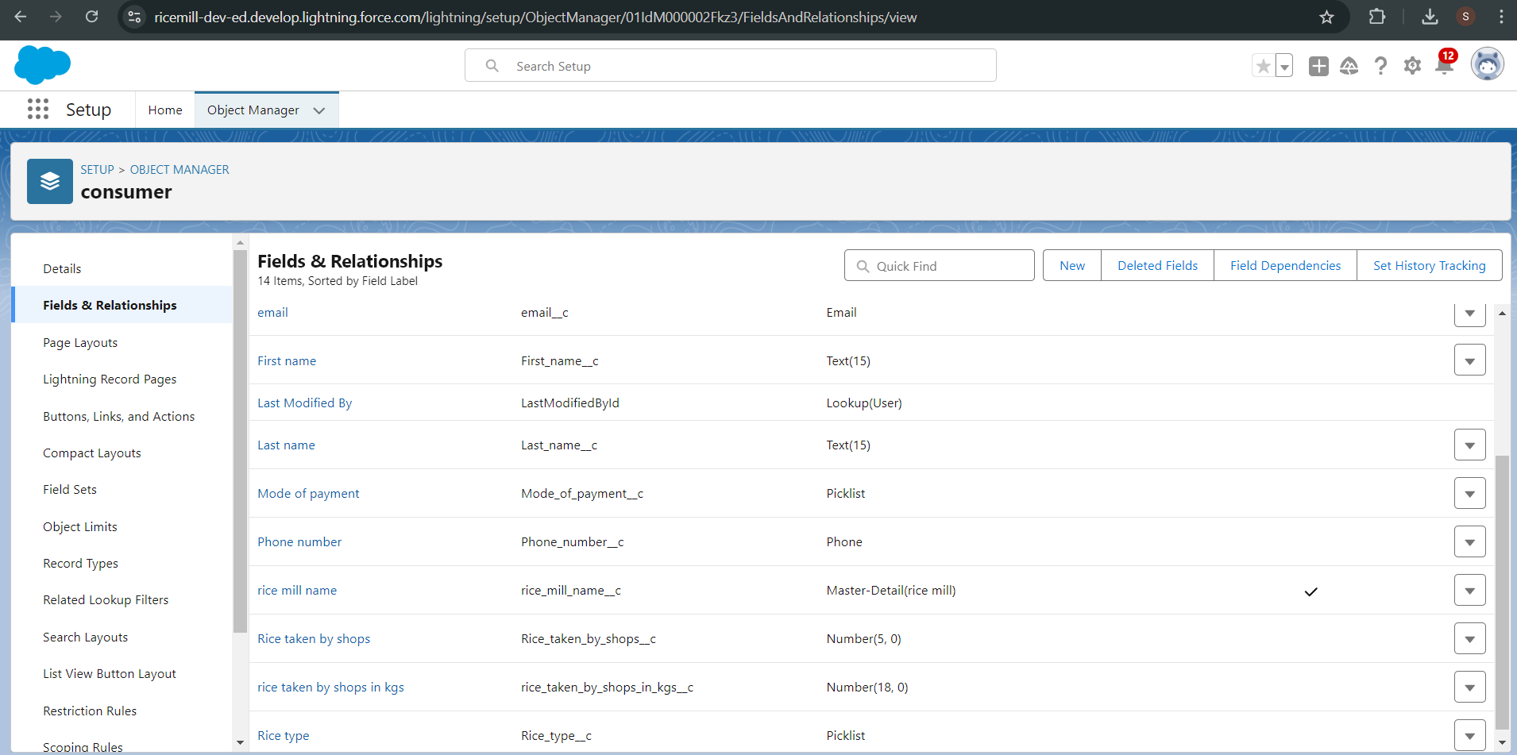

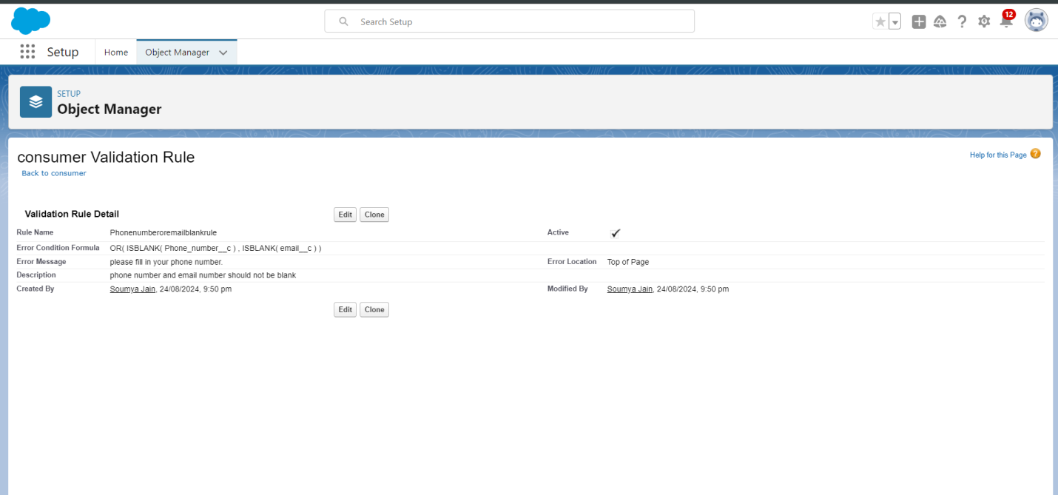

### Page Layouts

* **Steps:** Customizing page layouts for various profiles to streamline data entry and display.

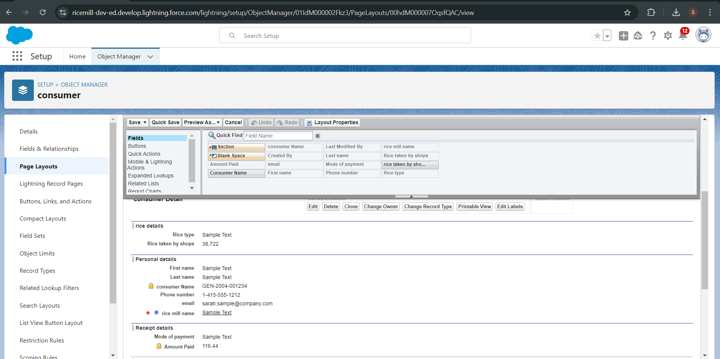

### Profiles and Roles

* **Owner Profile:** Full access to all data and functionalities.
* **Employer Profile:** Access to Worker data and limited access to other records.
* **Worker Profile:** Restricted access, primarily to their own data.

### Users and Permission Sets

* **OWD Setting:** Configured to restrict access according to organizational roles.
* **User Creation:** Setting up users for different roles and assigning appropriate permission sets.

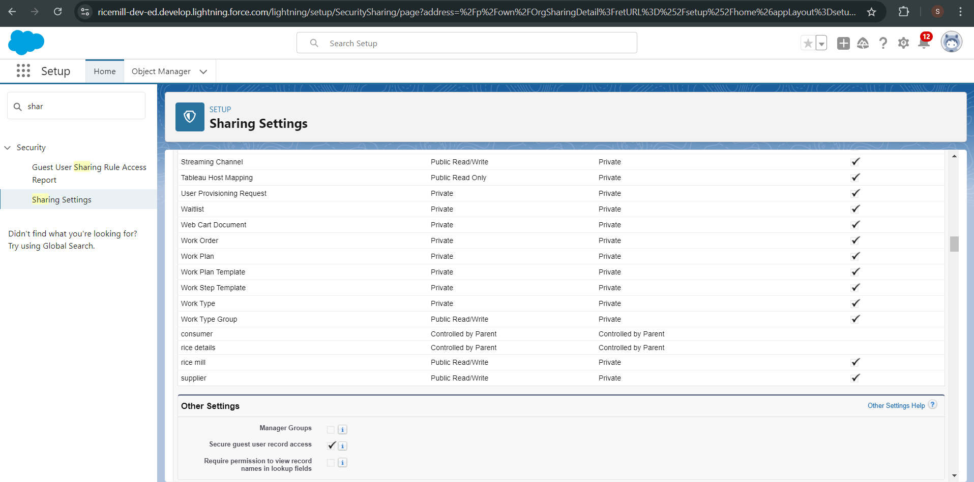

### Reports and Dashboards

* **Report Creation:** Designing reports to summarize daily sales and other key metrics.

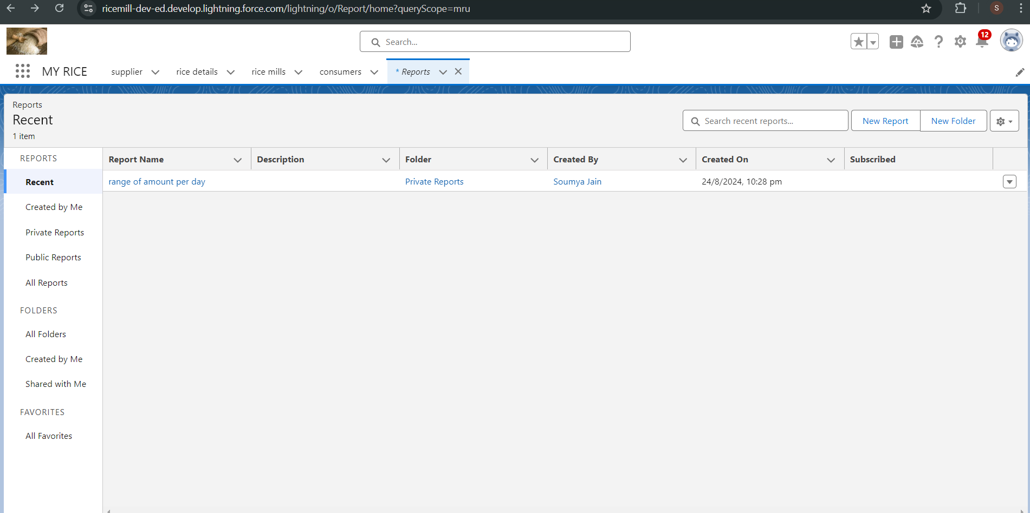

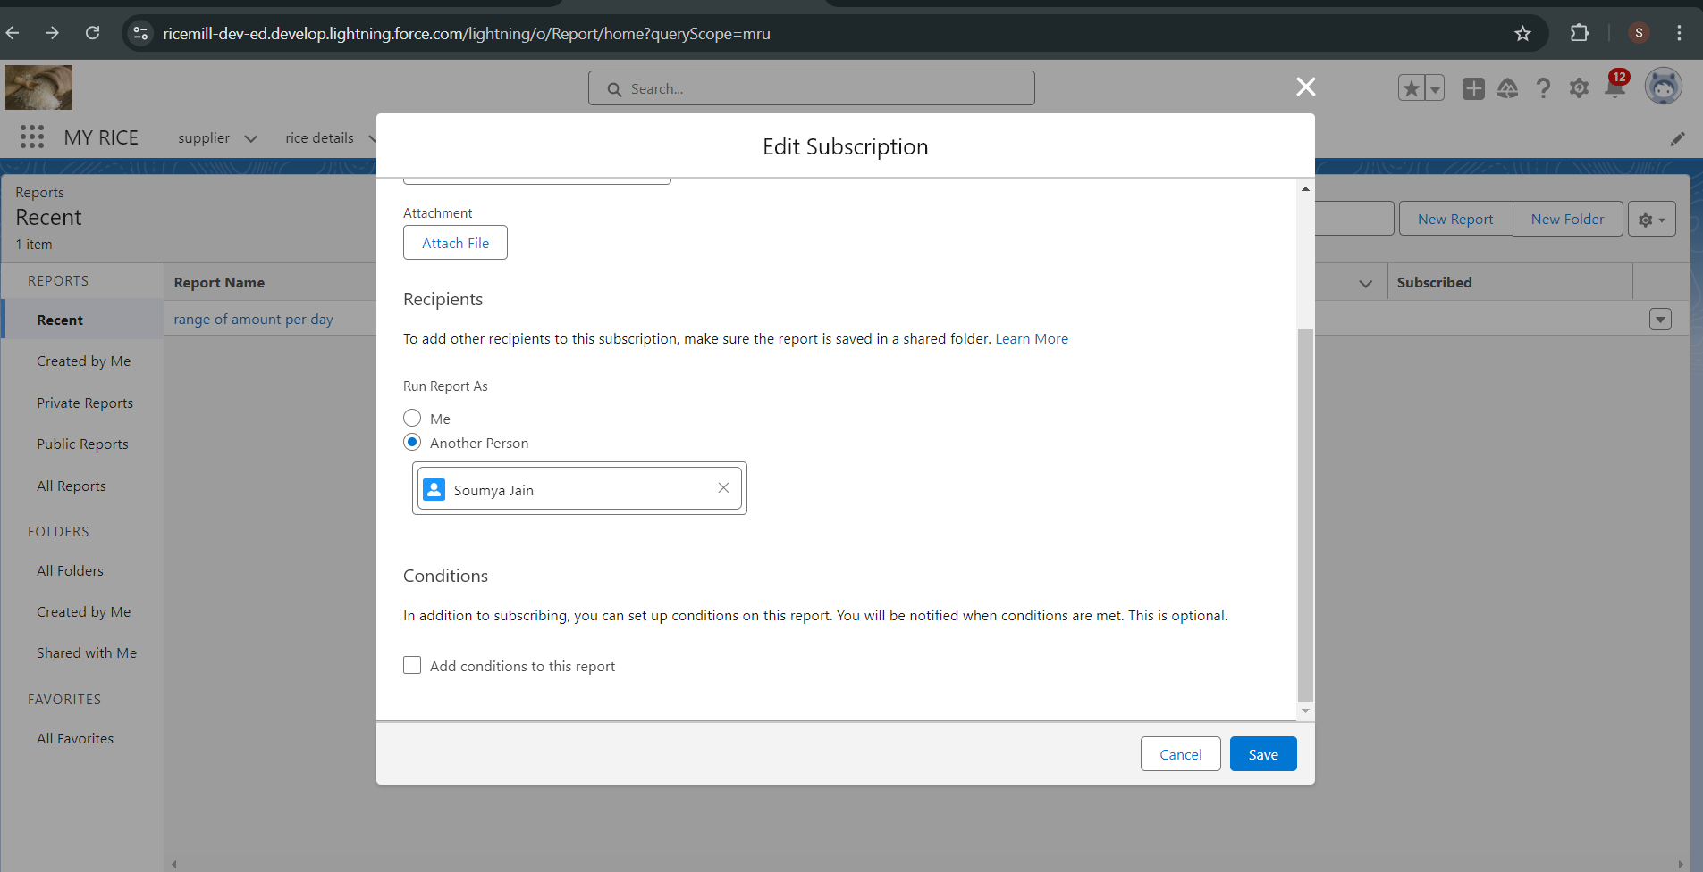

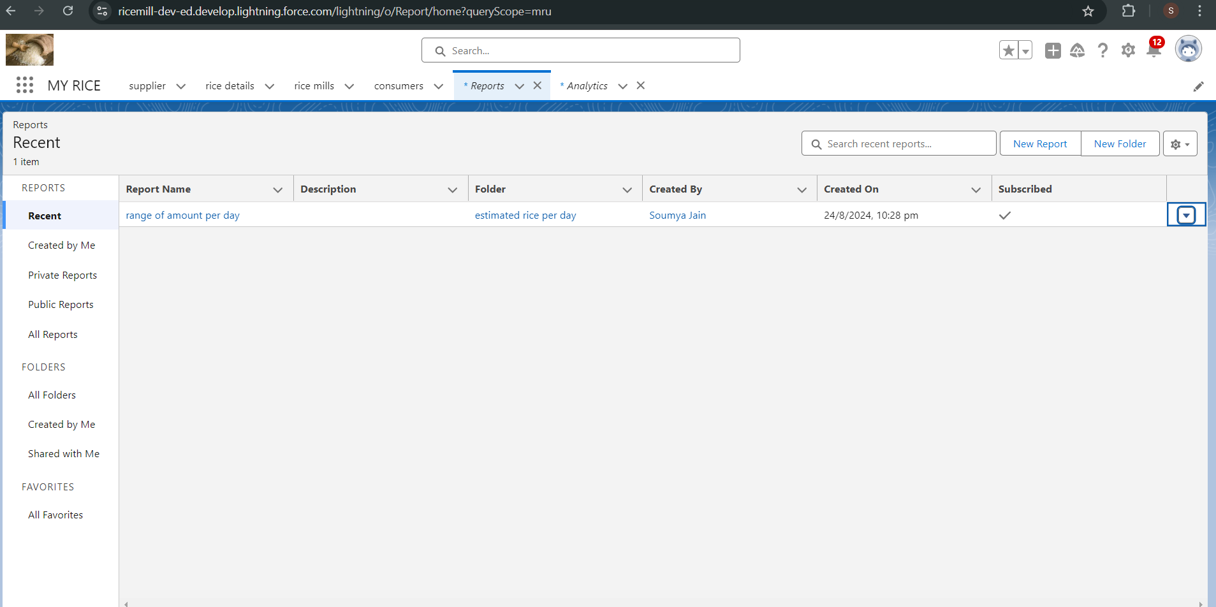

* **Dashboard Setup:** Creating a dashboard to visualize the data for quick insights.

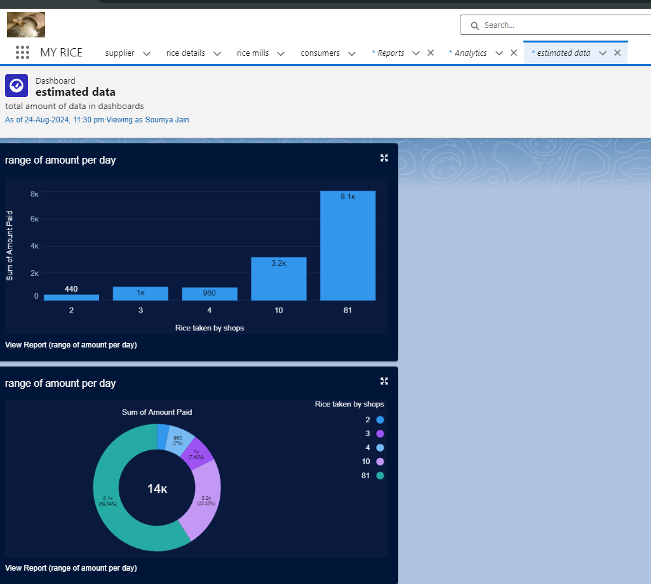

### Apex Development

* **Apex Class (ConsumerRecord):** Manages operations related to Consumer records.

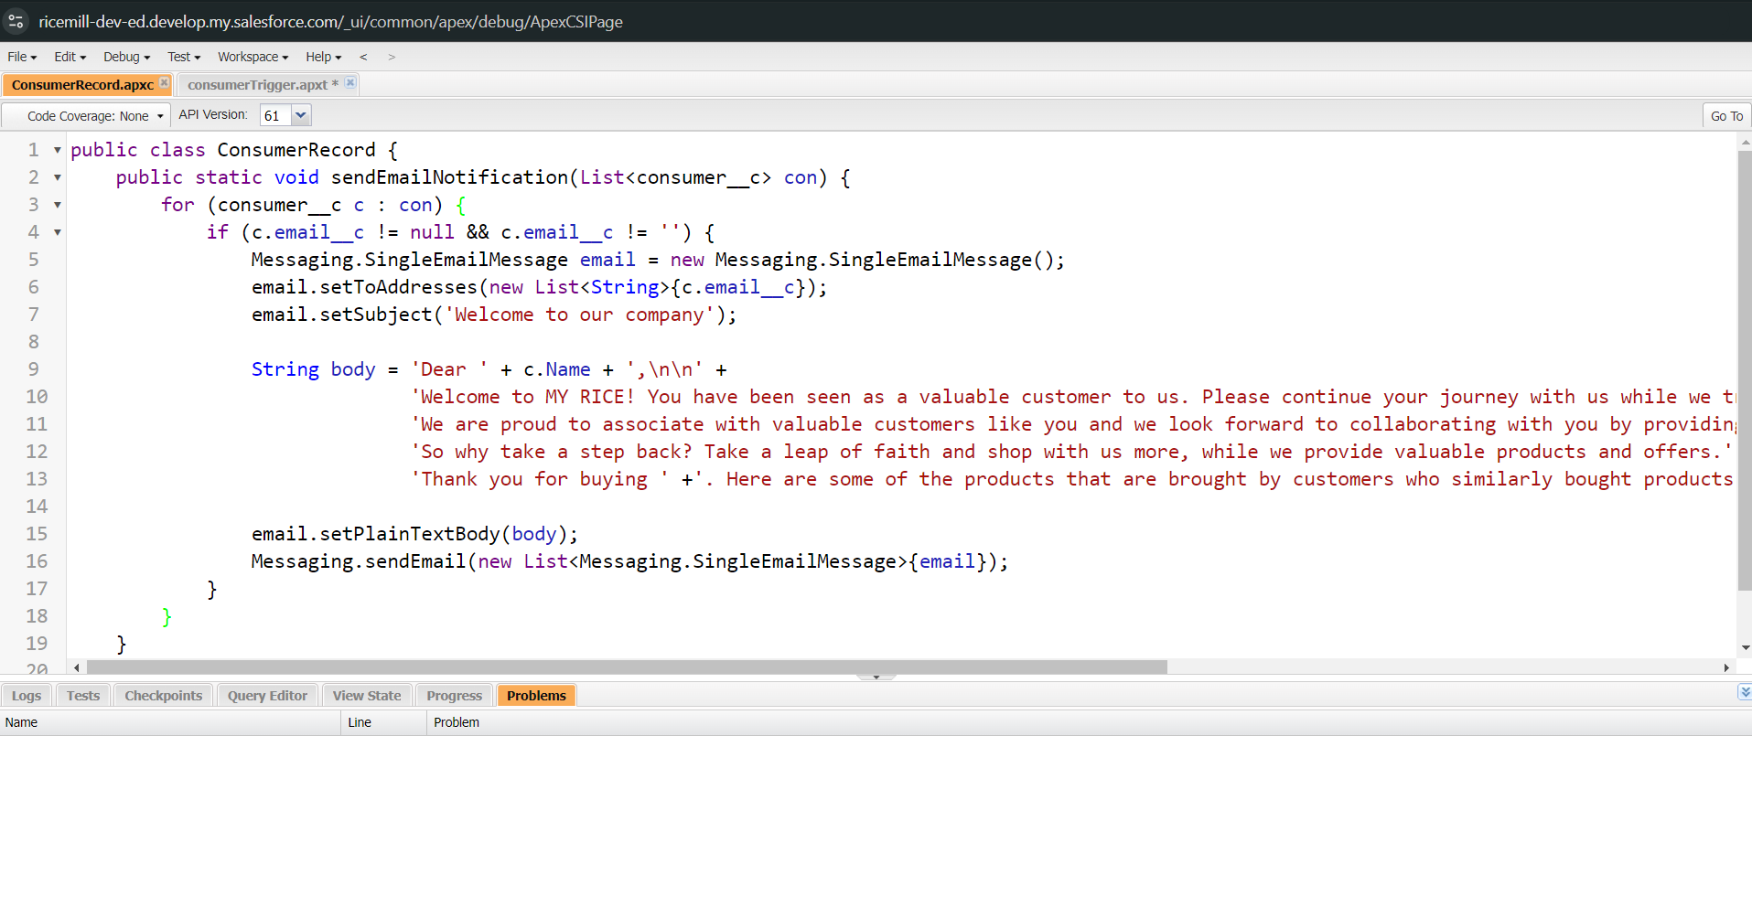

* **Apex Trigger:** Automates specific processes, such as updating related records when a Consumer record is modified.

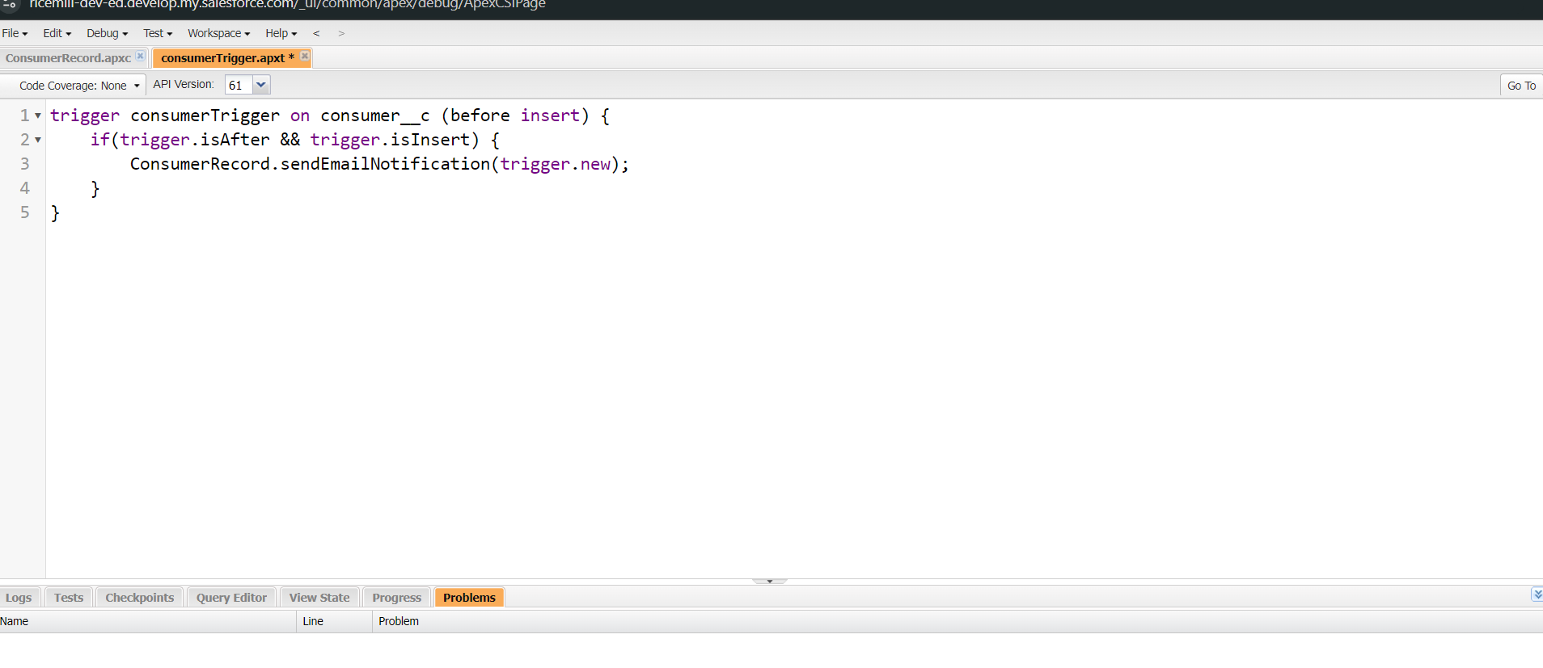

# What I Gained from the Project

Building the Rice Mill CRM Application has been an incredible journey for me. Here’s a summary of what I’ve accomplished and learned through this project:

* **Hands-On Salesforce Experience:** By working on this real-time Salesforce project, I’ve gained valuable experience in configuring and customizing CRM applications. I’ve navigated the Salesforce platform to build a functional CRM system tailored to the needs of a rice mill, which involved setting up various components like objects, fields, and relationships.
* **Understanding Objects & Relationships:** I’ve delved into how Salesforce objects and relationships work, learning to create and manage custom objects like Suppliers, Rice Mills, Consumers, and Rice Details. Understanding how these objects interrelate has been key to building a coherent and effective CRM system.
* **Developing Formula Fields and Validation Rules:** I’ve crafted formula fields to perform essential calculations and validate data. For instance, I created formulas to calculate the total payment due based on the quantity of rice and its price per kilogram. Validation rules have been implemented to ensure data integrity, such as preventing records with missing or incorrect information from being saved.
* **Applying Cross-Object Formula Fields:** I’ve used cross-object formula fields to link data across different Salesforce objects. This functionality has allowed me to pull information from related records and perform calculations, such as aggregating the total amount of rice purchased by each consumer and displaying it in a single view.
* **Designing Page Layouts:** I’ve designed and customized page layouts to make the CRM application user-friendly. This included arranging fields and sections in a way that makes it easy for users to access and manage their data, whether they are viewing details about rice purchases or reviewing supplier information.
* **Using Rollup Summary Fields:** I’ve implemented rollup summary fields to aggregate data from child records and display it on parent records. For example, I used rollup summaries to show the total amount of rice supplied by each supplier, which helps in tracking and managing inventory efficiently.
* **Creating Reports and Dashboards:** I’ve developed and customized reports and dashboards to visualize key metrics and insights. I set up reports to track daily rice sales, total income, and popular rice types, and created dashboards to provide an at-a-glance view of these metrics, aiding in better decision-making and resource planning.

Overall, this project has significantly enhanced my Salesforce skills and provided me with a practical tool that improves the management and efficiency of rice mill operations. I’m proud of the progress I’ve made and excited about the positive impact this CRM application will have on the business.

# Future Enhancements

Looking ahead, there are several exciting ways to take the Rice Mill CRM Application to the next level. Here’s what I’m envisioning:

* **Advanced Reporting Capabilities:** I see the potential for diving even deeper into the data. Adding features like custom report filters, scheduled email updates, and interactive dashboards could really help users get a better handle on their rice sales and customer trends. Imagine being able to see detailed sales patterns over time or receive automatic reports on key metrics—this could make decision-making a lot smoother.
* **Integration with External Systems:** To make things even more seamless, integrating with external systems such as accounting software or inventory tools could be a game-changer. This would help eliminate the need for manual data entry and ensure that everything from financial records to inventory levels is always in sync.
* **Enhanced User Interface and Experience:** I’m excited about the possibility of making the user experience even better. Improving the interface to be more intuitive, adding customizable dashboard widgets, and ensuring the design works well on mobile devices could make interacting with the CRM more enjoyable and efficient for everyone.
* **Automated Workflows and Notifications:** Introducing automated workflows and notifications could really streamline operations. For instance, setting up automatic reminders for things like payment deadlines or inventory restocking could help keep everything running smoothly and reduce the chances of missing important tasks.
* **Integration of AI and Analytics:** The future holds exciting possibilities with AI and advanced analytics. By incorporating tools that predict trends, spot potential issues, or analyze customer behavior, we could make even more informed decisions and stay ahead of changes in the market.
* **Expanded User Training and Support:** Finally, making sure everyone can use the CRM to its fullest is important. Providing detailed user guides, video tutorials, and a support helpdesk would be great ways to ensure that everyone feels confident and supported as they use the application.

These enhancements are all about making the CRM application even more powerful and user-friendly. I’m looking forward to seeing how these updates can further improve the way the rice mill operates and helps the business grow.

# 

# Conclusion

Reflecting on the development of the Rice Mill CRM Application, I’m truly pleased with what I’ve accomplished. This project has been a significant learning experience, allowing me to apply and enhance my Salesforce skills in a real-world context.

By building this CRM system, I’ve gained hands-on experience with Salesforce’s powerful features, such as object creation, formula fields, and validation rules. I’ve also explored how to design user-friendly page layouts and utilize rollup summary fields to streamline data management. Creating customized reports and dashboards has enabled me to visualize key metrics and provide valuable insights.

Looking ahead, I’m excited about the possibilities for future enhancements. From adding advanced reporting capabilities and integrating with external systems to improving the user interface and incorporating AI-driven analytics, there’s a lot of potential to further elevate the CRM application. I’m also eager to enhance data security measures and expand user training and support to ensure the CRM continues to meet the evolving needs of the rice mill.

Overall, this project has not only improved my technical skills but also resulted in a practical tool that can make a real difference in managing rice mill operations. I’m proud of what I’ve achieved and optimistic about the continued growth and impact of this CRM application.