Job Search RAG Technical Report
GenAI Takeaway Assignment
Hybrid Search and Reranking with a Local LLM
Repository: https://github.com/nihal8866/job-search-rag
Table of Contents
1 Problem and data ......................................................................................................................... 3
2 Data preparation and search ......................................................................................................... 3
Reasons for the main choices ..................................................................................................... 5
3 Local answers .............................................................................................................................. 5
4 Setup and API .............................................................................................................................. 6
Installation from the repository ................................................................................................. 6
Recorded requests and responses ............................................................................................... 8
5 Evaluation .................................................................................................................................... 9
6 Reproducibility .......................................................................................................................... 10
7 Limitations and further work ...................................................................................................... 11
8 Assumptions and submission ...................................................................................................... 11
List of Figures
Fig 1: Data Preparation Pipeline ...................................................................................................... 3
Fig 2: Question Answering Pipeline ................................................................................................ 4
This project searches the supplied job listings and returns relevant jobs with quoted source evidence. It includes the required RAG pipeline and FastAPI endpoint, plus hybrid search and a cross-encoder reranker. All models run locally without a paid model API. The results below describe development checks; independent human relevance review remains future work.

1 Problem and data
The goal is to search the supplied job listings and answer questions using their source evidence. The input is data/raw/LF Jobs.xlsx: 1,000 listings, nine columns, 145 companies, and seven job categories. Descriptions contain HTML.
There are nine missing locations, 880 missing tag values, and no repeated job IDs or fully duplicated rows. All descriptions remain nonempty after cleaning. All publication dates parse as UTC and range from February 1, 2023 to August 1, 2025. These dates do not confirm whether a vacancy is still open. Eleven descriptions contain characters in the checked CJK range; this is a character check, not full language detection.

2 Data preparation and search
The offline path prepares a persistent index:

Fig 1: Data Preparation Pipeline
The query path combines semantic and keyword matches:
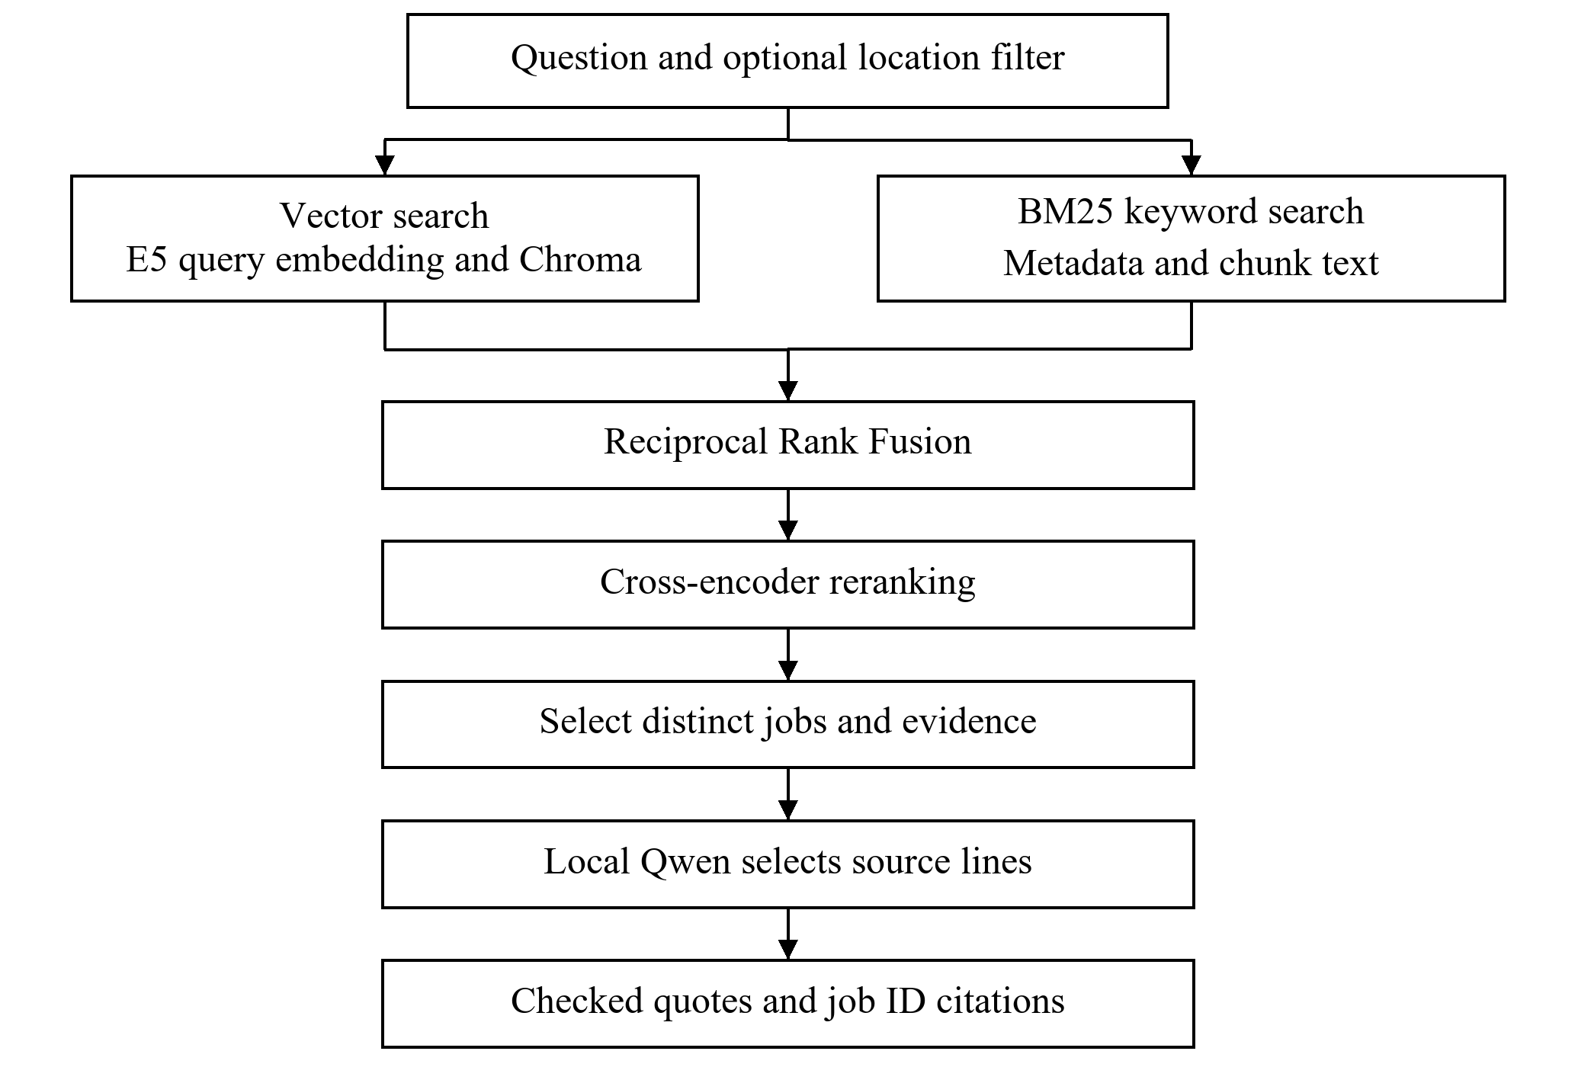
Fig 2: Question Answering Pipeline
BeautifulSoup removes HTML while the original description and date strings are retained. Descriptions are split into 384-token windows with 48-token overlap. This produces 3,618 chunks covering all jobs.
The embedding model is intfloat/multilingual-e5-small. Each input contains the passage prefix, job title, company, category, level, and chunk text. Including long location lists initially pushed 35 inputs over 512 tokens. Location is kept as metadata instead; the final complete input has a maximum of 438 tokens.
GPU encoding produces normalized vectors with shape (3618, 384). Checks cover finite values, unit norms, unique chunk IDs, job coverage, and saved-file alignment. Reload checks compare both values and missing-value positions.
Chroma stores the vectors, source text, and metadata using cosine distance. BM25 indexes metadata and chunk text, including full locations. The shared keyword tokenizer normalizes case, preserves C++/C#, and separates common CJK/kana characters. It does not translate, stem words, or perform linguistic CJK word segmentation.
Vector and BM25 search each return up to 20 chunks. Equal-weight RRF combines their rankings with k=60. BAAI/bge-reranker-v2-m3 then scores query/chunk pairs in batches of four, after checking the 512-token pair limit. Results keep the best candidate chunk per distinct job. This does not merge a job's full description.
An explicit location filter restricts both retrievers before their result limits. It uses case-insensitive literal matching against recorded location strings. It does not infer geography, aliases, or remote eligibility from the question.

Reasons for the main choices
Multilingual E5 supports a dataset containing English, Chinese, and Japanese text. Its small variant fits the available machine, and token-based chunking keeps long descriptions within its input limit. Overlap retains some context around boundaries, although it can repeat evidence and split sentences.
Chroma provides a local persistent vector store without a hosted database. BM25 complements semantic retrieval with exact terms such as programming languages. Reciprocal Rank Fusion (RRF) combines rank positions instead of directly mixing incompatible vector and BM25 score scales. A cross-encoder examines each candidate together with the question, at a higher latency cost. The small evaluation below does not establish a general quality gain from it.
Full locations remain in metadata and the BM25 corpus because long location lists exceeded the embedding budget. Filtering both retrievers before their candidate limits prevents an explicit location constraint from being applied only after relevant local candidates have already been discarded.

3 Local answers
The answer model is qwen3:4b-instruct-2507-q4_K_M through local Ollama. Early free-form answers overstated skills and produced incorrect inline citations. Prompt-only revisions did not reliably fix those errors.
The current model selects up to three numbered source lines per job. A per-request JSON schema limits the choices to that source. Application code checks the choices, copies the text, and attaches the actual job ID. Empty selections produce an insufficient-evidence answer; empty retrieval skips generation. Known metadata can also be selected for company, location, level, and publication date.
This prevents model-written paraphrase and citation-typing errors in this adapter. It does not guarantee relevant or complete evidence. Quotes can contain boilerplate, repetition, or text cut at chunk boundaries. Historical data cannot establish current application availability. See answer_design.md for the validation flow.

4 Setup and API
The tested machine uses Windows, Python 3.10.11, and an RTX 4060 Laptop GPU with 8 GB VRAM. Ingestion and notebooks use CUDA. The API uses CPU retrieval to leave GPU memory for Ollama. It runs locally without a paid API or model API key.
The README contains installation and startup commands. job-rag ingest prepares the data/index; search returns ranked evidence; ask adds the local answer step. The original workbook is unchanged. If ingestion is interrupted, it must be rerun because files and database updates are not one transaction.
POST /api/query accepts:
{
"query": "Python backend developer working with APIs and databases",
"top_k": 2
}
top_k defaults to 2 and accepts 1-5. An optional location field applies the filter. The response includes answer, cited_job_ids, jobs with source text/chunk IDs/scores, and normalized request fields. Missing metadata becomes JSON null.
No eligible jobs returns HTTP 200 with empty results. Invalid input/model limits return 422; busy or failed local inference returns 503; unexpected errors return 500 without internal details. One service loads at startup and processes one inference at a time. GET /health checks retrieval readiness, not Ollama availability. The listener is bound to 127.0.0.1 for local review. See api_usage.md for examples.

Installation from the repository
Install Python 3.10.11, Git, and Ollama first. The verified ingestion configuration uses an NVIDIA GPU and a compatible driver; CPU-only ingestion and other platforms have not been independently verified. Initial package and model downloads require internet access and several GB of free storage. The project has no paid API or hosting requirement; existing hardware, electricity, and connectivity are separate.
Run in PowerShell:
git clone https://github.com/nihal8866/job-search-rag.git
cd job-search-rag
python -m venv .venv
.\.venv\Scripts\Activate.ps1
python -m pip --isolated install --index-url https://pypi.org/simple -r requirements-dev.txt
python -m pip --isolated install --no-build-isolation --no-deps -e .
python -m pip check
job-rag ingest
The first two lines download the repository and enter its folder. The next two create and activate an isolated Python environment. The two install commands install the recorded dependencies and make the local package available as job-rag. pip check verifies dependency consistency. The final command cleans the supplied workbook, generates embeddings, and builds the local index. Generated indexes and embeddings are recreated locally and are not in Git.
Download the selected local answer model once:
ollama pull qwen3:4b-instruct-2507-q4_K_M
Quit any already running Ollama tray app before starting a manually configured server. In a separate PowerShell terminal, run:
$env:OLLAMA_NO_CLOUD = "1"
ollama serve
The first line disables Ollama cloud features for this terminal's server process. The second starts the local model server; leave that terminal running. Do not start a second server if one is already serving on port 11434.
In the activated project terminal, start the API:
python -m uvicorn job_rag.api:app --host 127.0.0.1 --port 8000 --workers 1
This loads the FastAPI application with one worker, listening only on this computer. After startup completes, open http://127.0.0.1:8000/docs. Expand POST /api/query, click Try it out, replace the example request, and click Execute. Read the JSON under Response body. The root URL has no homepage and returns 404. This local URL cannot be used by a reviewer on a different computer.

Recorded requests and responses
The following examples come from the actual October 29 API run. The first response is a projection showing only selected fields; the complete responses, source chunks, metadata, and scores are retained in docs/api_examples.json and evaluation/api_results_2026-10-29.json. Model selections and timings can vary between runs; the examples are observations, not exact-output guarantees.
Example request with a location filter:
{
"query": "Python backend developer working with databases",
"location": "sInGaPoRe",
"top_k": 2
}
Observed HTTP 200 response fields:
{
"query": "Python backend developer working with databases",
"location_filter": "sInGaPoRe",
"cited_job_ids": ["LF0247", "LF0175"]
}
The first result was Backend Software Engineer - Global E-commerce (Governance Service), TikTok, Singapore, job LF0247. Its answer included these exact lines:
- Candidate should have at least 5 years of experience in developing highly scalable backend services and systems using at least one of the following programming languages: Java, Golang, or Python.
- In-depth knowledge of common databases and messaging frameworks such as MySQL, Redis, Kafka, and MQ is required.
The second result was Solutions Engineer, TikTok Ads, job LF0175. Its selected evidence supported only part of the question. This distinction matters: the API returns ranked evidence, not a guarantee that every result meets every condition.
Example request with an unknown location:
{
"query": "Python developer",
"location": "NO_SUCH_LOCATION_000",
"top_k": 2
}
Observed complete HTTP 200 response:
{
"query": "Python developer",
"location_filter": "NO_SUCH_LOCATION_000",
"answer": "No jobs were retrieved for the requested search and filters.",
"cited_job_ids": [],
"jobs": []
}
For a missing-fact check, the question "What is the exact annual salary for the EPAM Senior Python Developer?" with location Brezno and top_k 1 returned HTTP 200 with LF0265 and the answer "An answer is not established by the selected evidence for this job [LF0265]." Blank questions, blank locations, and top_k above 5 returned HTTP 422 in the recorded validation cases.

5 Evaluation
Eight assistant-curated, source-derived queries test whether a known target job is found. They cover six categories and include a Chinese query. These are development cases, not independent labels or a held-out set. Other jobs remain unjudged, so exhaustive recall, precision, and general accuracy are not claimed.
Method | Target first | Target in top five | MRR@5 | Mean retrieval seconds
Vector | 8/8 | 8/8 | 1.0000 | 0.122
Hybrid | 8/8 | 8/8 | 1.0000 | 0.173
Hybrid + reranker | 7/8 | 8/8 | 0.9375 | 6.476

The displaced target was behind another relevant meal-plan internship. This small set does not show a general improvement from either optional enhancement. Timing is one CUDA run excluding startup and generation, not a repeated benchmark.
Five fixed-evidence answer cases checked partial skills, missing salary/current status, a known salary range, and recorded location. All passed reference checks. Assistant source review found supported quotes and appropriate abstentions, but also a less relevant selected line and no explicit list of missing API evidence.
Twelve live API cases covered mixed-case location filters, unknown locations, invalid inputs, Chinese/Japanese targets, unsupported facts, one misleading user instruction, and metadata. All applicable contract checks passed. Three known targets ranked first; four unsupported-fact cases abstained. Review found repeated Chinese source text and generic/fragmentary Japanese secondary evidence.
The eight inference requests averaged 17.65 seconds excluding startup. Different workloads and one run per case preclude benchmark claims. Unit tests mock models and database calls; real ingestion, generation, and HTTP checks are separate. All 106 automated tests pass. Results, raw outputs, query provenance, and review limits are retained in evaluation/ and described in evaluation.md/api_evaluation.md.

6 Reproducibility
All four notebooks completed in separate fresh kernels on October 28. On October 29, a new Python 3.10.11 environment with no system site-packages installed the development requirements and editable package. pip check and all 106 tests passed.
A separate source snapshot rebuilt 1,000 jobs, 3,618 chunks, normalized vectors, and Chroma records. IDs, text, and embedding inputs matched working artifacts; vectors matched within 1e-5. Import paths were checked. A fresh API query returned the expected LF0265/LF0247 jobs with valid source quotes/citations in 37.86 seconds after startup. The temporary server was stopped afterward.
The same Windows machine, driver, and existing package/model caches were used. This does not test another platform, a clean user profile, or first-model downloads. Ten indirect dependency versions differed from the earlier working snapshot; both sets are retained. See setup_verification.md and the dated environment records.

7 Limitations and further work
Listings are historical. Location matching is literal, keyword segmentation is basic, and token windows can split sentences. One-chunk job ranking can miss requirements elsewhere in a description. Evidence selection can repeat passages, include headings, or return only partial matches.
Next steps are independent relevance review, harder/no-answer queries, source- prompt tests, multi-chunk evidence, and repeated latency/memory measurements. Current checks do not establish production throughput or broad adversarial robustness.

8 Assumptions and submission
The supplied workbook is the source of job information. The assignment's isolated diabetes-classification sentence is treated as a copy-paste error; the implementation follows its job-RAG requirements. Both optional enhancements are included.
The source workbook is the supplied assignment input and is kept in the repository. Missing metadata is not invented. Scores are ranking signals rather than match probabilities. Publication dates describe historical records rather than live vacancy status. The local interface is intended for one reviewer at a time.
The repository contains code, notebooks, tests, the source workbook, dependency records, and this report. The accompanying Word document is prepared for import into Google Docs. The submission consists of the GitHub repository URL and the Google Docs report URL after conversion and reviewer-access verification.
Detailed supporting records are in docs/decisions.md, docs/answer_design.md, docs/evaluation.md, docs/api_evaluation.md, and docs/setup_verification.md. The manager walkthrough and final handoff checklist are in docs/submission.md.

