PASSENGER DEMAND
PREDICTION REPORT
MACHINE LEARNING & TABLEAU DASHBOARD
PROJECT

PROJECT REPORT
BY
NIHALA SHERIN A

DATA SCIENTIST

UNDER THE GUIDANCE & SUPERVISION OF
Miss AMRITHA
Palakkad, Kerala, 678702

CONTENTS

INTRODUCTION
ABSTRACT
OBJECTIVE
METHODOLOGY
DATASET OVERVIEW
DATA ANALYSIS & EDA VISUALS
MODEL DEVELOPMENT & RESULTS
DASHBOARD OERVIEW
CONCLUSION & FUTURE SCOPE

Public transportation is a vital component of urban mobility, providing essential services for daily commuting. Efficient planning of transport schedules is crucial to meet the varying needs of passengers while avoiding overcrowding during peak hours and underutilization during off-peak periods.
Passenger Demand Prediction involves analyzing historical transportation data, including passenger counts, routes, stops, times, and days, to estimate future demand. By understanding these patterns, transport authorities can optimize bus schedules, allocate resources efficiently, and improve the overall passenger experience.
Importance of Passenger Demand Prediction
- Efficient Planning: Helps authorities schedule buses to meet real-time demand.
- Reduced Congestion: Prevents overcrowding during peak hours.
- Resource Optimization: Avoids running underutilized buses during low-demand periods.
- Passenger Satisfaction: Ensures better service reliability and comfort.
- Smart City Planning: Supports data-driven decisions in urban transport systems.
With growing urban populations and increasing reliance on public transport, accurate passenger demand prediction is essential for creating reliable, sustainable, and efficient transportation systems.

2. ABSTRACT

Accurate prediction of passenger demand is essential for improving the efficiency and reliability of local public transportation systems. Fluctuations in passenger counts across routes, stops, and time periods often lead to overcrowding or underutilization of transport resources. This project presents a Passenger Demand Prediction System using Machine Learning (Decision Tree and Random Forest) and Tableau, leveraging historical data such as passenger count, route, stop location, time of day, and day type.
The predicted passenger demand is visualized through interactive Tableau dashboards, highlighting stop-wise demand, peak-hour trends, route-wise distribution, and overcrowding patterns. These insights help transport authorities optimize schedules, allocate resources efficiently, and enhance the overall passenger experience. By combining predictive analytics with intuitive visualization, this project demonstrates a data-driven approach to passenger demand forecasting in local public transportation.

The core objectives of the project are as follows:
• Analyze passenger demand patterns across routes and time.
• Predict passenger numbers using Machine Learning models.
• Compare models to find the most accurate one.
• Visualize results with interactive Tableau dashboards.
• Help transport authorities plan schedules and manage resources efficiently.

Step 1: Data Collection

Dataset sourced from public transportation records containing bus routes, stops, passenger counts, time, and day type.

Step 2: Data Preprocessing

Handled missing values and removed outliers.

Converted timestamps into separate components (hour, day, month).

Normalized numerical variables where required for model training.

DATASET OVERVIEW

- Source: Kaggle – Rideshare Dataset (Uber and Lyft)
- Total Records: ~6,745 rides
- Key Features:
o Cab type – Uber or Lyft o distance – Distance of the trip o price – Fare amount (target variable) o surge multiplier – Surge pricing factor o weather attributes – Temperature, humidity, wind speed o time features – Hour, day, month extracted from timestamp
Target Variable: price – Represents the fare amount for the ride.

DATA ANALYSIS & EDA VISUALS

Key Observations
- Price Distribution: Most fares range between $5 and $25; outliers exceed $50.
- Distance vs Price: Positive correlation observed; longer distances yield higher fares.
- Impact of Surge Multiplier: Surge pricing significantly increases fare; common during peak hours.
- Cab Type Comparison: Premium services like Lyft Lux and Uber Black charge substantially higher fares.
- Time Trends: Evening and weekend rides show increased pricing due to higher demand.
Visualizations Used:
Histograms, scatter plots, Column charts, Map Chart, Card, correlation heatmaps.

MODEL DEVELOPMENT & RESULTS

Models Applied:
- Linear Regression: Baseline model; limited in handling non-linearity.
- Random Forest Regressor: Best performing model; handles complex relationships and feature interactions.
- Gradient Boosting Regressor: Competitive performance with marginal improvement over RF.

Best Model – Random Forest
- R² Score: 0.89
- RMSE: ~$3.74
- MAE: ~$2.10
Top Predictive Features:
- Distance
- Surge Multiplier
- Cab Type

DASHBOARD OVERVIEW

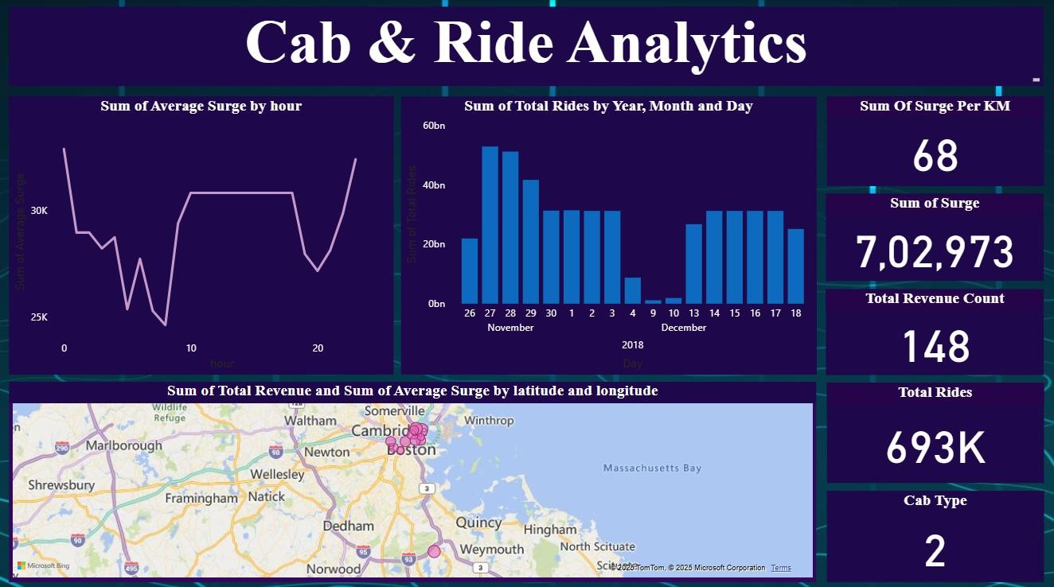

The Power BI dashboard presents key business metrics and interactive visuals for decisionmaking:
KPIs Displayed:
- Sum of Surge
- Sum of Surge Per KiloMeter
- Total Rides
- Total Revenue Count
- Cab Type Visuals:
- Sum of Average Surge by Hour (Line Chart)
- Sum of Rides by Year, Month & Day (Clustered Column Chart)
- Sum of Total Revenue & Sum of Average Surge by Latitude & Longitude (Map)

CONCLUSION & FUTURE SCOPE

Conclusion:
This project successfully demonstrates the application of machine learning for predicting cab fares based on historical rideshare data. The analysis identified distance, surge multiplier, and cab type as the most significant predictors influencing fare variability.
Among the models implemented, Random Forest Regressor achieved the highest performance with an R² score of 0.89, confirming its suitability for handling non-linear relationships and complex feature interactions.
The Exploratory Data Analysis (EDA) provided critical business insights, including surge pricing behavior during peak hours and fare differences across cab types. The integration of these findings into an interactive Power BI dashboard further enhances decision-making by enabling stakeholders to visualize key patterns and trends effectively.
Overall, this study demonstrates that leveraging predictive modeling combined with visual analytics can substantially improve pricing transparency for customers and optimize pricing strategies for service providers.

Future Scope:
- Integrate real-time traffic and weather data for dynamic fare prediction.
- Add demand-supply indicators and event-based data for better surge forecasting.
- Deploy the model as a web service or mobile application for real-time usage.
- Automate model retraining and monitoring pipelines for scalability.
- Explore advanced machine learning and deep learning techniques to enhance accuracy.

