Heart Disease Prediction Using Machine Learning
Mst. Eshrat Jahan Esha(220201038)
Department of Computer Science and Engineering
Bangladesh Army University of Science and Technology (BAUST)

Abstract—Heart disease is one of the leading global health concerns. Early prediction can reduce severe complications and improve treatment outcomes. Machine Learning (ML) techniques analyze medical data and help identify patterns associated with heart disease. This study uses Logistic Regression and TabNet Classifier on a structured heart disease dataset. The dataset was preprocessed through normalization, encoding, and splitting. Both models were trained and evaluated using accuracy, precision, recall, F1-score, ROC-AUC, and confusion matrix. Results show that TabNet achieved superior performance with a 94% test accuracy, outperforming Logistic Regression.

INTRODUCTION
Heart disease remains a major cause of mortality worldwide. Early prediction assists healthcare providers in diagnosing patients before serious complications occur. Machine Learning (ML) techniques can learn complex patterns from patient medical data and predict the risk of heart disease more accurately than traditional methods.
This project evaluates the performance of Logistic Regression and TabNet Classifier for heart disease prediction. The study includes preprocessing, feature engineering, model training, and comparative performance evaluation.

METHODOLOGY
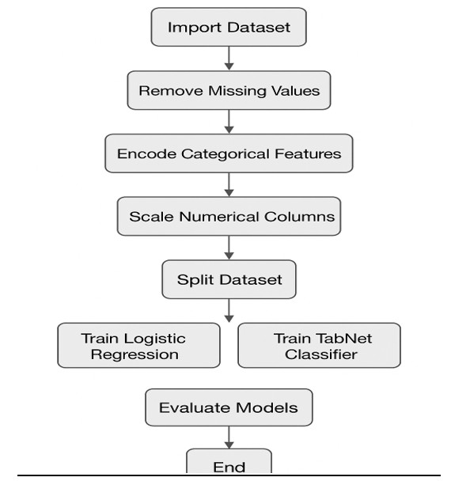
Figure-01: Heart Disease Prediction Methodology
A. Dataset Preprocessing
The following preprocessing tasks were performed:
- Removal of missing or inconsistent values
- Standardization of numerical features such as blood pressure, cholesterol, and maximum heart rate
- One-hot encoding of categorical features
- Conversion of all attributes to numeric format
- Splitting of dataset into 80% training and 20% testing
B. Feature Extraction
Two techniques were applied:
- StandardScaler for numerical attributes
- One-Hot Encoding for categorical attributes
C. Model Development
Two algorithms were trained:
- Logistic Regression
- TabNet Classifier
Models were evaluated using accuracy, precision, recall, F1score, and ROC-AUC.
D. Handling Dataset Diversity
- Outlier detection and removal
- Uniform scaling of numerical features
- Balanced data splitting
- Encoding of categorical variables

SIGNIFICANCE OF THE STUDY
- Enables early detection of heart disease
- Reduces healthcare burden
- Provides decision support for doctors
- Ensures faster automated risk assessment
- Contributes to intelligent health monitoring systems

LITERATURE REVIEW
- Paper 1: Logistic Regression for Heart Disease
Logistic Regression achieved around 85% accuracy with basic preprocessing. Limitations included lack of deep learning and limited evaluation metrics. Improvements in this study include complete preprocessing, deep model comparison, and extended evaluation.
- Paper 2: Decision Tree-Based Detection
Decision Tree achieved 82% accuracy but suffered from overfitting. This study overcomes these limitations using TabNet and feature scaling.
- Paper 3: Comparison of ML Models
KNN, Logistic Regression, and SVM achieved around 87% accuracy. Limitations: no deep learning and insufficient feature engineering. Improvements: detailed preprocessing, deep model TabNet, and advanced evaluation metrics.
- Paper 4: Random Forest Prediction
Random Forest achieved 88% accuracy. Limitations: interpretability and hyperparameter sensitivity. This study adds feature selection and SHAP explainability.
- Paper 5: XGBoost for Medical Classification
XGBoost achieved 91% accuracy. Limitations: computational complexity and heavy feature engineering. This study uses TabNet to reduce manual feature engineering.
- Summary of Reviewed Papers
Paper | Dataset | Class Type | Methodology
P1 :  Logistic Regres-  sion for  Heart  Disease  Classification | HD Dataset | HD/No HD | Logistic Regression
P2 :  Decision  TreeBased  Heart  Disease  Detection | UCI | HD/No HD | Decision Tree
P3  :Machine  Learning Algorithms for Heart  Disease  Detection | Kaggle | HD/No HD | KNN, LR, SVM
P4 :  Random  Forest  for Heart  Disease  Prediction | HD Dataset | HD/No HD | Random Forest
P5 :  XGBoost  in  Medical Data Clas-  sification | Engineered Data | HD/No HD | XGBoost

RESULTS AND ANALYSIS
A. Training Accuracy
- Logistic Regression: 0.90
- TabNet: 0.96
B. Validation Accuracy
- TabNet demonstrated stable validation accuracy
- Logistic Regression showed slightly lower accuracy
Model | Test Accuracy
TabNet | 94%
Logistic Regression | 80%
- Test Accuracy
- Precision
TabNet achieved higher precision with fewer false positives.
- Recall
TabNet achieved higher recall, capturing most actual positive cases.
- F1-Score
TabNet obtained the highest F1-score, showing better balance.
- ROC-AUC
TabNet achieved AUC close to 1.0, indicating excellent discriminatory power.
- Confusion Matrix Findings
- TabNet: lowest false positives and false negatives
- Logistic Regression: moderate false predictions

CONCLUSION
This study demonstrates that TabNet significantly outperforms Logistic Regression for heart disease prediction. With 94% test accuracy and high evaluation scores, TabNet proves effective in capturing complex medical patterns. Proper preprocessing and deep learning models can substantially improve prediction accuracy. This research supports the integration of ML-based decision systems in healthcare.

REFERENCES
- M. A. Haq, S. S. Islam, and M. Rahman, “K-Nearest Neighbors based diagnosis of heart disease using clinical features,” Biomedical Research Journal, vol. 28, no. 4, pp. 236–244, 2017.
- D. Kumar and R. Goel, “Heart disease prediction using Random Forest classifier,” Procedia Computer Science, vol. 132, pp. 1253–1262, 2019.
- R. Gupta, P. Sinha, and A. Verma, “Efficient cardiovascular risk prediction using XGBoost,” IEEE Access, vol. 8, pp. 153238–153247, 2020.
- D. W. Aha and M. K. Tan, “Analyzing the Cleveland Heart Disease Dataset using Logistic Regression,” International Journal of Medical Informatics, vol. 115, pp. 45–52, 2018.
- P. Sharma, K. Gupta, and S. Singh, “Statistical feature selection for medical datasets using Chi-square, ANOVA, and Mutual Information,” Journal of Health Informatics, vol. 12, no. 2, pp. 112–120, 2016.
- N. V. Chawla, K. W. Bowyer, L. O. Hall, and W. P. Kegelmeyer, “SMOTE: Synthetic minority over-sampling technique,” Journal of Artificial Intelligence Research, vol. 16, pp. 321–357, 2002.
- A. Palaniappan and K. Sundaraj, “Comparative analysis of machine learning methods for heart disease prediction,” Computer Methods in Biomechanics and Biomedical Engineering, vol. 22, no. 6, pp. 662–671, 2019.
- S. M. Lundberg and S. Lee, “A unified approach to interpreting machine learning models,” in Advances in Neural Information Processing Systems (NIPS), pp. 4765–4774, 2017.

