
Project documentation
Final report

SOFTWARE ENGINEERING PROJECT

SUBMITTED TO:

PROF. ANZAR AHMAD

SUBMITTED BY:

NIHAL E ADAN BITF24A017
EHTISHAM ADEEL BITF24A041
AYESHA SALEEM BITF24A001
FATIMA HAMID BITF24A045

TITLE :
ACADEMIC TO DO LIST

TABLE OF CONTENT

- PROJECT PROPOSAL
- REQUIREMENTS
- USE CASE DOCUMENTATION
- DOMAIN MODEL
- ACTIVITY DIAGRAM
- PROJECT REPORT

Project Proposal

Problem Statement
In today’s fast-paced academic and professional environment, individuals struggle to manage daily tasks, deadlines, and priorities efficiently. Traditional paper-based lists or unstructured notes often lead to missed deadlines, poor time management, and reduced productivity. There is a need for a centralized, easy-to-use digital solution that helps users organize, track, and manage their tasks effectively on a daily basis.

Unique Selling Point (USP)
The Smart Academic To-Do List App uniquely focuses on student-centered productivity by combining academic task organization, priority-based planning, and deadline-driven reminders in one simple system. Unlike generic to-do apps, it separates academic and personal tasks, provides daily productivity summaries, and is designed specifically for ease of use and clear task tracking, making it ideal for students managing multiple deadlines with minimal complexity.
Solution Description
Our team has decided to develop a multi-user To-Do List software application. This proposal outlines the plan for implementing a comprehensive task management solution that helps users organize their activities, track progress, and improve productivity. The system will support task creation, prioritization, scheduling, reminders, and progress tracking through a simple and user-friendly interface.

Brief Description of Basic Modules of Our Solution

Task Management
- Create, update, and delete tasks
- Assign priority levels (High, Medium, Low)
- Set due dates and deadlines
- Mark tasks as completed or pending

Daily Activity Management
- Display daily task list
- Track completed and pending tasks
- Overview of daily productivity

Reminder & Notification System
- Alerts for upcoming deadlines
- Notifications for overdue tasks
- Optional recurring reminders

User Management
- User registration and login
- Secure authentication
- Personalized task lists for each user

Category & Organization
- Categorize tasks (e.g., Study, Work, Personal)
- Filter and sort tasks by date, priority, or status

Progress Tracking
- View task completion statistics
- Daily and weekly task summaries

Software Architecture
Web Application:
- Multi-user system
- Centralized database for task storage
- Secure access and data consistency

Software Requirements Specification (SRS)
Smart Academic To‑Do List Application

1. Introduction
- Purpose
The purpose of this document is to define the functional and non-functional requirements for the Smart Academic To‑Do List Application. The system will help users, especially students, manage academic and personal tasks through scheduling, reminders, and productivity tracking.

- Scope
The system allows users to create, update, organize, and track tasks using a user‑friendly web interface. It supports multiple users, reminders, progress summaries, and secure authentication.

- Intended Users
Students
Teachers and academic professionals
Individuals managing daily tasks

- System Overview
The system will be implemented as a multi‑user web application with a centralized database for task storage.

2. Functional Requirements
- User Management
• The system shall allow users to register using email and password.
• The system shall allow users to log in and log out securely.
• The system shall maintain separate task lists for each user.
• The system shall allow users to update their profile information.

- Task Management
• The system shall allow users to create new tasks.
• The system shall allow users to edit existing tasks.
• The system shall allow users to delete tasks.
• The system shall allow users to set due dates and deadlines.
• The system shall allow users to mark tasks as completed or pending.

- Category & Organization
• The system shall allow users to sort tasks based on priority or due date.

- Daily Activity Management
• The system shall display tasks scheduled for the current day.
• The system shall show completed and pending tasks for the day.

- Reminder & Notification System
• The system shall send alerts for upcoming deadlines.
• The system shall notify users of overdue tasks.

3. Non‑Functional Requirements
- Performance Requirements
• The system shall respond to user actions within two seconds.
• The system shall support at least 100 concurrent users.

- Security Requirements
• The system shall encrypt user passwords.
• The system shall implement secure authentication and session handling.
• The system shall restrict unauthorized access to user data.

- Usability Requirements
• The interface shall be simple and intuitive.
• The system shall be easy to use for non‑technical users.
• The system shall present clear task organization and navigation.

- Reliability & Availability
• The system shall ensure data consistency across users.
• The system shall recover from unexpected failures without data loss.

- Maintainability
• The system shall follow modular and well‑documented code structure.

- Portability
• The system shall run on major web browsers and mobile devices.

4. System Constraints
• Internet connection required
• Web‑based implementation
• Centralized database storage

USE CASE, DOMAIN MODEL
AND ACTIVITY DIAGRAM

1. User View Diagram (Proactive Use Cases)
Diagram Overview:
The User View Diagram presents the system from the user’s point of view, highlighting all the actions a user (student, teacher, or individual) can actively start in the Smart Academic To-Do List Application. It focuses only on what the user does, without describing how the system processes those actions.

Key Components
A. Primary Actor:
User (Student/Teacher/Individual)
- Shown as a standard UML stick figure
- Placed on the left side of the diagram
- Represents the person who starts all interactions
B. System Boundary:
- Labeled: “Smart Academic To-Do List Application”
- All use cases are inside a rectangular boundary
- Marks the limits of the system being modeled

C. User-Initiated Use Cases (12 Proactive Actions)
Account Operations:
- Register – User creates a new account using email and password
- Login – User signs in to access the system
- Logout – User ends the current session
- Update Profile – User edits personal information
Task Management:
5. Create Task – User adds a new academic or personal task
6. Edit Task – User changes details of an existing task
7. Delete Task – User removes a task
8. Mark Complete – User marks a task as finished
View and Organization:
9. View Daily Tasks – User views tasks for the current day
10. View Statistics – User checks progress charts and analytics
11. Sort/Filter Tasks – User organizes tasks by chosen criteria
12. Categorize Task – User assigns tasks to categories

Connections
- Solid lines link the User actor to each of the 12 use cases
- Each line shows a direct, user-initiated action
- No lines represent system reactions or internal processing

Diagram Characteristics
- Success-Focused: Shows only normal, successful interactions
- High-Level: No technical or implementation details
- User-Centered: Displays only what users can do
- Simple: Clear and easy for non-technical viewers

Purpose and Usage
- Requirements Checking: Confirms all user needs are included
- User Training: Helps users learn system features
- Development Planning: Supports early development priorities
- Client Communication: Easy format for client review

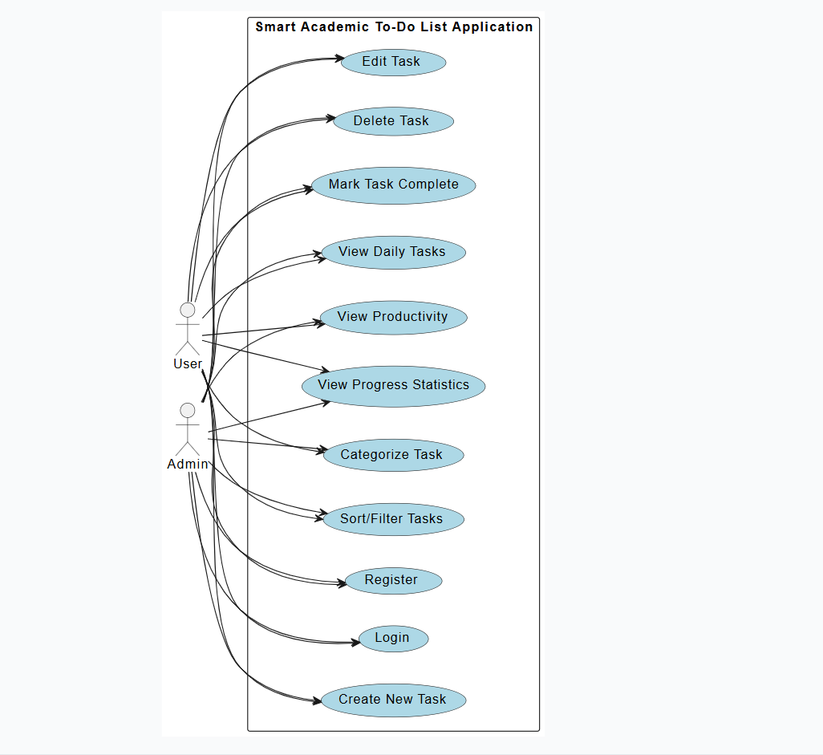

2. System View Diagram (Reactive Use Cases)
Diagram Overview:
The System View Diagram shows the application from the system’s perspective. It highlights all automated, reactive processes inside the Smart Academic To-Do List Application. This diagram focuses only on how the system responds to user actions and manages itself, without displaying the user who triggered those actions.

Key Components
A. System Actor:
System (Background Process)
- Represented by a labeled stick figure
- Placed on the left side of the diagram
- Acts as the active entity, running automated processes
B. System Boundary:
- Labeled: “Smart Academic To-Do List Application”
- Uses the same boundary as the User View Diagram but with different content
- Contains only internal system processes

C. System-Initiated Use Cases (Reactive Processes)
Data Management:
- Initiate Process – System starts user sessions and initializes data
- Validate Input – System checks data for accuracy and security
- Store Data – System saves user and task information to the database
- Update Records – System updates existing data
Task Processing:
5. Update Status – System updates task states and timelines
6. Clean Data – System removes outdated or unused data
7. Organize Data – System structures data for efficient access
8. Backup Data – System creates backups for recovery
Analytics and Communication:
9. Generate Reports – System produces statistics and analytics
10. Send Alerts – System sends reminders and notifications
11. Generate Display – System formats data for the user interface
12. Manage Session – System controls login and session state

Connections
- Solid lines connect the System actor to each reactive use case
- Each line represents an automated system activity
- No user interactions appear in this diagram

Diagram Characteristics
- Internal Focus: Shows behind-the-scenes processes
- Fully Automated: All actions occur without user involvement
- System-Oriented: Emphasizes technical and backend behavior
- Conceptual: Helps developers understand system structure

Purpose and Usage
- Architecture Design: Supports system structure planning
- Database Design: Guides database schema creation
- Background Processing: Helps design automated services
- Technical Documentation: Provides clarity for developers

Key Idea
“System as a Reactive Entity” – The system automatically responds to user actions through predefined processes. This view is essential for building dependable, efficient, and maintainable backend systems that work with minimal human involvement.
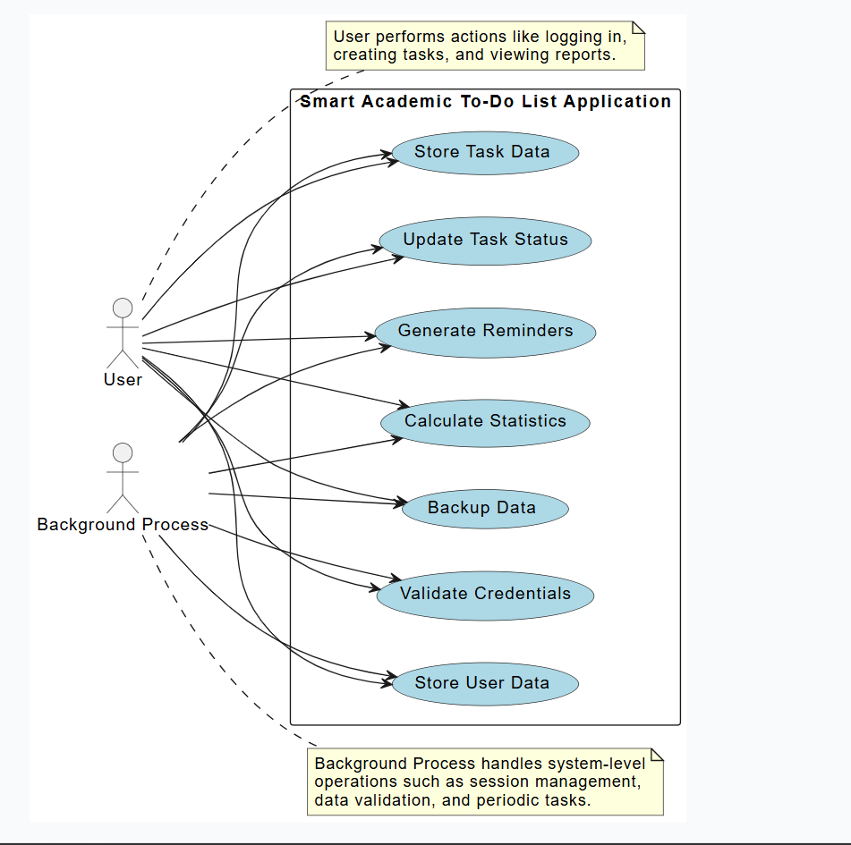

Use Case Combined Diagram :
The Combined Use Case Diagram merges user-initiated actions and system-automated responses into one system-level view.
The diagram is organized with the system name at the top, two parallel columns inside the system boundary, and the User actor placed between them. The left column lists proactive user actions, while the right column lists reactive system processes. Each user action on the left implicitly triggers the corresponding system response on the right (e.g., Register → Initiate Process, Create Task → Store Data).
Only the User actor connects to the left column, showing that the user initiates actions. The system does not initiate; it only responds automatically through code. There is no human involvement on the system side.
This is a high-level, system-level diagram:
- No technical or implementation details
- No error or alternative flows
- Only normal, successful interactions
- Focuses on what happens, not how
Its purpose is to serve as the main starting point for requirements analysis. It helps communicate clearly with both clients and developers, defines project scope, and provides the foundation for more detailed analysis. Later stages expand this into analysis-level use case diagrams that include detailed steps, alternatives, and failure scenarios.

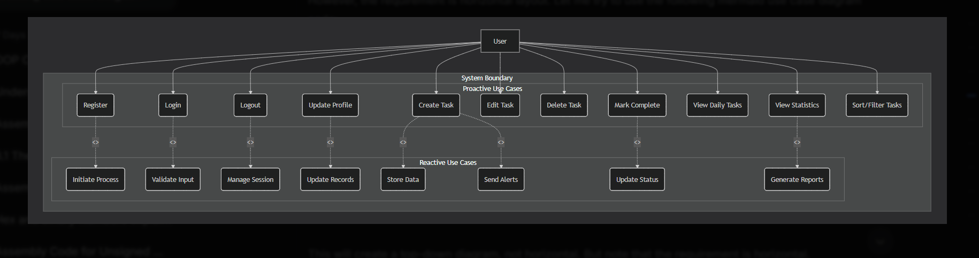

2. DOMAIN MODEL DIAGRAM

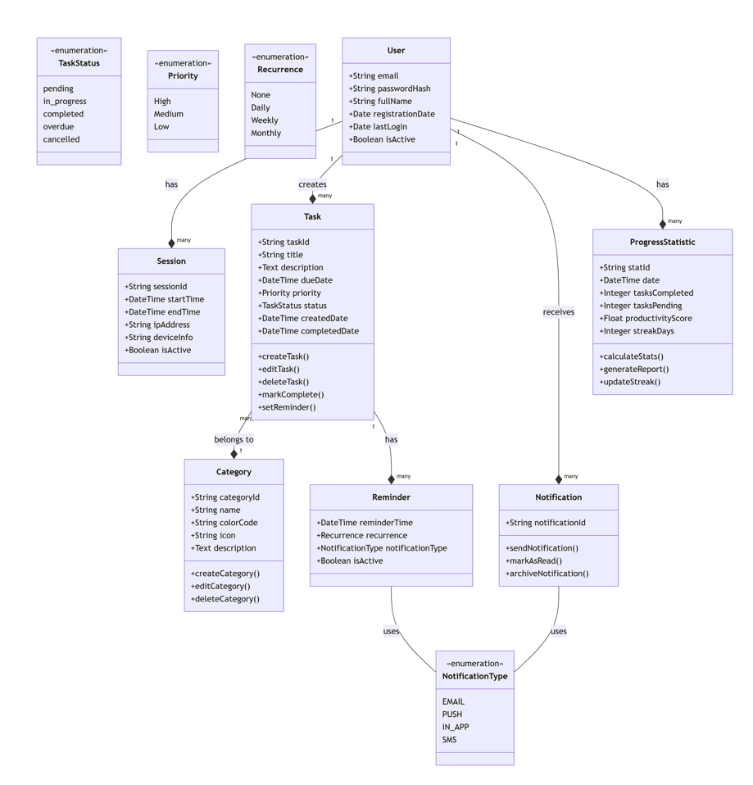

CORE ENTITIES
User
- Primary Actor: Authenticated person using the system
- Attributes: email, passwordHash, fullName, registrationDate, lastLogin, isActive
- Role: Owns and manages all other entities
Task
- Central Business Object: Academic or personal work item
- Attributes: title, description, dueDate, priority, status, createdDate, completedDate, category
- Lifecycle States: pending, in_progress, completed, overdue, cancelled
SUPPORTING ENTITIES
Category
- Purpose: Organizes tasks into logical groups
- Attributes: name, colorCode, icon, description
- Operations: createCategory(), editCategory(), deleteCategory()
Reminder
- Purpose: Notifies users about upcoming deadlines
- Attributes: reminderTime, recurrence, notificationType, isActive
- Notification Channels: EMAIL, PUSH, IN_APP, SMS
SESSION MANAGEMENT
Session
- Purpose: Tracks user login sessions
- Attributes: startTime, endTime, ipAddress, deviceInfo, isActive
- Security: Manages authenticated access periods
ANALYTICS & TRACKING
Progress Statistic
- Purpose: Tracks user productivity metrics
- Attributes: date, tasksCompleted, tasksPending, productivityScore, streakDays
- Operations: calculateStats(), generateReport(), updateStreak()
ENTITY RELATIONSHIPS
Primary Relationships
- User → Task (1:N)
  - Each user can create multiple tasks
  - Tasks are owned and managed by individual users
- Task → Category (N:1)
  - Multiple tasks can belong to one category
  - Categories help organize task grouping
- Task → Reminder (1:N)
  - Each task can have multiple reminders
  - Reminders ensure timely task completion
Secondary Relationships
- User → Session (1:N)
  - Users can have multiple login sessions
  - Sessions track active usage periods
- User → ProgressStatistic (1:N)
  - Users have multiple statistics entries over time
  - Statistics track productivity patterns
KEY BUSINESS RULES
Data Integrity Rules
- Every Task must have exactly one owning User
- A User must have a valid email and passwordHash
- Tasks can exist without a Category (optional relationship)
- Reminders are dependent on Tasks (cannot exist independently)
- Sessions automatically expire after inactivity
Workflow Rules
- Task Creation Flow: User → creates → Task → (optionally) assigns → Category
- Notification Flow: Task → triggers → Reminder → sends → Notification
- Progress Tracking: System → automatically → updates → ProgressStatistic
- Session Management: User → logs in → creates → Session
ENTITY RESPONSIBILITIES
User Responsibilities
- Authentication and authorization
- Task creation and management
- Profile maintenance
- Session initiation
Task Responsibilities
- Capturing work requirements
- Tracking completion status
- Managing deadlines
- Triggering reminders
System Responsibilities
- Session management
- Notification delivery
- Progress analytics
- Data persistence
This domain model provides a comprehensive view of the system's structure, clearly showing how all entities relate to each other while maintaining separation of concerns.

PROJECT REPORT

1. PROJECT OVERVIEW

1.1 Introduction
The Smart Academic To-Do List Application is a digital productivity system created for academic and professional use. It helps users organize tasks, manage deadlines, and handle responsibilities in a structured and efficient manner.

1.2 System Type
Category: Web-based Task Management System
Users: Students, teachers, professionals, and individuals
Platform: Responsive web application
Deployment: Cloud-based system with centralized database

1.3 Core Purpose
The main objective is to provide a deadline-oriented, well-organized platform that helps users manage academic and personal tasks through smart tracking and reminder features.

2. PROBLEM ANALYSIS (BEFORE THIS SOFTWARE)

2.1 Existing Issues in Academic Task Management

2.1.1 Limitations of Traditional Methods
Paper-Based Systems:
- Easily lost or damaged
- No automatic reminders
- Hard to update or reorganize
- No way to track progress
Basic Digital Notes:
- No deadline management
- No priority settings
- No categorization
- No progress analysis

2.1.2 Limitations of Current Digital Tools
Generic To-Do Apps:
- Not built for academic needs
- No exam or assignment tracking
- No academic progress features
Calendar Applications:
- Focus on events, not tasks
- No task completion tracking
- Poor organization tools
- No productivity reports

2.1.3 User Experience Problems
Disorganization:
- Use of multiple apps
- No single platform
- Scattered information
- Manual tracking required
Missed Deadlines:
- No reminder system
- No priority alerts
- Late awareness of deadlines
- Increased stress
Lack of Insight:
- No performance tracking
- No productivity data
- No trend analysis
- No improvement guidance

3. SOFTWARE FUNCTIONALITIES

3.1 Core Features

3.1.1 User Account Management
- User Registration with email verification
- Secure Login system
- Profile editing options
- Safe session handling

3.1.2 Task Management
- Create tasks with title, description, and category
- Edit tasks
- Delete tasks
- Track status: pending, in-progress, completed
- Set deadlines

3.1.3 Organization Tools
- Categorize tasks (Study, Assignment, Exam, Personal)
- Set priority levels (High, Medium, Low)
- Sort by date, priority, or category
- Filter tasks
- Search functionality

3.1.4 Daily Features
- View today’s tasks
- Quick task entry
- Daily progress summary
- Visual task status indicators

3.1.5 Reminder System
- Automatic deadline notifications
- Alerts for overdue tasks
- Custom reminder settings
- Email and in-app alerts

3.1.6 Progress Analytics
- Completion tracking
- Productivity measurement
- Performance trends
- Weekly and monthly reports

3.2 System Capabilities

3.2.1 Data Management
- Encrypted data storage
- Regular backups
- Data accuracy and consistency
- Fast data access

3.2.2 System Operations
- Automated background tasks
- Error recovery system
- Performance optimization
- Strong security controls

4. TARGET USERS

4.1 Primary Users

4.1.1 Students
- School students: homework, projects, exams
- College students: assignments, research, tests
- Postgraduates: thesis, research, publications

4.1.2 Academic Professionals
- Teachers: lessons, grading, meetings
- Researchers: experiments, deadlines
- Administrators: schedules, reports

4.1.3 General Users
- Individuals managing personal tasks
- Professionals organizing work
- Anyone needing structured task control

5. SYSTEM CHARACTERISTICS

5.1 Unique Features

5.1.1 Academic Orientation
- Exam preparation tools
- Assignment tracking
- Grade-related features (future scope)
- Academic calendar support

5.1.2 Smart Features
- Intelligent reminders
- Automatic prioritization
- Productivity suggestions
- Learning user behavior

6. BENEFITS AND IMPACT

6.1 User Benefits

6.1.1 Academic Benefits
- Improved time management
- Reduced stress
- Better grades
- Higher productivity

6.1.2 Practical Benefits
- One platform for all tasks
- Automatic tracking

6.2 Educational Impact

6.2.1 Student Growth
- Higher task completion
- Better exam preparation
- Improved performance
- Development of organization skills

6.2.2 Institutional Benefits
- Standardized tools
- Performance analysis options
- Fewer tools required
- Digital modernization

7. IMPLEMENTATION STRATEGY

7.1 Development Method
- Step-by-step development
- User-focused design
- Agile process
- Continuous testing

7.2 Rollout Phases
Phase 1: Basic Setup
- Task management
- Login system
- Basic organization
Phase 2: Improvements
- Advanced categories
- Reminders
- Simple analytics
Phase 3: Advanced Features
- Productivity reports
- Mobile optimization
- Detailed analytics

8. CONCLUSION

8.1 Overview
The Smart Academic To-Do List Application solves major academic task management problems by offering a single, organized system for managing tasks, deadlines, and responsibilities.

8.2 Value
- Students: Better performance and organization
- Teachers: Easier work management
- Institutions: Strong student support system
- Individuals: Improved productivity

8.3 Future Scope
The system can expand into team collaboration, institutional integration, mobile apps, and advanced analytics, making it suitable for long-term academic and professional use.

3. ACTIVITY DIAGRAM

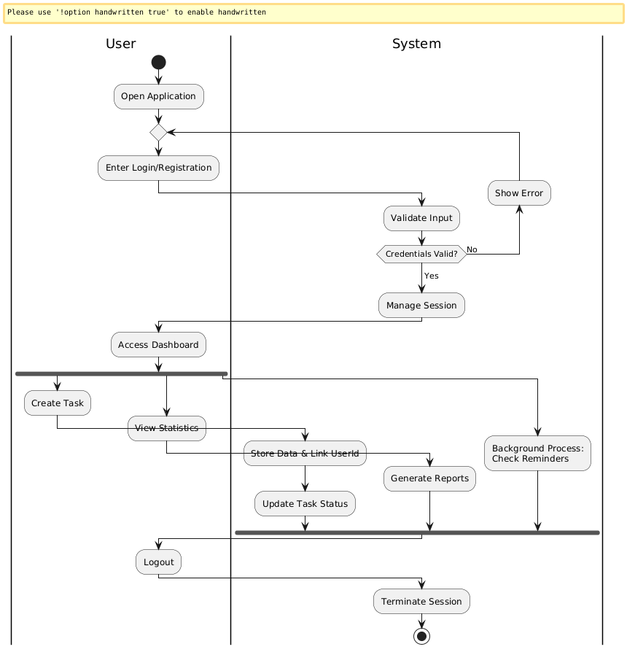

Authentication Phase
- The user opens the application and enters login or registration details.
- The system validates the input.
- If credentials are invalid, an error is shown; if valid, the session is created and the user is redirected to the dashboard.

User Interaction Phase
- After login, the user accesses the dashboard.
- The user can create tasks or view statistics.
- Task data is stored and linked to the logged-in user, and task status is updated.

Background Processing
- While the user is active, the system checks reminders in the background.
- The system also generates reports without interrupting the user.

Termination Phase
- The process ends when the user logs out.
- The system terminates the session securely.

