Question1:

list = ["saturday","sunday","monday","tuesday"]

print("The length of the list is", len(list))

out put

The length of the list is 4

Question2:

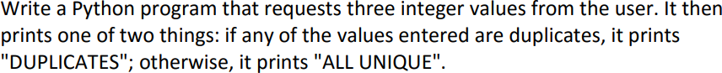

a = input("First number : ")

b = input("Second number : ")

c = input("Third number : ")

if a == b or a == c or b == c:

print "DUPLICATES"

else:

print "ALL UNIQUE"

Question3:



x = input("First number : ")

y = input("Second number : ")

z = input("Third number : ")

if x < y and x < z:

min = x

elif y < x and y< z:

min = y

else:

min = z

print "The smallest is ", mini

Question4:

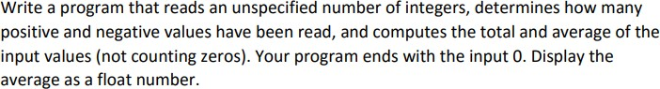

﻿count_p = 0

count_n = 0

total = 0

while True:

   number = int(input("Enter an integer, the input ends if it is 0: "))

   if number == 0:

break

   else:

       total += number

       if number > 0:

           count_p += 1

       elif number < 0:

           count_n += 1

print("The number of positives is: " + str(count_p))

print("The number of negatives is: " + str(count_n))

print("The total is: " + str(total))

print("The average is: " + str(total / (count_p + count_n)))