**Linked List**

* This is a basic structure of the linked list as per the internal working.

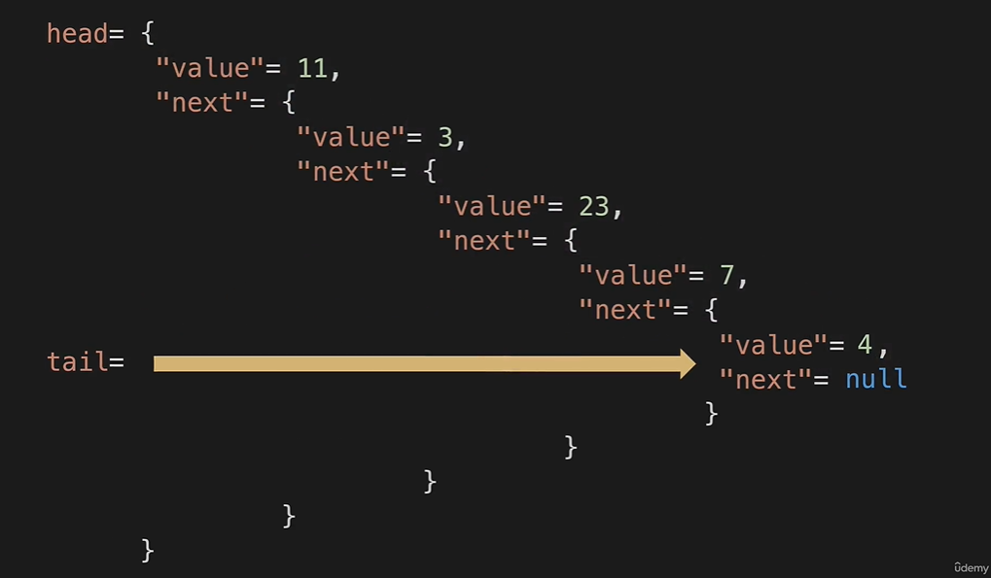

* Big O for LinkedList and array List

