Library Attendance Management System using PHP and MySQL

This simple website was made for my DBMS college project. So feel free to use and modify it if you want.

🏗️Built with

HTML, CSS, JavaScript, Bootstrap & jQuery used for front-end.  
PHP8 & MySQL used for backend.  
Template used for ADMIN dashboard :- <https://github.com/startbootstrap/startbootstrap-sb-admin-2>

Preview

[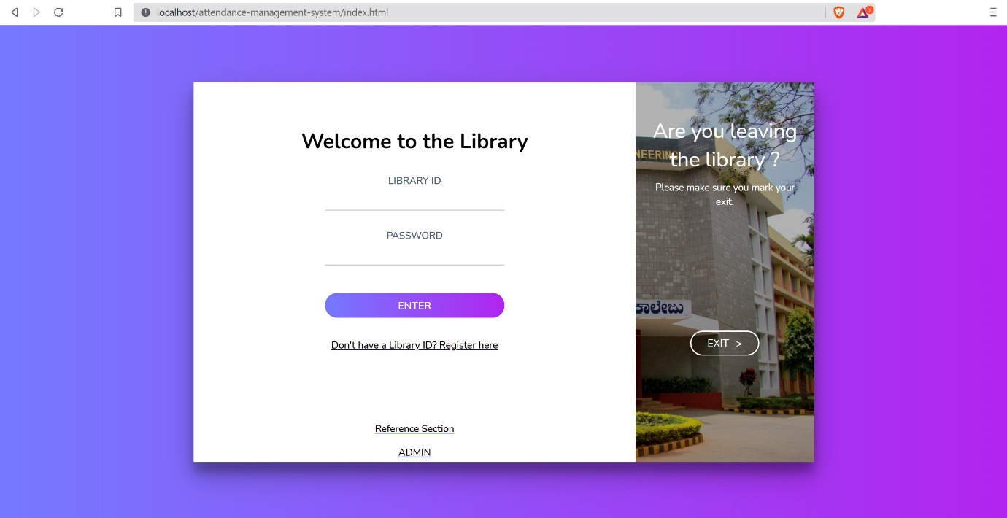](https://user-images.githubusercontent.com/54986806/123215016-88a44b80-d4e5-11eb-9da5-7bed769167ed.jpg)[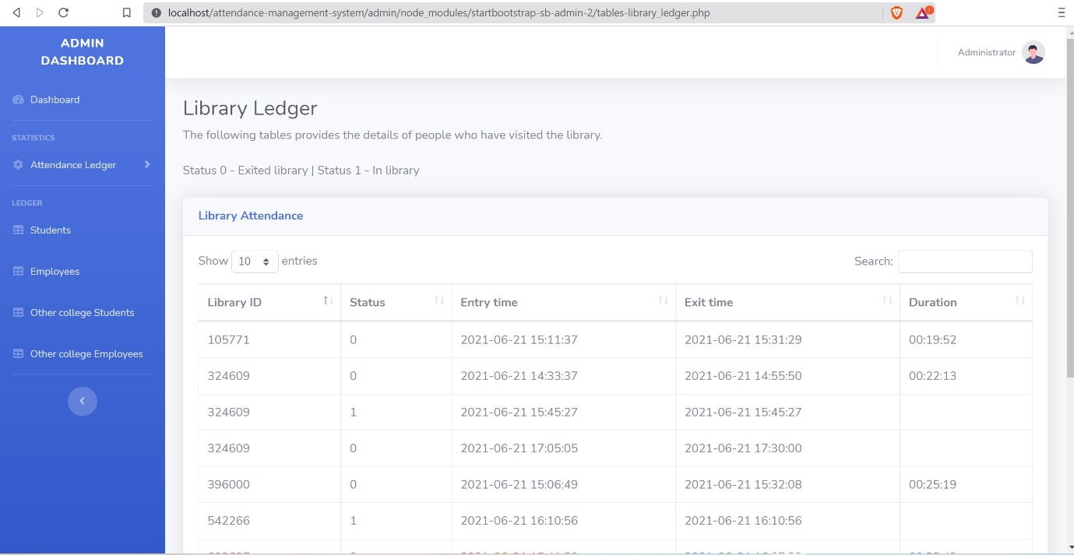](https://user-images.githubusercontent.com/54986806/123215344-f781a480-d4e5-11eb-94ee-b04f9cecda0a.jpg)

Steps to run the project (for Windows)

Step 1 : Download XAMPP for Windows - <https://www.apachefriends.org/index.html> (While installation make sure you check APACHE option to install)  
Step 2 : Download MySQL Community Server - <https://dev.mysql.com/downloads/mysql/>  
Step 3 : Setup a MySQL server with password mysql123, and setup a MySQL localhost Connection.  
Step 4 : Take the attendance-management-system.sql file and execute the file in MySQL Server instance.  
Step 5: Clone/Download the project files and place attendance-management-system (main folder) in C:\xampp\htdocs  
Step 6: Open XAMPP control panel and start the APACHE Server.  
Step 7: Open up the browser and type <http://localhost/Library-Management-System/index.html> . The project is up and running now, you can choose what you want to do further.  
Note (for admin login):- Only the employee with designation as "Librarian" can login to the admin section with his faculty ID and password. Hence register for librarian through register JSSSTU Faculty option.

✍️ Author

B Sathvik Shenoy (<https://github.com/Sathvik-Shenoy>)