Github link:- https://github.com/nihalodedra/JAVA_SEM3
Problem8.1 | Guarded calculator: read two numbers and an operator; throw a custom  DivideByZeroException and catch invalid-number input separately, printing a clear  message each time; loop until a valid calculation succeeds and use finally to log each  attempt.
Code: | import java.util.Scanner;  public class calculator{  public static double calculation(double num1,double num2,char num) throws DivideByZeroException,invalidnumber  {  if(num == '+') return num1 + num2;  if(num == '-') return num1 - num2;  if(num == '*') return num1*num2;  if(num == '/')  {  if(num2 == 0)  {  throw new DivideByZeroException("Are you mentaly ill?");  }  return num1/num2;  }  throw new invalidnumber("Error:" + num + "is an invalid operator!");  }  }  class DivideByZeroException extends Exception  {  public DivideByZeroException(String msg)  {  super(msg);  }  }  class invalidnumber extends Exception  {  public invalidnumber(String msg)  {  super(msg);  }  }  class Main  {  public static void main(String[] args)  {  System.out.println("25AIML039");  Scanner sc = new Scanner(System.in);  boolean bb = false;  int count = 0;  while(!bb)  {  count++;  try {  System.out.println("-------Attemp:" + count + "-------");  System.out.println("Enter number 1: ");  double num1 = sc.nextDouble();  System.out.println("Enter operator (+, -, *, /): ");  char operator = sc.next().charAt(0);  System.out.println("Enter number 2: ");  double num2 = sc.nextDouble();  double result = calculator.calculation(num1, num2, operator);  System.out.println("Result: " + result);  bb = true;  }  catch (DivideByZeroException e)  {  System.out.println(e.getMessage() + " Please try again.");  }  catch (invalidnumber e)  {  System.out.println(e.getMessage() + " Please try again.");  }  catch (Exception e)  {  System.out.println("Invalid input. Please enter valid numbers.");  sc.nextLine();  }  }  sc.close();  }  }
Output: | 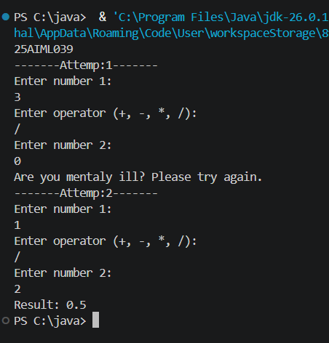

Problem8.2 | Stock issue: a Warehouse where issue(item, qty) throws a custom checked  OutOfStockException carrying the shortfall, and InvalidQuantityException for qty ≤ 0.  Process a list of requests, catching and reporting each failure without stopping the run.
Code: | import java.util.Scanner;  public class Warehouse {  static class InvalidQuantityException extends Exception {  public InvalidQuantityException(String msg) { super(msg); }  }  static class OutOfStockException extends Exception {  public OutOfStockException(String msg) { super(msg); }  }  public static void main(String[] args) {  Scanner scanner = new Scanner(System.in);  int appleStock = 10;  System.out.println("Welcome to the Warehouse!");  System.out.println("Starting Apple Stock: " + appleStock);  while (true) {  System.out.println("\n--- Current Apple Stock: " + appleStock + " ---");  System.out.print("Enter amount of apples to buy (or 999 to exit): ");  int qty = scanner.nextInt();  if (qty == 999) {  break;  }  try {  if (qty <= 0) {  throw new InvalidQuantityException("Quantity must be greater than 0.");  }  if (qty > appleStock) {  int shortfall = qty - appleStock;  throw new OutOfStockException("Not enough apples! Shortfall: " + shortfall);  }  appleStock = appleStock - qty;  System.out.println("SUCCESS! You got your apples.");  } catch (InvalidQuantityException e) {  System.out.println("FAILED -> Error: " + e.getMessage());  } catch (OutOfStockException e) {  System.out.println("FAILED -> Error: " + e.getMessage());  }  }  System.out.println("Warehouse closed. Goodbye!");  scanner.close();  }  }
Output: | 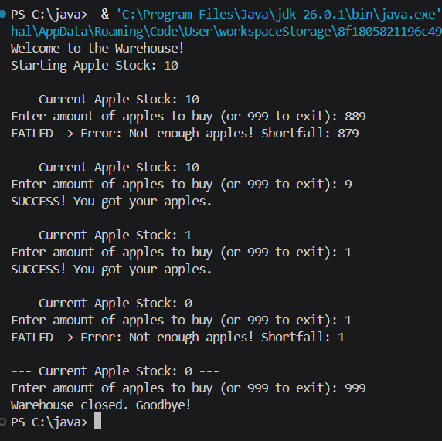

Problem8.3 | Create an AutoCloseable resource and use try-with-  resources to prove it always closes even when an exception is thrown inside the block and that the original error is the one reported. Decide what to model as the resource.
Code: | public class MyResource implements AutoCloseable {  public MyResource() {  System.out.println("25AIMML039");  System.out.println("Resource opened");  }  public void useResource() {  System.out.println("Using resource");  throw new RuntimeException("Error inside try block");  }  @Override  public void close() {  System.out.println("Resource closed");  }  public static void main(String[] args) {  try (MyResource r = new MyResource()) {  r.useResource();  } catch (Exception e) {  System.out.println("Original error: " + e.getMessage());  }  }  }
Output: | 