**Cluster Management**

Below are the steps needs to follow to configure cluster management.

We will be using 3 servers in this example, First is AD server which we will also be using as ISCSi server and 2 cluster node.  
LEXARDC01 – AD server (ISCSi Server)  
CLUS1 and CLUS2 as cluster node.

**Configure ISCSi Disk for both cluster node**.  
  
We need to create 2 ISCSi disk , one is for cluster role and other one is for Disk Quorum Witness.  
First we will create ISCSi disk for cluster role

1. 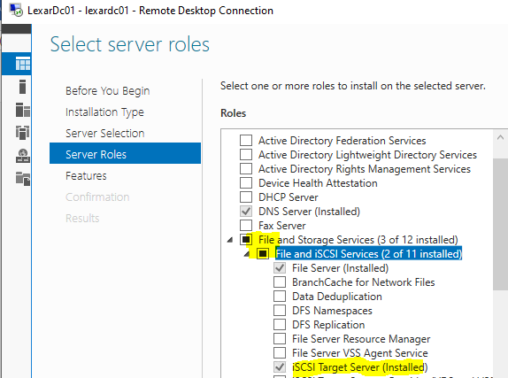To add ISCSi disk, first we need to install **ISCSi target server** role in LEXARDC01

1. 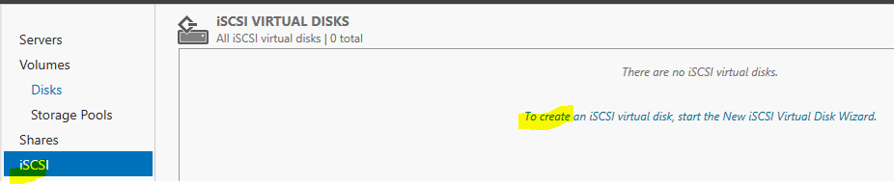Once ISCSi target server role is installed, we need to create new iSCSI Virtual Disk for shared storage. Click on “To Create…” to create new iSCSI Virtual Disk.
2. 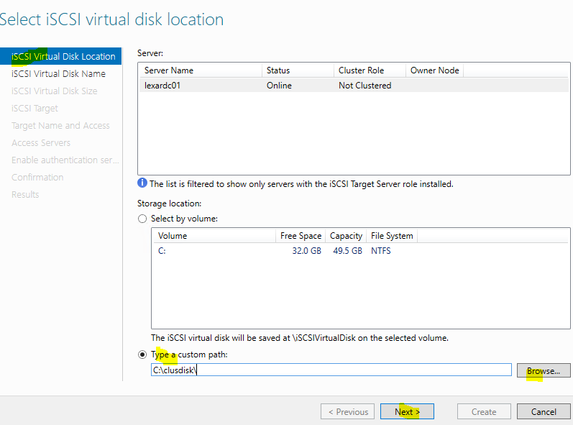Select the Disk Location, we can select the whole Volume as well as custom path, Here we are going with custom path, so browse the path , select the folder and click on next.
3. Give the Disk Name, it would create <diskname>.vhdx for shared storage.
4. Mention the size, here we are going with 3 GB and select “Dynamically Expanding”, so that it would grow as per the data written on it.
5. Then select the new target.
6. Now give any target name and click next.
7. 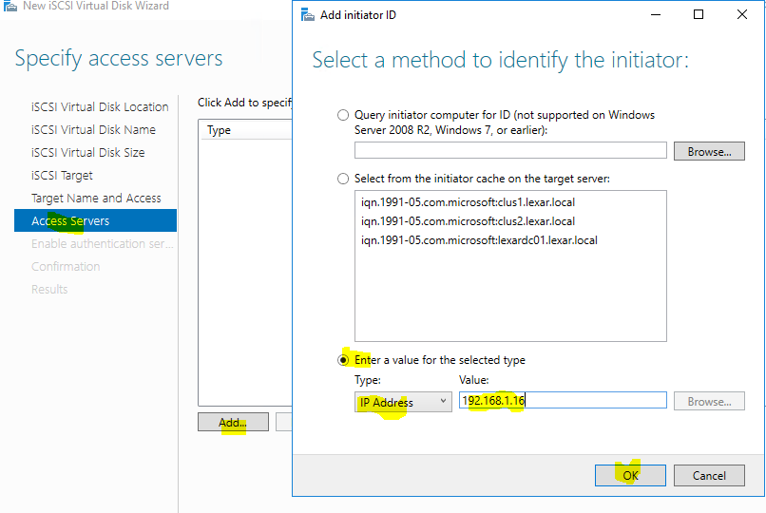In this section, we need to add the servers who will be accessing the ISCSi disk. here our servers would be both cluster node, i.e CLUS1 and CLUS2. To add the server, click on Add , select third option , select IP Address from the dropdown and enter the IP Address of CLUS1 and click on OK. Follow the same steps for adding CLUS2 as well.

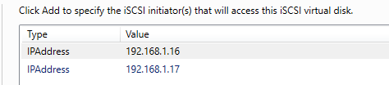Once both the server is added, it would look like this, click on next.

1. Skip the Enable Authentication section.
2. Click on Create on confirmation section.

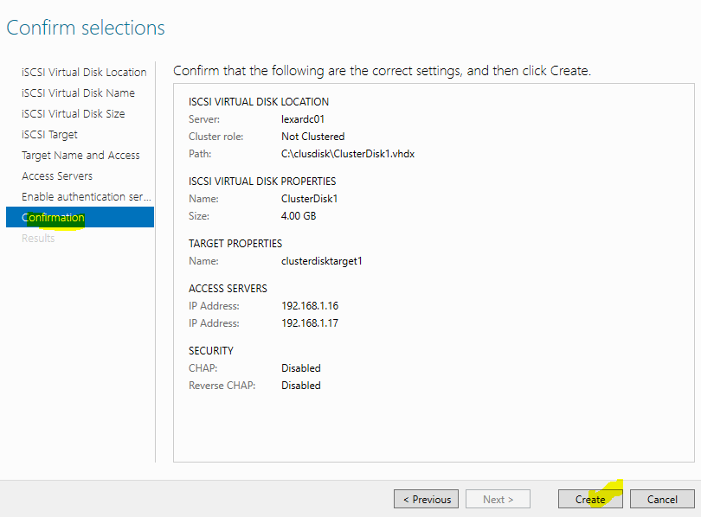

1. Check the progress on Results section.

Follow the same steps on LEXARDC01 to add another ISCSi disk of 500 MB for disk quorom witness. Once both ISCSi disk are created , it would look like this , Here green one is for Cluster role and blue one is for disk quorom witness  
  
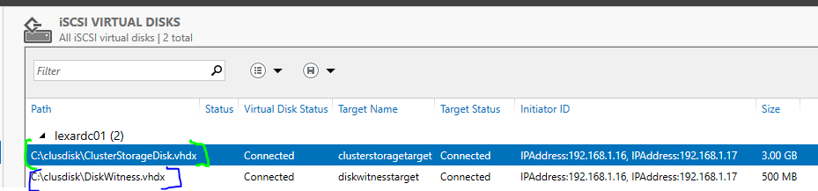

**Add the ISCSi disk on both the nodes**

1. Login to one of the node , here we will login into CLUS1.
2. 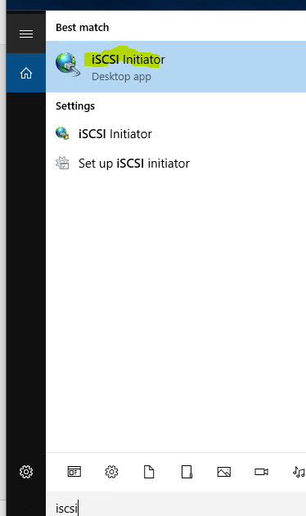Go to windows search and type “iSCI initiator”, this would connect both the iSCI disk to our server.  
   First time it would ask to permission to run “MS initiator” service , click on yes. After that it won’t ask anything.
3. 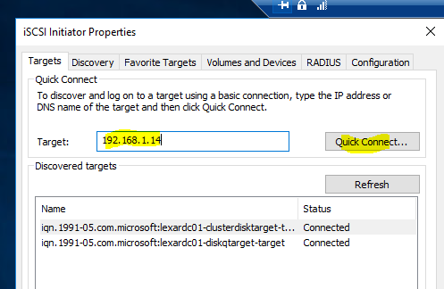Here in “target”, type IP address of iSCSI target server, here in our case it would IP address of LEXARDC01 and click on “Quick Connect”, it would open prompt , select every disk and click on connect to connect both disk.

1. Follow the same process on CLUS2 and make both the disk connect to server.

**Assign Disk**

1. 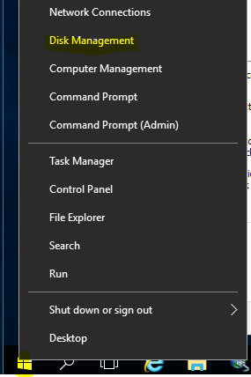Now open the Disk Management. Right click on Windows button and click on Disk Management.
2. As soon as disk Management open , it would load all the disk connect to server, we would observe that 2 disk would be on unknown state , right click on the disk , click on “Initialize Disk”  
     
   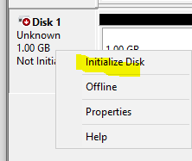
3. 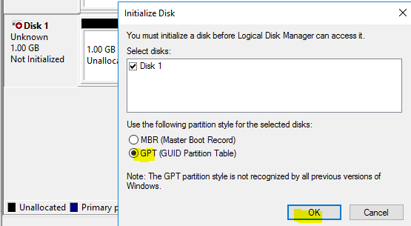Select GPT and click on OK.
4. Now disk has become online and unallocated.  
     
   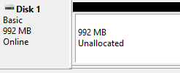
5. 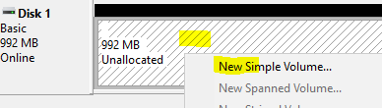Now right click on empty white area and click select “New Simple Volume”.
6. It would open up the wizard where volume can be created, just click on next until it is finished.
7. Now Volume has created.  
     
   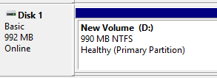
8. 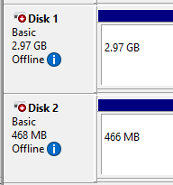On CLUS2 , as soon as disk would load into disk management , it would show like this , we don’t have to do anything on it, keep it like that.

**Install Cluster feature on both node**

1. Open Server manager on CLUS1 , click on “Add role and features”
2. Go to features section and install “Failover Cluster”

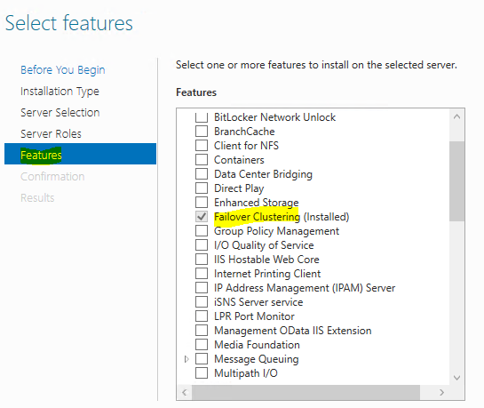

Follow the same process on CLUS2

**Validate Configuration on Cluster Management**

1. 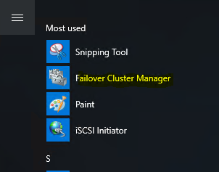Click on Windows Button and click on “Failover Cluster Manager”.
2. 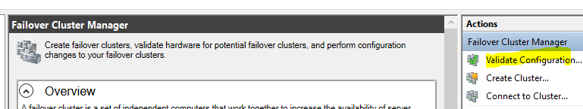Once the cluster management portal is opened, we need to validate the configuration. Click on Validate Configuration.

1. 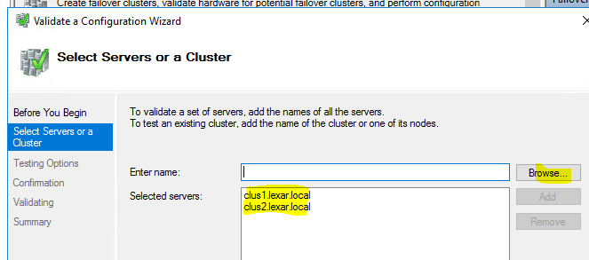Browse and select the both the nodes , i.e CLUS1 and CLUS2. and click on next.
2. Select “Run all tests”, then click next until validation gets finish.
3. Once validation is completed, view report to check if any error on the configuration, warning can be ignored.

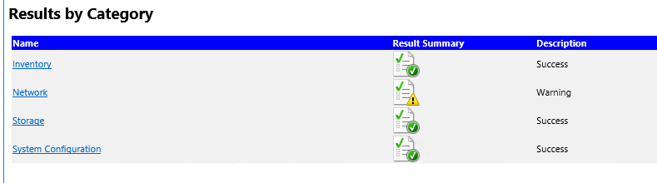

**Create Cluster on cluster Management**

1. Click on “create cluster” , Browse and select both the nodes and click on next.

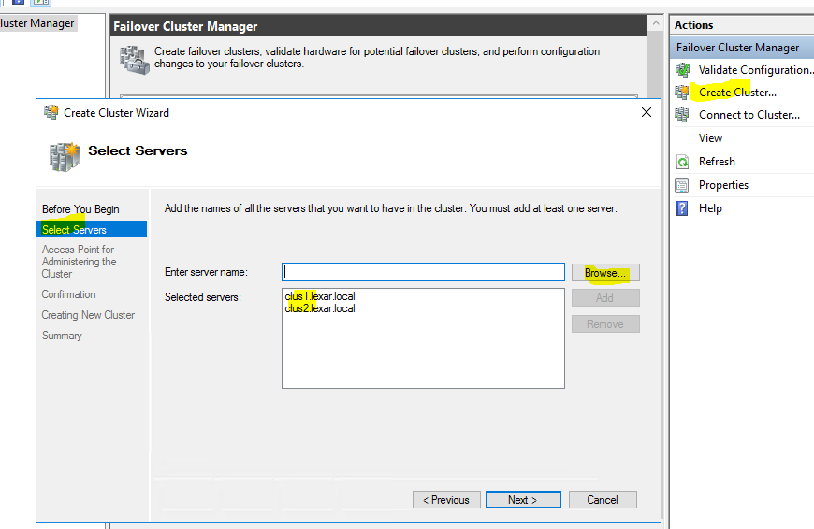

1. Mention any cluster name and assign the IP to the cluster, click on next.

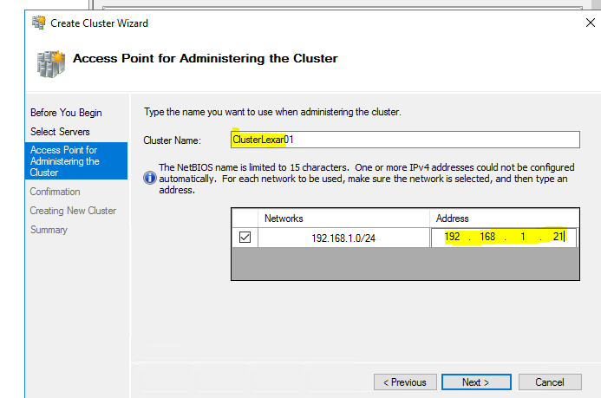

1. Uncheck “Add All eligible storage to cluster” and click next.

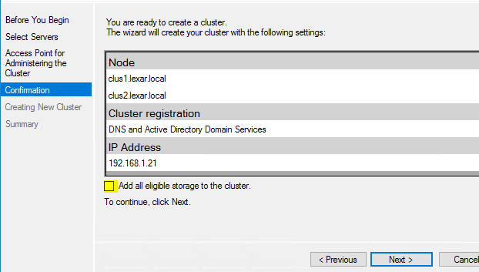

1. Now it will start creating the cluster as computer object in AD, once it is done, click on finish.
2. Below is our cluster as computer object in AD. And our both node is added to cluster.  
     
   Note- Check the DNS of this object, if it is not created, create it manually.

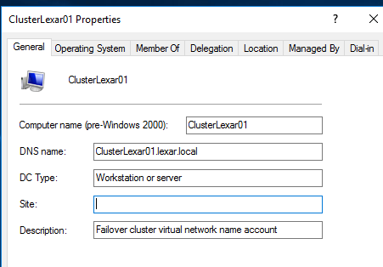

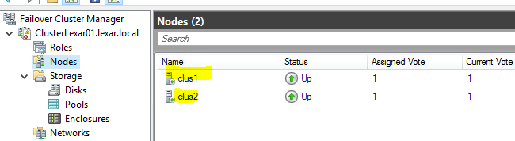

**Add disk in Cluster management**

1. 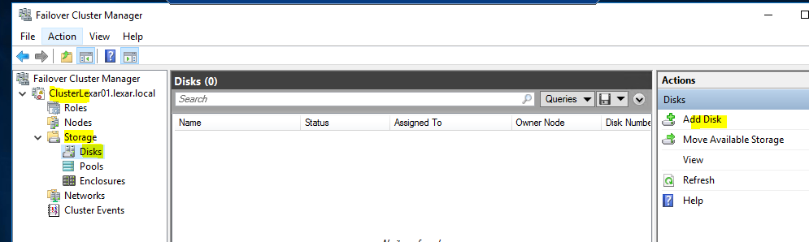Expand the cluster, then go to storage , expand it and click on disks. Again click on Add Disk on right hand side top.
2. As we have already create volume on CLUS1, so It would automatically take the disk from CLUS1, click on OK to add both the disk, one disk is for cluster role storage and another one is from disk witness quorum.

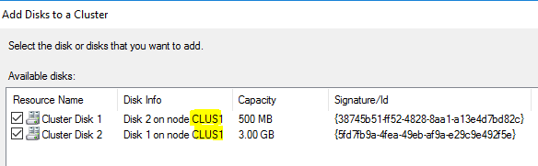

1. 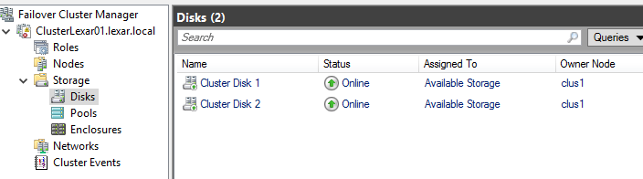Now both the disk has been added and online.
2. 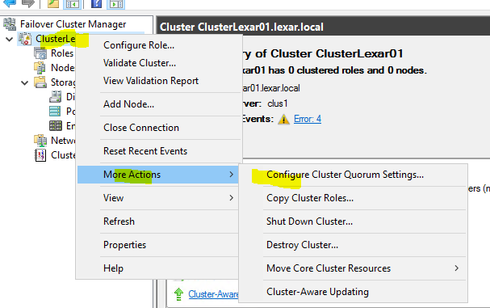Now we need to make one disk as Disk witness quorum, to make disk as Disk witness quorum , right click on clustername , go to more actions , click on “configure Cluster Quorum settings”
3. 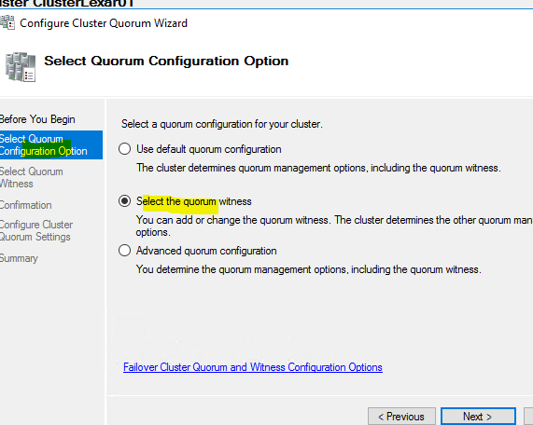Select second option as shown in below snap

1. Select “configure disk witness”.
2. Select cluster disk 1 as we have created one disk for disk quorum particularly and click on next until it is finised.

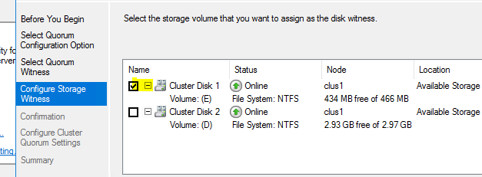

1. 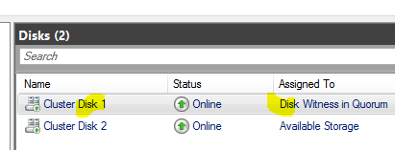Now we have one disk as Disk witness quorum.

**Assign Role in Cluster Management**

1. 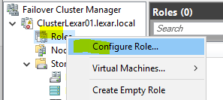Right click on “Roles” , click on “Configure Role”
2. Now select the role, in this example, we are going with File Server role. Before configuring the role in cluster, we need to make sure all the nodes should have same role installed.  
     
   for example – Here we are going with file server role on cluster, so CLUS1 and CLUS2 should have same role installed already, otherwise cluster management would throw an error.

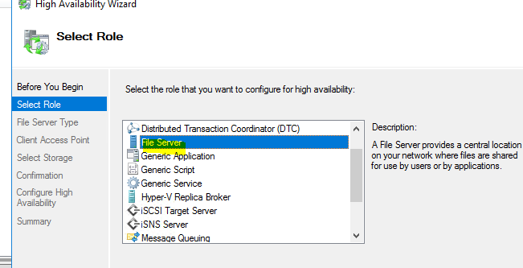

1. Select “File Server for General use”.
2. Here we need to provide the name of the FileShare which client would access and it’s IP address.

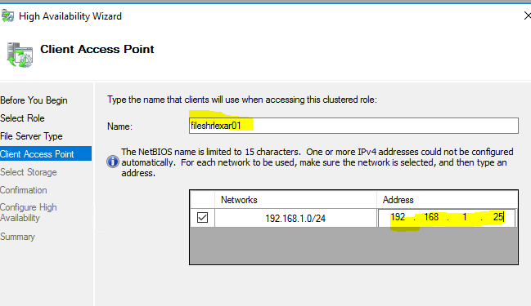

1. 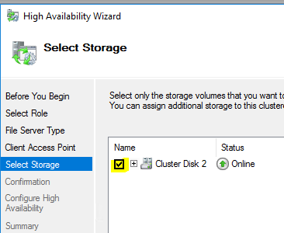We would use the another disk for File Server role. Now click Next until it is finished.
2. Now we can see Role has been configure in cluster management and it has created AD object of it.  
   We need to check the DNS and if it is not added, we need to add it manually.  
     
   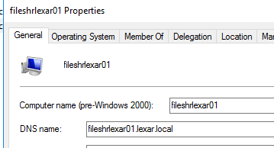

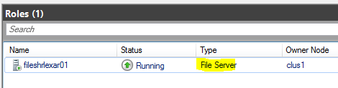

1. Next step is to add file share. To add file share, right click on “fileshrlexar01” , click on “Add File Share”.  
     
   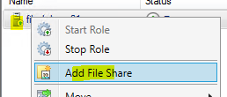
2. 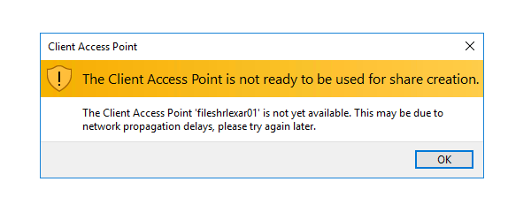If we get this warning , please wait for some time
3. Once Add file share prompt is open, select the “SMB Share-Quick”.
4. Browse the folder and select the one which we wanted to share.

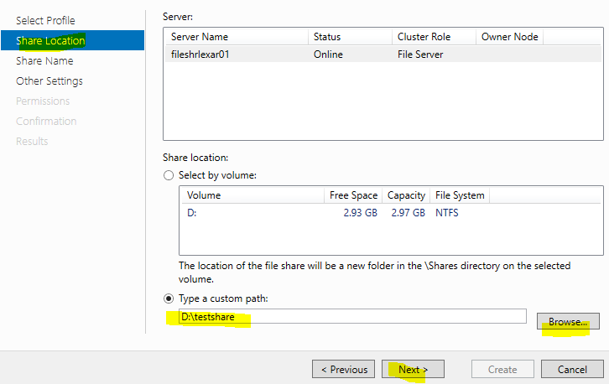

1. 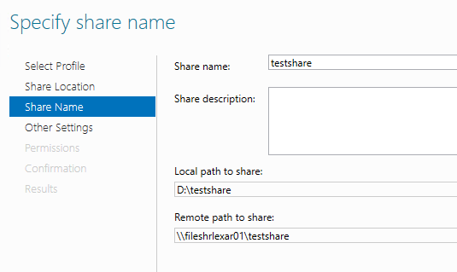Give the share Name.
2. Select next, go to the permission section , add permission if required, otherwise select next until it is finished.
3. 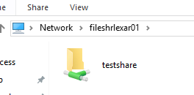Now our share has been created  
     
   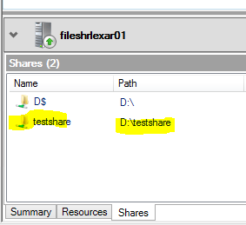

**Testing the Cluster**

As we can see here the owner node is CLUS1 , so right now CLUS1 is in function  
  
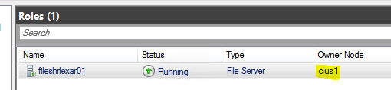

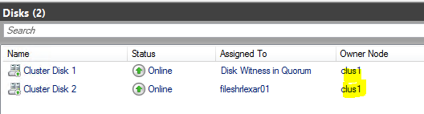

Now we will disconnect the CLUS1 network so it won’t be able to communicate with cluster and failover happens to CLUS2 to make the Fileshare availability up and running.  
  
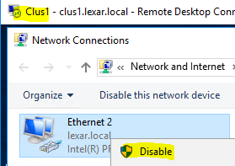

As we can see failover happen successfully and owner node CLUS2 is in function now.  
  
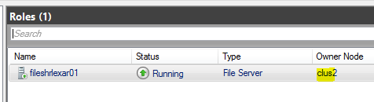

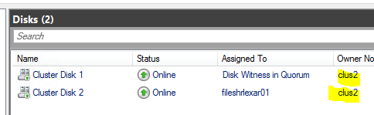

Note – Disk Witness only move when owner node of Disk Witness Disk goes down, so here if CLUS2 goes down then only it would move to CLUS1.

**Hence Our testing got successful.**

Extra Points – To make failover happen automatic on CLUS1 again , we can set the preferred owner setting.

To set preferred owner setting, click on “Any node” as shown in below screenshot.  
  
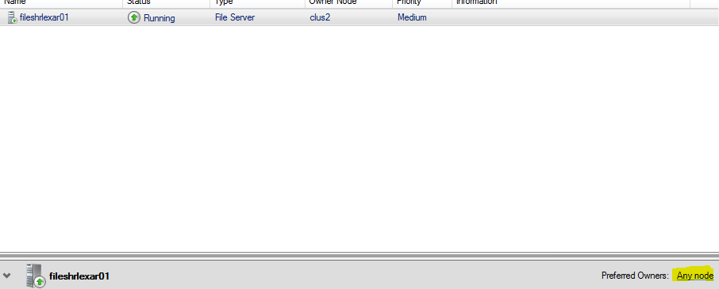

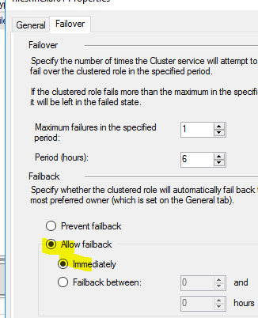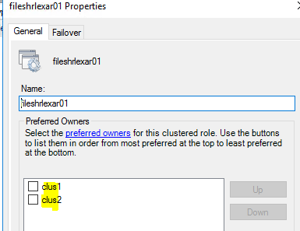Here we can select the node and change the order of it by using UP and DOWN button, top is most preferred node and select Allow Fallback.