**Registry GPO Test**

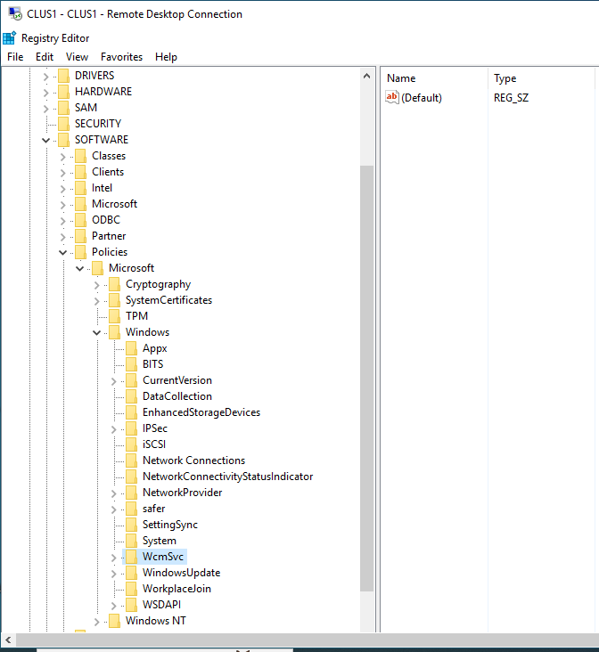  
We are testing whether GPO is able to create new Key and its associated value in registry.  
  
**Before Activity**There is no “WindowsCoPilot” key present

1. Create GPO in Group Policy Management Console
2. Go to Computer Configuration > Preference > Windows Setting > Registry
3. Right Click on Registry > new > Registry Item > select update > select Hive: “**HKEY_LOCAL_MACHINE**”
4. In this testing we are creating new key named “**WindowsCopilot**” (marked as yellow) on the path “**SOFTWARE\Policies\Microsoft\Windows\”.** So all together Key path would be **SOFTWARE\Policies\Microsoft\Windows\ WindowsCopilot**
5. Value Name – **TurnOffWindowsCopilot** (marked as red), Value Type – **REG_DWORD** , Value Data: **1** , Base: **Decimal**
6. After entering above value > Click Ok.
7. 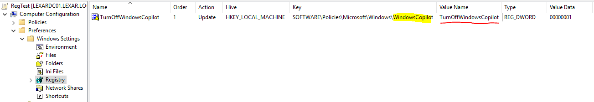GPO Should look like below snapshot.

1. Link this GPO in OU where Computer Object is present.
2. Now restart the Computer for the GPO to get apply.

**After Activity**

As we can notice that new key “**WindowsCoPilot**” and its value is created in registry via GPO.

