WSUS
- Group Policy Setting for WSUS
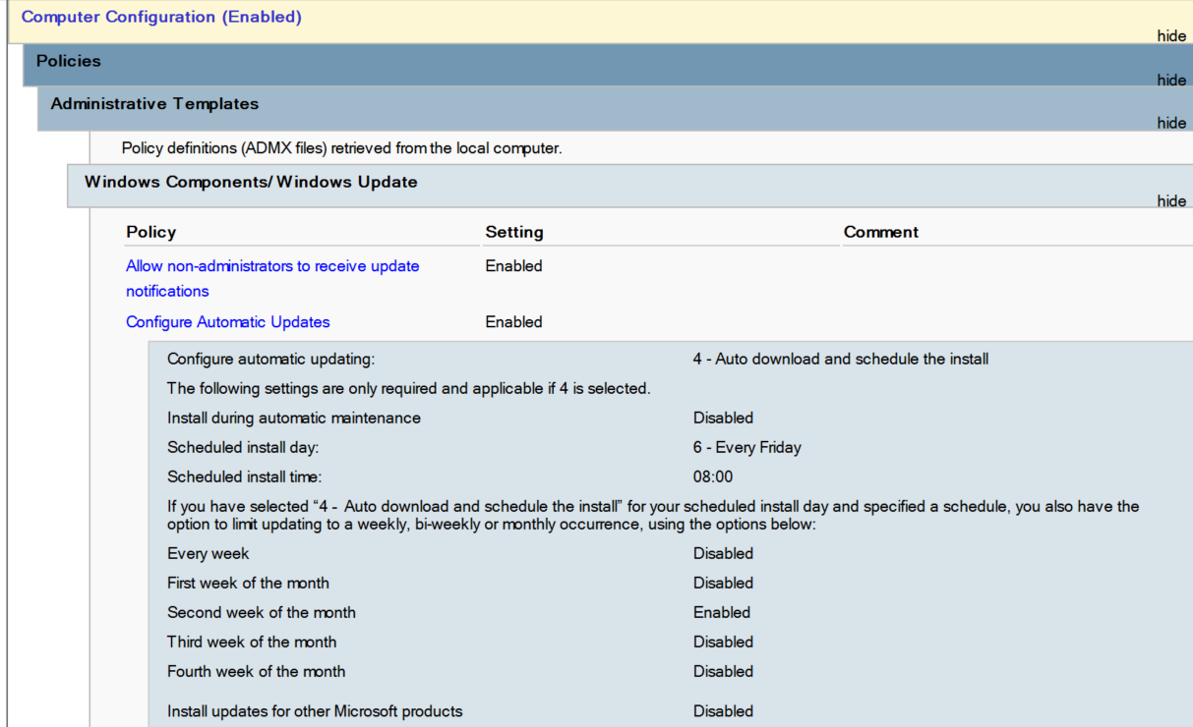

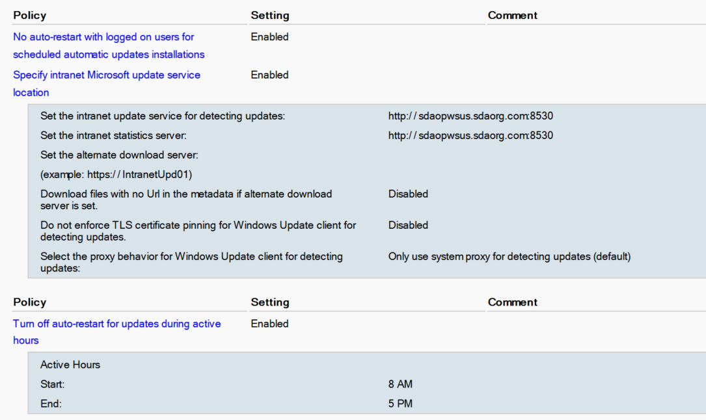

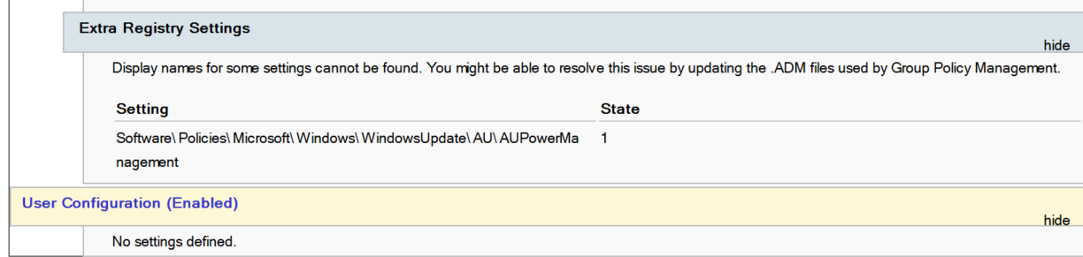

Note- If “Extra Registry Settings” is not visible, we can create Registry of above setting via GPO.

- Create OU in AD as per the schedule and move the AD Computer Object inside the OU.
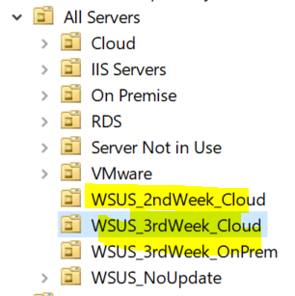

- Link the above GPO setting into the WSUS OU as per the schedule. (Note- Above GPO Setting is for installing updates on every Friday at 8:00 AM of every 2nd Week of every month), create similar GPO for different schedule and change the schedule timing.
- Login to PDC > open cmd as administrator > run “repadmin /SyncAll /AdeP” to sync all the changes with other additional DC.
- Run gpupdate /force on all the AD Computer Object which is part of WSUS OU to apply the group policy. It can be run via PSTools , Invoke-Command or login into Computer.
- Now we can wait for WSUS to take the clients automatically or we can run below command from client so that WSUS would take client immediately.
Open PowerShell as admin and run below command
(New-Object -ComObject Microsoft.Update.AutoUpdate).DetectNow()
- Once it is detected in WSUS, please wait for atleast 1 hour for the client to report to WSUS.

Troubleshooting
1. If client did not report prior to 1 hour and “Last Reported” Column is showing “Not reported yet” in WSUS Console. then
Remove the client from WSUS.
Login to effected client > check registry setting of WindowsUpdate and its sub-key and it should point to WSUS Server
Get-ItemProperty -Path 'HKLM:\Software\Policies\Microsoft\Windows\WindowsUpdate'
Get-ItemProperty -Path 'HKLM:\Software\Policies\Microsoft\Windows\WindowsUpdate\AU'
Default Update Service should be WSUS, and value should be true
$(New-Object -ComObject "Microsoft.Update.ServiceManager").Services | Select-Object Name, IsDefaultAUService
open google chrome or any browser > open below url
http://<wsus fqdn>:8530/selfupdate/iuident.cab
http://<wsus fqdn>:8530/ClientWebService/client.asmx
if WSUS is using SSL, then port number should be 8531.
If it is downloading cab file , which means it is pointing to WSUS server
Now Open PowerShell as admin and run below command
Get-Service -Name BITS, wuauserv
Stop-Service -Name BITS, wuauserv -force
Get-Service -Name BITS, wuauserv
Remove-ItemProperty -Name AccountDomainSid, PingID, SusClientId, SusClientIDValidation -Path HKLM:\SOFTWARE\Microsoft\Windows\CurrentVersion\WindowsUpdate\ -ErrorAction SilentlyContinue
Remove-Item "$env:SystemRoot\SoftwareDistribution\" -Recurse -Force -ErrorAction SilentlyContinue
Start-Service -Name BITS, wuauserv
wuauclt /resetauthorization /detectnow
(New-Object -ComObject Microsoft.Update.AutoUpdate).DetectNow()

Please wait for 24 hours after running this.

2. If Client did not report after running above steps, then go to windows setting > windows update > run “check for updates”. Now wait for some time, as client is not reporting in WSUS, it should give some error code while checking for update. Note the error code.
if error code is “0x8024401c” , follow the below article to fix it
https://itblog.ldlnet.net/index.php/2020/01/28/fixed-wsus-2016-2019-error-code-0x8024401c-windows-10-nor-windows-server-2016-reporting-to-wsus/
(Note- summarize points of above url is in page 5-6)

After following the update url. Open powershell and run below command
remove client from WSUS Console
Get-Service -Name BITS, wuauserv
Stop-Service -Name BITS, wuauserv -force
Get-Service -Name BITS, wuauserv
Remove-ItemProperty -Name AccountDomainSid, PingID, SusClientId, SusClientIDValidation -Path HKLM:\SOFTWARE\Microsoft\Windows\CurrentVersion\WindowsUpdate\ -ErrorAction SilentlyContinue
Remove-Item "$env:SystemRoot\SoftwareDistribution\" -Recurse -Force -ErrorAction SilentlyContinue
Start-Service -Name BITS, wuauserv
wuauclt /resetauthorization /detectnow
(New-Object -ComObject Microsoft.Update.AutoUpdate).DetectNow()
After this, client would be able to report to WSUS and receive update from it.
3. Open powershell as admin and run below command to get windows log for more troubleshooting.

Get-windowsupdatelog

4. Error code observed till now
80240016 - To fix this error code, stop and start the windows update service in the effect client, then check for update again.
Summarize solution of 0x8024401c
Go to IIS Manager on the WSUS Server

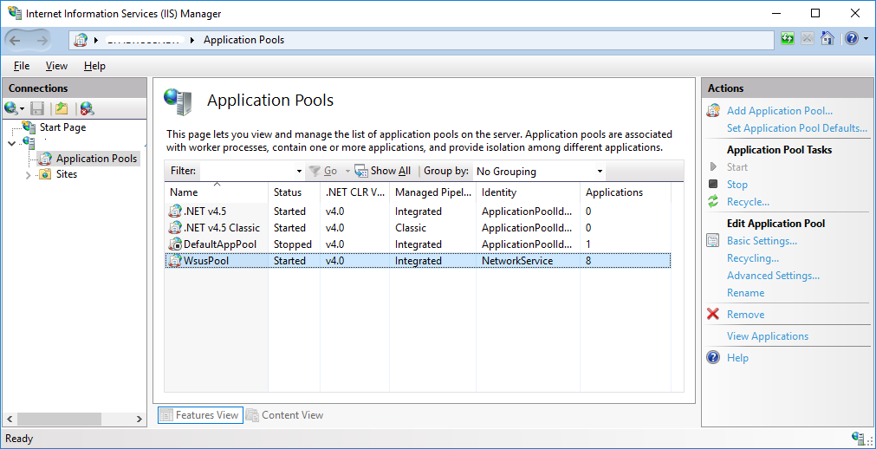

Goto Advanced Settings of WsusPool.
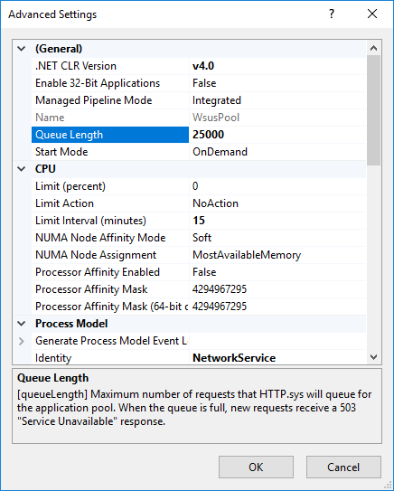

Make sure following settings are present/configured on the Pool, if not change it to below:
Queue Length: 25000
Limit Interval (minutes): 15
"Service Unavailable" Response: TcpLevel
Private Memory Limit (KB): 0

Stop IIS on the WSUS Server
Edit the web.config located at following location on WSUS Server:
C:\Program Files\Update Services\WebServices\ClientWebService\web.config
Replace the following lines in the config file and save in the same directory:
"<httpRuntime maxRequestLength="4096" />"

with

"<httpRuntime maxRequestLength="204800" executionTimeout="7200"/>"
Restart IIS on the WSUS Server

