**CHAPTER 6**

**EVALUATION**

To evaluate our Load balancing algorithm, we have distributed three virtual machines across three host machines, of which one contains two virtual machines the other machine contains the third virtual machine the last machine contains no virtual machines. The aim here is to scale efficiently the CPU resources or perform the migration of virtual machines to enable efficient resource provisioning there by reducing the response time of the virtual machines.

The host machines have identical specifications of Intel i3 processors with 2GB RAM. We allocate initially 512MB of RAM to each virtual machine. We run httperf software to find the response time of each virtual machine. Simultaneously we use stress load generator to generate load dynamically.

The load to be generated can be varied to the required amount by using Stress. Each time we experimented, we have observed the behavior with CPU load, memory load and with all of the loads mentioned above with our load balancing algorithm and with an instance without the use of the load balancing algorithm.

**6.1 Evaluation of the Load Balancing Algorithm:**

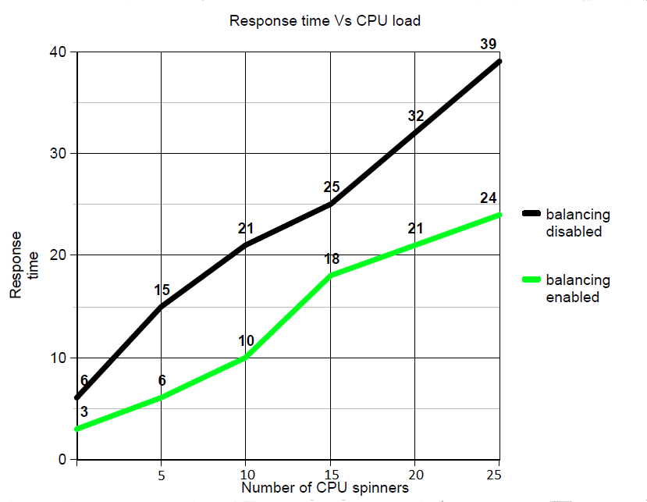

**Figure 6.1 Response time Vs CPU Load**

In the above sections, we have evaluated the performance of the virtual machines against various loads in the form of CPU and RAM. We have used the response time of the virtual machines as a parameter in deciding the rationale behind migration of the virtual machines to relevant servers as well as scaling of the CPU resources. On implementation of the load balancing algorithm, we have found out that the performance of the virtual machines are dependent on the amount of resources that have been allocated in the particular instance. The performance of the virtual machines have been found to vary when expanded loads were generated under the aegis of the Stress load generating software. We have found that the response time of a virtual machine may vary for same applied load depending on the background processes running. In brief, the load balancing algorithm has been successful in deciding the situations in which migration is inevitable and the situations in which scaling of the resources is imminent.