**APPENDIX**

**Images detailing the installation steps of XCP (Xen Cloud Platform):**

We have included here certain images which expand the understanding of the installation of the Xen Cloud Platform.

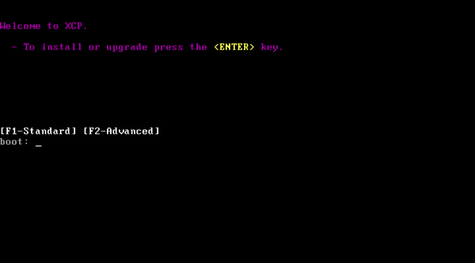

**Figure 9.1The boot stage of the XCP**

Figure 9.1 depicts the boot screen indicating the user to boot the computer using the main installation CD.

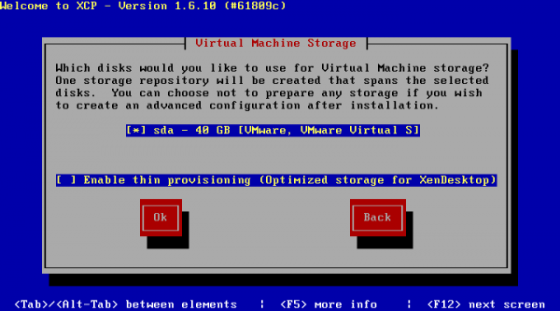

**Figure 9.2 Hardware analysis page**

Figure 9.2 depicts the hardware analysis screen which involves choosing the appropriate virtual machine storage disks.

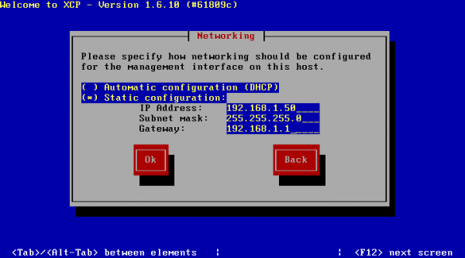

**Figure 9.3 Network configuration**

Figure 9.3 depicts the network interface configuration which allows you to choose between static and automatic configuration.

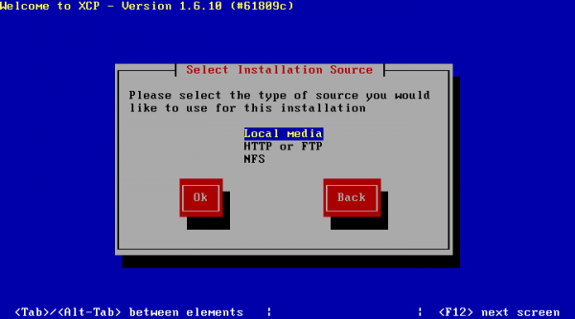

**Figure 9.4 Installation media page**

Figure 9.4 depicts the installation media page. It allows the user to select the type of source required for the installation.

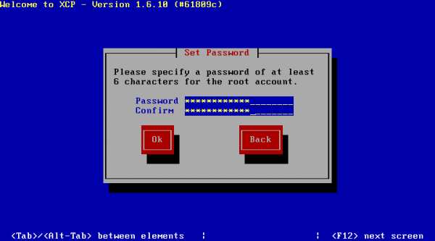

**Figure 9.5 The Password creation page**

Figure 9.5 depicts the password creation page. It allows the user to specify a password of desired length subject to the minimum criterion.

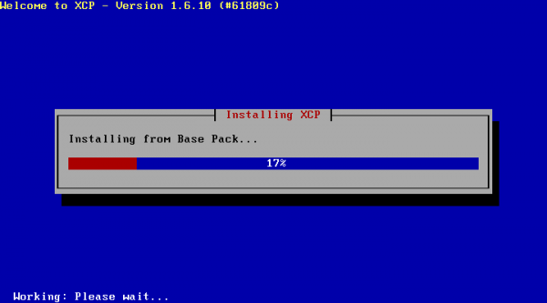

**Figure 9.6 Install in progress page**

Figure 9.6 depicts installation of XCP in progress with the help of an installation progress bar.



**Figure 9.7 The splash screen which shows the OS is booting**

Figure 9.7 depicts a splash screen which indicates that a particular operating system is booting.

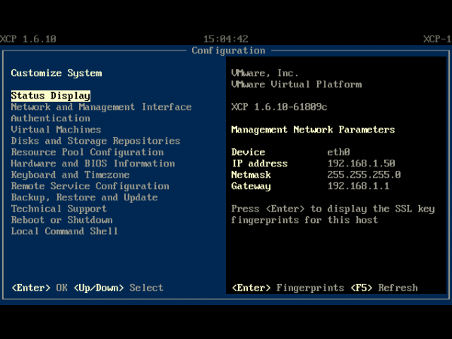

**Figure 9.8 The xsconsole**

Figure 9.8 depicts the user interface console page of XCP

**Images detailing the installation steps of XenCenter:**

Certain images which expand the understanding the installation of Citrix XenCenter are given below.

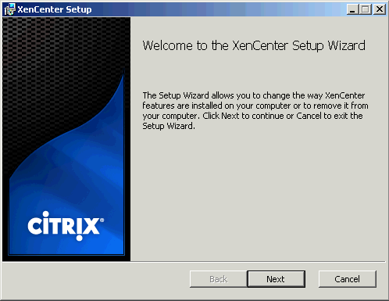

**Figure 9.9 Xen center setup wizard**

Figure 9.9 depicts the installation wizard for XenCenter.

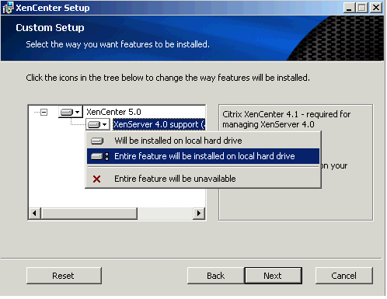

**Figure 9.10 Installation package selection**

Figure 9.10 depicts the installation package selection page allowing the user to select particulars.

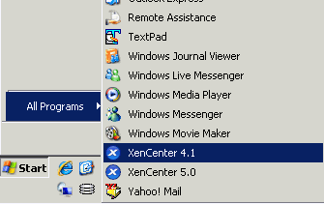

**Figure 9.11 Starting XenCenter**

Figure 9.11 shows how the user can start XenCenter by selecting Start in the taskbar and selecting XenCenter.