CHAPTER 4
METHODOLOGY

This chapter describes the methodology we used in order to achieve specific objectives of this research. For the problem that has been mentioned in the previous chapter, we have tested resource allocation for virtual machines by using Xen Hypervisor and XenCenter for administrative control over the virtual machines and servers. We have made use of load generating tools such as lookbusy, CPUbusy and stress. We have used httperf tool to measure the response time.

4.1 ARCHITECTURE
The architecture consists of a package called XCP (Xen cloud platform). The Xen Cloud Platform being a part of the Xen project is an open source virtualization software that allows the building of both private and public clouds. The Xen Cloud Platform includes the Xen Hypervisor, XenCenter, selected Xen API based tools and an integrated solution package for anomalies in cloud, storage and networking. The present scenario depicts a xen center enabled machine and servers holding virtual machines which are integrated with a help of an NFS. NFS is a distributed file system protocol allowing a user on a client computer to access files over a network.
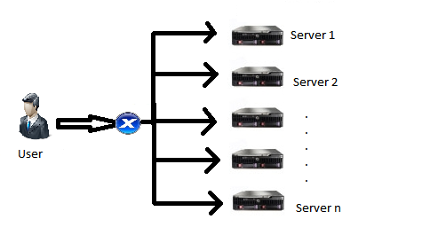
Figure 4.1 Cloud Architecture

Consider an environment in which the user as depicted in the figure sends a request for a virtual machine to XenCenter. XenCenter is graphical user interface software responsible for the administration of virtual machines. XenCenter then allocates the virtual machine which is hosted on an appropriate server, based on the user request. The user is now expected to execute the desired applications. If the resources required by any one applications exceed the limit defined by the Virtual machine or if the applications consume the minimal of resources specified by the operating system, a process called as scaling is performed. Scaling refers to the process of enhancing or reducing the system resources. If there aren’t enough resources to scale, then there arises a need to migrate the virtual machine to a different server. Migration refers to the process of transfer of a virtual machine(s) from one server to another suitable server. There are two types of migration: Live Migration and Non-Live Migration. In case of Non-Live Migration, the virtual machine to be migrated must be shut down completely for the migration to begin. The disadvantage of Non-Live Migration is in case of loss of user data due to abrupt shutting down of the virtual machine. Live Migration transfers the CPU and RAM data to another suitable server without shutting down the virtual machine. The migration is performed with the help of an algorithm called as “Load Balancing Algorithm”. Once migrated, the virtual machine continues to facilitate an environment to satisfy the request specified by the user by making use of resources provided by the new server.

4.2 INTERACTIONS
Module 1 User to Xen Center
Module 1 consists of two cycles of interactions. The first cycle consists of successful interaction.
Cycle 1
The user sends a request for resources such as amount of RAM (Random Access Memory), Processor Capability, and hard drive space to the Xen center interface. The interface verifies the request with the Xen Core (The main part of the Xen that handles the request processing), If the resources are available, then an infrastructure is created using these resources and a virtual machine is created on this infrastructure. The virtual machine is then assigned to the user.

:USER
:XENCENTER
INTERFACE
:XENCORE
Request for Resources
Verify Resources
Confirm resources
Assign virtual machine
Create virtual Machine
Grant resources

Figure 4.2 Interaction between user and XenCenter resulting in virtual machine assignment

Cycle 2
Cycle 2 consists of an unsuccessful interaction.
The user requests for resources such as amount of RAM (Random Access Memory), Processor Capability, and hard drive space to the Xen center interface. The interface verifies the request with the Xen Core. If the resources are not available with a particular server, the Xen core searches alternative servers for the required amount of resources. If the resources are yet again not available, an error message is sent to the user in each of the cases.
:USER
: XENCENTER
INTERFACE

:HYPERVISOR
Request for Resources
Verify Resources
Unsuccessful
Resources not available
Return error message
Verify Resources
Return error message
Resend request

Resources
Not available

Figure 4.3 Interaction between user and XenCenter resulting in failure in allocation of resources
Module 2
This module deals with the creation of the virtual machine.
The hypervisor (Hypervisor is a piece of computer software, firmware or hardware that creates and runs virtual machines) requests the user through the Xen Cloud Platform for an operating system to create a virtual machine. If the user denies or ignores the request, the hypervisor resends an appropriate request after certain duration of time. If the request is appropriate, the user sends the image of the operating system to the hypervisor through the Xen Cloud Platform. Subsequently, the hypervisor creates a virtual machine for the respective image. The newly created virtual machine sends an acknowledgement of successful creation to the user. Interaction is carried forward between the user and the virtual machine in the form of running the desired user application(s) within the purview of the created virtual machine.
:USER
:XEN
:HYPERVISOR

Request OS
Request OS
OS not available
OS not available
Request OS
Request OS
OS
Data
Data
create
:VIRTUAL MACHINE

OS installed
VM successfully created
Execute user applications & I/O’s

Figure 4.4 Interaction between Hypervisor and XCP resulting in VM creation

Module 3
This module consists of two cycles.
Cycle 1
Cycle 1 begins with the user interacting with the virtual machine created in module 2, in the form of execution of the application chosen by the user.
During the interaction, the XCP sends a status message to the virtual machine, requesting the details of resource usage of the virtual machine. If the resources granted to the virtual machine are underutilized (under loading), the virtual machine sends an under loading status message back to the XCP via the hypervisor. The XCP makes use of the existing scaling methods to indicate the level to which the resources must be scaled down. The information provided by the XCP is then sent to the hypervisor which performs the job of scaling down of the resources, the result of which is reflected in the operation of the virtual machine. The virtual machine then confirms the reduction in the resources. The surplus resources are then allocated to alternative virtual machines.
:USER
:XCP
:HYPERVISOR
:VM
Interactions
Status
Status
Underloaded
Underloaded
Give resource to some other VM
Confirm
Resources has been reduced to an optimal level
Reduce amount of resources
Scale down
Check solution
Confirm

Figure 4.5 Interaction between user and VM resulting in scaling

Cycle 2
Migrate to next free server
:USER
:XCP
:HYPERVISOR
:VM
User Interactions
Status
Status
Overloaded
Overloaded
Migration imminent
Confirmation
Resources given
Get resources
Scale up
Check solution
Confirmation
Not enough resources
Not enough resources

Figure 4.6 Interaction between user and VM resulting in migration

This cycle is initiated when the virtual machine is out of resources or if the resources are being depleted. The XCP then, sends a status message through the hypervisor requesting the details of resource utilization. The virtual machine sends an overloaded status message back to the XCP. The XCP searches for resources that are not used or wasted by other virtual machine. When some resources are found, the resources are then allocated to the virtual machine as per requirements (scaling up). Appropriate acknowledgment messages are sent as the messages are received.
In case there aren’t enough resources that can be provided, appropriate messages are sent to the XCP indicating the same. At this point, the virtual machine needs to migrate to a new server. There are two types of Virtual machine migration. They are Live migration and Non-Live Migration. Live Migration refers to the process of moving a running virtual machine or application between different physical machines without disconnecting the client or application. Memory, storage, and network connectivity of the virtual machine are transferred from the original host machine to the destination. The destination here refers to a new server.
The XCP now sends a message to the hypervisor indicating that migration is imminent. The server to which the virtual machine is migrated is decided based on the selection criteria provided in the “Load Balancing” algorithm. Based on the Load Balancing algorithm, the hypervisor initiates the migration of the virtual machine to a new server.

4.3 ALGORITHM
The Load Balancing algorithm verifies if the CPU usage and RAM usage are in the defined limits. Once verification is complete, the algorithm initially scales the resources in an upward or downward manner based on resource availability. If the resources required for scaling are not available, the algorithm performs the process of migration of the relevant virtual machines from one server to another suitable server.

4.3.1 Load Balancing Algorithm
This algorithm combines the processes of scaling and migration by calling the relevant functions.
Input: CPU utilization
Output: Scaling or Migration
- While VM is running do
  - if CPU utilization>70 and CPU utilization <95
    - if CPU utilization not reduced from 70 then
      - Scale Resources up by 20%
      - Wait for 20 seconds
      - If CPU > 70 and CPU<= 95 then
        - Scale Resources up by 20%
        - wait for 20 seconds
        - CPU ← CPU utilization
        - If CPU >70 and < 95 then
          - MigrateToServer( )
    - if CPU utilization > 95
      - Scale resources by 40%
      - If CPU utilization >95
        - MigrateToServer( )
  - if CPU utilization < 10
    - if CPU utilization not Increased from 10 then
      - Scale Resources down by 20%
      - Wait for 20 seconds
      - If CPU < 10 then
        - Scale Resources down by 20%
        - wait for 20 seconds
        - CPU ← CPU utilization
        - If CPU < 10 then
          - Migrate to next server
  - if RAM utilization>70 and RAM utilization <95
    - if RAM utilization not reduced from 70 then
      - Scale Resources up by 20%
      - Wait for 20 seconds
      - If RAM > 70 and RAM<= 95 then
        - Scale Resources up by 20%
        - wait for 20 seconds
        - RAM ← RAM utilization
        - If RAM >70 and < 95 then
1.3.1.3.4.1 MigrateUp( )
    - if RAM utilization > 95
      - Scale resources by 40%
      - If RAM utilization >95
        - MigrateUp( )
  - if RAM utilization < 10
    - if RAM utilization not Increased from 10 then
      - Scale Resources down by 20%
      - Wait for 20 seconds
      - If RAM < 10 then
        - Scale Resources down by 20%
        - wait for 20 seconds
        - RAM ← RAM utilization
        - If RAM < 10 then
1.4.1.3.4.1 MigrateDown( )
- Done

4.3.1.1 Algorithm for scaling
This algorithm performs the process of scaling of CPU or RAM according to the input parameters supplied to it.
Input: Amount in percent, instruction for scaling (0/1),Virtual Machine , CPU/RAM (0/1)
Output: Scaling
//where 0 is scale down and 1 is Scale up
- Amt←amount of scaling
- rule←Instruction for scaling
- VM←Virtual machine
- CR←CPU/RAM
5. If CR = 1
5.1 If rule = 1
5.1.1 Cap ← current CPU cap value of VM
5.1.2 If Cap < 100
5.1.2.1 Scale up the CPU by Amt

5.2 if rule = 0
5.2.1 Cap ← current CPU cap value of VM
5.2.2 If Cap < 20
5.2.2.1 Scale down the CPU by Amt
6. If CR = 2
6.1 SMin ← Static min value of VM
6.2 SMax ← Static max value of VM
6.3 DMin ← Dynamic min value of VM
6.4 DMax ← Dynamic max value of VM
6.5 if rule = 0
6.5.1 if DMax < SMin
6.5.1.1 Scale down RAM by Amt
6.6 if rule = 1
6.6.1 if DMax < SMin
6.6.1.1 Scale up RAM by Amt

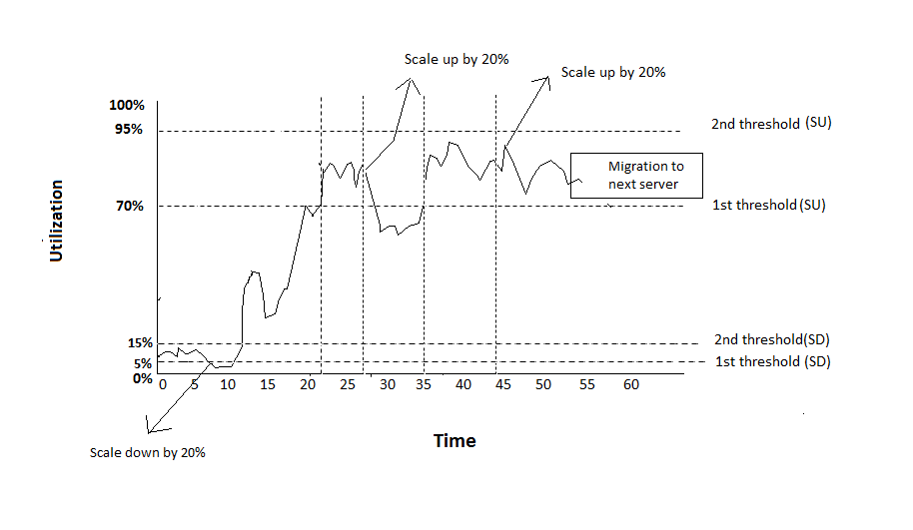
4.4 ILLUSTRATION

Figure 4.7 Utilization Vs Time

The above graph shows the CPU utilization of resources in a virtual machine. During the time interval of 5 to 10 minutes, the CPU utilization is stagnant , that is , it peaks between the defined thresholds for scaling down operation (5% and 15%) and hence scaling down is performed. For the next 5 minutes, the utilization of the virtual machine is optimal. From the time interval of 15 to 20 minutes, the utilization peaks within the two defined limits for scaling up (70% and 95%). At the end of this interval, at the 20th minute, we scale up the resources by 20% as shown in the graph by an upwardly pointing arrow. For the next 5 minutes, the virtual machine routinely operates without anomalies. At the 27th minute, the utilization of the virtual machine peaks between the defined thresholds. At the 37th minute, the resources are scaled up by 20%. Since the CPU utilization continues to peak even after scaling up the available resources, it becomes imminent to migrate the virtual machine to a new server.

