CHAPTER 5
IMPLEMENTATION

This chapter talks about the implementation details of the methodology presented in the previous chapter. We have installed the Xen Cloud Platform which contains a hypervisor which enables us to run multiple virtual machines. We have installed XenCenter which acts as an administrative tool to control our set-up. We have designed and implemented algorithms using shell script.
5.1 Experimental set-up
XCP
XCP
XCP
SWITCH
XenCenter Center
NFS
CLIENT
Figure 5.1 Experimental set up of cloud architecture
Figure 5.1 shows three Xen cloud platform enabled servers pre-loaded with virtual machines. The set up consists of a network file storage which acts as a virtualized hard drive. The set up consists of a XenCenter enabled system to monitor the virtual machines. All the connections are enabled by the use of a switch. The load balancing algorithm is stored locally in the servers and begin execution as and when load is generated by the client system. The load balancing algorithm, then decides on whether to scale the resources for the virtual machines or decides on migration of virtual machines if necessary, thereby reducing the response time of the virtual machines. The availability of resources is checked by a Xen api called xentop.

5.2 System Specifications
The system specifications required to establish the set-up are as follows:
- Three systems having the following specifications:
Intel® i3 2.93 Ghz processor, 2 GB RAM, 100Mbps Network card .
- A Network File System having the following specification:
Intel® Core™2 Duo CPU T6500 @ 2.10GHz, 4 GB RAM, 100Mbps Network card , 500 GB Secondary storage.
The Operating Systems used in our set-up are: XCP 1.6.1^{[14]} (Xen Cloud Platform) for the servers, Ubuntu 13.04 for Network File System, Windows/Linux for client.

5.3 Installing XCP
5.3.1 Introduction to XCP:
The Xen Cloud Platform^{[14]} being a part of the Xen project is an open source virtualization software that allows the building of both private and public clouds. The Xen Cloud Platform includes the Xen Hypervisor, selected Xen API based tools and an integrated solution package for anomalies in cloud, storage and networking. The Additional functionality offered by the Xen Cloud Platform are:
- Virtual Machine Lifecycle: This Functionality includes the features of screen snapshots, migration of the virtual machines and creation of checkpoints.

- Resource Pools: Resource pools can be created, thereby enabling flexible storage and networking.

- Event Tracking: Particular events of interest can be tracked by using the progress and the notification features.

- Performance Monitoring: The Xen Cloud Platform offers real time performance monitoring and alerting.

- XenMotion Live Migration: XenMotion is a feature than enables the migration of a virtual machine from one server to another server. This functionality also enables cross pool migration.
5.3.2 Requirements for XCP:
The Xen Cloud Platform is basically a 32/64 bit server class machine which has the capacity to run multiple virtual machines. The requirements to install the Xen Cloud Platform are as follows:
- CPU: one or more 32/64 bit CPU’s, with a minimum clock frequency of 1.5Ghz and it is recommended to have a 2Ghz or faster multicore CPU. It is noted that, to support virtual machines running windows, an Intel VT or AMD-V 32/64 bit based system with one or more CPU’s is required. In order to run virtual machines, hardware support for virtualization must be enabled on the Xen Cloud Platform host.

- RAM: 2GB of RAM is required as a minimum.

- Disk Space: Locally attached storage with 16 GB of disk space as a minimum 60 GB of disk space is recommended.

- Network: 100 Mbit /s or faster network interface card also known as NIC. A gigabit NIC is recommended for faster export/import data transfers and for live relocation/migration of virtual machines.
5.3.3 Installing Xen Cloud Platform:
- Boot the computer from the main installation CD.

- After the initial boot messages, the installer does some hardware detection and initialization.

- The Welcome to Xen Cloud Platform screen is displayed. Select Install or upgrade Xen Cloud Platform host and choose OK to proceed.

- At this point, if the computer on which you are installing the Xen Cloud Platform host does not have a CPU which supports hardware virtualization, or if the support is disabled a message appears to warn you that you will not be able to run Windows VMs. Choose OK to proceed.

- The next screen asks you to specify the source of the installation packages. If you are installing off the CD, you will most likely want to select Local media. If the computer as multiple network interfaces, you are prompted to select one of them to be used to access the Xen Cloud Platform product repository. Select one and choose OK to proceed.

- If the computer has a single network interface, that interface is used to access the Xen Cloud Platform product repository and no prompt is displayed.

- Select Static configuration, which prompts you to configure the properties of the NIC manually.

- You are next prompted to set a root password. Enter the desired password and enter it again to verify it.

- A message is displayed that the installation is ready to proceed and that this will format the primary disk and any other disks selected for VM storage, destroying any data that is currently on them. Choose Install Xen Cloud Platform to proceed. A progress bar is displayed as the installation commences. If you chose to set the system date and time manually, a dialog box appears when the progress bar has reached about 90%. Enter the correct numbers in the fields and choose OK to proceed.

- From the Installation Complete screen, eject the installation CD from the drive and select OK to reboot the server.
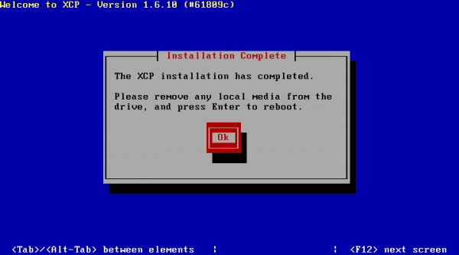

Figure 5.2 Install Complete Page

- After the server boots, Xen Cloud Platform displays a splash screen, followed by xsconsole, a system configuration console.

- To access a local shell from xsconsole, press Alt+F3.

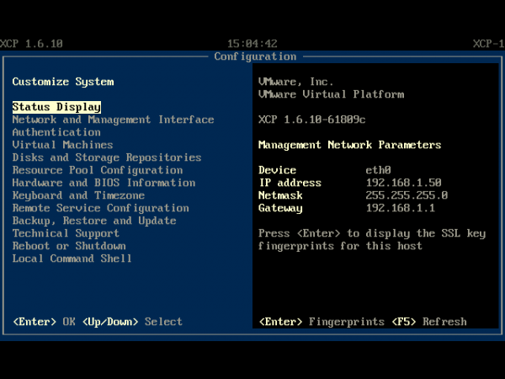

Figure 5.3 The xsconsole

- To return to xsconsole, press Alt+F1.

5.4 Installing XenCenter
5.4.1 Introduction to XenCenter
Citrix XenCenter^{[12]} is a graphical user interface on the windows platform which is used to manage virtual machines on Xen Cloud Platform. Some of the features of XenCenter include the following:
- Full virtual machine installation, configuration and lifecycle management.

- Dynamic memory management.

- VM snapshot management.

- Full memory snapshots and VM rollback.

- Performance metrics display.

- Long term metrics gathering and analysis.

5.4.2 Installation:
- Open the web browser and type the IP address of the host server.

- Click on XenCenter Installer.
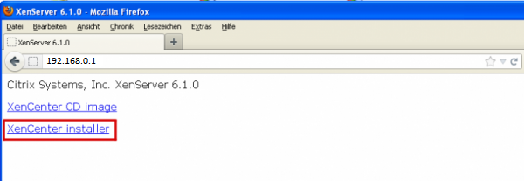
Figure 5.4 The web browser which contains the downloadable files

- Find the entry for XenCenter in the list of downloads and click Download Here.

- Browse to locate the folder where you want to put the new XenCenter MSI and then click Save to begin downloading the file.

- Click Next on the Welcome to the XenCenter Setup Wizard.

- Select the operation you wish to perform, in this case, select Change.

- Note that you can install XenCenter for both versions of XenServer 4.1 and 5.0. To do that you must also select XenServer 4.0 support while installing XenCenter 5.0. Click Next.

- Click Change to begin the installation.

- When XenCenter installation is complete, click Exit to close the Download Manager.

- Now you can use either XenCenter 4.1 or 5.1. Click Start > All Programs.

5.5 Installing Network File System:

5.5.1 Introduction to NFS:

The Network File System is a distributed file system protocol which allows the user or the client to access files over a network similar to how files are accessed locally.
We are using NFS for acting as a VHD (Virtual Hard Drive) between XCP (Xen Cloud Platform) servers thus reducing the period required for migration of virtual machines.

5.5.2 Installation:

We use Ubuntu 13.04 ^{[11]} as an operating system which supports NFS. The Installation steps are as follows:
- Initially we install the required package namely the nfs-kernel-server package using the command
# apt-get install nfs-kernel-server
- Traverse to the folder /etc and then, using vi editor, edit the file named exports

# vi /etc/exports

- Add the line /home *(rw,sync,no_root_squash) and exit the editor using the command :wq.
# /etc/exports: the access control list for filesystems which may be exported
# to NFS clients. See exports(5).
#
# Example for NFSv2 and NFSv3:
# /srv/homes hostname1(rw,sync,no_subtree_check) hostname2(ro,sync,no_subtree_check)
#
# Example for NFSv4:
# /srv/nfs4 gss/krb5i(rw,sync,fsid=0,crossmnt,no_subtree_check)
# /srv/nfs4/homes gss/krb5i(rw,sync,no_subtree_check)
/home *(rw,sync,no_root_squash)
~

- To run the network file system:
# sudo /etc/init.d/nfs-kernerl-server start

5.6 Installing virtual machines:
5.6.1 Using XenCenter GUI(Graphical User Interface) :
- Open XenCenter from the Start menu.
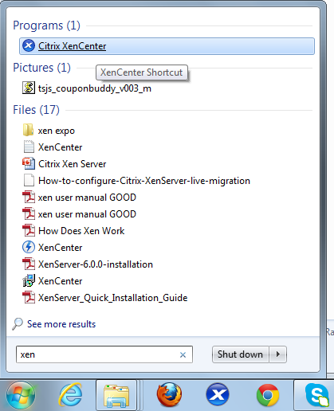

Figure 5.5 Start program
- Click on "Add your XenServer".

- You will be asked for your server's Hostname, your User name and your Password. You need to use your server's Private IP address (For example 10.x.x.x), the User name "root" and then your server's root password.
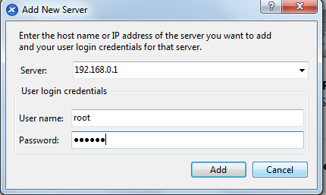

Figure 5.6 The dialogue box for entering the password and host address

- The wizard asks us to "Select an operating system for the new virtual machine". We select a version of Ubuntu and then click on "Next".
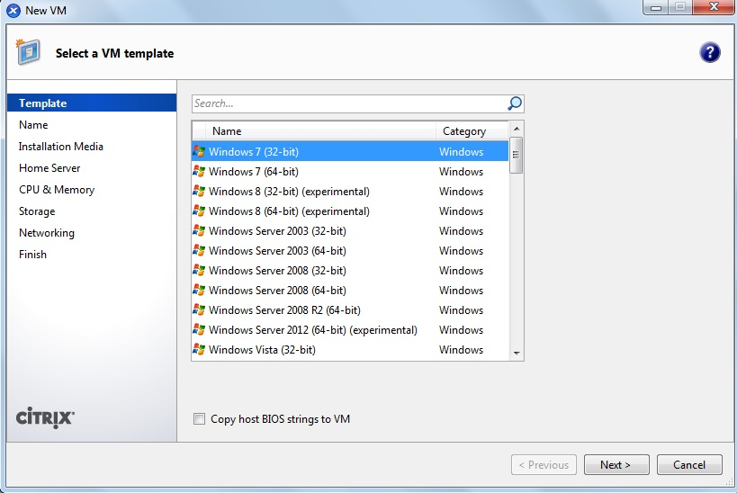

Figure 5.7 Select an template
- The wizard asks us to, "Enter a name and description for the new virtual machine".
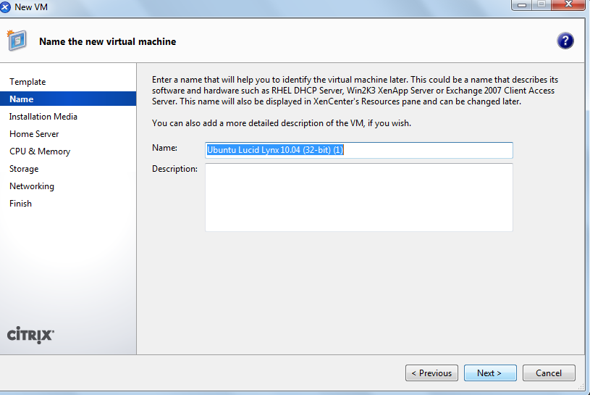

Figure 5.8 Enter the name of the operating system

- The wizard now asks us to, "Enter the location of the guest operating system installation Media".
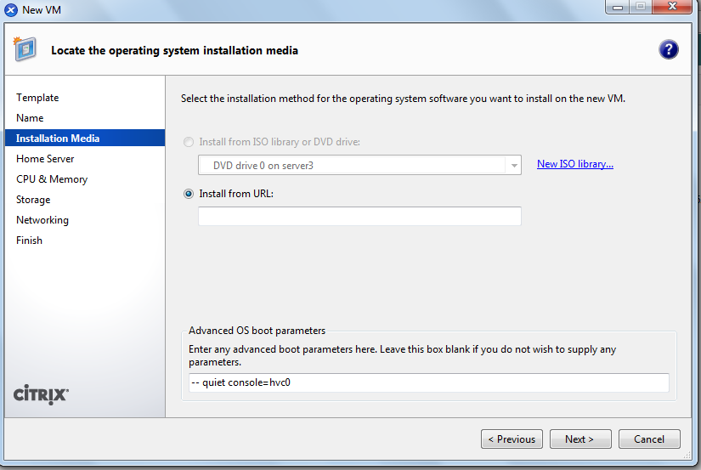

Figure 5.9 Selection of installation media
- The wizard is now asking us to provide some simple hardware allocations for the system. We can "Set the number of CPUs and the initial memory allocation for the new VM".
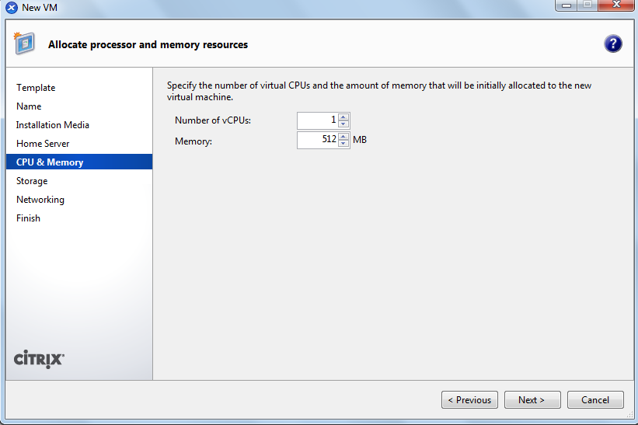

Figure 5.10 Select predefined Cpu and memory allocation

- On the next screen we can "Enter information about the virtual disks for the new virtual machine".
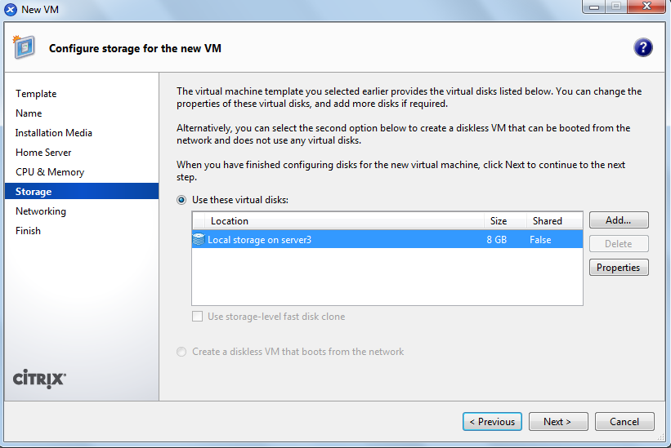

Figure 5.11 Disk information for the vm
- It is now possible to "Add or remove virtual network interfaces for the virtual machine".
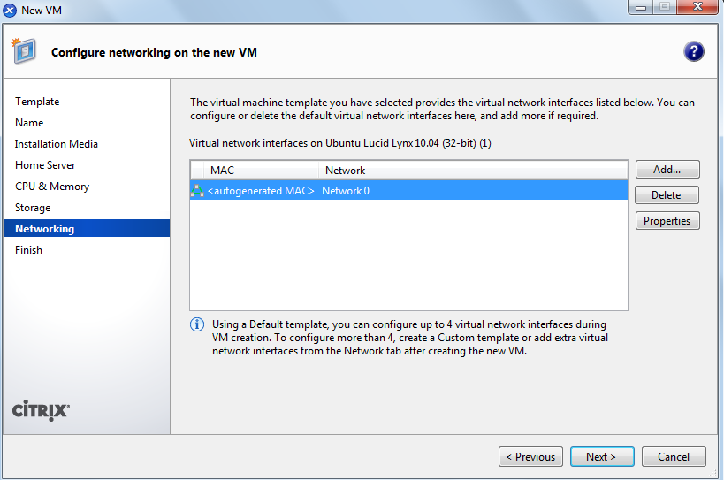

Figure 5.12 Enter the network settings

- Select your new VM and click on the "Console" tab.

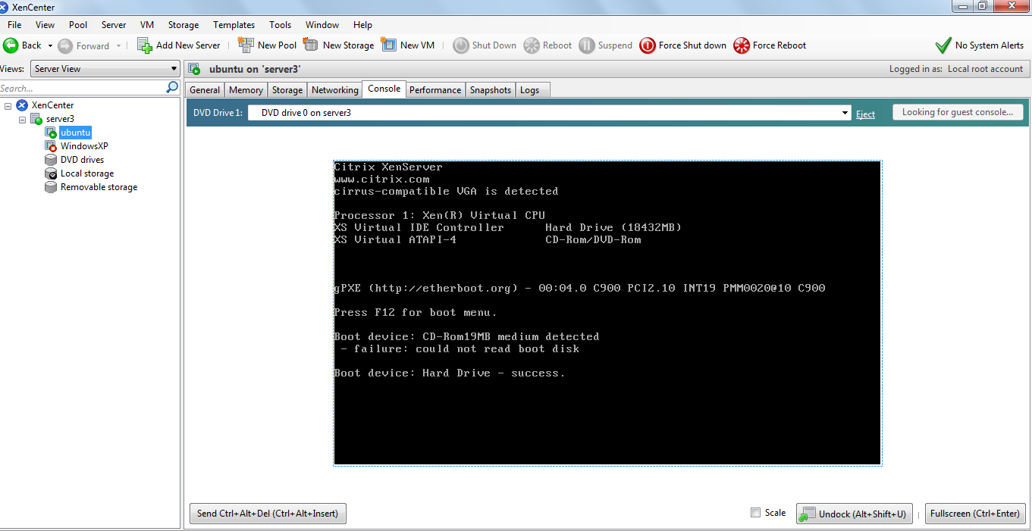

Figure 5.13 The console tab
5.6.2 Using CLI(Command Line Interface):
- To make an ISO library available to XenServer Hosts, create a CIFS share directory. The CIFS server must be set to allow root access to the share.
# xe-mount-iso-sr host:/volume

- We install the virtual machine from a template
xe vm-install new-name-label=<VM_NAME> template=<TEMPLATE NAME>
This command returns the UUID of the Machine.

- List the ISOs available:
xe cd-list

- Place the ISO into the virtual CD drive
# xe vm-cd-ad vm=<VM_NAME> cd-name=<NAME_ISO.iso> device=3

- Start and install the OS:
# xe vm-start vm=<VM-NAME>

    - Managing Virtual Machines:

- To Start a VM:
To start a virtual machine using CLI, we use the command
# xe vm-start vm=<VM-NAME>

- To Get Information regarding the VM:
# xe vm-list name-label=<VM-NAME>

- To Shut Down the VM:
# xe vm-shutdown vm=<VM-NAME>
- To Perform Forced Migration:
# xe vm-migrate vm=<VM-UUID> destination=<host-server> host=<destination-server>

- To Suspend the VM:
# xe vm-suspend vm=<VM-NAME>

5.7 Installing Httperf:
Httperf^{[13]} is a tool used to analyze the performance of a server. We have tweaked this tool to obtain the response time of the relevant virtual machine.
To install httperf run the following command in terminal after navigating to the httperf directory
# ./configure
# make
# sudo make install
The operation of httperf can be controlled through a number of options. The tool supports both short (one-character) and long (arbitrary-length) option names. Short options are prefixed with a single leading dash (-), long options with a double-dash (--). For example
httperf --hog --timeout=100 --server=192.168.0.17 --wsesslog=10000000,0,input.txt --rate $1 –v
The parameter rate is used to define the number of sessions created per second. Usually, Web applications users make requests interactively and take some time during requests, known as user think time. The parameter wsesslog defines the total number of sessions to generate, user think time, and input file name. The input file allows specification of a sequence of requests, the request method, and user think time per burst.

5.8 Installing LookBusy

LookBusy is a tool used for the generation of dynamic and static workloads for CPU and RAM. We have used this tool to simulate an environment in which a user interacts with the virtual machine.
To install LookBusy, run the following command in terminal after navigating to the LookBusy directory
# ./configure
# make
# sudo make install

5.9 List of commands

- xe host-list - Standard object listing command to list XenServer host objects
name-label – The name of the XenServer host

- xe vm-list - Standard object listing command to list VM objects
resident-on - The XenServer Host on which a VM is currently resident
power-state - Current power state; always halted for a Template

- xl sched-credit – Used to set or get weight and cap values of VMs
-d - specify the domain
-w - specify the weight value
-c - specify the cap value

- xe vm-param-get – Gets the values for all the parameters of the VM
uuid - unique ID of the VM
param-name - name of the parameter whose value is required

- xe vm-param-set - Sets the values for the specified parameter of the VM
uuid - unique ID of the VM
memory-dynamic-max - to set value for dynamic max

- xe vm-migrate – Migrate the specified VMs between physical hosts
vm - uuid of the VM to be migrated
destination – name of the server from where the VM is migrated
host - name of the server where the VM is migrated to

- xentop - Displays real-time information about a Xen system and domains
-v - output version information and exit
-b - output data in batch mode
-I - maximum number of iterations xentop should produce before ending

5.10 Implementation of the Algorithms

We have presented in the following lines, the shell script to perform the functions of scaling, migration and extraction of resource information.

5.10.1 Function to calculate CPU usage in percentage:

function calcpu
{
cpu="$(xentop -v -b -i 2|grep $vmt|cut -c 32-35)"
echo "current cpu utilization $cpu"
echo "$cpu" >> /waste/egc$i.txt
act=$(cut -c 1-2 /waste/egc$i.txt|head -n 2|tail -n 1)
echo $act
sc=$(xl sched-credit|grep -a $vmt|cut -c 48-50)
pac=`expr $act \* 100`
ac=`expr $pac / $sc`
}

Description:

The above function uses a built in command called xentop which obtains the current cpu usage in percentage, which is then compared to a capping as defined by the credit scheduler. For Example, if the capping defined by the credit scheduler is 50%, the limit is transmitted as a whole as 100% in the virtual machine.ie for every 1% increase in the processor usage would result in 2% increase in the virtual machine and this process is performed by the above function. The variable $i contains the depth of the iteration.

5.10.2 Function to calculate RAM usage:

function calram
{
ram="$(xentop -v -b -i 1|grep $vmt|cut -c 50-54)"
echo "$ram" >> /waste/egr$i.txt
ar=$(cut -c 1-2 /waste/egr$i.txt|head -n 1)
}

Description:

The above function uses the xentop command along with grep and cut sub-commands to obtain the RAM usage of the virtual machine in percentage. The variable $i contains the depth of the iteration.

5.10.3 Function to migrate to a higher priority server:

function migrateup
{
echo " migrate to higher";
d=`expr $serno + 1`
if [ $d -le $noofser ] && [ $d -gt 0 ]
then
vmu=$(xe vm-list name-label=$vmt power-state=running|grep uuid|cut -c 24-59)
xe vm-migrate vm=$vmu destination=$hostser host=server$d
fi
}

Description:

The above function obtains the UUID of the virtual machine. Using the received UUID, the function migrates the virtual machine contained in the variable $vmt to a higher priority server. This function is called when the virtual machine is to be migrated when all the resources allocated have been depleted.

5.10.4 Function to migrate to a lower priority server:

function migratedown
{
dd=`expr $serno - 1`
echo "migrate to lower";
if [ $dd -gt 0 ]
then
$vmu=$(xe vm-list name-label=$vmt power-state=running|grep uuid|cut -c 24-60)
$(xe vm-migrate --live vm=$vmu destination="$hostser" host="server$d")
fi }
Description:

The above function obtains the UUID of the virtual machine. Using the received UUID, the function migrates the virtual machine contained in the variable $vmt to a lower priority server. This function is called when the virtual machine is to be migrated when all the resources allocated are consumed inadequately leaving a large amount of resources under-utilized.

5.10.5 Function to Scale CPU resources:

function scale
{
case $4 in
1)
if [ $2 -eq 1 ]
then
echo "scaling up CPU of $3 by $1 % "
sca=$(xl sched-credit|grep -a $3|cut -c 48-50)
if [ $sca -ne 100 ]
then
recap=`expr $sca + $1`
xl sched-credit -d $3 -c $recap
echo "Scaling Complete"
return 1
else
return 0
fi
fi
if [ $2 -eq 0 ]
then
echo "scaling down CPU of $3 by $1 % "
sca=$(xl sched-credit|grep -a $3|cut -c 48-50)
if [ $sca -gt 20 ]
then
recap=`expr $sca - $1`
xl sched-credit -d $3 -c $recap
echo "Scaling Complete"
return 1
else
return 0
fi
fi
;;
2)
vmu=$(xe vm-list name-label=$vmt power-state=running|grep uuid|cut -c 24-59)
sat_min=$(xe vm-param-get uuid=$vmu param-name=memory-static-min)
sat_max=$(xe vm-param-get uuid=$vmu param-name=memory-static-max)
dyn_min=$(xe vm-param-get uuid=$vmu param-name=memory-dynamic-min)
dyn_max=$(xe vm-param-get uuid=$vmu param-name=memory-dynamic-max)
if [ $2 -eq 0 ]
then
echo "scaling down RAM of $3 by $1 % "
if [ $dyn_max -lt $sat_min ]
then
pc=`expr $1 / 100`
rt=`expr $dyn_max \* $pc`
dyn_smax=`expr $dyn_max + $rt`
xe vm-param-set uuid=$vmu memory-dynamic-max=$dyn_smax
fi
fi
if [ $2 -eq 1 ]
then
echo "scaling up RAM of $3 by $1 % "
if [ $dyn_max -lt $sat_min ]
then
pc=`expr $1 / 100`
rt=`expr $dyn_max \* $pc`
dyn_smax=`expr $dyn_max + $rt`
xe vm-param-set uuid=$vmu memory-dynamic-max=$dyn_smax
fi
fi
;;
esac
}

Description:

The above function is used to scale the resources used by the VM. This function takes four parameters stored respectively in variables $1, $2, $3, $4. $1 contains the percentage of scaling required. For example, if 20 is passed as the first parameter, the resources are to be scaled by 20%. $2 contains the scaling rule, which can be either 1 or 0, where 1 refers to scaling up and 0 refers to negative scaling. $3 contains the name of the virtual machine. $4 contains the preference to scale the CPU or the RAM with 1 referring to CPU and 2 referring to RAM. We use the credit scheduler to scale the CPU either ways(up and down). We make use of vm-param-set command to scale the RAM as required.

5.10.6 The Main function:

# main function

while [ $count -lt 2 ]
do
nvm=$(xe vm-list resident-on=$seruuid power-state=running|grep name|wc -l|cut -c 1-2)
nvm=`expr $nvm - 1`
if [ $nvm -gt 0 ]
then
while read vmt
do
temp1=$(xl sched-credit|grep -a $vmt|cut -c 48-50)
if [ $temp1 -eq 0 ]
then
xl sched-credit -d $vmt -c 50
echo "correctify";
fi
echo "----------------------------------Detected $vmt------------------------------"
calcpu
echo "comparing cpu usage $ac"
if [ "$ac" -gt 70 ] && [ "$ac" -lt 95 ];
then
scale 20 1 $vmt 1
sleep 20
calcpu
if [ "$ac" -gt 70 ] && [ "$ac" -lt 95 ];
then
scale 20 1 $vmt 1
sleep 20
calcpu
fi
if [ "$ac" -gt 70 ] && [ "$ac" -lt 95 ];
then
migrateup
fi
fi
calcpu
if [ "$ac" -gt 95 ];
then
scale 40 1 $vmt 1
calcpu
if [ "$ac" -gt 95 ];
then
migrateup
fi
fi
calcpu
if [ "$ac" -lt 10 ]
then
scale 20 0 $vmt 1
sleep 20
calcpu
if [ "$ac" -lt 10 ]
then
scale 20 0 $vmt 1
sleep 20
calcpu
if [ "$ac" -lt 10 ]
then
migratedown
fi
fi
fi
calram
echo "comparing ram usage $ar"
if [ "$ar" -gt 70 ] && [ "$ar" -lt 95 ];
then
scale 20 1 $vmt 2
sleep 20
calram
if [ "$ar" -gt 70 ] && [ "$ar" -lt 95 ];
then
scale 20 1 $vmt 2
sleep 20
calram
fi
if [ "$ar" -gt 70 ] && [ "$ar" -lt 95 ];
then
migrateup
fi
fi
calram
if [ "$ar" -gt 95 ];
then
scale 40 1 $vmt 2
calram
if [ "$ar" -gt 95 ];
then
migrateup
fi
fi
calram
if [ "$ar" -lt 10 ]
then
scale 20 0 $vmt 2
sleep 20
calram
if [ "$ar" -lt 10 ]
then
scale 20 0 $vmt 2
sleep 20
calram
if [ "$ar" -lt 10 ]
then
migratedown
fi
fi
fi
i=`expr $i + 1`
echo "$ac" >> /log/xencp.log
done < /waste/vname.txt
fi
rm -f /waste/vname.txt
nvm=$(xe vm-list resident-on=$seruuid power-state=running|grep name|wc -l|cut -c 1-2)
nvm=`expr $nvm - 1`
#clear
echo "no of vm in the system " $nvm
fg=$(xe vm-list resident-on=$seruuid power-state=running|grep name|tail -n $nvm|cut -c 24-100)
echo "$fg" >> /waste/vname.txt
done
fi

Description:

The Main function executes in an infinite loop which contains the core part of the algorithm which scans the resources and indicates whether migration or scaling is required. It also detects the number and the names of the virtual machines automatically and pauses when there are no virtual machines are running in the current server. The following functions are called in the Main Function: calcpu, migrateup, migratedown , scale, calram.

We make use of Httperf to find the response time of the virtual machine at certain intervals to compare the performance difference while executing the algorithm and when the algorithm is not in use. Httperf opens an html file and indicates the time required to execute the particular file.
The command to perform the same is as follows:

httperf –server localhost –port 80 –uri h.html –rate 150 –num-conn 1000 –num-call 1 –timeout 5

In this chapter, we have talked about the installations of the necessary packages to implement our idea as well as the implementation details of the algorithms which are necessary for load balancing. We have used shell script as our primary programming language.

