Assignment 1:
Healthcare Digital Service Modernization Initiative.

Group 5:
Gerald Abbey,
Ansu Joy,
Nihal Vellaramkallingal Sulaiman,
Souren Chowdhury.

Master of Data Analytics, University of Niagara Falls Canada

CPSC-620-3: Agile Software Development
Master of Data Analytics

Instructor: William Pourmajidi

25 April, 2026
- Summary
The purpose of this report is to present an Agile delivery approach for a healthcare digital service modernization initiative. The initiative aims to bring improvements in the process of how diagnostic imaging requests are processed by complying the updated operational and privacy requirements of the regional healthcare organization. The tasks involve all imaging requests such as X-ray examinations, Ultrasound appointments, MRI or CT scan requests are submitted, reviewed, prioritized, and tracked digitally by a specified implementation deadline.
As an Agile Team, our purpose is to propose how the delivery of the workflow would be organized and managed. Our focus is on the process and approach rather than software implementation. The proposed solution will cover only the diagnostic imagine requests ingestion process including request submission, validation, clinical review, recording, and generating audit trail. Subsequent processes such as appointment scheduling, interpretation or reporting, patient notification, identity checks, and billings are kept out of scope from this proposal.
While preparing this proposal, we acknowledged the regulatory and operational constraints with the understanding that privacy and documentation requirements must be in place and cannot be removed. Also, a formal privacy and operational review is required before releasing. At the beginning, clinical intake rules may not be fully defined and are subject to change before delivery. There may also be some requests which will be needing different attention based on urgency or risk.
We also recognize that physician input is only available through some scheduled review sessions after limited releases. Moreover, operational and compliance feedback is only available at certain fixed checkpoints; not by any on demand request. Daily internal meeting is possible while imaging staff and relevant stakeholders may be available in a limited capacity. All the above-mentioned constraints should be followed in the design.
The constraints required an adaptive and iterative Agile approach with a strong focus on compliance, feedback cycles, and controlled delivery.

- Part 1: Agile Delivery Approach Rationale
2.1 Proposed Agile Delivery Approach
To address the initiative of Diagnostic Imaging Request Intake Workflow, we plan to adopt Scrum-based agile approach with the combination of selected Kanban and XP practices. The reason of choosing this approach is that Scrum provides a structured framework through time-boxed iterations (Sprints), defined roles, and regular review points. Adding Kanban practices will support flexibility in managing continuous workflow. And XP practices will benefit by strengthening quality through disciplined development techniques.
In this approach, work will be delivered incrementally in short sprints that will allow team to build the workflow in manageable stages such as request submission, validation, review, and audit logging. This iterative approach will respect all the constraints given as well as it will enable team in early visibility of the progress. This approach will also allow team to adapt evolving clinical intake rules.
2.2 Work Organization and Management
The team will organize work using a Product Backlog that will contain prioritized user stories representing different parts of the intake workflow. Each user story will be defined from a user perspective (for example: physician, intake coordinator, etc.). Also, the process will include clear acceptance criteria to ensure completeness and compliance.
During the Sprint Planning stage, the team will select high-priority backlog items and then will move them into the Sprint Backlog. This step forms the scope of work for the sprint. A visual board will be used to track the progress. This will be accomplished by incorporating the Kanban principles to monitor progress across different stages such as “To-Do”, “In Progress”, and “Complete”.
The Scrum roles are defined as follows:
- Product Owner – Product Owner will prioritize work based on clinical and compliance needs.
- Scrum Master - Scrum Master will ensure adherence to Agile practices and remove blockers.
- Development Team – The team will collaborate the designs and deliver all the components of the workflow.
Moreover, daily meetings will be held to enable internal coordination. On the other hand, Sprint reviews will be used to demonstrate progress and collect structured feedback.
2.3 Justification for key delivery decisions
The selection of iterative Scrum-based approach is driven by the hidden uncertainty and evolving nature of the requirements. Especially when they are assumptions that clinical intake rules may be clarified during delivery. The team will follow an adaptive planning approach which will allow adjustments based on feedback and new information.
Incremental delivery is important due to limited access to physician and stakeholder feedback. Kanban practices support continuous workflow management such as handling updates, faults, smaller changes, etc. XP practices like clear acceptance criteria and continuous validation will help to ensure quality reduced risk in healthcare management industry. The controlled delivery approach is required to enforce privacy and operational reviews.
2.4 Explanation of why this approach fits the healthcare and operational context
The proposed approach will fit the healthcare context where risk management, traceability, and compliance are very crucial. Regulatory expectations will be met by integrating audit and document requirements into each iteration.
Scrum’s structure supports transparency, inspection, and adaptation which will help to manage complex workflows. Also, incremental delivery enables early identification of issues while controlled feedback cycles are aligned with limited stakeholder availability. Together, this approach will ensure safe and reliable delivery with each component validated before release.
2.5 One Agile practice not adopted
Due to strict regulatory requirements, the team chooses not to adopt continuous deployment. Each release must go through a formal privacy and operational review which will prevent immediate deployment.
Instead, a controlled release approach is selected where increments are properly validated and approved before release which ensures compliance and reduced risk.
- Part 2: Actions at Key Delivery Moments
Below is the ask.
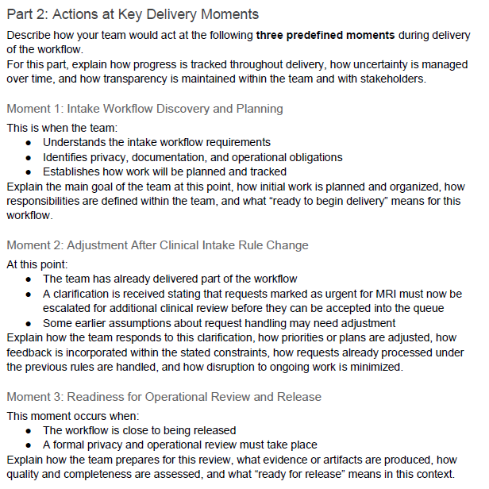
- Part 3: Evidence of Agile Values and Principles
Below is the ask.

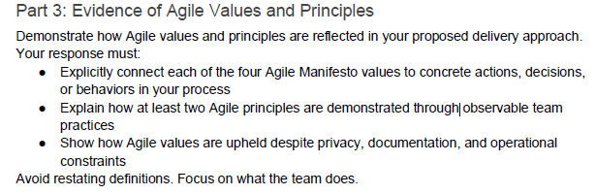
- Conclusion

