Project Report (23CSE304)

A Smart Safety and Security Kit for Bicycles

M Pranesh - (CB.SC.U4CSE23334)
P Sundar Tharsan - (CB.SC.U4CSE23348)
Y Nihanth - (CB.SC.U4CSE23367)

Abstract
This report is about a smart, all-in-one safety kit we built for bicycles. Bicycles often lack the safety features found in cars, leaving riders unsafe during accidents and making their bikes easy to steal. Our project solves this problem by adding a smart system to the bike. It has an anti-theft system that uses a password, sounds an alarm, and sends the bike's location to the owner's phone if someone tries to steal it. It also has an intelligent crash detector. If the rider has an accident, the system can tell and automatically sends an alert of location through coordinates to a contact. The whole system is controlled by an STM32 microcontroller and uses various sensors to make cycling safer and more secure.

Problem Statement
- Cars have airbags, automatic crash alerts, and advanced alarms. Even modern motorcycles have good locking systems and helmets that can detect a crash. But what about bicycles? 🚲
- Most bicycles only have a simple mechanical lock. If a rider has an accident and is unable to call for help, there's no system to automatically alert anyone. This safety gap makes cyclists vulnerable.
- Our project's main goal is to bring these modern safety features to bicycles. We have created a device that protects the bike from theft and, more importantly, helps the rider in case of a crash.

System Design
We designed a single unit that attaches to a bicycle and provides three key features. The "brain" of the unit is an STM32F401CC chip that manages all the parts.

1. Anti-Theft System
This feature protects your bike from being stolen. It's simple to use.
- Getting Started: When you turn the system on, you see a "Welcome" message on the LCD screen. To arm the system, you press "AAA" on the keypad.

- Password Entry: You then need to enter your secret password. You get two chances

- Correct Password: If you enter the correct password, the system unlocks and goes into "Ride Mode." You can now use your bike. If you want to change your password, you can press "***" to set a new one.

- Wrong Password: If you enter the wrong password twice, the system assumes it's a thief.
  - A loud buzzer starts ringing to attract attention.
  - The system gets the bike's current location using the GPS module.
  - It sends these GPS coordinates to your mobile phone using the HC05 Bluetooth module.

- Stopping the Alarm: If you accidentally triggered the alarm, you can stop the buzzer by entering a special code: "###".

- Turning Off: When you're done riding, you can turn the system off by pressing "DDD".

2. GPS Location Tracking
The NEO-6M GPS module is the system's way of knowing where it is in the world.
- It gets the bike's exact location (latitude and longitude) from satellites.

- This location is used for emergencies. It's sent to your phone when:
  - A theft is detected (after two wrong password attempts).
  - A crash is detected.

- The location is sent as a Google Maps link, so you can see exactly where the bike is on a map.(Future addition )

- At present only the coordinates are sent .

3. Smart Crash Detection
This is the most critical safety feature. We use an MPU6050 motion sensor to feel the bike's movements. We designed a very smart 6-stage process to make sure it only sends an alert when a real crash happens, not when you just hit a pothole.
Here’s how it works, step-by-step:
- Monitor (Always Watching): The system is constantly watching the motion sensor for any sudden changes.
- Trigger (Detecting a Fall): An alarm is triggered only if two things happen at once:
  - A hard impact (like hitting something).
  - A fast fall or rotation (like the bike tipping over quickly).
This prevents false alarms from just bumpy roads.
- Confirm (Making Sure It's a Real Crash): After the trigger, the system checks if the bike is lying on its side. It waits to see if the bike stays tilted more than 70 degrees. If you just drop your bike and pick it right up, no alert will be sent.
- Grace Period (A Chance to Respond): Once a crash is confirmed, a 30-second countdown starts. A loud buzzer sounds, giving you a chance to react.
- User Action (Canceling the Alert): If you are okay and don't need help, you can press a button on the keypad to cancel the alert during the 30-second countdown.
- Send Alert (Calling for Help): If you don't cancel the alert within 30 seconds, the system assumes you need help. It automatically sends a crash alert message, along with the Coordinates of your location, to your emergency contact via Bluetooth.

Schematic Diagram

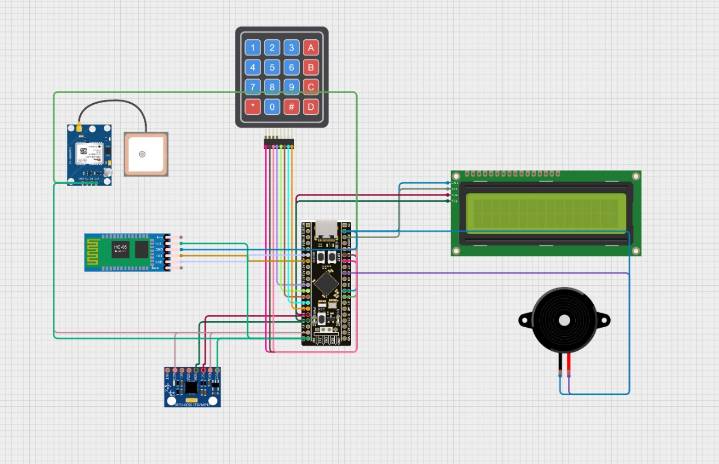

Component Connections (Pin Configuration)

This table shows exactly how the hardware components are wired to the STM32 microcontroller, as defined in the code:
Component | Connected To Pins | Connection Type | Purpose
4x4 Keypad | PB0 - PB7 | GPIO | For entering the password and other commands.
MPU6050 Sensor | PB8, PB9 | I2C | To detect motion and falls.
LCD Display | PB8, PB9 | I2C | To show messages to the user.
NEO-6M GPS | PA2, PA3 | UART | To get the bike's location.
HC05 Bluetooth | PA9, PA10 | UART | To send alerts to a smartphone.
Buzzer | PA9 | GPIO | To ring an alarm when crash or theft is detected. Also used for interactions with UI.
Onboard LED | PC13 | GPIO | Visual indicator for alerts.

Code Structure

The code is the "brain" of the entire system, bringing the hardware to life. It’s written in C for the STM32 microcontroller and is organized very neatly into different parts, where each part has a specific job. Think of it like a well-run office, with a main manager and several departments that handle their own tasks.

The Main Manager (The main() function)
When the system powers on, this function is the first thing that runs. It does two main things:

- Initialization: It "wakes up" all the hardware components one by one—the LCD screen, the keypad, the motion sensor (MPU6050), and the GPS module.

- Infinite Loop: After setup, it enters a while(1) loop, which is a loop that runs forever. Inside this loop, it constantly checks everything:
  - Has a key been pressed?
  - Has new data arrived from the GPS?
  - Is it time to check the motion sensor for a crash?
  - What is the system's current state (e.g., is it waiting for a password, or is the alarm on)?

System States: The Core Logic
To manage everything cleanly, the code uses a powerful concept called a State Machine. This means the system is always in one specific "state" at any given time. This makes the logic easy to follow. The main states are:

- STATE_OFF: The system is powered down and waiting for the "AAA" command.
- STATE_PASSWORD_ENTRY: The user is prompted to enter the password.
- STATE_LOGGED_IN: The password was correct, and the bike is in "Ride Mode."
- STATE_ALARM: The password was wrong, and the theft alarm (buzzer) is active.
- STATE_ACCIDENT: The crash detection algorithm has been triggered, and the system is in an emergency alert mode.
The main loop contains a big switch statement that checks which state the system is in and then runs the code specific to that state.

The "Departments": How the Code is Organized
The code is broken down into several logical blocks:
- Configuration (#defines): This is the "Settings" section at the very top. It holds all the important values in one place, like the password length, the I2C addresses for the sensors, and—most importantly—the sensitivity thresholds for crash detection (e.g., IMPACT_THRESHOLD_G, TILT_THRESHOLD_DEG). This makes it easy to adjust how the system works without digging deep into the code.

- Low-Level Drivers (The Translators): These are the functions that handle the raw communication with the hardware parts. The I2C1 functions, for example, are a set of rules for "speaking" the I2C language, which is used to talk to the LCD screen and the MPU6050 motion sensor.

- Helper Functions (The Specialists): These are easy-to-use functions that handle specific jobs:

  - LCD Functions: LCD_Init(), LCD_Print(), LCD_Clear() make it simple to display text on the screen.
  - Keypad Functions: Keypad_Scan() checks which button on the keypad is being pressed.
  - Buzzer/LED Functions: Simple functions like Buzzer_On() and LED_Toggle() control the alarm and lights.

- GPS Manager (USART and NMEA parsing): This department is responsible for location. It uses a hardware feature called USART (and an interrupt) to listen for data coming from the NEO-6M GPS module. An interrupt is like having a dedicated assistant who taps you on the shoulder the moment a message arrives, so you don't miss it. Once the data comes in, the parse_gga_sentence function translates it from the raw GPS format into useful latitude and longitude numbers.

- Crash Detection Unit (The Safety Officer): This is one of the smartest parts of the code. The MPU6050_SampleAndProcess() function contains its own mini-state machine to execute the 6-stage crash algorithm:

  - It starts in the ST_MONITOR state, just watching the sensor data.
  - If it detects a big impact and a fast fall, it moves to the ST_CONFIRM state to check if the bike stays tilted on the ground.
  - If the crash is confirmed, it moves to the ST_GRACE state, which starts the 30-second countdown with the buzzer and flashing light.
If the countdown finishes, it sets a flag (alert_send_flag) to tell the main loop to switch the whole system into the STATE_ACCIDENT.

Challenges We Faced and How We Solved Them:

- The Challenge: The crash detector was sometimes giving false alarms. Hitting a big pothole or dropping the bike would occasionally trigger an alert. `
Our Solution: Our smart 6-stage algorithm solved this perfectly. The "Confirm" step, where the system checks if the bike is actually lying on the ground for a few seconds, was the key. This step filters out accidental drops and bumps, making the system very reliable.

- The Challenge: Sometimes, the GPS module took a while to find its location after the crash is detected. This could delay an emergency alert. `
Our Solution: We programmed the system to be smart about this. We use interrupts and when ever the NEO 6M updates a new location, system reads the data and updates the global variables. So if a crash is detected, we already have the location co ordinates ready to send.

Conclusion

We successfully created a smart, reliable, and affordable safety and security system for bicycles. Our device protects a bike from theft using a password and alarm system, and it protects the rider by automatically detecting a crash and sending an alert for help. This project shows that it's possible to give cyclists the same level of safety and peace of mind that car drivers have.
In the future, we could make it even better by adding a dedicated mobile app, or by using a SIM card to send SMS alerts directly, so it doesn't need to be connected to a phone. For now, our toolkit is a huge step forward in making cycling safer and secure for everyone.

