DC&CN Lab Practice

By: Nihar Singla: 220381  
CSE - 2

1. List 3 different protocols that appear in the protocol column in the unfiltered packet listing window.

Ans- Some Protocols in unfiltered packet listing is  
1. ARP  
2. HTTP  
3. TCP

2. How long did it take from when the “HTTP GET” message was sent until the “HTTPOK” reply was received? (By default, the value of the Time column in the packet- listing window is the amount of time, in seconds, since Wireshark tracing began. To display the Time field in time-of-day format, select the Wireshark View pull down menu, then select Time Display Format, then select Time-of-day.)

Ans- As you can see, it took exactly 0.425097 seconds for the HTTPOK request to receive.

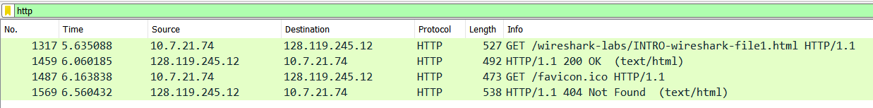

3. What is the Internet address of the gaia.cs.umass.edu (also known as www-net.cs.umass.edu)?

Ans- As you can see from the below image that, the ip address of our requested website is `128.119.245.12` only.



4. What is the Internet address of your computer?

Ans- As you can see from the below image that our machines internet address is `10.7.21.74`.  


5. Print (as pdf) the two HTTP messages (GET and OK) referred to in question 2 above. Todo so, select Print from the Wireshark File command menu, and select the “Selected Packet Only” and “Print as displayed” radial buttons, and then click OK.

Ans-

