DC&CN Lab Practice

By: Nihar Singla: 220381  
CSE - 2

**Answer the following questions:**

Q.1 What is the IP address of your computer?



Q.2 Within the IP packet header, what is the value in the upper layer protocol field?

Ans- ICMP (1)



Q.3 How many bytes are in the IP header? How many bytes are in the payload of the IP datagram? Explain how you determined the number of payload bytes.

Ans- 

Payload bytes: 36 (total length 56 minus the 20 header bytes = 36)

Q.4 Has this IP datagram been fragmented? Explain how you determined whether the datagram has been fragmented.

Ans- From the previous screenshot, we do not see any IPv4 fragments. We will see these later when we transmit longer ICMP echo requests.

Q.5 Which fields in the IP datagram always change from one datagram to the next within this series of ICMP messages sent by your computer?

Ans- Identification field is incrementing.

Time to live is also incrementing.

Q.6 Which fields stay constant while moving from one datagram to the next within this series of ICMP messages?

Ans- The following fields remain constant-

1. version (IPv4 always used)
2. header length (doesn’t change since we are always using IPv4)
3. source IP (my computer’s IP address doesn’t change)
4. destination IP (usc.edu’s IP address doesn’t change)
5. differentiated services (same protocol every time)
6. upper layer protocol (same protocol every time)
7. header checksum (verification disabled in my tests)

Q.7 Describe the pattern you see in the values in the Identification field of the IP datagram.

Ans- They are incrementing with each datagram.

Q.8 Find the first ICMP Echo Request message that was sent by your computer after you changed the Packet Size in ping plotter to be 2000 or 3500. Has that message been fragmented across more than one IP datagram?

Ans- Yes, the message has been fragmented across more than one IP datagram.

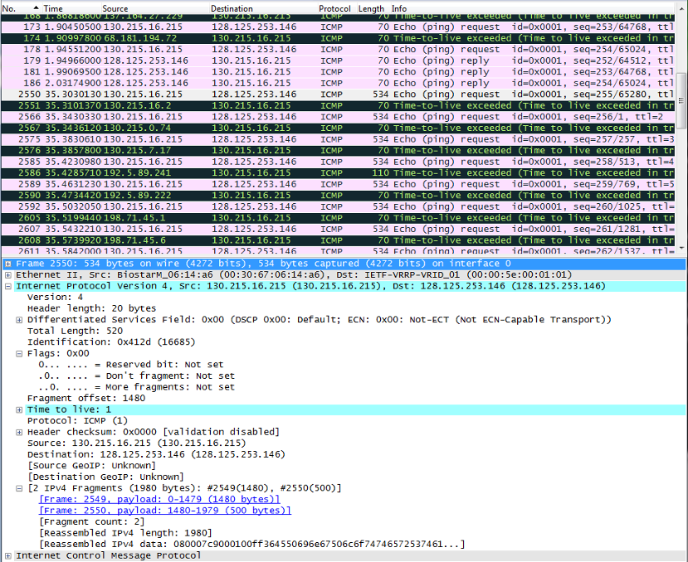

Q.9 What fields change in the IP header between the first and second fragment?

Ans- Total length, the more fragments bit, fragment o set. Note that identification and time to live don’t change.