**MedEase**



**Submitted By**

Rashid Ali MCS-172024

Zafar Habib MCS-172041

Session 2017 – 2019

**Department of Computer Science**

**Khwaja Fareed University of Engineering & Information Technology**

**Rahim Yar Khan**

# Project Detail

|  |  |  |  |  |  |
| --- | --- | --- | --- | --- | --- |
| Type (Nature of project) | | | [✔ ] **D**evelopment [ ] **R**esearch [ ] **R**&**D** | | |
| **Project Group Members** | | | | | |
| Sr.# | Reg. # | Student Name | | Email ID | \*Signature |
| (i) | MCS172024 | Rashid Ali | | Jamrashid633@gmail.com |  |
| (ii) | MCS172041 | Zafar Habib | | Zafar.habib.503@gmail.com |  |

\*The candidates confirm that the work submitted is their own and appropriate credit has been given where reference has been made to work of others

# Plagiarism Free Certificate

This is to certify that, I am \_\_\_\_\_\_\_\_\_\_\_\_\_\_\_\_\_\_\_\_\_\_\_\_ S/D/o \_\_\_\_\_\_\_\_\_\_\_\_\_\_\_\_\_\_\_\_\_\_\_, group leader of FYP under registration no \_\_\_\_\_\_\_\_\_\_\_\_\_\_\_\_\_ at Computer Science Department, Khwaja Fareed University of Engineering and Information Technology, Rahim Yar Khan. I declare that my FYP proposal is checked by my supervisor and the similarity index is \_\_\_\_\_\_\_\_% that is less than 20%, an acceptable limit by HEC. Report is attached herewith as Appendix A.

Date: \_\_\_\_\_\_\_\_\_\_\_\_ Name of Group Leader: \_\_\_\_\_\_\_\_\_\_\_\_\_\_\_\_\_\_\_\_\_\_\_\_ Signature: \_\_\_\_\_\_\_\_\_\_\_\_\_

Name of Supervisor: \_\_\_\_\_\_\_\_\_\_\_\_\_\_\_\_\_\_\_\_\_ Co-Supervisor (if any):\_\_\_\_\_\_\_\_\_\_\_\_\_\_\_\_\_\_\_\_

Designation: \_\_\_\_\_\_\_\_\_\_\_\_\_\_\_\_\_\_\_\_\_ Designation: \_\_\_\_\_\_\_\_\_\_\_\_\_\_\_\_\_\_\_\_\_

Signature: \_\_\_\_\_\_\_\_\_\_\_\_\_\_\_\_\_\_\_\_\_ Signature: \_\_\_\_\_\_\_\_\_\_\_\_\_\_\_\_\_\_\_\_\_

HoD: \_\_\_\_\_\_\_\_\_\_\_\_\_\_\_\_\_\_\_\_\_

Signature: \_\_\_\_\_\_\_\_\_\_\_\_\_\_\_\_\_\_\_\_\_

# Abstract

The proposed project is a smart appointment booking system that provides patients or any user an easy way of booking a doctor’s appointment online. This is a web based application that overcomes the issue of managing and booking appointments according to user’s choice or demands. The task sometimes becomes very tedious for the compounder or doctor himself in manually allotting appointments for the users as per their availability. Hence this project offers an effective solution where users can view various booking slots available and select the preferred date and time. The already booked space will be marked yellow and will not be available for anyone else for the specified time. This system also allows users to cancel their booking anytime. The application uses Latest Web Technologies as a front-end and PHP with MySQL database as the back-end.

Doctor Appointment System (DAS) is a Web app which sets up online communication between a doctor and a patient. This app is helpful to patients to ask questions and state their concerns to doctors regarding their health condition. This app will facilitate the patients to interact with doctors without making any physical appointments, but the patients are restricted to only one message per day before receiving a reply. If the patient gets a response from the corresponding doctor, the patient is allowed to send another message. In addition using this app, the patient can make an appointment to meet the doctor in clinic/hospital. DAS app would also facilitate the patient’s pharmacy selection to pick up the medication. Similarly, this app is beneficial to doctors by providing the following functionalities: patient interaction through messaging, sending prescription to pharmacies, confirming appointments, information sharing with other doctors, and patient referrals. Unlike other similar kinds of apps, DAS has unique features such as issuing online prescription to patients, referring patients to a specialist, sending health tips to patients, and effectively, reducing the cost of customer service and providing a vital communication link between doctors and patients.

# Acknowledgement

First and for most, we would like to express our sincere thanks to the almighty ALLAH for the gift of life, wisdom understanding he has given to us, a reason for our existence and to our families for the love and support they had been provided throughout our life.

**Mr. Muhammad Afzal** whom we regard as our parent and supervisor, we thank him for the expertise and intelligence he has displayed whole supervising this project. We believe this good work in a result of his good guidance and cooperation.

We cannot forget our friends in the faculty of Computer Science & Information Technology for the academic interactions and Ideas.

May Allah bless them and keep them safe. We love you all.

Contents

[CHAPTER 1 1](#_Toc18053572)

[1.1 Introduction 1](#_Toc18053573)

[1.2 System Overview 1](#_Toc18053574)

[1.3 Objectives 1](#_Toc18053575)

[1.4 Problem definition 2](#_Toc18053576)

[1.5 Project Scope 2](#_Toc18053577)

[1.6 Advantages 2](#_Toc18053578)

[1.7 Features 2](#_Toc18053579)

[2 CHAPTER 2 4](#_Toc18053580)

[2.1 Existing System 4](#_Toc18053581)

[2.2 Drawbacks of existing system 4](#_Toc18053582)

[2.3 Proposed system 4](#_Toc18053583)

[2.4 Need to replace existing system: 4](#_Toc18053584)

[2.5 Understanding the proposed system 4](#_Toc18053585)

[2.6 User involvement 4](#_Toc18053586)

[2.6.1 Requirements elicitation 5](#_Toc18053587)

[2.6.2 Requirements analysis 5](#_Toc18053588)

[3 CHAPTER 3 6](#_Toc18053589)

[3.1 Detailed description of Proposed System 6](#_Toc18053590)

[3.2 Features of Proposed System 6](#_Toc18053591)

[3.3 Advantages of Proposed System 7](#_Toc18053592)

[3.4 Scope of Proposed System 7](#_Toc18053593)

[3.5 Hurdles to optimize the current system 8](#_Toc18053594)

[4 Chapter 4 9](#_Toc18053595)

[4.1 Software Process Model 9](#_Toc18053596)

[4.2 Software Requirement analysis 9](#_Toc18053597)

[4.2.1 Functional Requirements 9](#_Toc18053598)

[4.2.2 Non Functional Requirements 9](#_Toc18053599)

[4.3 Design 10](#_Toc18053600)

[4.4 Benefits of selected Model 10](#_Toc18053601)

[4.5 Limitations of selected Model 10](#_Toc18053602)

[4.6 Use Case Diagram 11](#_Toc18053603)

[4.7 Collaboration Diagram 12](#_Toc18053604)

[4.8 Class Diagram 13](#_Toc18053605)

[5 Chapter 5 14](#_Toc18053606)

[5.1 Implementation 14](#_Toc18053607)

[5.2 Code details 14](#_Toc18053608)

[6 Chapter 6 15](#_Toc18053609)

[6.1 Development of computer program 15](#_Toc18053610)

[6.2 Hardware 15](#_Toc18053611)

[6.3 Software 15](#_Toc18053612)

[6.4 Tool Used 15](#_Toc18053613)

[6.5 User interface Component 16](#_Toc18053614)

[6.5.1 Home Page 16](#_Toc18053615)

[6.5.2 Footer 16](#_Toc18053616)

[6.5.3 Contact 17](#_Toc18053617)

[6.5.4 SignUP 17](#_Toc18053618)

[6.5.5 Signin 18](#_Toc18053619)

[6.5.6 Search 18](#_Toc18053620)

[6.6 Program Coding 19](#_Toc18053621)

[6.6.1 Home 19](#_Toc18053622)

[6.6.2 Footer 20](#_Toc18053623)

[6.6.3 SignUP 20](#_Toc18053624)

[6.6.4 SignIn 21](#_Toc18053625)

[6.6.5 Contact 21](#_Toc18053626)

[7 Chapter 7 22](#_Toc18053627)

[7.1 Testing 22](#_Toc18053628)

[7.2 Type of Testing involved 22](#_Toc18053629)

[7.3 Testing Report 22](#_Toc18053630)

[7.3.1 Reliability testing 22](#_Toc18053631)

[7.3.2 Usability testing 22](#_Toc18053632)

[7.3.3 Space testing 23](#_Toc18053633)

[7.3.4 Scalability testing 24](#_Toc18053634)

[7.3.5 Ethic testing 24](#_Toc18053635)

[8 Chapter 8 25](#_Toc18053636)

[8.1 Results 25](#_Toc18053637)

[8.2 Evaluation 25](#_Toc18053638)

[8.3 Conclusions and Further Work 25](#_Toc18053639)

[9 Chapter 9 27](#_Toc18053640)

[References 27](#_Toc18053641)

# CHAPTER 1

## Introduction

Aim of this project is to create doctor patient handling management system that will help doctors in their work and will also help patients to book doctor appointments and view medical progress. The system allows doctors to manage their booking slots online. Patients are allowed to book empty slots online and those slots are reserved in their name. The system manages the appointment data for multiple doctors of various date and times. Each time a user visits a doctor his/her medical entry is stored in the database by doctor. Next time a user logs in he may view his/her entire medical history as and when needed. At the same time a doctor may view patient’s previews medical history while the patient visits him. The system also consists of Blood donor module. This module allows for Blood donation registration as well as Blood group search. The module is designed to help urgent Blood requirements through easy/instant searches.

## System Overview

Smart appointment booking system provides patients or any user an easy way of booking a doctor’s appointment online. A web based application that overcomes the issue of managing and booking appointments according to user’s choice or demands.

## Objectives

The main objective of this project is to develop a website for a medical clinic to provide an efficient and economical way of making appointments and help in all the related tasks, clinic and doctor time table management, queue management, and patient appointments exportation. It is wanted that patients have a fast and easy access to clinic’s services and administering of all the appointments made. Meanwhile, it is also required that doctors can easily see all the upcoming appointments and give the results to these appointments to the patients.

Our modern age of technology is greatly depends on internet. Everything is converted to computer based for easier and faster communication. Here I tried to develop such a system, which will ensure some aspects:

* + - Reliability, maintainability, cost-effectiveness and a nice user-friendly environment.
    - The objective of the project is to provide an opportunity of getting doctor appointment easily.
    - Proper management of appointments, securely stores all records.
    - Save money and time.

## Problem definition

The study intends to investigate the benefits of Online Clinic Reservation System to clinic’s staffs and patients. In the current marketplace there are several apps for communication between doctors and patients but most of their functionalities are commercial, and not really helpful to the users. There are no apps which actually meet the patient’s basic needs and no such apps that fulfil the patient’s expectations from the doctors. Though these apps have publicized themselves as the best service providers but all the service is just limited to money making by making appointments with doctors, tracking the visit history, patient billings, and very minimal interaction related to disease condition of the patients. This project aims at changing this kind of misleading and unnecessary interaction between doctors and patients, with a new initiative which focuses more on patient benefits relating to his/her disease treatment and facilitating the doctors with an easy and optimal way to treat the patients. Specifically, the study seeks to answer the following statements:

* How to minimize the time and effort being spent on appointment reservation?
* Who will be benefited on the implementation of online clinic reservation system?
* How to easily manage and update information of patients and doctors?
* How to schedule patients’ appointments conveniently?

## Project Scope

This system help reduce the problems occur when using the manual system and helps patients to skip endless queues. The important thing is it will become easier for the data record and retrieval. This software also stores all the patient details, patients profile, prescriptions etc. This system enables doctors and clinic assistant to manage patient records and appointments. User can enter their details, update their profile and they can select doctors to make appointments.

## Advantages

* Easily take doctor appointment.
* No Need to do Paper Work.
* To save the environment by using paper free work.
* To increase the accuracy and efficiency of the procedure.
* Management of Patient and doctor Data.

## Features

* Appointments would be done in more better and efficient ways
* Better user experience.
* Very easy to access.
* establish real time communication
* System will compatible with user device such as pc, laptop, tab & smart phone.

# CHAPTER 2

## Existing System

Presently people are making appointments manually. This is a time consuming process, patient has to physically go to the clinic in order to make appointment. Some clinics provide the opportunity to make appointments by placing a phone call. But in this case, people are often left unattended

## Drawbacks of existing system

By analyzing the existing system, some of its drawbacks are listed.

* + 1. Time consuming.
    2. Lack of efficiency.
    3. Needs to be physically present at the clinic.
    4. Can’t make appointments in advance for long intervals.

## Proposed system

Proposed system will overcome the drawbacks of existing system. Existing system is manual and available appointment applications are not user friendly. Proposed system is computerized and user friendly. The proposed system has many advantages.

## Need to replace existing system:

As mostly existing systems are manual, less efficient and time consuming therefore it needed to replace the existing system.

## Understanding the proposed system

This project aims at changing this kind of misleading and unnecessary interaction between doctors and patients, with a new initiative which focuses more on patient benefits relating to his/her disease treatment and facilitating the doctors with an easy and optimal way to treat the patients

## User involvement

Here we will specify what kind of users will be using the website. We can say that we will have 3 types of users:

**Guests:** those are the users that are not registered and access our website. We can say that they are our potential clients so we have to let them see all the information they might be interested in about services provided by.

**Patients:** this user group is the one that created an account in our website and had logged in. They have all the functionality provided to Guest user group (except register/login form and make guest appointments)

**Doctors:** this user group are the ones logged in with a credentials provided to them by a company. They have Guest functionality (except Register/login form and make guest appointments

### Requirements elicitation

After analyzing the data collected, we formulated a number of requirements namely user requirement, system hardware software attribute. These were grouped as user, functional, non-functional and systems requirements. During data collection we investigated and found out how the current system operates, not only that but also tried out which problems are faced and how best they can be settled. The users described some of the basic requirements of the system this includes Search for Patients, Register Patient, Updaterecord, Doctor information record, view doctor availability record and view all types of reports.

### Requirements analysis

Accept of submissions in form of raw patients; perform analysis of financial to authenticate the users of the system. The system must verify validate all users input ant user must be notified in case of errors detected in the database, the system should allow room for expansion.

# CHAPTER 3

## Detailed description of Proposed System

Doctor Appointment System (DAS) is a Web app which sets up online communication between a doctor and a patient. This app is helpful to patients to ask questions and state their concerns to doctors regarding their health condition. This app will facilitate the patients to interact with doctors without making any physical appointments, but the patients are restricted to only one message per day before receiving a reply. If the patient gets a response from the corresponding doctor, the patient is allowed to send another message. In addition using this app, the patient can make an appointment to meet the doctor in clinic/hospital. DAS app would also facilitate the patient’s pharmacy selection to pick up the medication. Similarly, this app is beneficial to doctors by providing the following functionalities: patient interaction through messaging, sending prescription to pharmacies, confirming appointments, information sharing with other doctors, and patient referrals. Unlike other similar kinds of apps, DAS has unique features such as issuing online prescription to patients, referring patients to a specialist, sending health tips to patients, and effectively, reducing the cost of customer service and providing a vital communication link between doctors and patients.

## Features of Proposed System

This is a powerful medical doctor appointment scheduling software to meet all challenges that may surface during your appointment scheduling and hospital management. This online doctor appointment booking software is user-friendly at both front and back ends, which means that the process of booking appointments and scheduling management of DAS is easy for both the doctors and patients

* Appointments would be done in more better and efficient ways
* Better user experience.
* Very easy to access.
* establish real time communication
* System will compatible with user device such as pc, laptop, tab & smart phone.

## Advantages of Proposed System

The use of proposed system will avoid the problems of the existing system and we also get a new system for managing information under the Clinic Appointment System. The proposed system offers:

* Manual work which is time consuming can be reduced.
* Easy to store data in the database.
* Administrator can add/remove new doctors, patients & departments.
* Increase processing speed.
* An easily access environment for users.
* Doctors can view/cancel appointments.
* Doctors can send prescription.
* Automatic removal of past appointments.
* Easy to use real time search facility.
* Responsive layout that fits all devices.

## Scope of Proposed System

This system help reduce the problems occur when using the manual system and helps patients to skip endless queues. The important thing is it will become easier for the data record and retrieval. This software also stores all the patient details, patients profile, prescriptions etc. This system enables doctors and clinic assistant to manage patient records and appointments. User can enter their details, update their profile and they can select doctors to make appointments. Other than that, the system is user friendly and it can help the clinic to manage their appointments. The system helps to avoid making duplicate appointments. Users can view available doctors and their timings and can make appointments according to it. Users also get an option to cancel their appointments. Users can view their upcoming appointments and past appointments are deleted automatically.

## Hurdles to optimize the current system

Traditionally, medical appointments have been made with schedulers over the telephone or in person. These methods are based on verbal communications with real people and allow for maximum flexibility in complicated situations. However, because these traditional methods require the intervention of schedulers, the ability to get a timely appointment is not only limited by the availability of appointment slots, but also by the schedulers and phone lines. Patients’ satisfaction with appointment booking is influenced by their ability to book at the right time with the right health service provider

# Chapter 4

## Software Process Model

A software process model represents the order in which the activities of software development will be undertaken. It describes the sequence in which the phases of the software lifecycle will be performed. Therefore we chose **waterfall model** for our project.

## Software Requirement analysis

If you are into software development at some point or the other, you would have bumped into the [Waterfall Model](https://en.wikipedia.org/wiki/Waterfall_model" \t "_blank).

Considered as the traditional method of explaining the software development process in software engineering, waterfall model happens to clarify the process into a linear flow with a specified sequence to let the users understand that further level is made progressive on completion of the previous one.

Moreover, this methodology also talks about the fact that going back to deal with the changes is not possible.

### Functional Requirements

Typically, functional requirements will specify a behaviour or function, for example:  
“Display the name, total size, available space and format of a flash drive connected to the USB port.” Other examples are “add customer” and “print invoice”. In this project functional requirements are as follows.

* Creating Doctor Profile
* Creating Patient Profile
* Verifying password at LOG IN time
* Making Appointment
* Notifying Patient and Doctor about Appointment
* Posting Feedback with accuracy

### Non Functional Requirements

Non-Functional requirements cover all the requirements which are not covered in Functional requirements. Non-Functional requirements are as follows.

* Performance will be good because it’s and web based system, that you can use on any device which has internet access and browser access
* Database work will be good for both doctor and patient and will be fast
* Update field will be immediately appear for doctor and patient
* Accuracy will be good and also constraints works very will

## Design

After interpretation of the data, tables were drawn and process of data determined to guide the researcher of the implementation stage of the project. The tools, which were employed during this methodology stage, where mainly tables, Data Flow Diagrams and Entity Relationship Diagrams. The design ensures that only allows authorized users to access the systems information.

## Benefits of selected Model

Every software developed is different and requires a suitable SDLC approach to be followed based on the internal and external factors. Some situations where the use of Waterfall model is most appropriate are:

1. Requirements are very well documented, clear and fixed.
2. Product definition is stable.
3. Technology is understood and is not dynamic.
4. The project is short.
5. Simple and easy to understand and use
6. Easy to manage due to the rigidity of the model. Each phase has specific deliverables and a review process.
7. Phases are processed and completed one at a time.
8. Easy to arrange tasks.

## Limitations of selected Model

Following are some of the limitations of waterfall model we noticed during the development:

1. Only matches precise needs
2. Not applicable for maintenance projects
3. No option to know possible outcome of a project
4. Not excellent for long and ongoing projects

## Use Case DiagramCapture.PNG

## Collaboration Diagram

**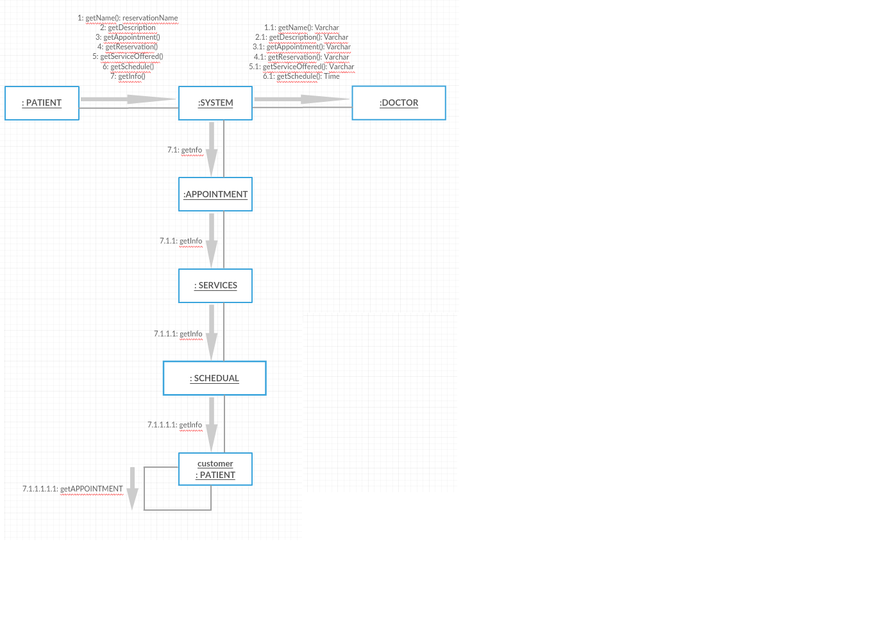**

## Class Diagram

**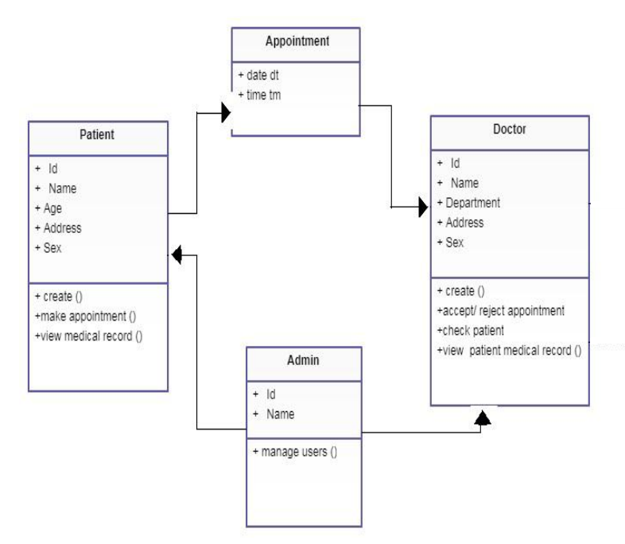**

# Chapter 5

## Implementation

With inputs from system design, the system is first developed in small programs called units, which are integrated in the next phases. Each unit is developed and tested for its functionality which is referred to as Testing.

## Code details

With inputs from system design, the code details are as follows:

Front-End: HTML, CSS, JS, and Bootstrap

Backend: PHP, JS

# Chapter 6

## Development of computer program

In the first place, we should consider all the necessary things to run effectively the website. There are three types of resources that we will need:

**Hardware**: all the physical devices needed

**Software:** all the programs needed in our hardware

**Developers:** people that can code the project

## Hardware

|  |  |  |
| --- | --- | --- |
| **SL** | **Hardware** | **Description** |
| 01 | Processor | 2.4 GHz Processor speed |
| 02 | Memory | 2 GB RA |
| 03 | Disk Space | 500 GB |

## Software

|  |  |  |
| --- | --- | --- |
| **SL** | **Software** | **Description** |
| 01 | Operating System | Windows Server 2008,Windows7 |
| 02 | XAMP | Local host |
| 03 | IDE | Notepad/notepad++/sublime |

## Tool Used

1. HTML
2. CSS
3. BOOTSTAP
4. JAVASCRIPT
5. PHP

## User interface Component

### Home Page

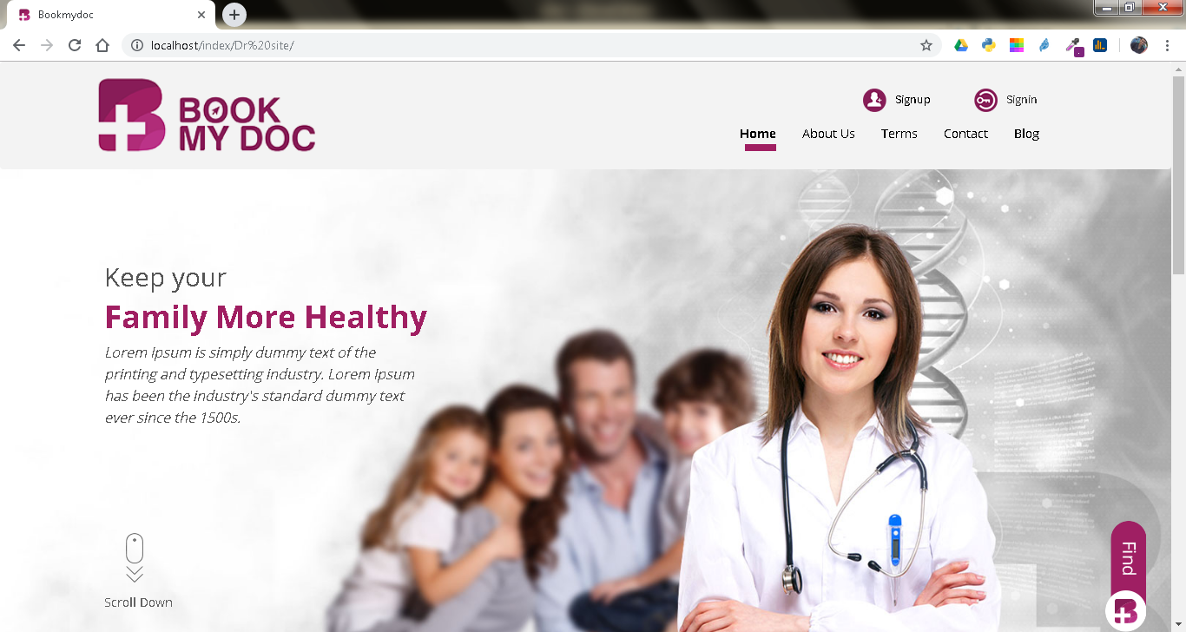

### Footer

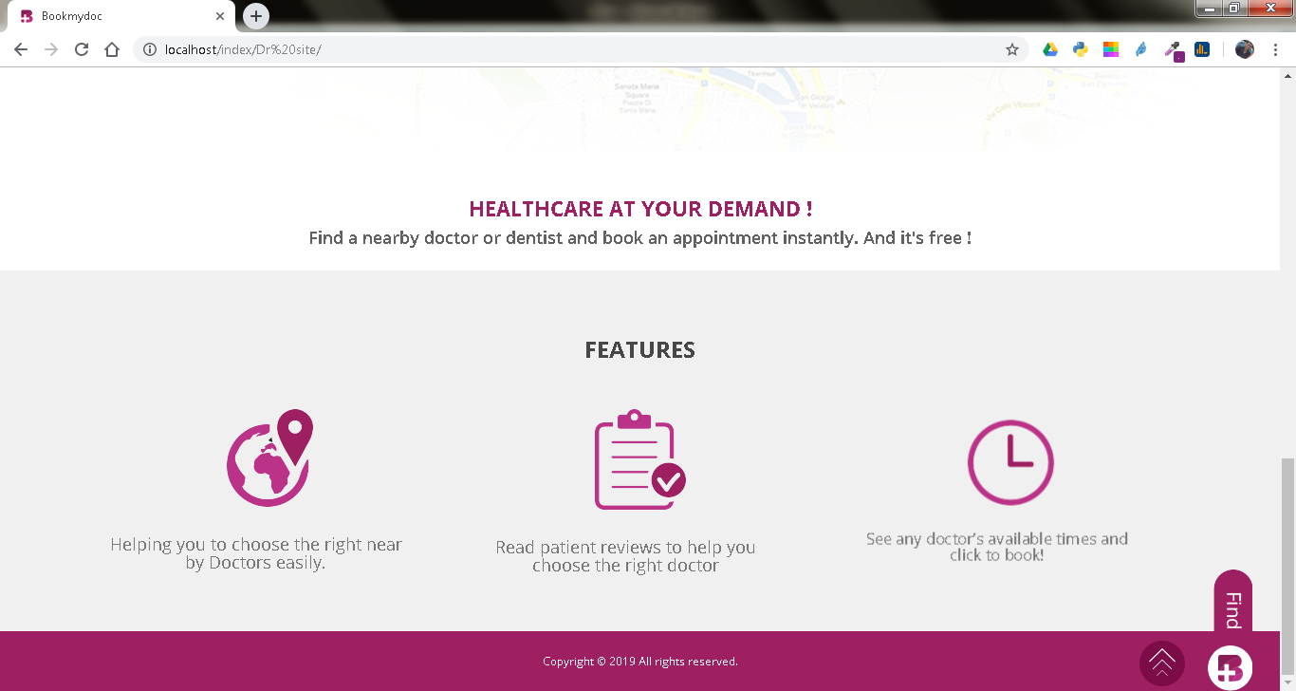

### Contact

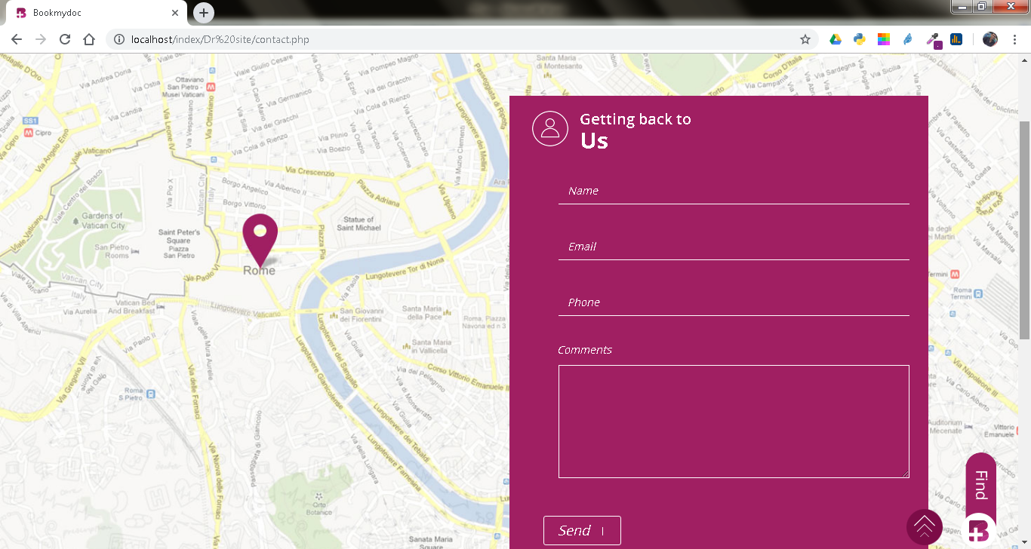

### SignUP

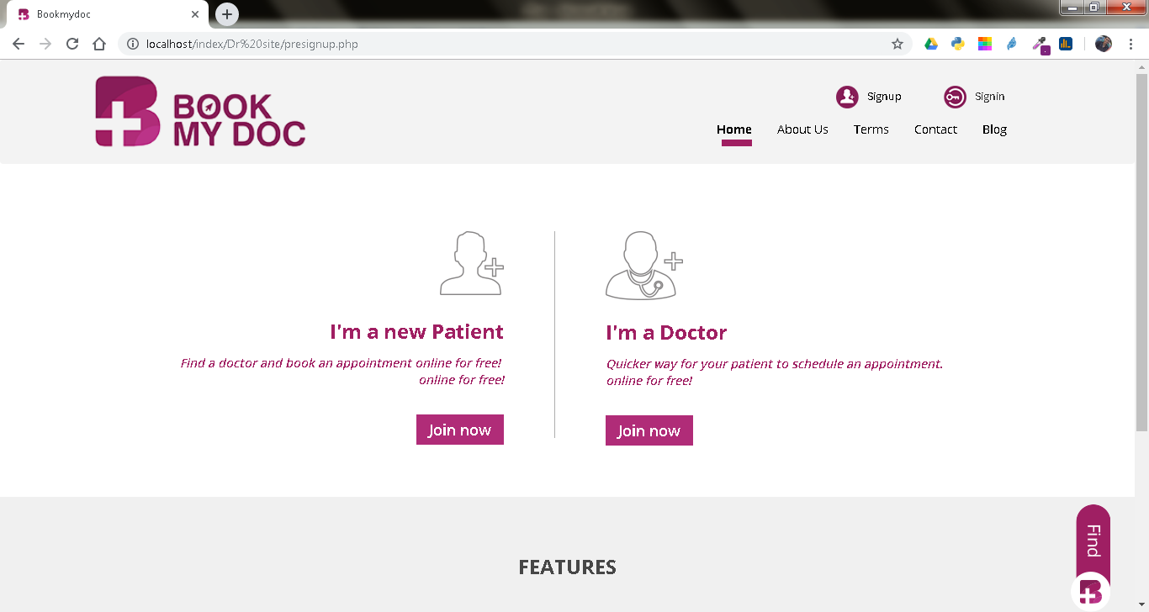

### Signin

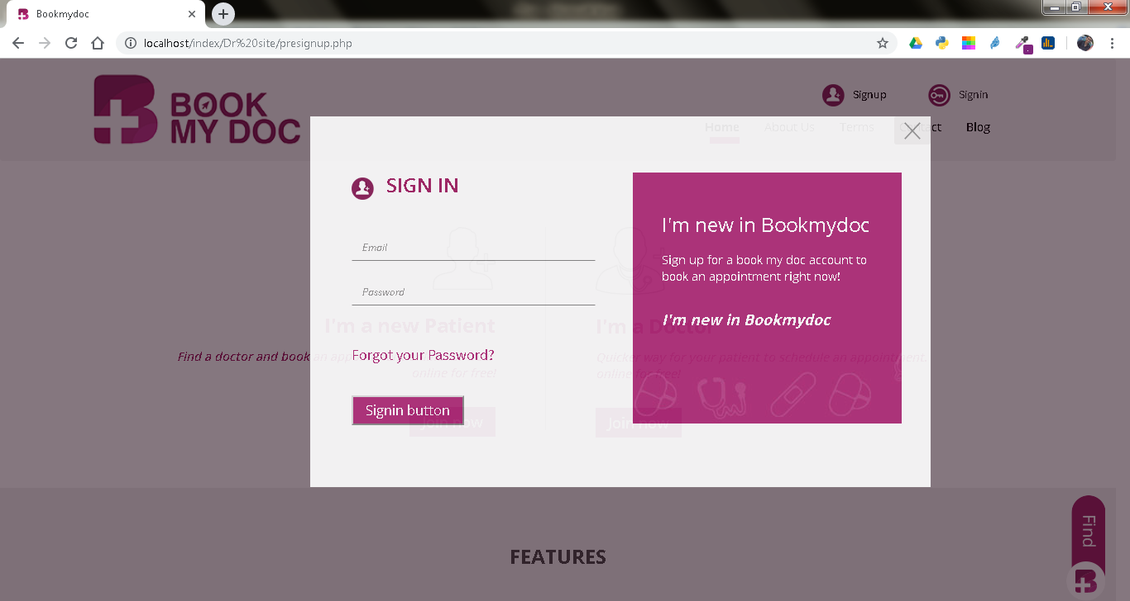

### Search

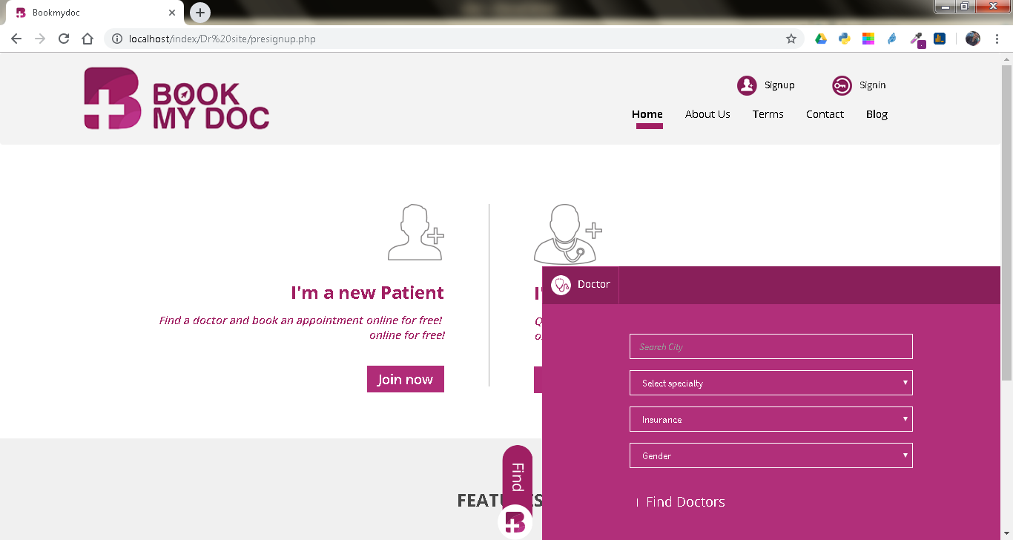

## Program Coding

### Home

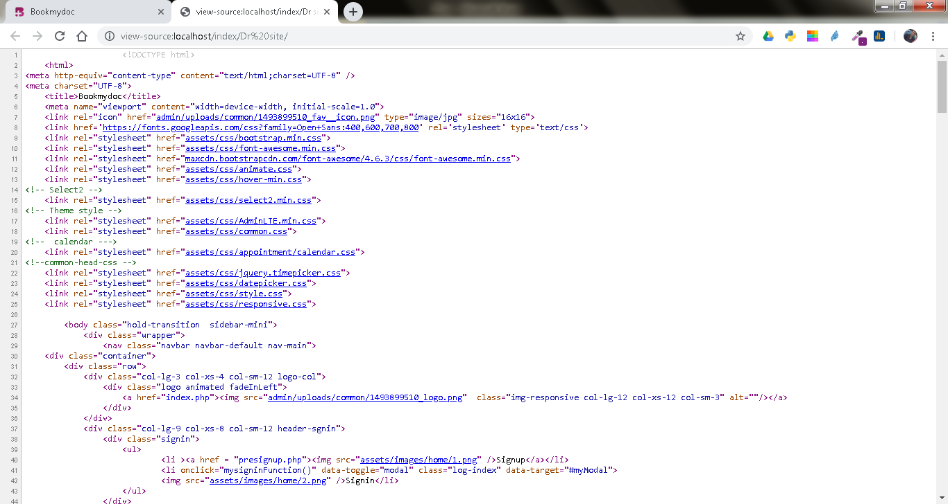

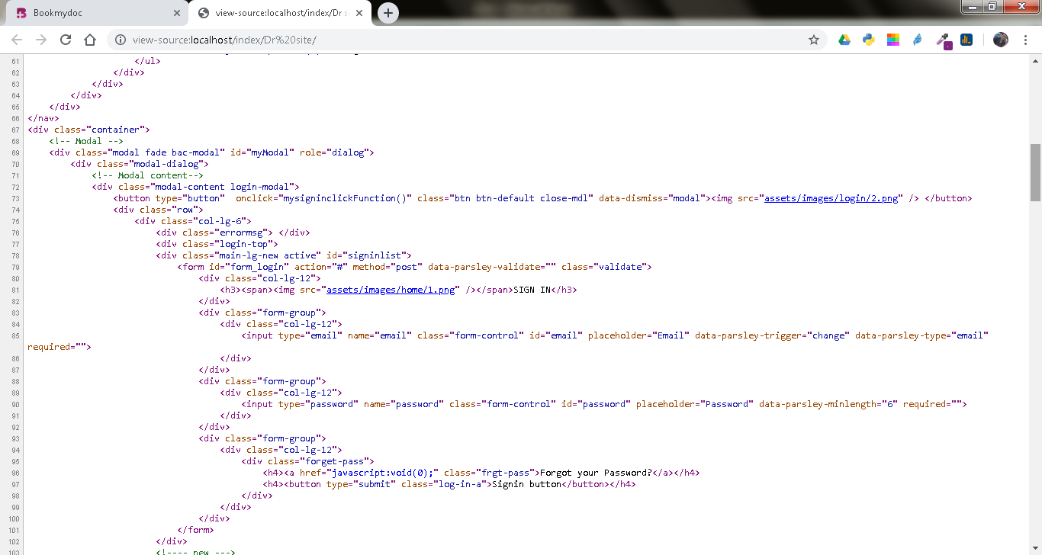

### Footer

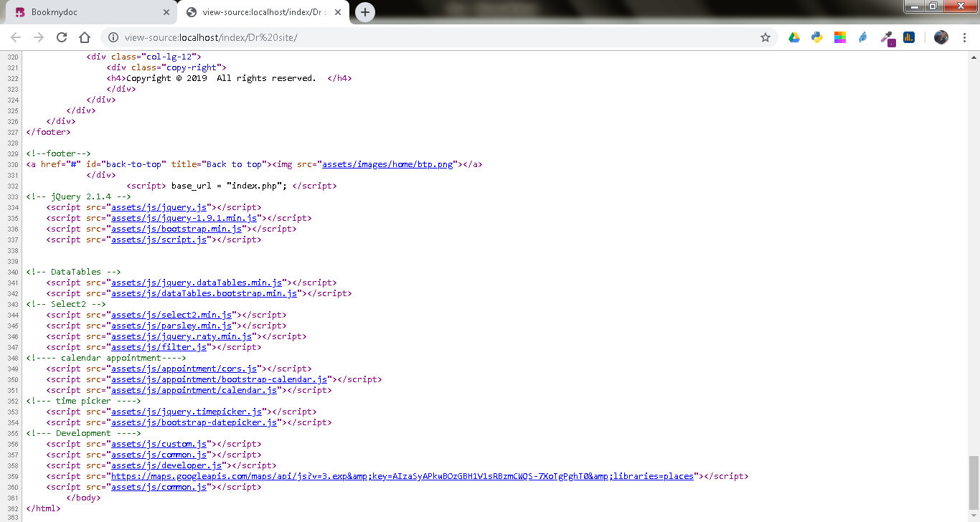

### SignUP

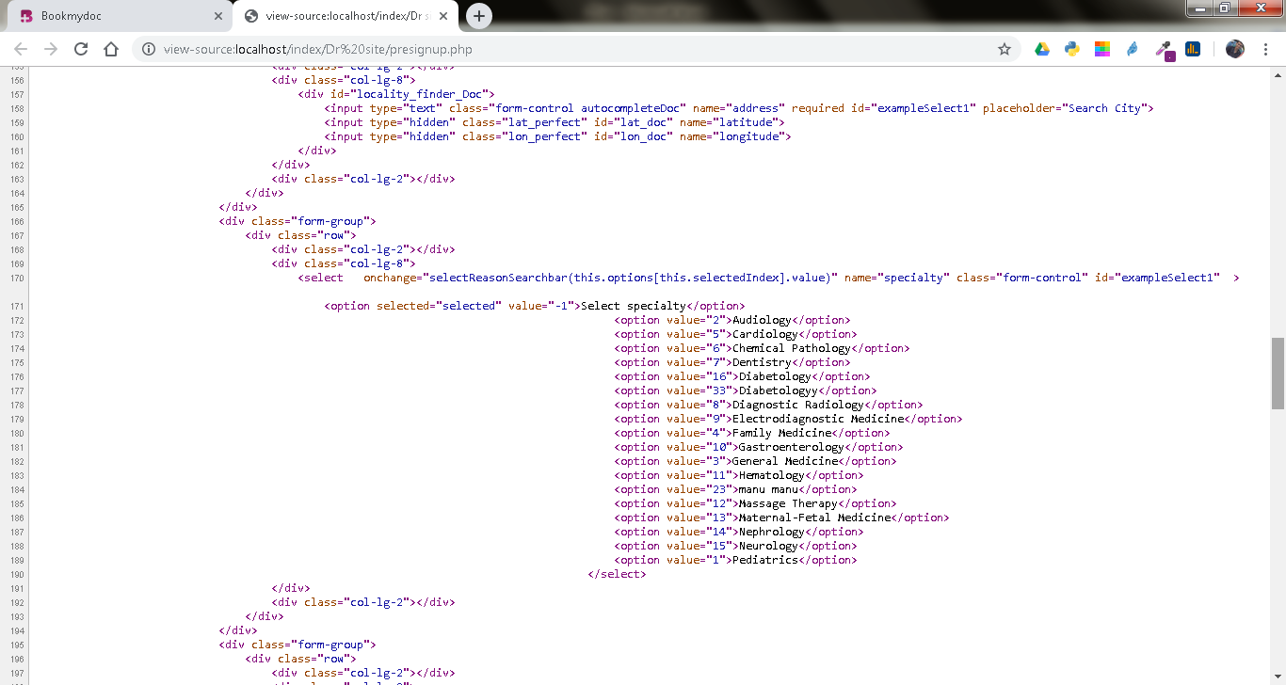

### SignIn

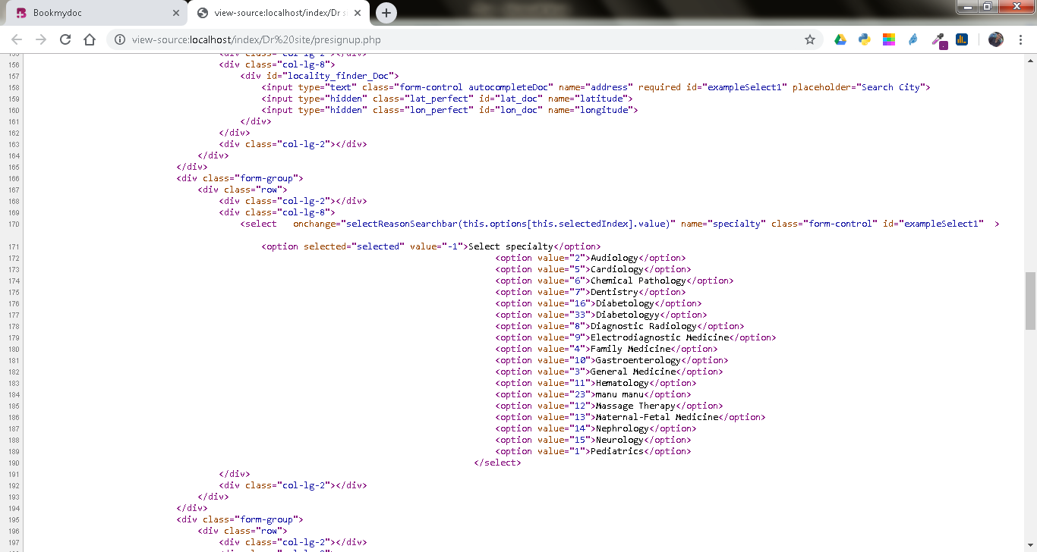

### Contact

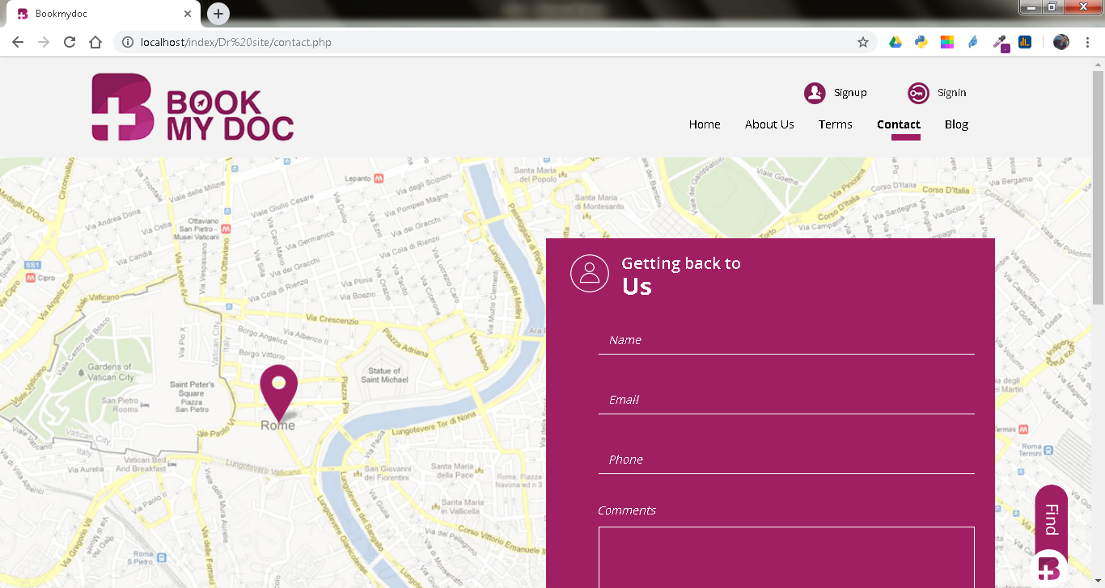

# Chapter 7

## Testing

Each one of the requirements need to have a way to evaluating if they have been successfully done or not. In this section, we will put the different tests that will be conducted to see if the previous requirements have been implemented successfully.

## Type of Testing involved

1. Reliability testing
2. Usability testing
3. Space testing
4. Portability testing
5. Performance testing
6. Security testing
7. Scalability testing
8. Ethic testing

## Testing Report

### Reliability testing

Reliability testing is used to find out the errors, bugs or failures before the deployments of the final product.

Unluckily, software reliability cannot be directly measured as of now. Other factors should be measured instead such as development process, faults and failures found.

We made ‘x’ number of tests (usually 7) and saw how many of them failed in some sort. When a requirement succeeded, we proceeded with the development.

### Usability testing

Usability is tested by testers to see how easy it is to use the system. It is a black box testing (internal structure/ design/ implementation of the item being tested is not known to the tester) which will also reveal how comfortable with our system they are. It will test how easy the website is to use and how easy is to learn to use.

The tests that we will perform are:

Take some testers and give them some tasks to do such as make an appointment, create an account or see the appointments made by them. It could be also done for doctors but with different things to do. While they do it, we time them and see how much time they needed to do the action. If they accomplished it in less than the amount specified in a requirement, than the test was successful.

At the end of the testing, each tester will give his/her feedback as to what things they found really nice and what things they found badly developed, hard to spot or just things to improve on in general.

### Space testing

Size testing is used to see how much memory, both RAM and/or hard drive is needed for a correct functioning of a website.

We require that users do not need to install any additional software or download anything other than a browser with which they will access our website.

This requirement is quite easy to compute. We will see if we can use a website with just a browser installed on a PC.

**Portability testing**

We will see how the website functions on different devices. We used it on different browsers (Chrome, Firefox, Opera, Safari) and saw website’s performance on all of them.

**Performance testing**

Performance testing tests how fast a system responds in different environments. It also measures the system workload.

If finance allows it, a clinic could hire a lab to do quantitative tests such as measuring the response time in MIPS (millions of instructions per second).

Since we are limited in budget, we will test each functionality several times and compute the average time for each one of them. The average time should be less than 5 seconds.

And for concurrent users, we will just connect several users to a website at the same time and see how it performs. If all will be fine, the requirements will be satisfied.

**Security testing:**

Security testing checks whenever a software/website is secure or not by checking is it is vulnerable to attacks, of anyone can access a database or if anyone can login without authorization. Several test cases exist to check some of the security of the website that we performed before deployment phase:

• Access bookmarked page without logging into the system

• Check password strengths

• Restricted pages can’t be accessed by restricted users

### Scalability testing

Scalability testing tests the ability of a system to continue to function when more size or bandwidth is required.

We will achieve it by using a remote web hosting that will enable us to control the amount of bandwidth we will have and the storage space provided to us

### Ethic testing

When users will make appointments, they will be asked to read their rights and obligations and accept them. This will be asked every time they make an appointment.

The risk of services will be notified by the doctors in a visit.

# Chapter 8

## Results

Making clinic appointments shouldn’t be hard, but often due to the manual way of making appointments, patients find it’s hard to make appointments with their desired doctor. Often patients have to wait in long queues and yet sometimes they won’t be able to book their appointments. Clinic Appointment System is an easy solution for such patients. They don’t have to wait in endless queues or ask someone to do them a favour, because Clinic Appointment system has everything they need to make an appointment with their desired doctor. Clinic Appointment System comes with a clean and responsive interface, so that user can make appointments from every device, all they need is an internet connection.

## Evaluation

As discussed in the previous chapters the main problem that we addressed was dealing with patient, doctor and hospital document. It is the above situation that above us to techniques of developing this Online Doctor Appointment System to be used the Patient, Doctor and Hospital to enable them to handle details on policies efficiently and effectively. The Project has implemented most of the objectives stipulated in earlier chapter. The Online Doctor Appointment System offers a number of benefits to the user

## Conclusions and Further Work

The core reason for the establishment of computerizing Online Doctor Appointment System is to enable the convenient, fair environment between patient and doctors. Therefore the IT used should support the core objective of the system if it is to remain relevant to the hospital.

The idea of this feature came into my mind because the patients living in faraway places have to come multiple times for the “laboratory test results” and “doctors' advice/ follow-up appointment” based on those tests. So, after the laboratory tests, patients just have to book an online time and they can have an online conversation with some fewer fees. Online payment is again another feature I would like to add at later stages. And laboratory testing services

# Chapter 9

## References

[1] Software design description, http://en.wikipedia.org/wiki/software\_design\_description, retrieved on January 5, 2015

[2] Chutisant Kerdvibulvech+, Nwe Ni Win, The Dentist online Reservation System Design and Implementation Web Based Application and Database Management System Project” , (ICETC2012) IPCSIT vol.43(2012)

[3] Xiuju Zhan, Xiufeng Lin, “Design and Implimentation of Clinic Appointment Registration System”, Scientific research, Engineering, 2013, 5, 527-529

[4] Mohd Helmy Abd Wahab, Norlida Hassn, Zaidah Wali Mohd,Hafizul Fahri Hanafi,” WEB BASE INTELLIGENT APPOIINTMENT SYSTEM”, Seminar Kebangsaan E-komuniti 2009 Merapatkan Jurang Digital: asyarakat Berpengetahuan, Model Malaysia

[5] Testing, http:// en.wikipedia.org/wiki/Sorftware\_testing, retrieved on March 21, 2015. XAMPP, http:/en.wikipedia.org/wiki/XAMPP, retrieved on March 11, 2015.