**Data Visualization Project**

**Srikar Bokka-999903957**

**Niharika Kompally-999903860**

**Kathyayini Paruchuri-999903474**

In this project we are trying to delve into different libraries like pandas, matplotlib and seaborn.

Problem 1:

A histogram using the data in Birthrate column and For the tallest bar when creating a histogram of the Literacy rate, what are the lower value and upper value?

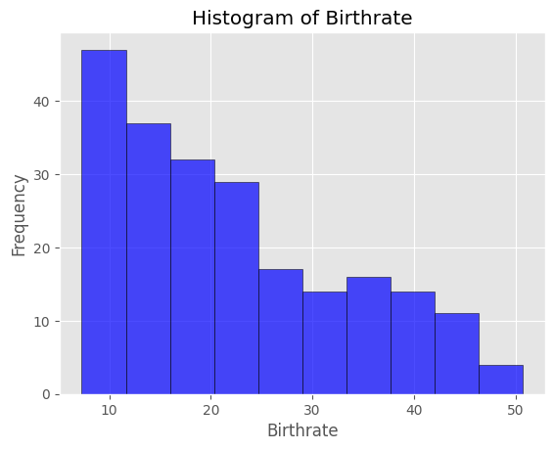

The **Birthrate histogram** displays the distribution of birth rates across countries. Most countries have moderate birth rates, while fewer fall into the very low or very high ranges. The tallest bar represents the range with the most countries, indicating where birthrates are most common, and the smallest bars show rarer birthrate ranges.

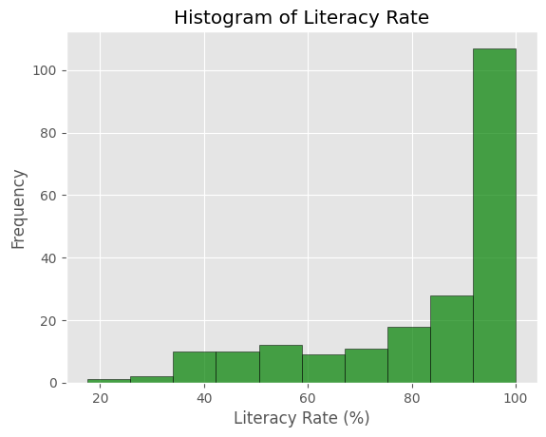  
The **Literacy Rate histogram** shows the spread of literacy percentages. The tallest bar falls between **91.76 and 100**, meaning most countries have literacy rates in that range. The shortest bars indicate literacy levels that are rare among countries, either very low or very high.

Problem 2:

Scatter plots for disclosing relationships.

1. A simple scatter plot of area versus population of the countries, i.e. x is “Population”, and y is “Area”.

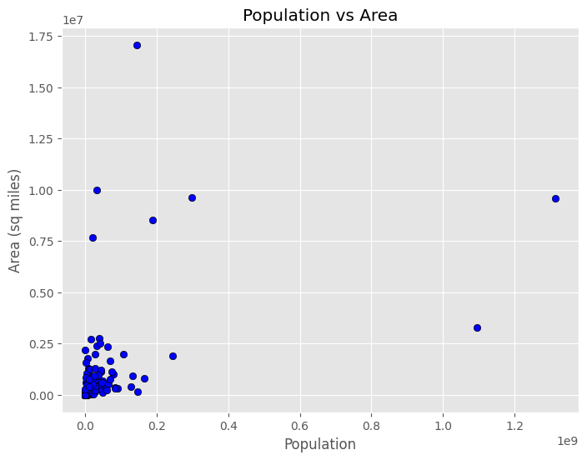

Here,each point represents a country, positioned based on its population (x-axis) and area in square miles (y-axis).

The plot helps reveal patterns, like whether larger countries (by area) also tend to have larger populations — or whether some countries are very large but sparsely populated.

b)Scatter plot for each pair of columns: Birthrate, Deathrate, Infant mortality, and GDP

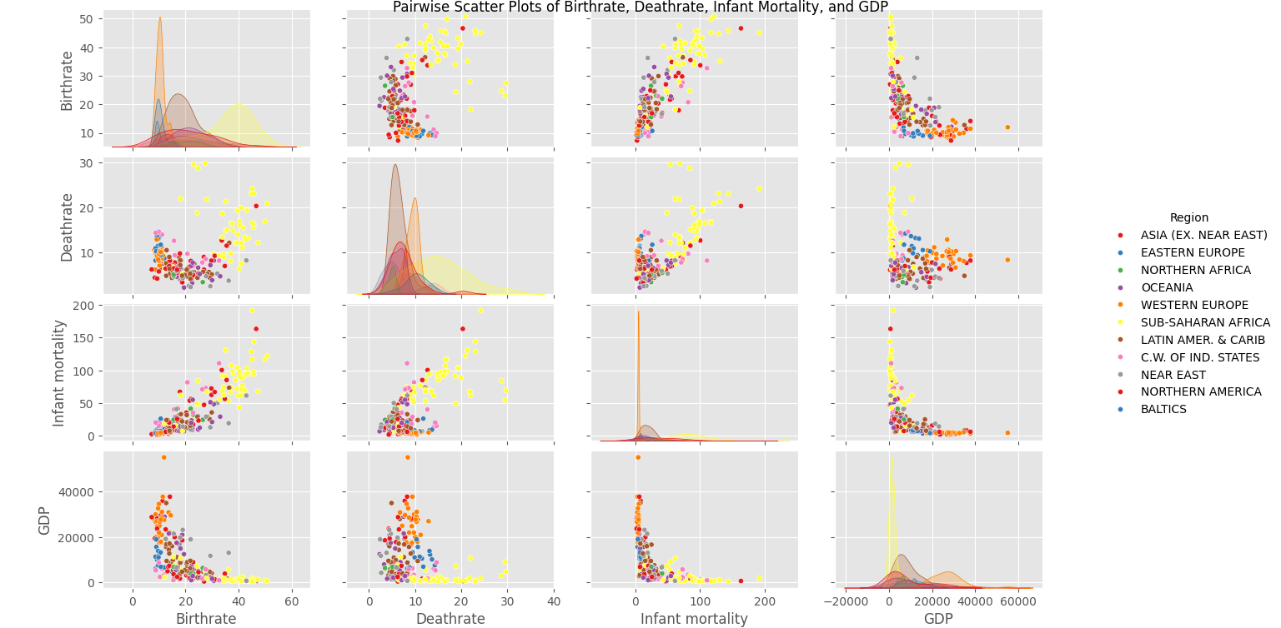

We are generating a **pairplot** showing all pairwise scatter plots between **Birthrate**, **Deathrate**, **Infant Mortality**, and **GDP**. The diagonal plots show the distribution of each individual variable.

In the pairplot, coming to the **strongest negative correlation** is often seen between **GDP and Infant Mortality** — as GDP increases, Infant Mortality tends to decrease.  
A **mild negative correlation** might exist between **GDP and Birthrate** — richer countries often have lower birthrates.  
Meanwhile, **Birthrate and Infant Mortality** could show a **positive correlation** — countries with higher birthrates may also have higher infant mortality rates.  
The strength and direction of these relationships can be confirmed by calculating the **correlation matrix**.