**POST ROOT : /api/register**

**POSTMAN OUTPUT:**

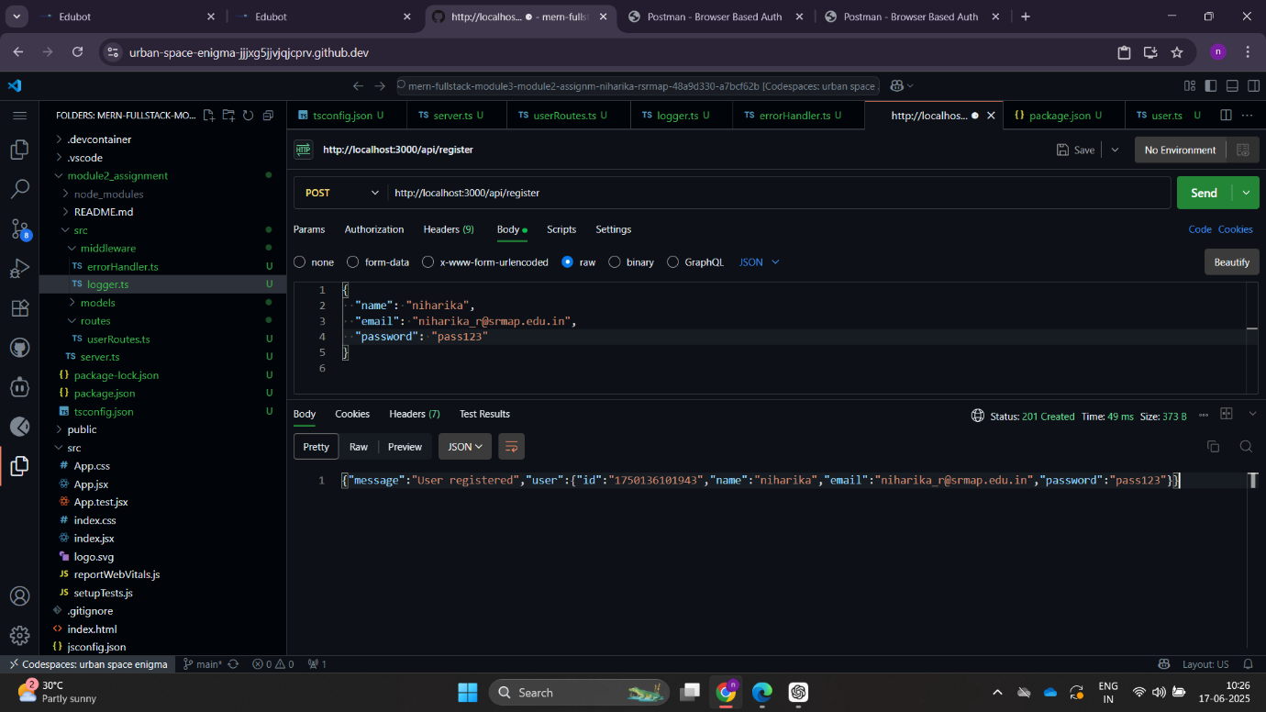

**USER SAVED IN DB:**

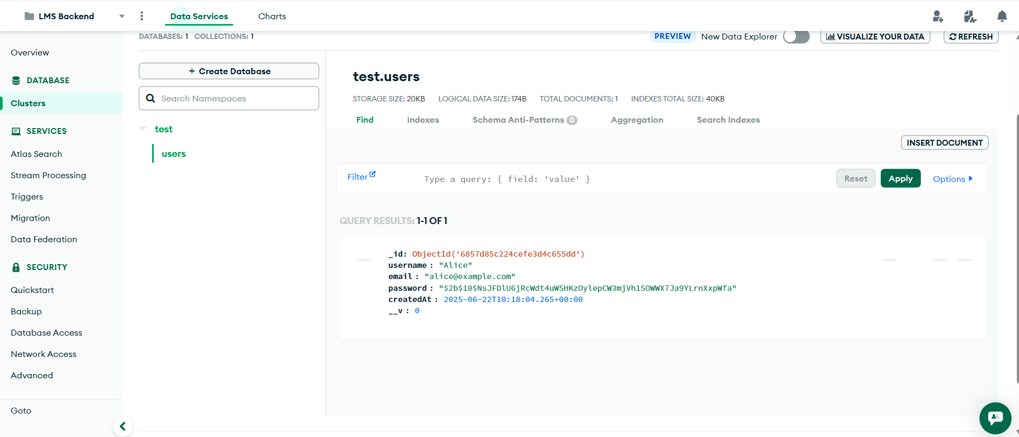

**WHEN SAME USER TRIES TO REGISTER:**

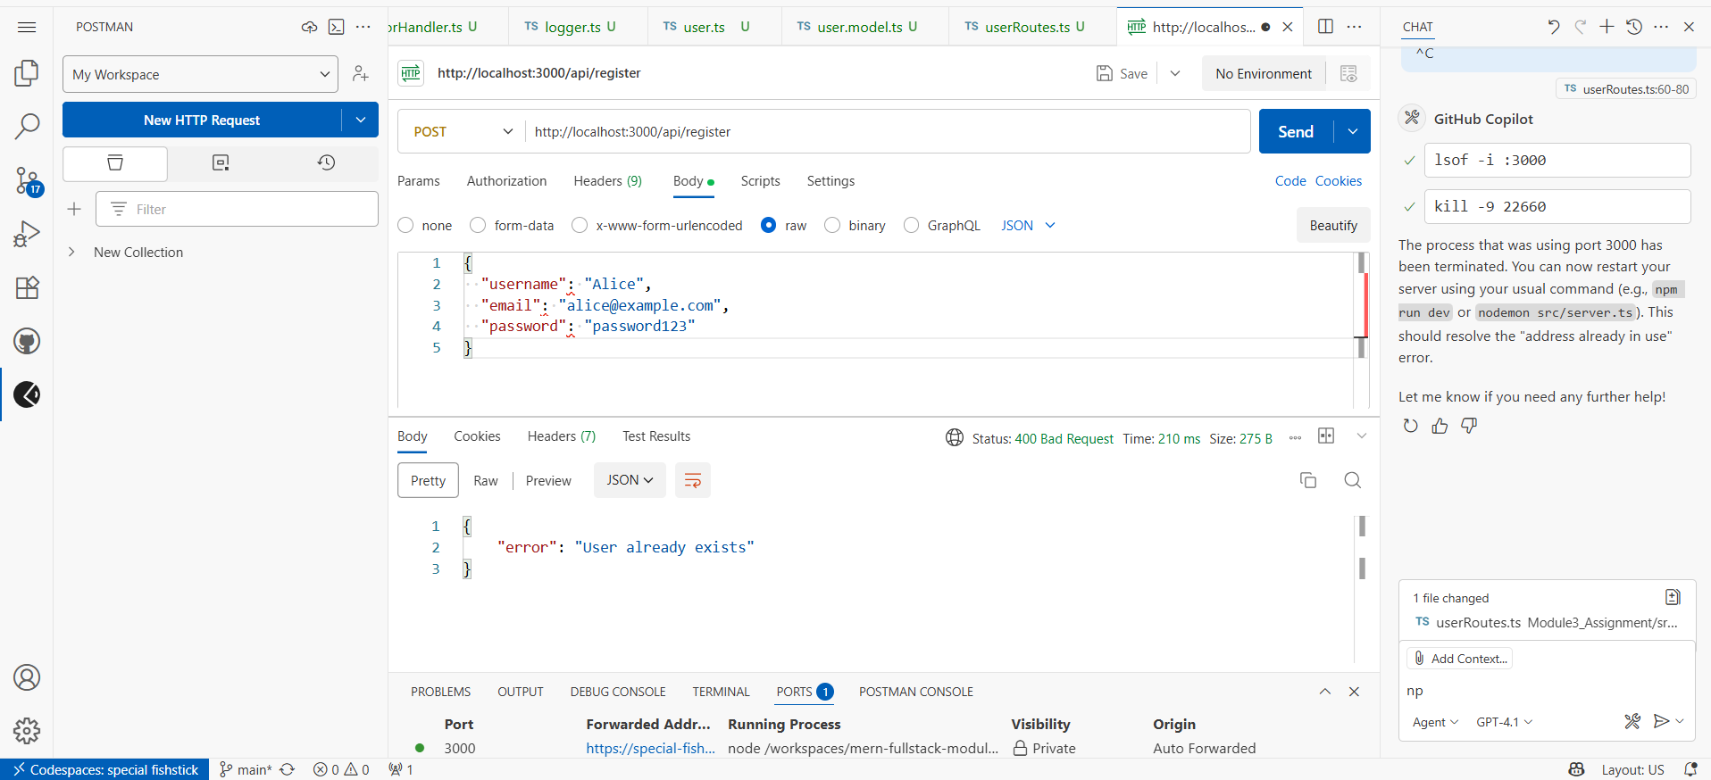

**GET ROOT : /api/user/:id**

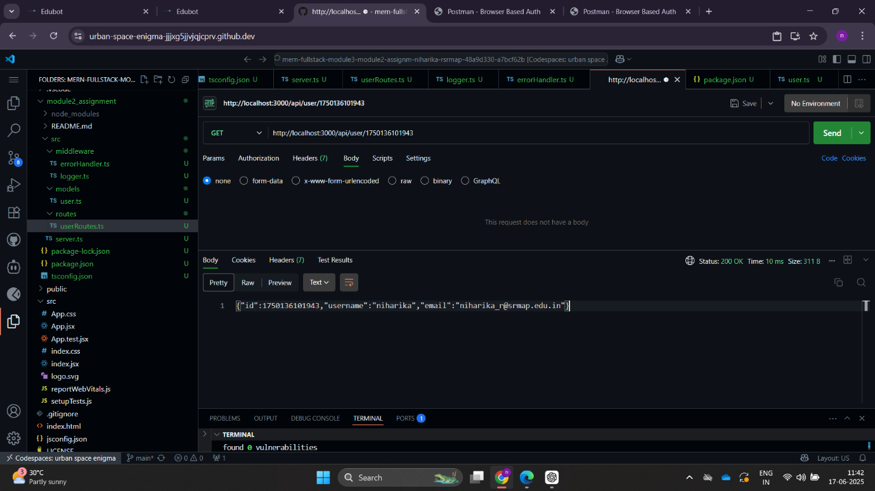

**GET ROOT : /api/users**

