ASSIGNMENT – 7(B)

1. Implementing Accessibility of members across packages and classes

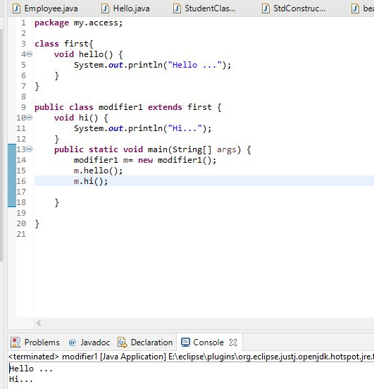

By using different packages.

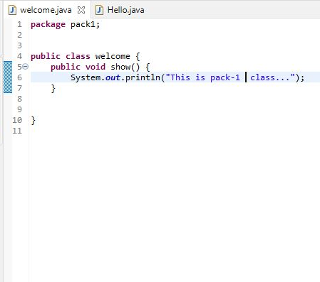

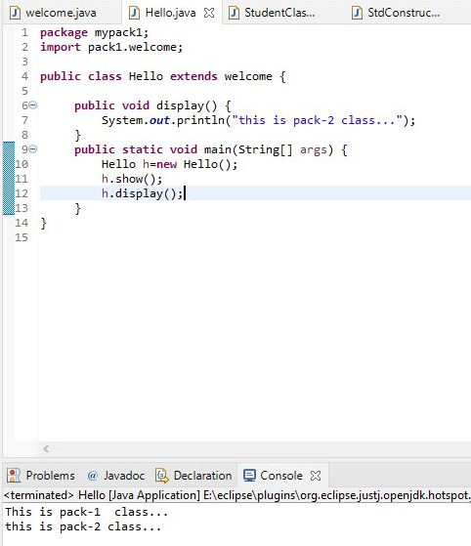

1. create a PrivateAccess class, private data members when we are trying to call the private data member and method of a PrivateClass class it gives us a compile-time error because private data members and methods have an access level to PrivateClass class only.

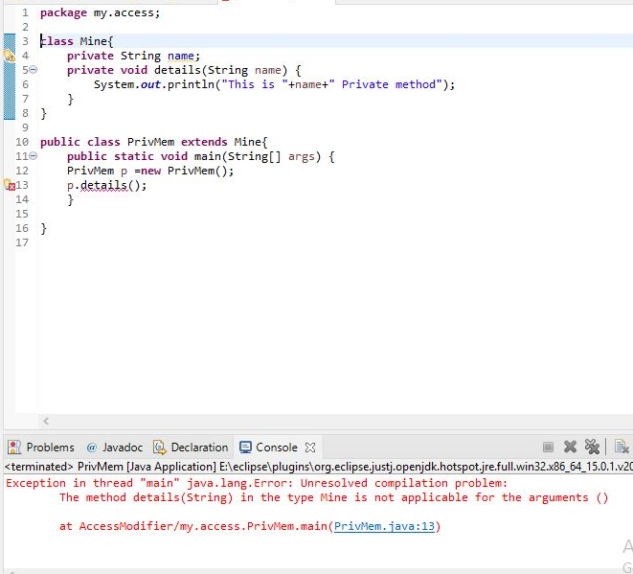

1. create a class ProtectedClass under a package pack1 in which we declare a protected method show(), create a class ProtectedAccess under a package mypack1 and import a package pack1.

