Assignment -8(a)

1. Create sample classes to understand boxing & unboxing.

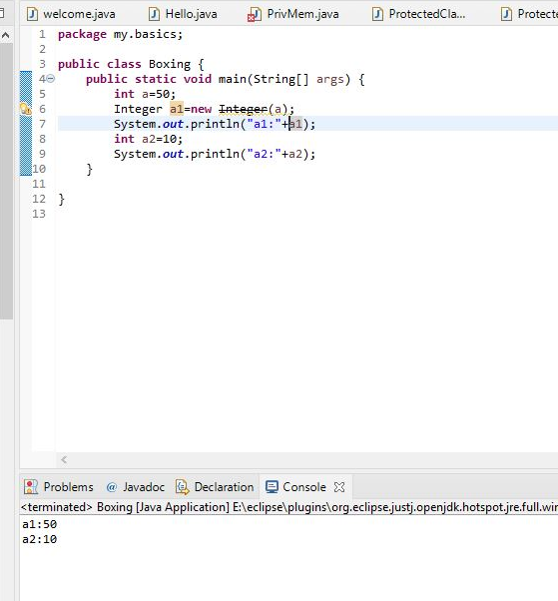

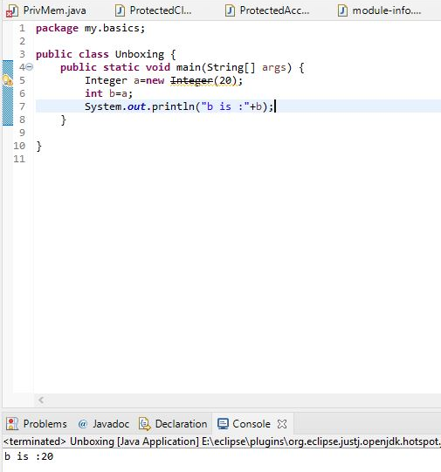

1. Use different methods of java defined wrapper classes.
2. **package** my.basics;
3. **public** **class** WrapperClass {
4. **public** **static** **void** main(String[] args) {
5. **int** a=5;
6. **float** b=50.4f;
7. **short** c=30;
8. String d="Niharika";
10. Integer a1=**new** ~~Integer~~(a);
11. Float b1=**new** ~~Float~~(b);
12. Short c1=**new** ~~Short~~(c);
13. String d1=**new** String(d);
14. System.***out***.println("Wrapped Objects:");
15. System.***out***.println(a1);
16. System.***out***.println(b1);
17. System.***out***.println(c1);
18. System.***out***.println(d1);
20. **int** a2=a1;
21. **float** b2=b1;
22. **short** c2=c1;
23. String d2=d1;
24. System.***out***.println("Un-Wrapped Objects:");
25. System.***out***.println(a2);
26. System.***out***.println(b2);
27. System.***out***.println(c2);
28. System.***out***.println(d2);


32. }

}

OUTPUT:

Wrapped Objects:

5

50.4

30

Niharika

Un-Wrapped Objects:

5

50.4

30

Niharika

3.create a class and convert all primitive datatypes into wrapper classes.

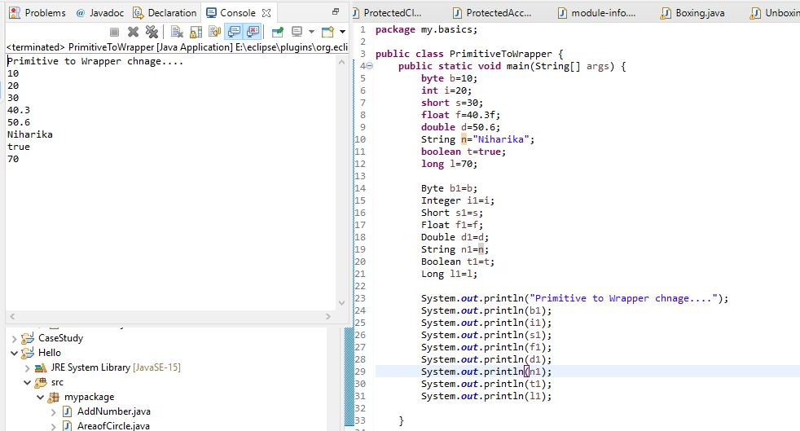

*4.create an EnumClass define* enum inside class traverse it.

1. **package** my.basics;
2. **enum** leveling{
3. ***First***,***Second***,***Third***
4. }
5. **public** **class** EnumClass {
6. **public** **static** **void** main(String[] args) {
7. System.***out***.println("Objects are:");
8. **for**(leveling l:leveling.*values*()) {
9. System.***out***.println(l);
11. }
12. }

}

Output:

Objects are:

First

Second

Third

5.Create a class ArrayEx and sort the elemnts by using ArraySort method.

**package** my.basics;

**import** java.util.Arrays;

**public** **class** ArraySort {

**public** **static** **void** main(String[] args) {

System.***out***.println("Sorted Array is ...");

String[] name= {"Niharika","Manish","Ritika","Nupur","Sunny","Dev"};

Arrays.*sort*(name);

System.***out***.println(Arrays.*toString*(name));

}

}

OUTPUT:

Sorted Array is ...

[Dev, Manish, Niharika, Nupur, Ritika, Sunny]

6. Create a class and apply static import package into that class;

**package** my.basics;

**import** **static** java.lang.System.*;

**public** **class** StaticImport {

**public** **static** **void** main(String[] args) {

System.***out***.println("Hello, Niharika this side...");

}

}

OUTPUT:

Hello, Niharika this side...

7.Create a class and create deafault and param construtcor and create constructor chaining.

1. **package** my.basics;
2. **public** **class** ConstructorChaining {
3. **public** ConstructorChaining() {
4. **this**("Niharika");
5. System.***out***.println("This is Default Constructor");
6. }
7. **public** ConstructorChaining(String s) {
8. **this**(23,"Mansi");
9. System.***out***.println("This is parametrized with single parameter");
10. }
11. **public** ConstructorChaining(**int** n , String s) {
12. System.***out***.println("This is param constructor with 2 parameters");
13. }
14. **public** **static** **void** main(String[] args) {
15. ConstructorChaining c=**new** ConstructorChaining();
17. }

}

OUTPUT:

This is param constructor with 2 parameters

This is parametrized with single parameter

This is Default Constructor