**CLUB REGISTRATION SYSTEM**

**NIHARIKA TAILOR**

**MCA/10022/19**

**Guided By –**

**INDRAJIT MUKHERJEE SIR**

**INTRODUCTION**

* This Java web development tutorial will teach you how to do basic database functions that are CREATE RETIEVE UPDATE and DELETE . using Mysql Database. The INSERT, SELECT, UPDATE and DELETE statements can be used in any database system, because this is support by all relational database systems.
* We will learn how to INSERT, SELECT, UPDATE and DELETE in database by writing code to manage the **records** table in the database named **mysql**.
* **records**table consist of following columns **name, location, charges**.

## PURPOSE

* The system displays the list of all issues that are open, closed, in progress.
* If the user can get registered by clicking on the register button and provide the required information as specified.
* Each time the registered customer come on to the site he/she can makes use of the user name and the password that is allocated to him.

**SOFTWARE & HARDWARE REQUIREMENTS**

**Software requirements -**

Operating System : Windows 10 Pro

User interface : Java, Servlets, JSP, Html, CSS

Database : XAMPP

Documentation Tool : Ms Office

IDE : Apache Netbeans IDE 12.3

Server : Tomcat 8.5

# Hardware requirements –

Processor : Intel® Core™ i3-6006U CPU @ 2.00GHz 2.00GHz

RAM : 4 GB

Hard Disk : 1 TB

System Type : 64-bit OS, x64-based processor

**DESIGN AND PROCEDURE**

* Created 5 jsp files(index.jsp, view.jsp, registration.jsp, update.jsp, delete.jsp)
* Created 1 css file for styling(style.css)
* Created database(mysql) with 1 table(record) and 3 columns(name, game, fee)
* Connected jar file
* Added jdbc connection

**INDEX.JSP**

In this page system shall be able to record the user details then system shall be able to retrieve user details.

<%@page contentType="text/html" pageEncoding="UTF-8"%>

<%@page import="java.sql.*" %>

<%

if(request.getParameter("submit")!=null)

{

String name = request.getParameter("name");

String game = request.getParameter("game");

String fee = request.getParameter("fee");

Connection con;

PreparedStatement pst;

ResultSet rs;

Class.forName("com.mysql.cj.jdbc.Driver");

con = DriverManager.getConnection("jdbc:mysql://localhost:3306/mysql?zeroDateTimeBehavior=CONVERT_TO_NULL","root","");

pst = con.prepareStatement("insert into record(name,game,fee)values(?,?,?)");

pst.setString(1, name);

pst.setString(2, game);

pst.setString(3, fee);

pst.executeUpdate();

%>

<script>

alert("Record Addded Successfully");

</script>

<%

}

%>

<!DOCTYPE html>

<html>

<head>

<meta http-equiv="Content-Type" content="text/html; charset=UTF-8">

<title>JSP Page</title>

<link href="bootstrap/css/bootstrap.css" rel="stylesheet" type="text/css" />

<link href="bootstrap/css/bootstrap.min.css" rel="stylesheet" type="text/css" />

<link rel="stylesheet" href="style.css">;

</head>

<body>

<nav>

<div class="logo">

<h2>CLUB REGISTRATION SYSTEM </h2>

</div>

<ul>

<li><a href="index.jsp">HOME</a></li>

<li><a href="view.jsp">VIEW</a></li>

<li>

<a href="registration.jsp">REGISTRATION</a>

</ul>

</nav>

</body>

</html>

**VIEW.JSP**

<%@page contentType="text/html" pageEncoding="UTF-8"%>

<%@page import="java.sql.*" %>

<%

if(request.getParameter("submit")!=null)

{

String name = request.getParameter("name");

String game = request.getParameter("game");

String fee = request.getParameter("fee");

Connection con;

PreparedStatement pst;

ResultSet rs;

Class.forName("com.mysql.jdbc.Driver");

con = DriverManager.getConnection("jdbc:mysql://localhost:3306/mysql?zeroDateTimeBehavior=CONVERT_TO_NULL","root","");

pst = con.prepareStatement("insert into record(name,game,fee)values(?,?,?)");

pst.setString(1, name);

pst.setString(2, game);

pst.setString(3, fee);

pst.executeUpdate();

%>

<script>

alert("Record Addded Successfully");

</script>

<%

}

%>

<!DOCTYPE html>

<html>

<head>

<meta http-equiv="Content-Type" content="text/html; charset=UTF-8">

<title>JSP Page</title>

<link href="bootstrap/css/bootstrap.css" rel="stylesheet" type="text/css" />

<link href="bootstrap/css/bootstrap.min.css" rel="stylesheet" type="text/css" />

<link rel="stylesheet" href="style.css">;

</head>

<nav>

<div class="logo">

<h2>CLUB REGISTRATION SYSTEM </h2>

</div>

<ul>

<li><a href="index.jsp">HOME</a></li>

<li><a href="view.jsp">VIEW</a></li>

<li>

<a href="registration.jsp">REGISTRATION</a>

</ul>

</nav>

<section class="Hero1">

<br>

<div class="col-sm-8">

<div class="panel-body">

<table id="tbl-student" class="table table-responsive table-bordered" cellpadding="0" width="100%" height="50%">

<thead>

<tr>

<th class="r20">NAME</th>

<th class="r20">GAME</th>

<th class="r20">FEE</th>

<th class="r20">EDIT</th>

<th class="r20">DELETE</th>

</tr>

</thead>

<%

Connection con;

PreparedStatement pst;

ResultSet rs;

Class.forName("com.mysql.cj.jdbc.Driver");

con = DriverManager.getConnection("jdbc:mysql://localhost:3306/mysql?zeroDateTimeBehavior=CONVERT_TO_NULL","root","");

pst = con.prepareStatement("insert into record(name,game,fee)values(?,?,?)");

String query="select * from record";

Statement st= con.createStatement();

rs=st.executeQuery(query);

while(rs.next())

{

String id=rs.getString("id");

%>

<tr>

<td class="r12">

<%=rs.getString("name")%>

</td>

<td class="r12">

<%=rs.getString("game")%>

</td>

<td class="r12">

<%=rs.getString("fee")%>

</td>

<td class="r12"><a href="update.jsp?id=<%=id %>"><h4>Edit</h4></a></td>

<td class="r12"><a href="delete.jsp?id=<%=id %>"><h4>Delete</h4></a></td>

</tr>

<%

}

%>

</table>

</div>

</div>

</div>

</section>

</body>

</html>

**REGISTRATION.JSP**

<%@page contentType="text/html" pageEncoding="UTF-8"%>

<%@page import="java.sql.*" %>

<%

if(request.getParameter("submit")!=null)

{

String name = request.getParameter("name");

String game = request.getParameter("game");

String fee = request.getParameter("fee");

Connection con;

PreparedStatement pst;

ResultSet rs;

Class.forName("com.mysql.cj.jdbc.Driver");

con = DriverManager.getConnection("jdbc:mysql://localhost:3306/mysql?zeroDateTimeBehavior=CONVERT_TO_NULL","root","");

pst = con.prepareStatement("insert into record(name,game,fee)values(?,?,?)");

pst.setString(1, name);

pst.setString(2, game);

pst.setString(3, fee);

pst.executeUpdate();

%>

<script>

alert("Added Successfully");

</script>

<%

}

%>

<!DOCTYPE html>

<html>

<head>

<meta http-equiv="Content-Type" content="text/html; charset=UTF-8">

<title>JSP Page</title>

<link href="bootstrap/css/bootstrap.css" rel="stylesheet" type="text/css" />

<link href="bootstrap/css/bootstrap.min.css" rel="stylesheet" type="text/css" />

<link rel="stylesheet" href="style.css">;

</head>

<body>

<nav>

<div class="logo">

<h2>CLUB REGISTRATION SYSTEM</h2>

</div>

<ul>

<li><a href="index.jsp">Home</a></li>

<li><a href="view.jsp">View</a></li>

<li><a href="registration.jsp">Registration</a></li>

</ul>

</nav>

<section class="Hero">

<br>

<div class="row">

<div class="col-sm-4">

<fieldset style="width: 50%;" >

<center>

<form method="POST" action="#" >

<div align="left">

<label class="r22" form-label>NAME</label>

<input type="text" class="form-control" placeholder="name" name="name" id="name" required="required">

</div>

<br>

<div align="left">

<label class="r22" form-label>GAME</label>

<input type="text" class="form-control" placeholder="game" name="game" id="game" required="required">

</div>

<br>

<div align="left">

<label class="r22" form-label>FEE</label>

<input type="text" class="form-control" placeholder="fee" name="fee" id="fee" required="required">

</div>

<br>

<div align="right">

<input type="submit" id="submit" value="submit" name="submit" class="btn btn-primary">

<input type="reset" id="reset" value="reset" name="reset" class="btn btn-warning">

</div>

</form>

</center>

</fieldset>

</div>

</div>

</section>

</body>

</html>

**UPDATE.JSP**

<%@page contentType="text/html" pageEncoding="UTF-8"%>

<%@page import="java.sql.*" %>

<%

if(request.getParameter("submit")!=null)

{

String id= request.getParameter("id");

String name = request.getParameter("name");

String game = request.getParameter("game");

String fee = request.getParameter("fee");

Connection con;

PreparedStatement pst;

ResultSet rs;

Class.forName("com.mysql.jdbc.Driver");

con = DriverManager.getConnection("jdbc:mysql://localhost:3306/mysql?zeroDateTimeBehavior=CONVERT_TO_NULL","root","");

pst = con.prepareStatement("update record set name = ?,game = ? ,fee = ? where id = ?");

pst.setString(1, name);

pst.setString(2, game);

pst.setString(3, fee);

pst.setString(4, id);

pst.executeUpdate();

%>

<script>

alert("Record Updated Successfully");

</script>

<%

}

%>

<!DOCTYPE html>

<html>

<head>

<meta http-equiv="Content-Type" content="text/html; charset=UTF-8">

<title>JSP Update Page</title>

<link href="bootstrap/css/bootstrap.css" rel="stylesheet" type="text/css"/>

<link href="bootstrap/css/bootstrap.min.css" rel="stylesheet" type="text/css"/>

</head>

<body>

<h1>Updation</h1>

<br>

<div class="row">

<div class="col-sm-4">

<form method="POST" action="#">

<%

Connection con;

PreparedStatement pst;

ResultSet rs;

Class.forName("com.mysql.jdbc.Driver");

con = DriverManager.getConnection("jdbc:mysql://localhost:3306/mysql?zeroDateTimeBehavior=CONVERT_TO_NULL","root","");

String id=request.getParameter("id");

pst = con.prepareStatement("select * from record where id = ?");

pst.setString(1, id);

rs = pst.executeQuery();

while(rs.next())

{

%>

<div align="left">

<label class=""form-label>NAME</label>

<input type="text" class="form-control" placeholder="name" value="<%= rs.getString("name")%>" name="name" id="name" required="required">

</div>

<div align="left">

<label class=""form-label>GAME</label>

<input type="text" class="form-control" placeholder="game" value="<%= rs.getString("game")%>" name="game" id="game" required="required">

</div>

<div align="left">

<label class=""form-label>FEE</label>

<input type="text" class="form-control" placeholder="fee" value="<%= rs.getString("fee")%>" name="fee" id="fee" required="required">

</div>

<% } %>

<br>

<div align="right">

<input type="submit" id="submit" value="submit" name="submit" class="btn btn-info">

<input type="reset" id="reset" value="reset" name="reset" class="btn btn-warning">

</div>

<div align="right">

<p><a href="index.jsp"> Click Back</a></p>

</div>

</form>

</div>

</div>

</body>

</html>

**DELETE.JSP**

<%@page import="java.sql.*" %>

<%

String id= request.getParameter("id");

Connection con;

PreparedStatement pst;

ResultSet rs;

Class.forName("com.mysql.cj.jdbc.Driver");

con = DriverManager.getConnection("jdbc:mysql://localhost:3306/mysql?zeroDateTimeBehavior=CONVERT_TO_NULL","root","");

pst = con.prepareStatement("delete from record where id = ?");

pst.setString(1, id);

pst.executeUpdate();

%>

<script>

alert("Record Deleted Successfully");

</script>

<div align="center">

<p><a href="index.jsp"> Click Back</a></p>

</div>

**STYLE.CSS**

*{

margin: 0;

padding: 0;

box-sizing: border-box;

}

a{

text-decoration: none;

}

body{

font-family: Arial,Helvetica,sans-serief;

max-width: 1440px;

margin: 0 0;

background-image: url(background.jpg);

background-size: cover;

}

nav {

margin: 0 0 0 0 ;

width: 100vw;

height: 100px;

background: black;

padding: 0 0;

display:flex;

justify-content: space-between;

align-items: center;

max-width: 1440px;

color: white;

font-weight: bold;

}

nav>.logo {

color: #00ff00;

}

nav ul {

display: flex;

}

nav ul li a {

display: inline-block;

padding: 0.5em 1.5em;

color: white;

}

.Hero {

float:inherit;

margin: 0,0,0,0;

padding-top: 10px;

height: 100vh;

max-height: 900px;

background-image: url(bg6.jpg);

background-size: cover;

display: flex;

justify-content: center;

align-items: center;

}

.Hero h1 {

color: rgb(233, 233, 233);

text-align: center;

font-size: 2.5rem;

line-height: 1.2;

width: 25ch;

}

@media screen and (max-width:808px) {

.Hero h1 {

flex-direction: column;

align-items: center;

font-size: 1.75rem;

}

nav ul {

flex-direction: column;

align-items: center;

}

footer .left {

flex: 0;

}

footer {

flex-direction: column;

}

}

ul,

ol {

list-style: none;

}

.row{

padding: 1rem;

border-radius: 70px 80px;

width: 100%;

max-width: 1430px;

height: 100%;

max-height: 1400px;

font-size: large;

}

.input-box{

width: 100%;

background: transparent;

border: 1px solid #fff;

margin: 6px 0;

height: 32px;

border-radius: 20px;

padding: 0 10px;

box-sizing: border-box;

outline: none;

text-align: center;

color: #fff;

}

.r12 {

color: aqua;

font-weight: normal;

font-size: 2rem;

line-height: 1;

width: 20ch;

}

.r20 {

color: black;

font-weight: bold;

font-size: 2rem;

line-height: 1;

width: 20ch;

}

.r22 {

color: #0000ff;

font-weight: bold;

font-size: 2rem;

line-height: 1;

width: 20rem;

display: flex;

justify-content: space-between;

}

h4{

color: #ffff00;

}

.panel-body{

}

.col-sm-4{

backface-visibility: hidden;

}

.col-sm-8{

border: 3px solid black;

backface-visibility: hidden;

box-sizing: border-box;

}

.r13{

padding: 1rem;

border-radius: 70px 80px;

width: 100%;

max-width: 1430px;

height: 100%;

max-height: 1400px;

background-image: url('https://images.unsplash.com/photo-1615708927395-8a395e039156?ixid=MnwxMjA3fDB8MHx0b3BpYy1mZWVkfDg2fDZzTVZqVExTa2VRfHxlbnwwfHx8fA%3D%3D&ixlib=rb-1.2.1&auto=format&fit=crop&w=500&q=60');

font-size: large;

background-color: #9b5de5;

border: 2px solid black;

}

.r14{

padding: 1rem;

border-radius: 70px 80px;

width: 100%;

max-width: 1430px;

height: 100%;

max-height: 1400px;

background-image: url('https://images.unsplash.com/photo-1617209637559-e5189a9c234c?ixid=MnwxMjA3fDB8MHxwaG90by1wYWdlfHx8fGVufDB8fHx8&ixlib=rb-1.2.1&auto=format&fit=crop&w=1100&q=80');

font-size: large;

background-color: #f15bb5;

border: 2px solid black;

}

.r15{

padding: 1rem;

border-radius: 70px 80px;

width: 100%;

max-width: 900px;

height: 100%;

max-height: 700px;

background-image: url('https://images.unsplash.com/photo-1616709268128-cf847356c69f?ixid=MnwxMjA3fDB8MHx0b3BpYy1mZWVkfDEzOHw2c01WalRMU2tlUXx8ZW58MHx8fHw%3D&ixlib=rb-1.2.1&auto=format&fit=crop&w=500&q=60');

font-size: large;

background-color: #fee440;

border: 2px solid black;

}

.r15 h2{

color: black;

}

.r15 p{

color: #ff6d00;

}

.r13 h2{

color: #ffffff;

}

.r13 p{

color: #ff6d00;

}

.r14 h2{

color: #ffffff;

}

.r14 p{

color: #ff6d00;

}

.Hero1 {

float:inherit;

margin: 0,0,0,0;

padding-top: 10px;

height: 100vh;

max-height: 900px;

background-image: url('http://wallpoper.com/images/00/39/12/09/wood-panels_00391209.jpg');

background-size: cover;

display: flex;

justify-content: center;

align-items: center;

}

.Hero1 h1 {

color: rgb(233, 233, 233);

text-align: center;

font-size: 2.5rem;

line-height: 1.2;

width: 25ch;

}

**ER DIAGRAM**

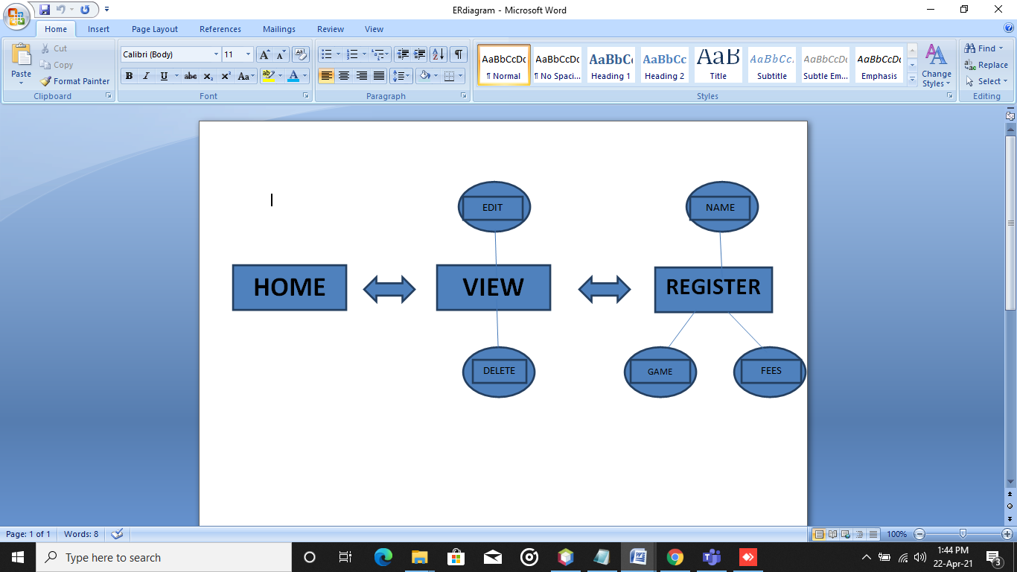

**OUTPUT OF PROJECT**

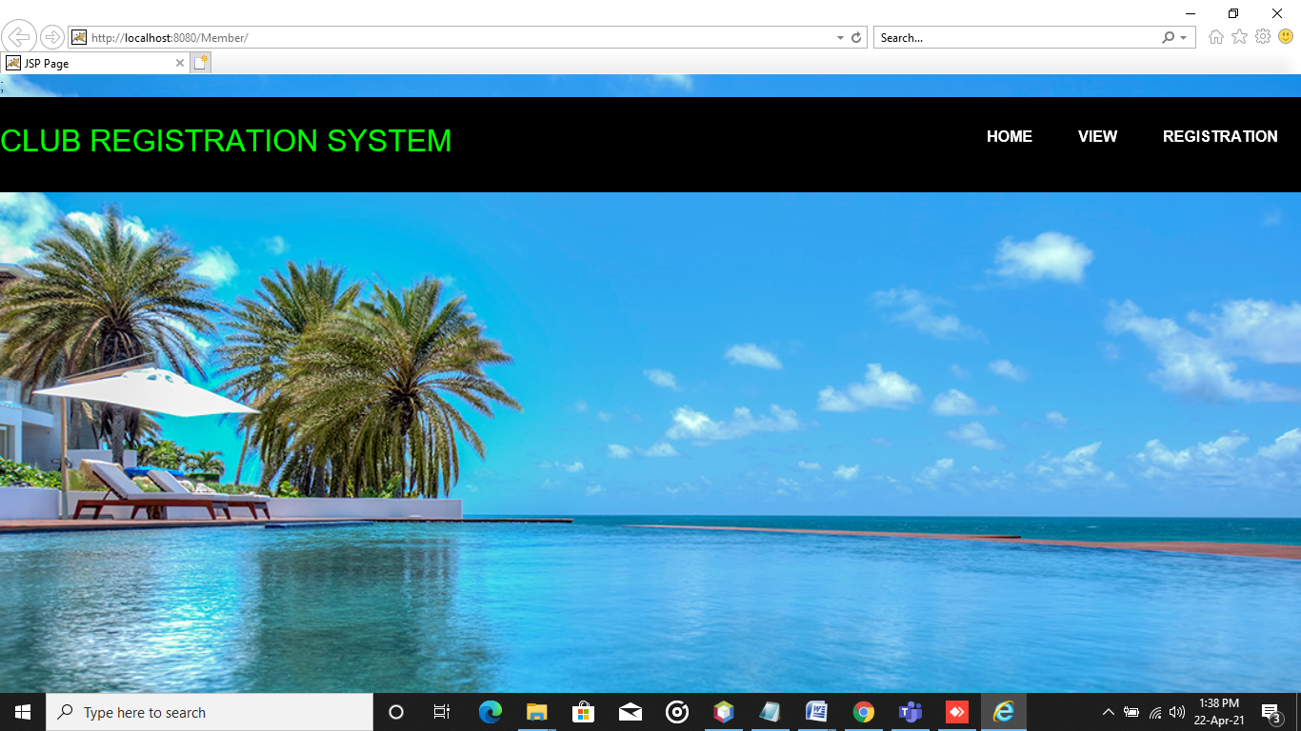

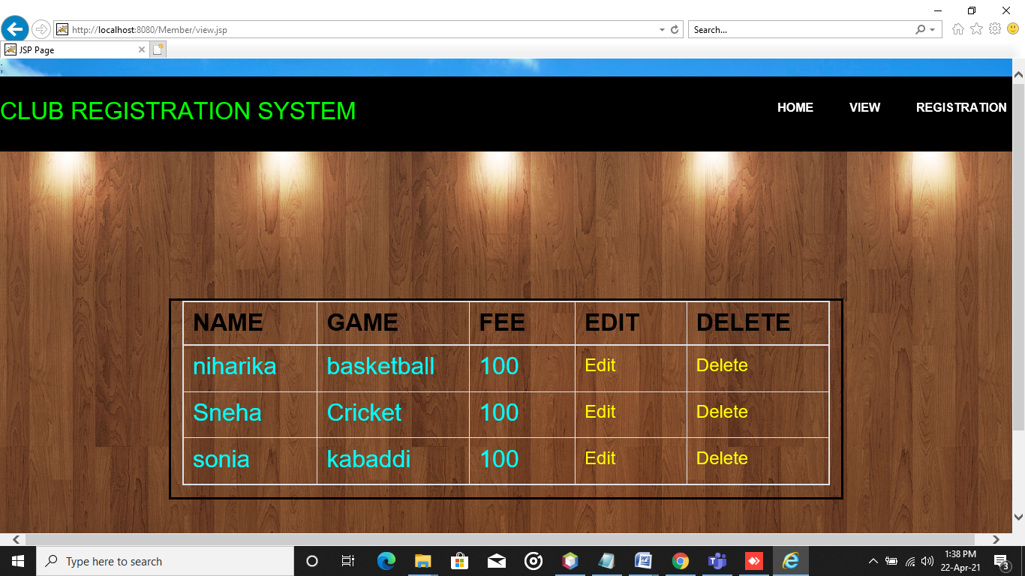

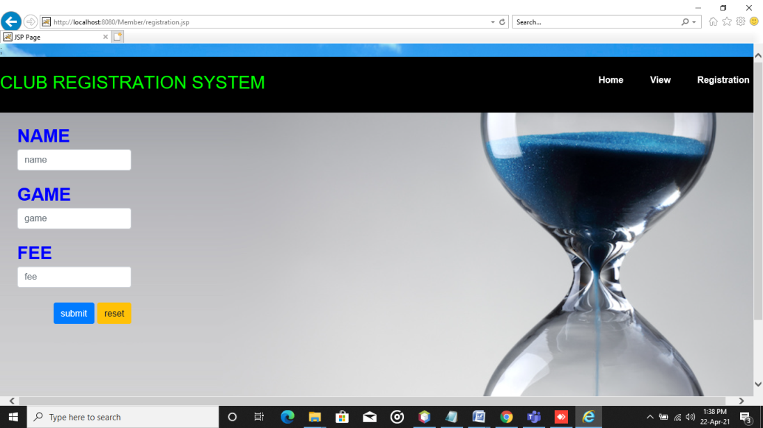

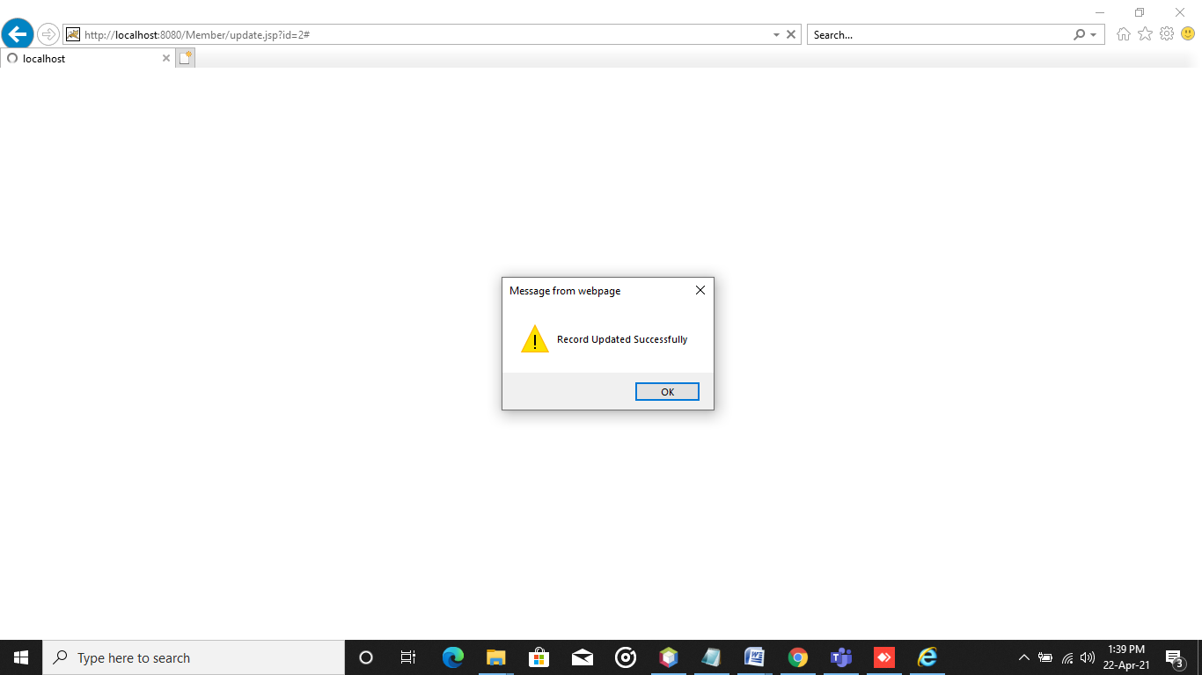

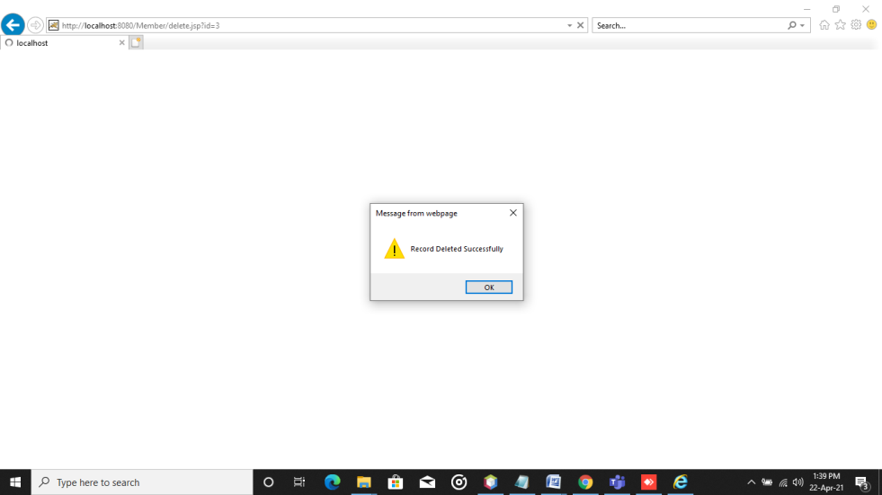

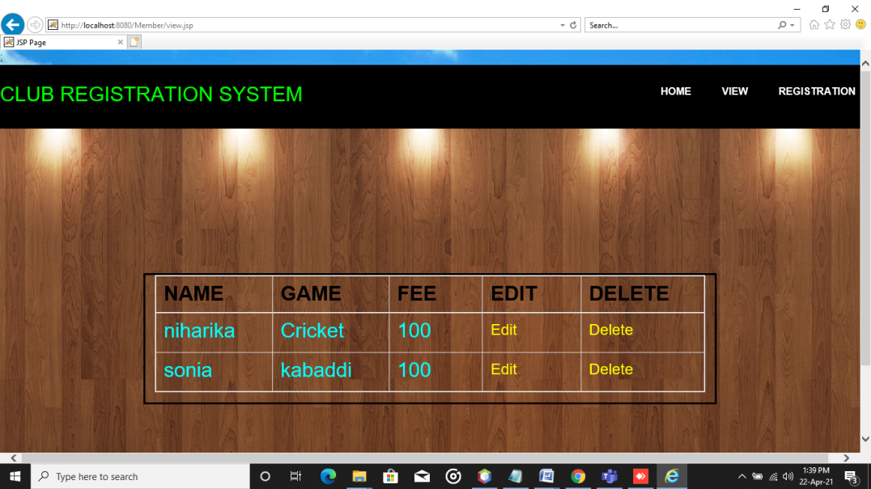

# CONCLUSION

From a proper analysis of positive points and constraints on the component, it can be safely concluded that the product is a highly efficient GUI based component. This application is working properly and meeting to all user requirements. This component can be easily plugged in many other systems.

**FUTURE ENHANCEMENTS**

Now the developed System is a web based system, it gives all the user details. In the future the results can be directly printed, and this functionality can be made available to the user. This can also be enhanced by giving the user more services.

**REFERENCES**

- Herbert Schildt, Java Complete Reference, 5th edition

- Raghurama Krishnan, Database Management Systems

- <http://www.oracle.com>

-various youtube channels