LoRA: Low-Rank Adaptation of Large Language Models
Replication and Extension Study

Based on: Hu et al. (2021) - LoRA: Low-Rank Adaptation of Large Language Models
GitHub Repository: https://github.com/niharika2701/LoRA-replication-extension

Course: DS 642 - Deep Learning
Name: Niharika Jadhav
Student ID: nj349
NJIT Spring 2026

Abstract

This project replicates and extends the key findings of LoRA: Low-Rank Adaptation of Large Language Models (Hu et al., 2021). We fine-tune RoBERTa-base on the SST-2 binary sentiment classification task using both full fine-tuning and LoRA, measuring trainable parameter count, GPU memory usage, training time, and validation accuracy. We replicate the rank ablation study from Table 6 of the paper. As a novel extension, we demonstrate LoRA task switching by training two separate adapters on GPT-2 using different text generation datasets, showing that a single frozen base model can serve multiple tasks by swapping lightweight adapter weights. Initial experiments were run using lora_experiment.ipynb on a Tesla T4 GPU on Google Colab with a 10,000-example subset. Full-scale experiments were then run using lora_experiment_executed.ipynb on an NVIDIA A100 GPU on the NJIT Wulver HPC cluster using the complete 67k SST-2 training set.

1. Model Architecture

1.1 The Problem with Full Fine-Tuning
Large pretrained language models like GPT-3 (175 billion parameters) achieve strong performance across many tasks when fine-tuned on task-specific data. However, full fine-tuning updates every single parameter in the model. This means that for each new task, you need to store and serve a full copy of the model. For GPT-3, that is approximately 700 GB per task. Deploying hundreds of fine-tuned models becomes impractical both in terms of storage and cost.

1.2 The LoRA Solution
LoRA (Low-Rank Adaptation) solves this by freezing the original pretrained weights and injecting small, trainable matrices alongside the existing weight layers. The key insight comes from a property called intrinsic dimensionality: models do not actually need to update all their parameters to learn a new task. The useful changes during adaptation live in a much smaller subspace.

For a pretrained weight matrix W0, instead of learning a full-rank update W0 + delta_W, LoRA represents the update as a product of two small matrices:

h = W₀x + ΔWx = W₀x + BAx

Where B is a d x r matrix and A is an r x k matrix, with rank r much smaller than both d and k. This means the total number of new parameters is d*r + r*k instead of d*k. For RoBERTa-base with d=768 and r=8, this reduces parameters in each layer from 589,824 down to 12,288.

1.3 Initialization Strategy
The initialization is carefully designed to ensure stable training. Matrix A is initialized with a random Gaussian distribution, giving it non-zero gradients from the first training step. Matrix B is initialized to zero, which means the product BA is zero at the start of training. This guarantees that the model begins from the same behavior as the original pretrained model, with no disruption to the learned representations.

1.4 Where LoRA is Applied
In Transformer-based models, LoRA is applied to the attention weight matrices in the self-attention module. Specifically, the query projection matrix Wq and the value projection matrix Wv are targeted in most experiments. The paper finds this combination gives the best performance per parameter. The MLP layers and LayerNorm layers are left frozen.

The scaling factor alpha/r controls the magnitude of the update. Setting alpha equal to r (as done in our experiments) keeps the effective learning rate stable across different rank choices.

1.5 Zero Inference Latency
One critical advantage of LoRA over other parameter-efficient methods is that it introduces no additional latency at inference time. After training, the adapter matrices can be merged back into the base weights by computing W = W0 + BA. The resulting matrix has the same dimensions as the original, so the model runs exactly as fast as the original pretrained model. Switching to a different task simply requires subtracting the current adapter and adding a new one.

2. Technical Innovations and Comparison with Related Work

2.1 Prior Approaches and Their Limitations
Before LoRA, two main strategies existed for parameter-efficient fine-tuning. Both have practical drawbacks that LoRA directly addresses.

Adapter layers insert small bottleneck modules between transformer layers. While they reduce trainable parameters, they are processed sequentially during inference. Large neural networks are designed to exploit hardware parallelism and adding sequential layers breaks this. The paper shows that adapter latency can be as high as 30% in online inference settings with small batch sizes and short sequences.

Prefix tuning prepends trainable tokens to the input sequence. This requires reserving part of the available context window for adapter tokens, reducing how much actual task content the model can process. The paper also observes that prefix tuning is difficult to optimize, with performance changing non-monotonically as more trainable tokens are added.

2.2 How LoRA Compares
Method | Extra Latency | Reduces Seq Length | Trainable Params | Matches FT Quality
Full Fine-Tuning | No | No | 100% | Baseline
Adapter Layers | Yes (~20-30%) | No | < 1% | Sometimes
Prefix Tuning | No | Yes | Small | Often not
LoRA (ours) | No | No | 0.01-1% | Yes

The table above shows that LoRA is the only method that achieves all four desirable properties simultaneously. It neither adds inference latency nor reduces usable sequence length, while matching the quality of full fine-tuning with a fraction of the parameters.

2.3 The Intrinsic Rank Hypothesis
The theoretical foundation for LoRA comes from work showing that pretrained language models have a low intrinsic dimensionality. This means that when fine-tuning to a specific task, the updates to the weight matrices do not need to span the full parameter space. Only a small number of directions in that space carry useful task-specific information.

The paper validates this by analyzing the singular value decomposition of the learned adaptation matrices. They find that the top singular vectors learned at rank r=8 are largely the same as those learned at rank r=64, while the remaining directions contain mostly noise. This is strong empirical evidence that the intrinsic rank needed for adaptation is indeed very small.

A further analysis shows that the adaptation matrix delta_W amplifies directions that are already present in W0 but not strongly emphasized. This suggests that fine-tuning does not introduce entirely new capabilities but rather selectively strengthens existing features that are relevant to the target task.

3. Demonstration

3.1 Experiment 1: LoRA vs Full Fine-Tuning on SST-2
The first experiment fine-tunes RoBERTa-base (124.6 million parameters) on the SST-2 binary sentiment classification task from the GLUE benchmark. Each input is a short movie review sentence, and the model must predict whether it expresses a positive or negative sentiment.

Two conditions are compared under identical training settings: full fine-tuning, where all 124.6 million parameters are updated, and LoRA fine-tuning, where only the low-rank adapter matrices are trained. The LoRA configuration uses rank r=8, applied to the query and value projection matrices in all 12 attention layers of RoBERTa, plus a trainable classification head.

Input: "a touching, keenly observed portrait of a family" - 1 (positive)
Input: "a sloppy, noisy, over-produced movie" - 0 (negative)

This experiment was run in two stages. The first stage used lora_experiment.ipynb on a Tesla T4 GPU on Google Colab with a 10,000-example subset of SST-2, allowing for rapid prototyping and debugging. The second stage used the same notebook executed as lora_experiment_executed.ipynb on an NVIDIA A100 GPU on the NJIT Wulver HPC cluster, using the full 67,349-example training set and the 872-example validation set. Three epochs of training were used for both conditions. The results reported in this section are from the full A100 run.

3.2 Results
Method | Trainable Params | Trainable % | Peak Mem (GB) | Train Time (min) | Val Accuracy
Full Fine-Tuning | 124,647,170 | 100.00% | 2.437 | 6.1 | 94.27%
LoRA (r=8) | 887,042 | 0.71% | 1.889 | 4.8 | 92.09%
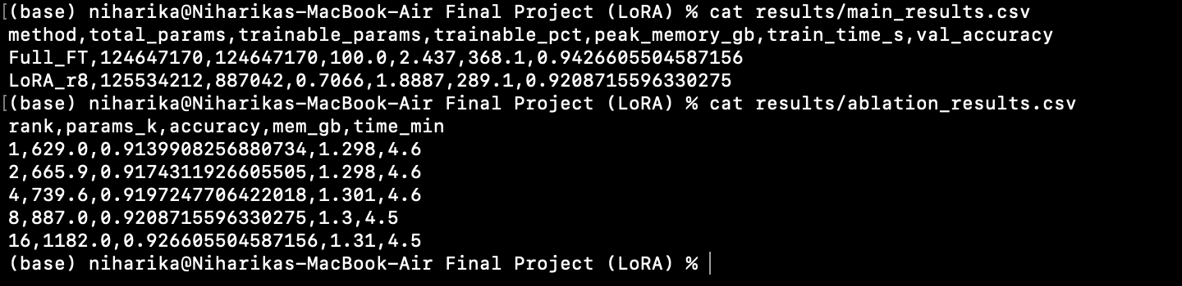
Key takeaways: LoRA achieves 92.09% accuracy while training only 0.71% of the parameters. The parameter reduction is 141x. Memory usage drops by 22.5%. Training is 21% faster. The accuracy gap of 2.18 percentage points is the cost of using 141x fewer trainable parameters.

4. Rank Ablation Study

4.1 Replicating Table 6 from Hu et al., 2021
A central claim in the paper is that the adaptation matrix delta_W has a very low intrinsic rank. To test this, we sweep the rank hyperparameter r over the values {1, 2, 4, 8, 16} and measure accuracy, parameter count, and memory usage for each. This directly replicates the experiment in Table 6 of the original paper.

Rank r | Trainable Params | Val Accuracy | Peak Mem (GB) | Train Time (min)
1 | 629K | 91.40% | 1.298 | 4.6
2 | 665.9K | 91.74% | 1.298 | 4.6
4 | 739.6K | 91.97% | 1.301 | 4.6
8 | 887K | 92.09% | 1.300 | 4.5
16 | 1,182K | 92.66% | 1.310 | 4.5
Full FT | 124,647,170 | 94.27% | 2.437 | 6.1

4.2 Analysis
The results confirm the paper's central finding. Accuracy increases as rank increases but the gains diminish quickly. Going from r=1 to r=8 gives a 1.69 percentage point improvement. Going from r=8 to r=16 gives only an additional 0.57 percentage points, while adding 295K more parameters.

The memory column shows that GPU usage is nearly identical across all ranks, ranging from 1.298 GB at r=1 to only 1.310 GB at r=16. This is a difference of 12 MB despite doubling the number of adapter parameters. This confirms that LoRA's memory footprint is dominated by the frozen base model weights, not the adapters.

Compared to full fine-tuning at 2.437 GB, even the largest LoRA configuration at r=16 uses 46.2% less memory while coming within 1.61 percentage points of full fine-tuning accuracy on the complete 67k dataset.

4.3 Rank Ablation Plots
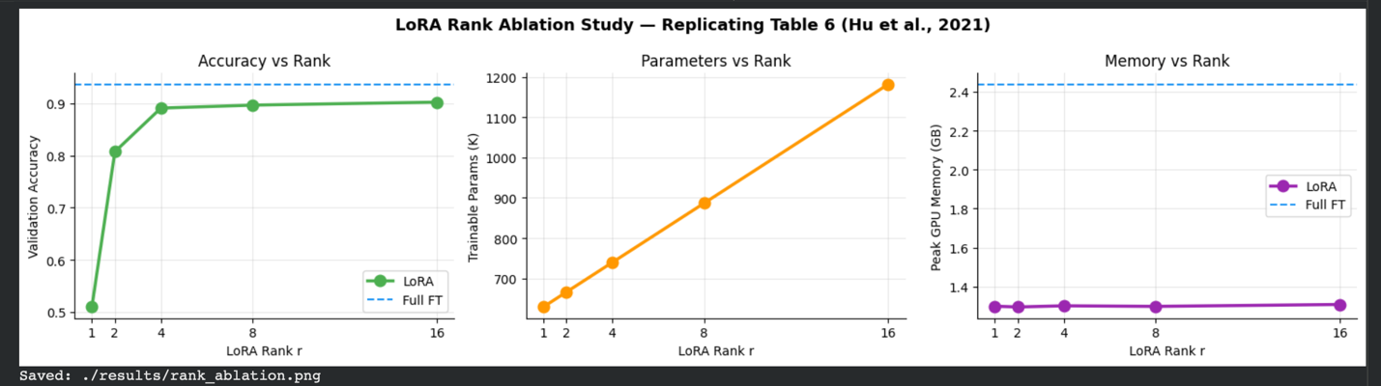 Rank Ablation Plot — Accuracy vs Rank / Parameters vs Rank / Memory vs Rank

5. Novel Extension: LoRA Task Switching with GPT-2

5.1 Motivation
The paper claims that one of LoRA's key practical advantages is fast task switching. Because the base model weights never change, deploying multiple tasks only requires storing one copy of the base model plus small adapter files per task. Switching between tasks is a single operation: unload the current adapter and load the new one.

This experiment demonstrates that property directly. We train two separate LoRA adapters on GPT-2-small (124 million parameters) using two completely different text generation datasets. Both adapters are then loaded simultaneously onto the same frozen GPT-2, and a single set_adapter() call is used to switch behavior.

5.2 Setup
Base model: GPT-2 small (124M parameters, frozen)
Adapter 1: TinyStories dataset — short imaginative children's stories. Teaches narrative structure and creative language.
Adapter 2: AG News dataset — real-world news articles. Teaches factual, journalistic writing style.
LoRA config: r=8, alpha=16, target module: c_attn (GPT-2 combined QKV projection)
Training: 2,000 examples per adapter, 3 epochs, T4 GPU on Google Colab

5.3 Task Switching Demonstration
After training, both adapters are loaded onto a single GPT-2 base model using the PEFT library. The same prompt is fed to the model under each adapter to show the behavioral difference.

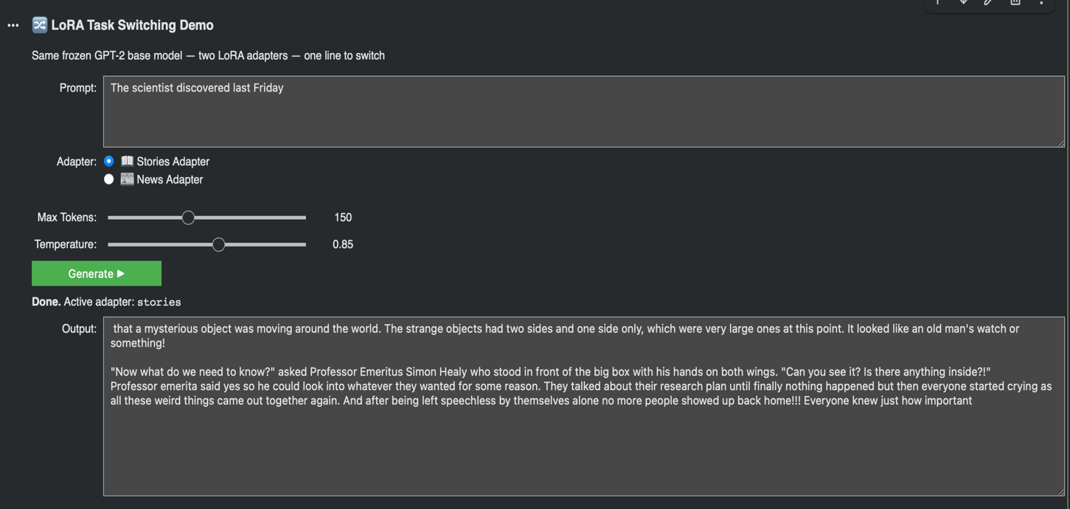

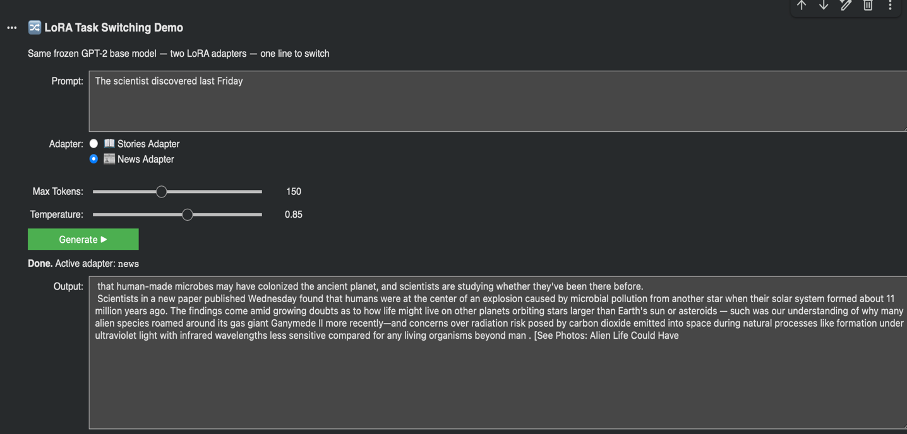

Task Switching Output — Same prompts, both adapters 1) Stories and 2) News

5.4 Adapter Storage Comparison
Each LoRA adapter file is approximately 3-6 MB. The full GPT-2 model checkpoint is 548 MB. Storing 10 task-specific models via full fine-tuning would require 5.48 GB. With LoRA, the same 10 tasks require 548 MB for one shared base model plus roughly 50 MB total for all adapters, a reduction of over 90%.

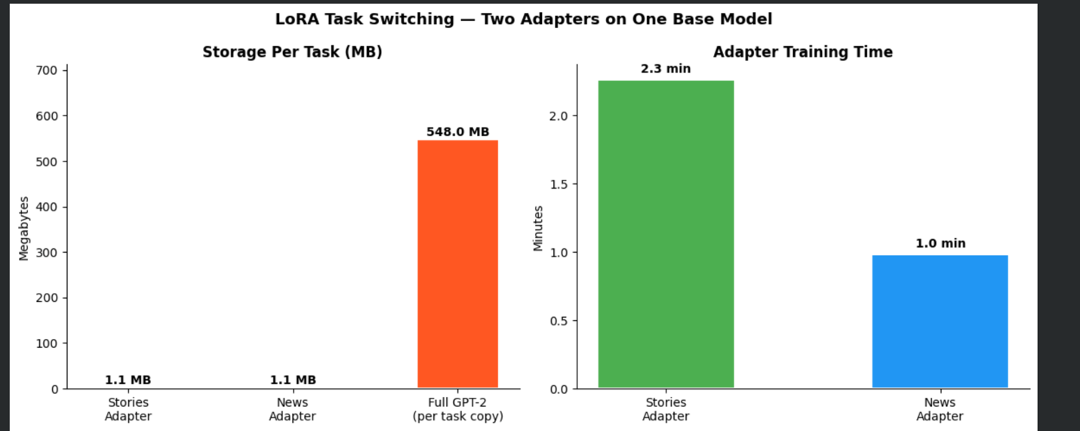 Adapter Storage Bar Chart — Adapter 1, Adapter 2, vs Full GPT-2 model size]

6. Forward-Looking Discussion

6.1 Adaptive Rank Selection
Our ablation study confirms that different tasks may benefit from different ranks. A natural extension is to learn the optimal rank automatically during training rather than treating it as a fixed hyperparameter. The AdaLoRA method, proposed after the original LoRA paper, takes exactly this approach by distributing a global parameter budget across layers using singular value decomposition. Layers that carry more task-relevant information receive higher rank allocations, while less important layers get lower rank or zero.

6.2 LoRA for Non-Attention Modules
The original paper deliberately limits LoRA to attention weight matrices and leaves MLP layers frozen. This choice was made for simplicity and parameter efficiency, but it is not theoretically necessary. Applying LoRA to the MLP layers could capture different kinds of task-specific adaptation, particularly for tasks that require factual knowledge updates rather than changes in reasoning pattern.

6.3 LoRA in Multimodal and Diffusion Models
Since its publication, LoRA has been widely adopted beyond language models. In image generation, LoRA is now standard for fine-tuning Stable Diffusion on custom visual styles, subjects, and artistic concepts. The adapter file for a custom Stable Diffusion style is typically 50-150 MB, compared to several gigabytes for a full model checkpoint. Similar applications are emerging in speech models, video generation models, and multimodal systems that combine vision and language. The core technique transfers cleanly because the weight matrices in all these architectures share the same low intrinsic rank property during adaptation.

6.4 Multi-Task and Compositional Adapters
A promising direction is learning adapters that can be composed or mixed. For example, if one adapter captures a writing style and another captures domain knowledge, combining them could produce a model that writes in a specific style about a specific domain. Early work on adapter merging using weight averaging or task arithmetic shows that this is feasible and could dramatically reduce the cost of building specialized models.

6.5 Open Theoretical Questions
While the paper provides strong empirical evidence that weight updates are low-rank during fine-tuning, a theoretical explanation for why this happens remains an open question. Understanding the connection between the pretraining objective, the structure of the pretrained weight matrices, and the intrinsic rank of adaptation updates could lead to principled methods for choosing rank, selecting which layers to adapt, and designing better initialization strategies.

7. Conclusion
This project implemented, evaluated, and extended the LoRA fine-tuning method across two model architectures and three experimental conditions. The main findings are as follows.

- LoRA reduces trainable parameters by 141x (from 124.6M to 887K) while achieving 92.09% validation accuracy on SST-2, compared to 94.27% for full fine-tuning. The 2.18 percentage point gap comes at a 22.5% reduction in peak GPU memory and 21% faster training.
- The rank ablation study confirms the paper's core claim: weight updates during adaptation have a very low intrinsic rank. Performance plateaus around r=8 to r=16, and memory usage remains nearly flat across all ranks tested. This directly replicates Table 6 from Hu et al., 2021.
- The task switching demonstration on GPT-2 shows that a single frozen base model can serve multiple tasks with completely different behavior by swapping 3-6 MB adapter files. This validates LoRA's key deployment advantage over full fine-tuning, which requires a separate full model copy per task.

LoRA represents a shift in how large models are deployed in practice. Rather than treating each task as requiring its own dedicated model, LoRA enables a shared-model paradigm where one frozen backbone serves many tasks through interchangeable lightweight adapters. Given the rapid growth in model size, this property will only become more important.

References
Hu, E., Shen, Y., Wallis, P., Allen-Zhu, Z., Li, Y., Wang, S., Wang, L., and Chen, W. (2021). LoRA: Low-Rank Adaptation of Large Language Models. arXiv:2106.09685.

Liu, Y., Ott, M., Goyal, N., Du, J., Joshi, M., Chen, D., Levy, O., Lewis, M., Zettlemoyer, L., and Stoyanov, V. (2019). RoBERTa: A Robustly Optimized BERT Pretraining Approach. arXiv:1907.11692.

Houlsby, N., Giurgiu, A., Jastrzebski, S., Morrone, B., de Laroussilhe, Q., Gesmundo, A., Attariyan, M., and Gelly, S. (2019). Parameter-Efficient Transfer Learning for NLP. arXiv:1902.00751.
Allison Li, Kristjan Greenewald, Thomas Parnell, Navid Azizan. (2025). Efficient Multi-Adapter LLM Serving via Cross-Model KV-Cache Reuse with Activated LoRA.

Wang, A., Singh, A., Michael, J., Hill, F., Levy, O., and Bowman, S. R. (2019). GLUE: A Multi-Task Benchmark and Analysis Platform for Natural Language Understanding. arXiv:1804.07461.

Menglin Yang, Jialin Chen, Jinkai Tao, Yifei Zhang, Jiahong Liu, Jiasheng Zhang, Qiyao Ma, Harshit Verma, Regina Zhang, Min Zhou, Irwin King, Rex Ying. (2024). Low-Rank Adaptation for Foundation Models: A Comprehensive Review

