Pharmacy Procurement Report
Generated: February 26, 2026 at 09:25 AM

Summary
Monthly overview of pharmacy procurement activities, including total orders, spending, and savings indicators.
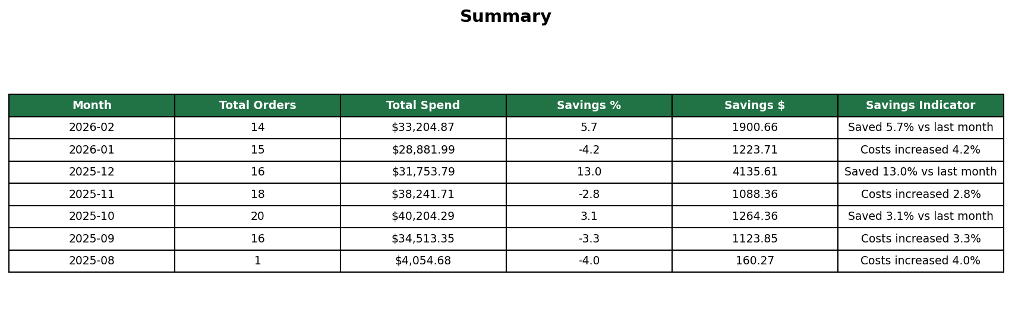

Orders
Detailed order records showing hospital, pharmacy, drug information, pricing, and invoicing status.
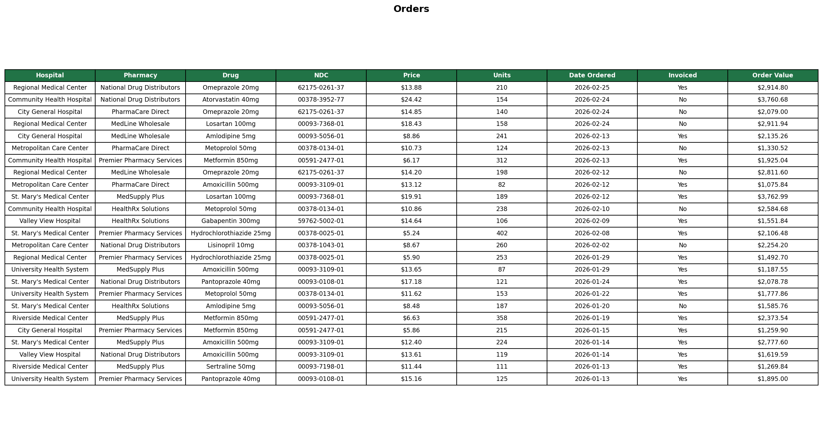

Visualizations & Analytics
The following charts provide visual insights into NDC spending patterns and savings trends across the reporting period.

Top 5 NDC by Spend
This chart shows the top 5 National Drug Codes (NDC) ranked by total spend, helping identify high-cost medications for contract negotiations and formulary review.
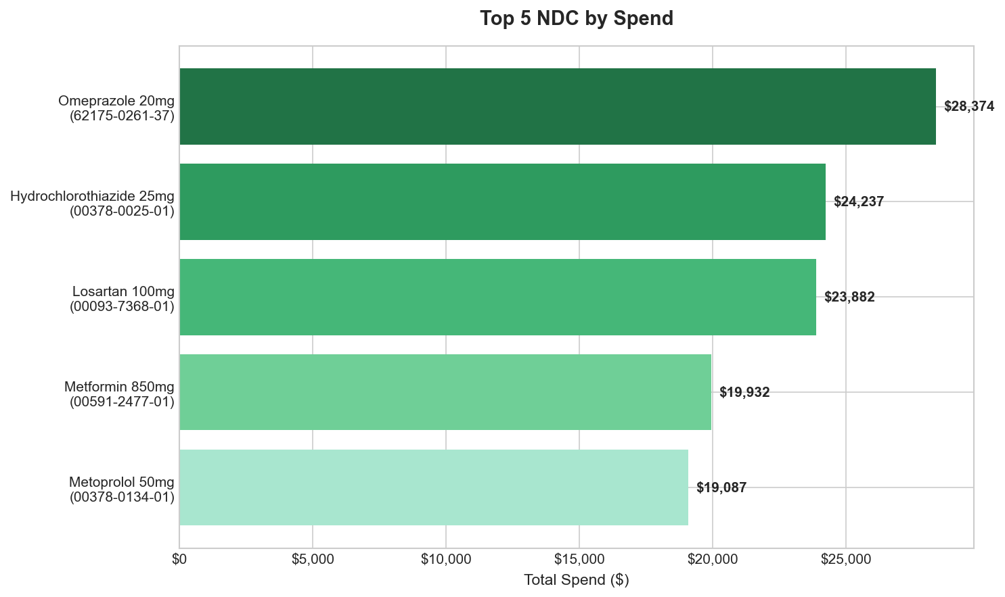

Monthly Savings
This chart displays the savings achieved each month compared to the previous period. Green bars indicate savings, while red bars indicate cost increases.
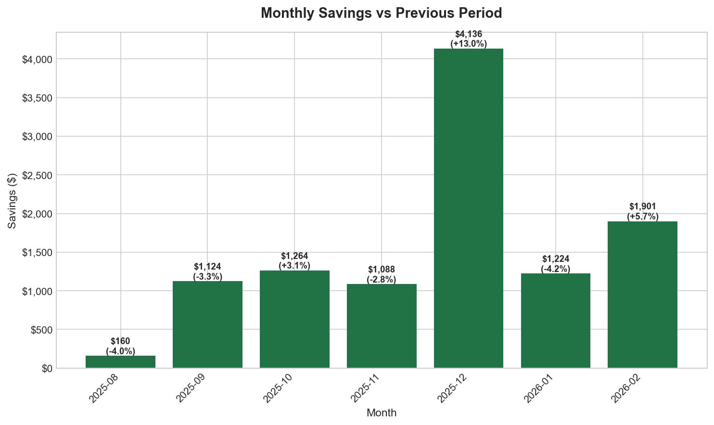

Top 5 NDC Spend Distribution
Pie chart showing the distribution of spend across the top 5 NDC codes, illustrating the concentration of pharmacy procurement costs.
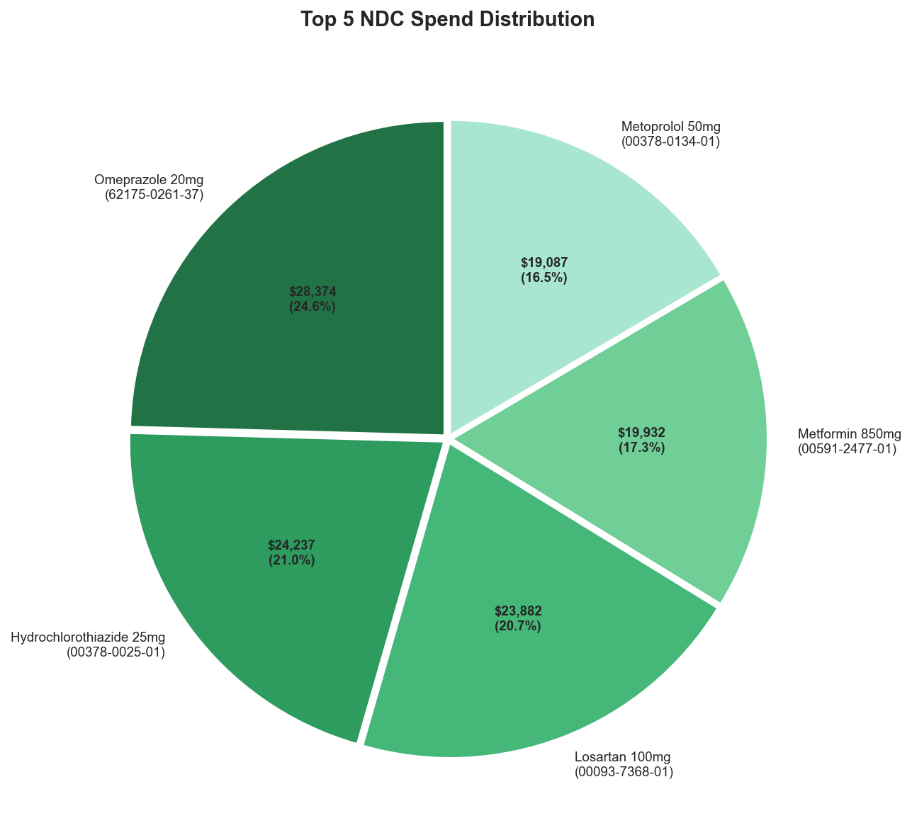

This report was automatically generated. For questions, contact the Procurement Department.

