Step by step introduction about the assignment:-

(all the import files for bootstrap , jumbotron , routing , font awesome icons , dropdown , animated modal are included wherever needed in the code)

1 ) Main page(live jobs):-

(running over <http://localhost:3000/>)

I have stored all the information regarding the jobs in an array and with the help of mapping it is displayed over the main page inside a jumbotron

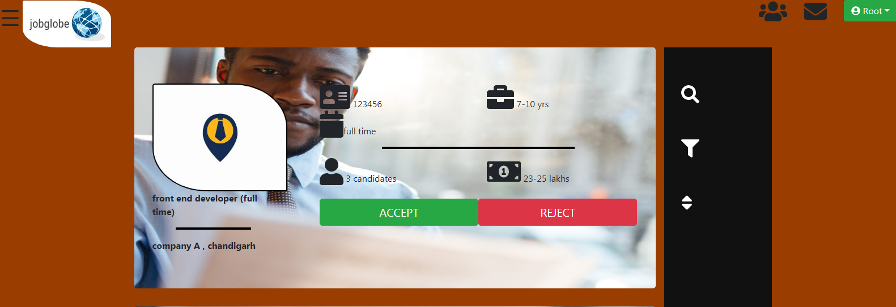

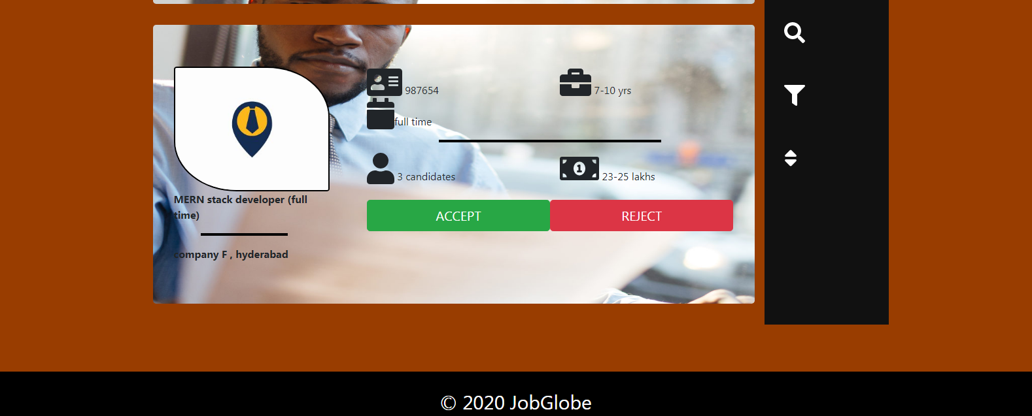

1.1 ) By clicking on line structure on top left corner:- 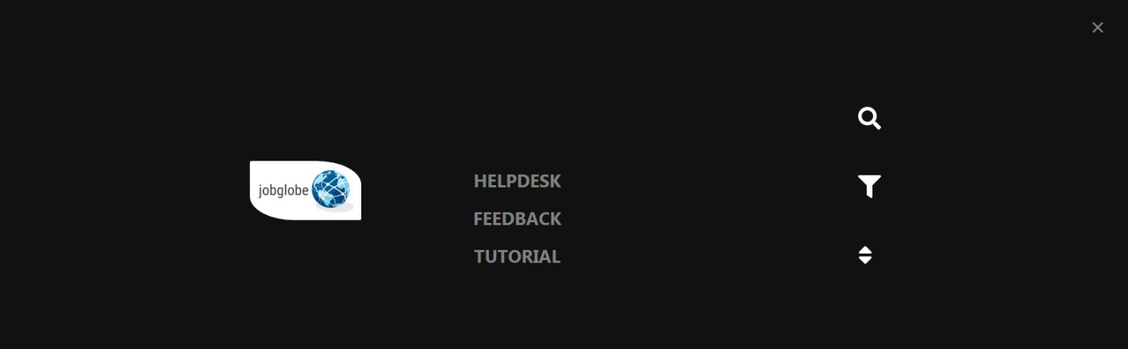

By clicking on helpdesk, feedback or tutorial; user will get redirected to the specific webpage

1 .2 ) By Clicking on accept/reject button:-

Whenever user will click on either accept or reject button of a particular job ,the whole data regarding that job will get stored in an array named ‘DETAILS’ and hence can be displayed over modal.

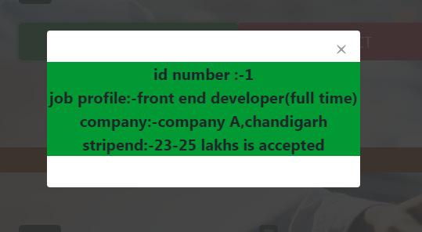

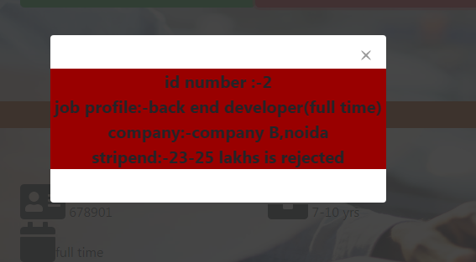

1.3 ) By clicking on the root button:-

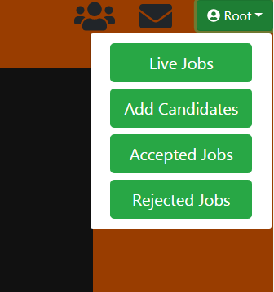

2) Add candidates:-

(running over <http://localhost:3000/candidate>)

After clicking on the add candidate button from the main page user will be redirected to:-

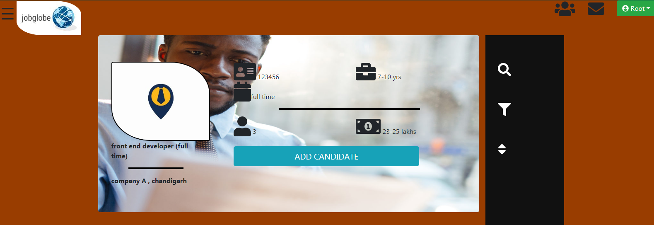

2.1) by clicking on add candidate button:-

Whenever user will click on add candidate button of a particular job ,the whole data regarding that job will get stored in an array named ‘DETAILS’ and hence title can be displayed over modal.

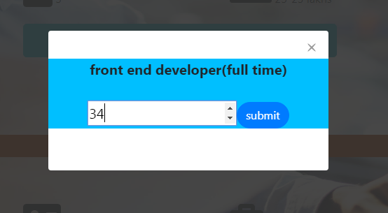

2.2) if user clicks the submit button without giving a number

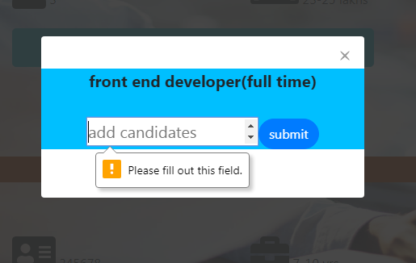

3) accepted jobs:-

(running over <http://localhost:3000/accepted>)

After clicking on the accepted jobs button from the main page user will be redirected to:-

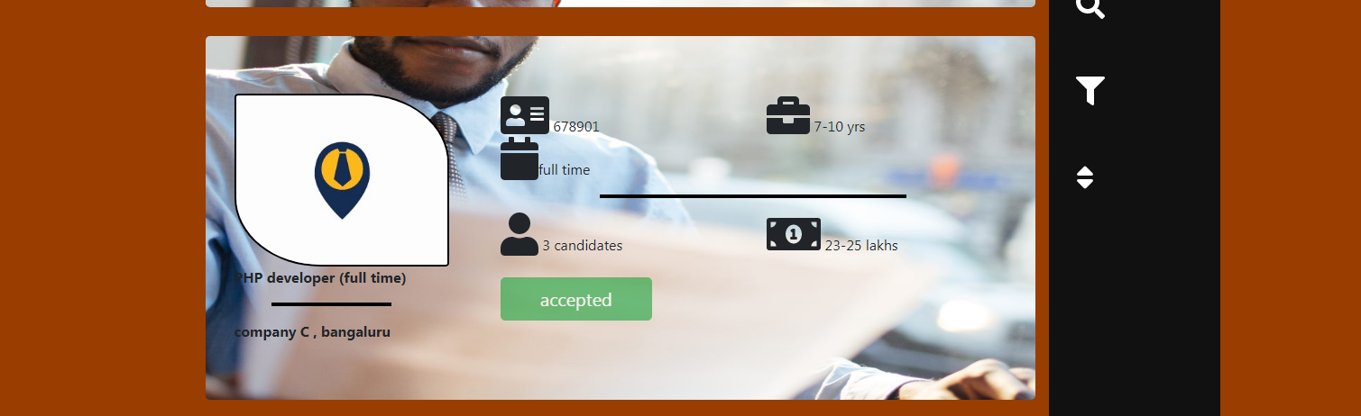

Here the green button is disabled

4) rejected jobs:-

(running over <http://localhost:3000/Rejected>)

After clicking on the rejected jobs button from the main page user will be redirected to:-

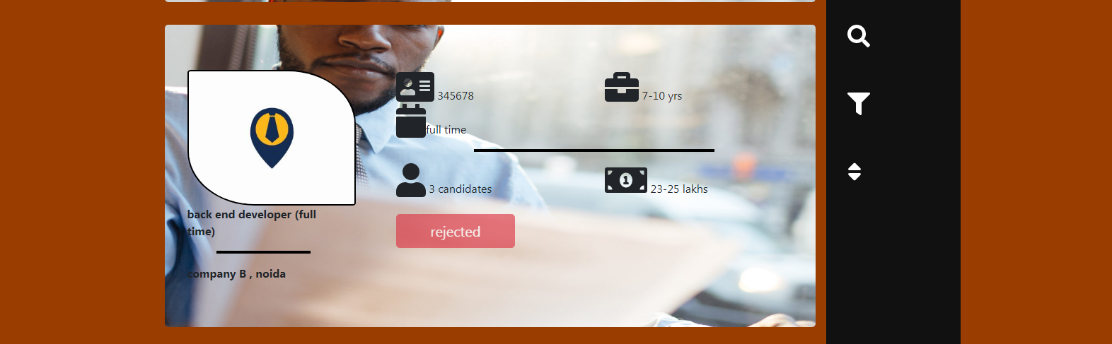

Here the red button is disabled

RESPONSIVENESS

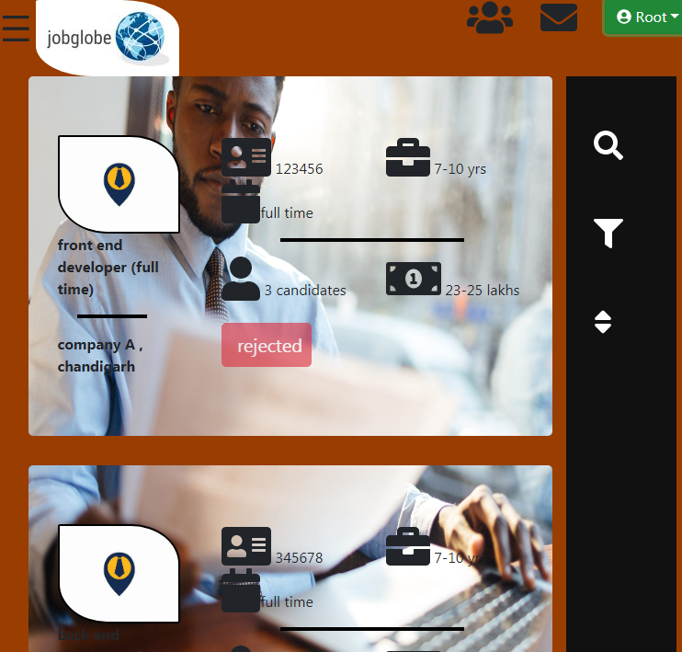

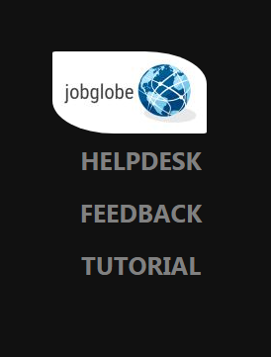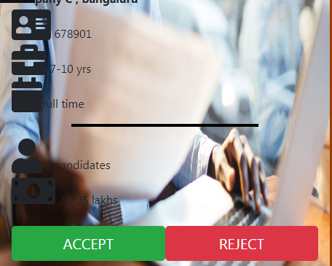

COMMANDS/LINKS USED

1 install node js:-

<https://nodejs.org>

2 deleted npm –cache folders

npm cache clear --force

npm cache verify

3 update npm to latest version

npm i -g npm

4) react folder

npm i -g create-react-app

create-react-app react-app

5) install dependency

npm install react-router-dom

npm install @material -ui/core

npm install redux react-redux

npm install react-bootstrap bootstrap --save

npm install react-modal --save

npm install --save react-animated-modal

npm install react-dropdown --save

npm i --save @fortawesome/fontawesome-svg-core @fortawesome/free-solid-svg-icons @fortawesome/react-fontawesome

6) run(inside the main folder)

npm start