Contents

1. INTRODUCTION 1

1.1 Purpose 1

1.2 Scope 1

1.3 Overview of the project 2

2. OVERALL DESCRIPTION 3

2.1 Product Perspective 3

2.2 Product Functions 3

2.3 User Characteristics 3

3. SYSTEM STUDY AND ANALYSIS 5

3.1 Existing System 5

3.2 Proposed System 5

3.2.1 Advantages of proposed system 5

3.3 Feasibility study 6

3.3.1 Economic Feasibility 6

3.3.2 Technical Feasibility 6

3.3.3 Behavioral Feasibility 6

3.4 Process Model 6

3.4.1 Suitable Process Model 6

3.4.2 Design the model 7

3.4.3 Constraints of other models used 8

4. SOFTWARE DESIGN AND SPECIFICATION 9

4.1 Data Flow Diagram (Level 0, 1, 2) 9

5. CONTROL FLOW DIAGRAM 13

6. USER INTERFACE DESIGN 14

7. COST ESTIMATION 15

8. DESIGNING TEST CASES – MODULE 1 17

9. DESIGNING TEST CASES – MODULE 2 18

# INTRODUCTION

## 1.1 Purpose

           Our project is a “web enabled application” for students and for Training and placement   cell of our college. This application provides an automated system for online recording of academic details of the students for all the semesters along with their other achievements.

          This website will help students to find internship/campus jobs/jobs related to their fields and interests. This application can help the Training and placement cell in shortlisting the students on the basis of the criterion specified by the company along with student’s interests and the names of the shortlisted students’ can be sent to the company directly using generated mail.

## 1.2 Scope

Our project will be applicable and used by students of multiple branches of a college.

This could also be used by placement committees of college to keep records.

Our project will be used by

* Students:

a. Maintenance of documents

b. Easy access to CV and SOP

c. Student can prepare their profile from the first year itself and update it whenever they want.

d. Security: Only the student himself and the company can read his/her profile.

e. The students can understand where they stand and whether they have to improve to get into their desired company.

f. The students wouldn’t have to carry all the documents at every interview they go for, minimizing the risk of losing or damaging the documents.

* Companies:

a. Easy sorting. Hence, the company will access profile of only those who are of the required field.

b. Student profile will be sorted on basis of criteria.

c. The companies will not have to deal with a pile of papers as the CV and SOP will be available on the website at all the times.

* Placement Committees:

a.    Access to data of current and previous year students will help them in marketing purposes.

b.    Easy monitoring and recording of placements data will be possible.

## 1.3 Overview of the project

In our project, we intend to design a website which could be made of use by the placement cell of our college. It would be an online portal where the students could have their own customized account and would be able to share their achievements and field interests with the members of the placement cell so as to be able to make the process of placements easier.

The website would also provide information regarding the company choices one was eligible for, according to the students’ academic qualifications such as the cumulative grade point average; for example, a particular student would not be eligible to appear for the interview of a particular company if his academic scores did not fulfill the company’s qualification requisites.

To fulfill the conditions of the project, we have made use of MySQL to make a database to store the details of students, such as personal information, qualifications and documents required at the time of placement interviews. We have worked on HTML5 and CSS3 for the front-end / graphical user interface and used JavaScript to code the other functionalities of the website, such as mathematical condition requirements. We have made use of PHP 5.0 for connecting the database to the user interface.

Along with helping students, this would also help to mitigate paper-work and prevent chances of losing hard-copies of important documents. We hope that this attempt to create such a website would be beneficial for students to get placed in companies related to their course fields and fields of interest, based on their academic and extracurricular achievements.

# OVERALL DESCRIPTION

## 2.1 Product Perspective

Developer:

We intend to create this website for the placement cell of our college. We believe that this would be of great help not only to the students but also to the placement managing faculty of this institution. It would help students store a soft copy of the documents of their achievements, thereby reducing the chances of losing important documents. Also, on the day of the interview for placements, there would be no need for the student to carry the documents along, as the recruiters would directly be able to access an interviewee’s information and documents through the website. This would consequently make the process of placement interview easier for the students.

Customer:

         Since different companies that come to colleges to recruit students, do so on basis of their CGPA (cumulative grade point averages) and other criteria; the process would be faster and more efficient as the recruiters would only interview those students whose CGPA met their requisites and extracurricular activities appalled them. This process would help the recruiters to shortlist the students for interviews. They would also be able to access the profile of the students online, after recruitments, while taking final decisions of recruiting, which would help avoid paper-work.

## 2.2 Product Functions

The website primarily means to serve the purpose of making placement process of the college easier. The added advantage of making a website for the placement cell is that it helps reduce paper-work and consequently, the possibility of losing documents. Students can feed in their information in their ‘Placering’ account in the first year itself and keep updating it as and when needed, to build their profiles. The simple architecture and user-friendly interface of the website makes it easier for the student to edit/update his/her information and for the recruiting company to find any specific document related to any specific student.

The survey conducted for a particular batch of students to know their secured grades and non-academic participations can help to predict the placement offers that the next batch of students is likely to receive.

    Another salient feature of the website is security. The information of all students remain secure, that is, one student cannot access the documents of another; and other than the student, the documents can only be accessed by the placement committee and the recruiters.

## 2.3 User Characteristics

The users allowed to access the website would be students of the college, the placement committee and the companies that would recruit. The students would use the website to keep their details such as personal information, qualifications, academic and extracurricular achievements and would also be able to update it as and when required. The placement committee would be able to keep track of the academic and extracurricular activities of the students in the college, hence, suggesting them other ventures which would help make their profiles such that they are worthy of getting recruited. The recruitment companies could go through the profiles of students to shortlist the ones who meet their criteria, hence, expediting the process of recruitment.

# SYSTEM STUDY AND ANALYSIS

## 3.1 Existing System

 There are no existing systems with the same functionalities in other educational institutions; moreover, we plan on creating this website for our own college.

## 3.2 Proposed System

## 

We proposed a project which is a “web enabled application” called ‘PLACERING’ for students and for the Training and placement cell of our college. This application provides an automated system for online recording of academic details of the students for all the semesters along with their other achievements. The placement cell keeps a track of the students’ records, making the process of recruitments easier.

This website would help students to find internship/campus jobs related to their fields and interests. This application can help the Training and placement cell in shortlisting the students on the basis of the criterion specified by the company along with student’s interests and the names of the shortlisted students’ can be sent to the company directly using generated mail.

### 3.2.1 Advantages of proposed system

A few advantages of the proposed system are:

* Easy user interaction with the web application.
* The company can access profile of only those who are of the field required.
* Student profile can be sorted on basis of criteria.
* The companies will not have to deal with a pile of papers as the CV and SOP of the students will be available on the site at all times.
* Student can filter the desired companies as per their interest.
* Less hardware requirements.

## 3.3 Feasibility study

### 3.3.1 Economic Feasibility

Our project 'Placering' is primarily for the placement cell of our college. The only expense the website handler is required to make is a monthly payment of a reasonable amount for the domain name of the website. Considering the decent charges of the domain name, our project is economically feasible. Our project does not require any excessive hardware. Also the website can be used on any platform or device, may it be a PC, laptop, tablet or mobile phone. No special devices are required either.

### 3.3.2 Technical Feasibility

Our project is a website which is developed using mark-up language like HTML5 and CSS, Bootstrap; and scripting language like JavaScript. MySQL has been used to create databases to store the records of students. We have used PHP to connect the interface of the website with the database. These languages can easily be learnt and implemented to create a website. Hence, our project is technically feasible. It works on all types of browsers, also on old version of internet explorer to Microsoft EDGE.

### 3.3.3 Behavioral Feasibility

The website has a very user-friendly interface, which implies that the user needs to have minimal knowledge about a computer and the internet, to be able to use it. Also, since every student has his/her own account, a student’s data is safe; security is well handled. Hence, our project is behaviorally feasible.

## 3.4 Process Model

### 3.4.1 Suitable Process Model

The most suitable process model for our project ‘Placering’ would be the incremental model. In incremental model the core product is created and deployed in the market or given to the customer. Improvements and updates are gradually incorporated in the project to make it simpler and more efficient over a period of time.

Our projects will have three models of increment:

1. First Increment: The basic user interface with basic functionalities.
2. Second Increment: Development of a better user interface. Also, editing and debugging as per the feedback received.
3. Third Increment: We are planning to build different login and interface pages for students and companies as per their convenience.

### 3.4.2 Design the model



Stages in designing the model:

* COMMUNICATION:

In this stage, we communicated with the Placement Head of the college, understanding the basic requirements for the project and the functionalities required in the website.

* PLANNING:

In this stage, we would be deciding the functionalities of our project and the people working on it. Also, we worked on the Software Requirements Specification and the platform we built our website on.

* MODELING:

In this stage, we decided the process model as Incremental, and how it would be implemented.

* CONSTRUCTION:

This stage involved the designing and scripting of the website layout and modules.

* DEPLOYMENT:

This stage involved the hosting of the project on the server and deployment to the Placement Cell of our college. Also, feedback regarding the functionalities of the website is taken into consideration. Necessary changes hence will be made in the next model of our incremental.

### 3.4.3 Constraints of other models used

Waterfall model would not be very appropriate because a website needs to be modified and updated over time, as per the needs of the customer, which waterfall model does not allow. The RAD (Rapid Application Development Model) model would not be suitable either, because it is not a complex project and feedback is necessary in this case to upgrade the website. Prototype model involves scraping the initial product to make a better one. This would be unnecessary in the case of creating a website as modifications could be made to the website rather than making a completely different one. Since, the website does not have any risk factors; it will not be a spiral process model.

# SOFTWARE DESIGN AND SPECIFICATION

## 4.1 Data Flow Diagram (Level 0, 1, 2)

LEVEL 0

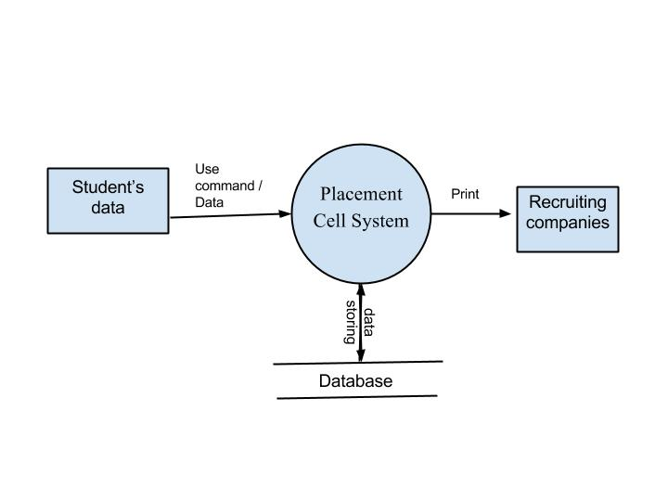

LEVEL 1

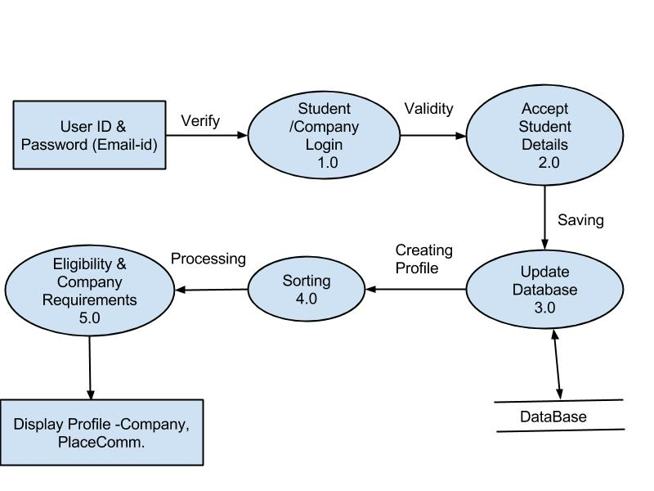

LEVEL 2

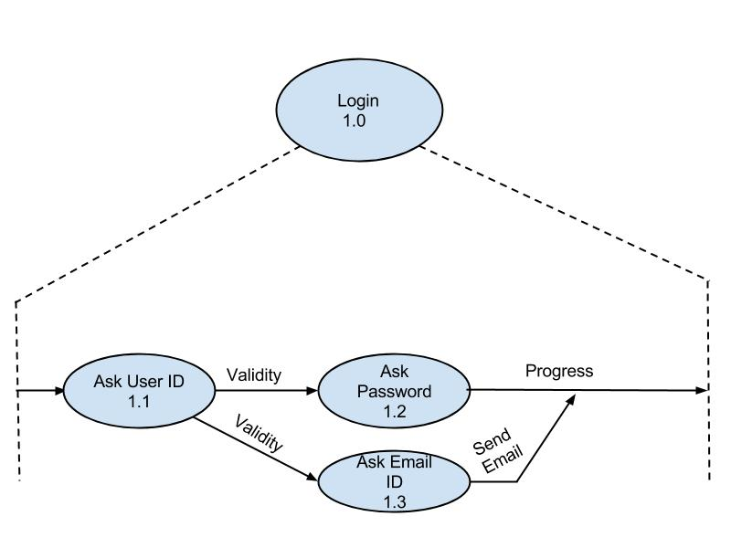

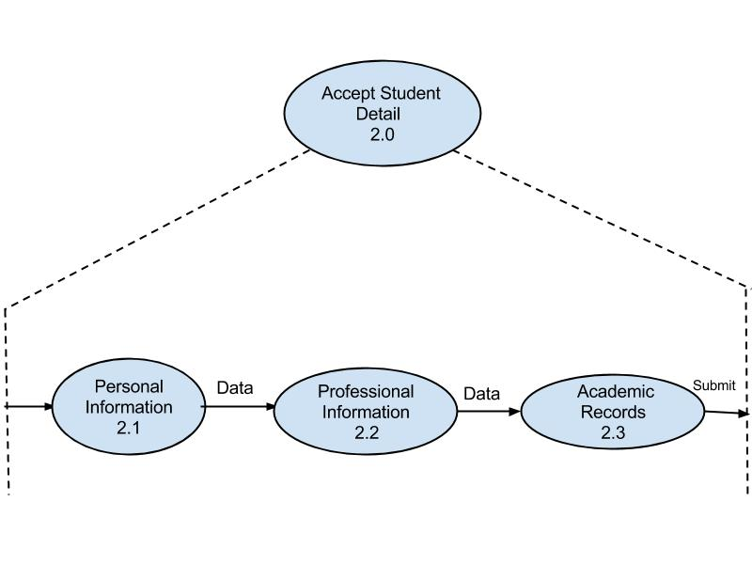

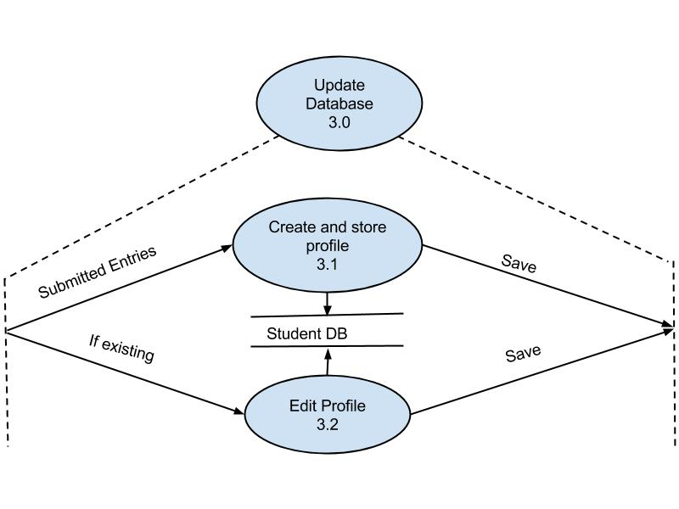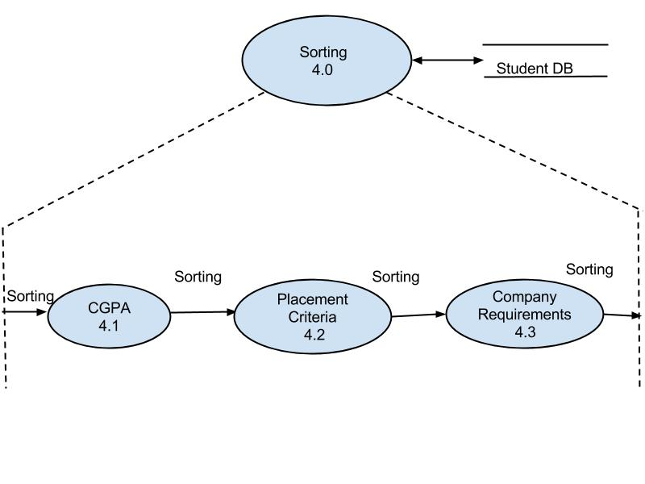

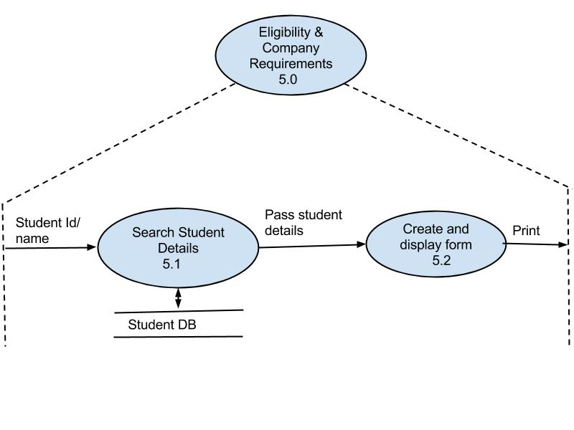

# CONTROL FLOW DIAGRAM

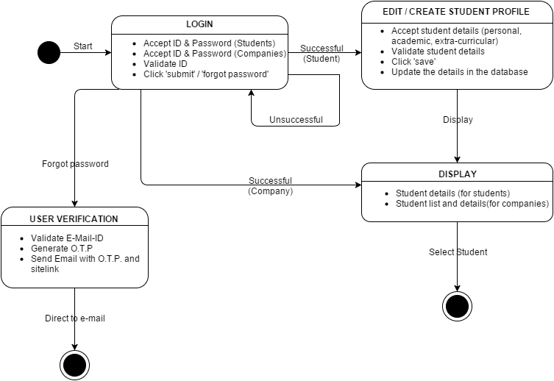

# USER INTERFACE DESIGN

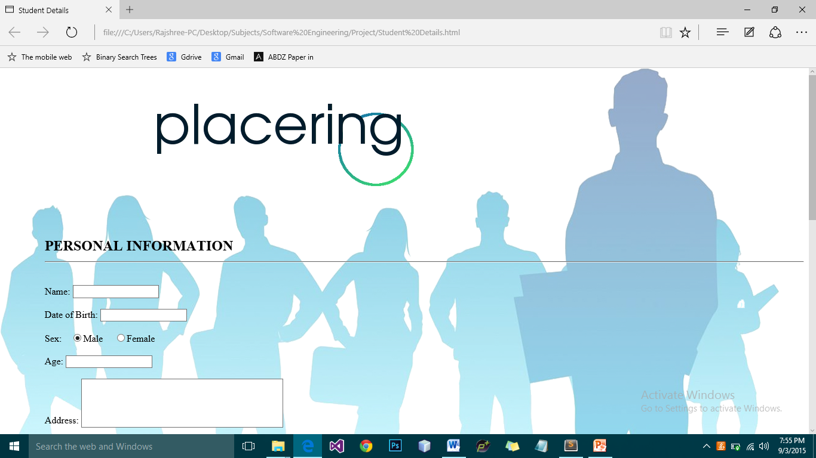

# COST ESTIMATION

ESTIMATED PROJECT COST

|  |  |
| --- | --- |
| **COST FACTORS** | **COST** |
| 1. Developing Cost | 5000 |
| 1. Designing cost | 2000 |
| 1. Testing cost | 1000 |
| 1. Hosting cost | 1000 |
| **Total estimated cost (in Rs.)** | **10,000** |

FUNCTION POINT

1. COUNT TOTAL

|  |  |  |  |
| --- | --- | --- | --- |
| **INFORMATION DOMAIN VLAUE** | **COUNT** | **WEIGHTING FACTOR (SIMPLE)** | **TOTAL** |
| External Inputs (EIs) | 4 | 3 | 12 |
| External Outputs (EOs) | 2 | 4 | 8 |
| External Inquiries (EQs) | 3 | 3 | 9 |
| Internal Logic Files (ILFs) | 6 | 7 | 42 |
| External Interface Files (EIFs) | 5 | 5 | 25 |
| **Total Count** | | | **96** |

1. QUESTIONS

|  |  |
| --- | --- |
| **QUESTIONS** | **COUNT** |
| 1. Is the system critical to use? | 2 |
| 1. Is the user interface simple to use? | 8 |
| 1. Is the memory requirement high? | 8 |
| 1. Was it difficult to create the system? | 6 |
| 1. Is the system very expensive? | 6 |
| 1. Does it take more time in loading? | 2 |
| 1. Requires more maintenance time? | 6 |
| 1. Are the input, output, files complex? | 4 |
| 1. Is the code reusable? | 10 |
| 1. Is the processing complicated? | 4 |
| **sigma(Fi)** | 56 |

C. CALCULATE: Fi

FP = count total*[0.65+ (0.01*sigma(Fi)]

= 96*[1.21]

**FP = 54.41**

# DESIGNING TEST CASES – MODULE 1

|  |  |  |  |  |  |  |  |
| --- | --- | --- | --- | --- | --- | --- | --- |
| **Test Case Template** | | | | | | | |
| Test Case ID: PR_1 | | | | Test Designed By: abcdef | | | |
| Test Priority : Medium | | | | Test Designed Date: 30/10/2015 | | | |
| Test Title: Verification of login page | | | | Test Executed By: ghijk | | | |
| Description: The main objective of the test is to check the efficient and proper working of Login page of Placering. | | | | Test Execution Date: 9/11/2015 | | | |
|  | | | | | | | |
| Preconditions: The user-ID and password of the user’s should be same and match .Also it is Case sensitive. | | | | | | | |
| Steps | Test Steps | Test Data | Expected Result | | Actual Result | Status | Notes |
| 1 | Entering User ID | Should not be longer than 20 characters  Should not have any special characters (&,$,*,@,#) | Successful acceptance of user ID | | Successful acceptance of user ID | True | - |
| 2 | Entering password | Password is case sensitive  Password is the same as the User ID | Successful acceptance of password | | Unsuccessful acceptance of password | False | Case sensitivity was not checked |
| 3 | Clicking on Submit button | Results in logging in of the user | Successful login | | Unsuccessful login | False | Password not entered correctly, hence the failure |

# DESIGNING TEST CASES – MODULE 2

|  |  |  |  |  |  |  |  |
| --- | --- | --- | --- | --- | --- | --- | --- |
| **Test Case Template** | | | | | | | |
| Test Case ID: PR_2 | | | | Test Designed By: psn | | | |
| Test Priority : Medium | | | | Test Designed Date: 30/10/2015 | | | |
| Test Title: Verification of registration page | | | | Test Executed By: nsp | | | |
| Description: The main objective of the test is to check the efficient and proper working of registration page of Placering. | | | | Test Execution Date: 9/11/2015 | | | |
|  | | | | | | | |
| Preconditions: It is necessary to fill all mandatory fields in registration page. Before submitting, incorrect data will rise a warning, or incorrect submission. | | | | | | | |
| Steps | Test Steps | Test Data | Expected Result | | Actual Result | Status | Notes |
| 1 | Name | It should only be characters with space between name and surname  It should not contain any special character (@,$,&,etc.) | Successful acceptance and saving | | Accepted and save | True |  |
| 2 | Date of birth | Should be in numerical value separated by ‘/’ between  date / month / year | Successful acceptance | | Accepted and save | True |  |
| 3 | Age | Should be a numerical value  Should match with calculation of age with given DOB | Successful acceptance and matching with the age calculation | | Accepted but wrong acceptance and calculation with respect to DOB | False |  |
| 4 | Sex | Radio button of male female  Should click to select | Successful selection and saving | | Accepted | True |  |
| 5 | Address | Should be lesser than 500 words | Successful storage | | Accepted | True |  |
| 6 | CGPA | Precise CGPA should not be greater than maximum CGPA (i.e 4) | Successful storage and validation | | Stored and validated | True |  |
| 7 | Month of internship | The value must be more than 28 days | Stored and Validate | | Stored | False |  |
| 8 | Documents attachment | Attachment of documents:  12th marksheet  CV  Semester Report  Certificates if any | Uploaded And saved | | Uploaded And saved | True |  |
| 11 | Submit | Click the button | Saving and submission | | Saving and submission | True |  |