DBS Group
Synthetic Internal Investment Committee Note
Ticker: D05 | Sector: Singapore Banks | Currency: SGD
SYNTHETIC DATASET — FOR AI PROTOTYPE TESTING ONLY.

1. Investment Context
This synthetic investment note evaluates DBS Group using market data, fundamental metrics and historical investment events. The purpose is to test whether an AI research agent can connect structured and unstructured evidence.

2. Key Metrics
Metric | Latest Value
NIM | 2.23%
ROE | 14.34%
CET1 | 17.17%
NPL | 1.10%
P/E | 10.42x
P/B | 1.34x

3. Price Performance
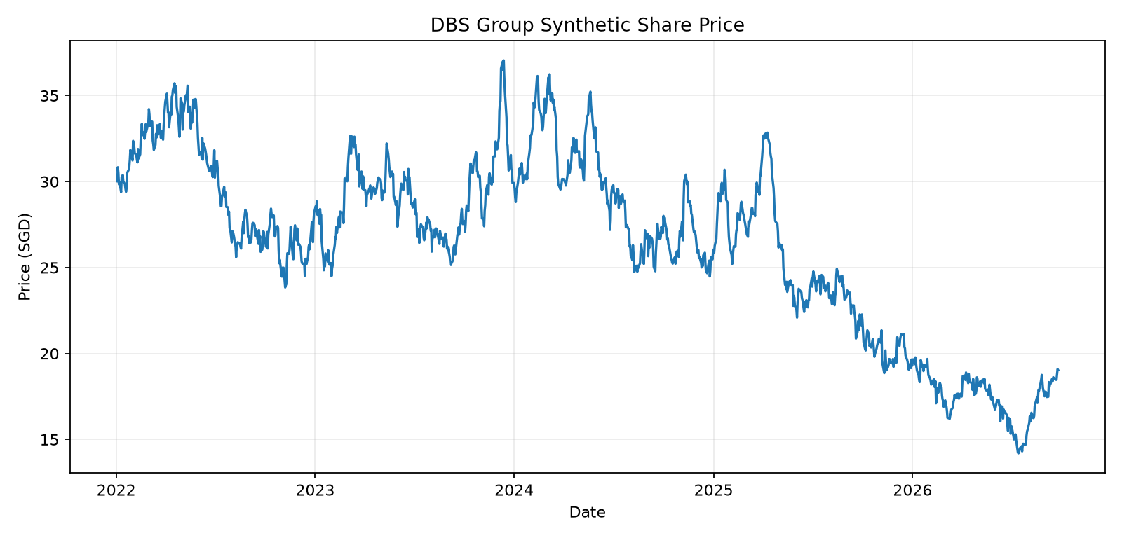
Figure 1. Synthetic share-price history. Source: market.db / daily_prices.

4. Fundamental Trend
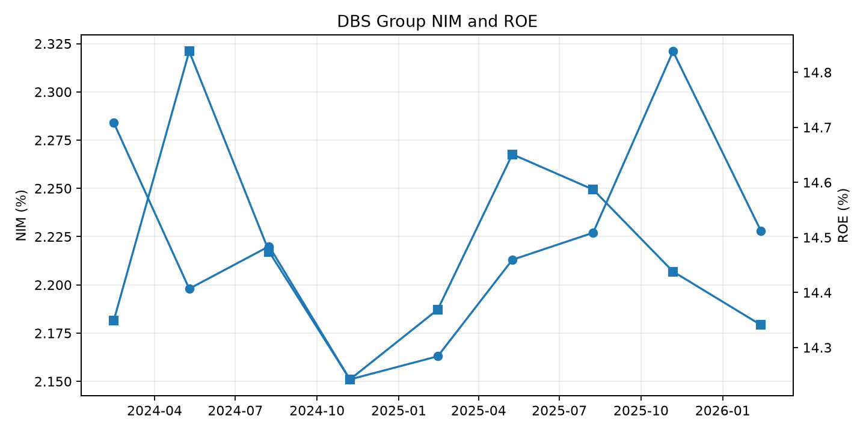
Figure 2. Synthetic NIM and ROE trend. Source: market.db / fundamentals.

5. Event Analysis
The following events are deliberately aligned with market-price shocks and will later appear in other document formats.
Event ID | Date | Description
EVENT-001 | 2024-02-15 | DBS FY2023 Earnings Release
EVENT-002 | 2024-05-10 | DBS Q1 2024 Earnings
EVENT-003 | 2024-08-08 | DBS Q2 2024 Earnings
EVENT-004 | 2024-11-07 | DBS Q3 2024 Earnings
EVENT-005 | 2025-02-14 | DBS FY2024 Earnings
EVENT-006 | 2025-05-09 | DBS Q1 2025 Earnings
EVENT-007 | 2025-08-08 | DBS Q2 2025 Earnings
EVENT-008 | 2025-11-06 | DBS Q3 2025 Earnings
EVENT-009 | 2026-02-13 | DBS FY2025 Earnings
EVENT-010 | 2025-09-18 | Synthetic Monetary Policy Shock

6. Analyst Questions
- Was the market reaction justified by the earnings trajectory?
- Did valuation change materially around the event?
- Did volume confirm unusual investor activity?
- How does the company compare with its sector peers?
- What additional evidence should the research agent retrieve?

7. Provenance
Evidence | Location
Prices | market.db / daily_prices
Volume | market.db / daily_volume
Fundamentals | market.db / fundamentals
Events | data/reference/events.json
Dataset status | Synthetic

Employee bio:
Name: Niharika Yadav
Employment History : Niharika has worked in DBS in 2022 to 2023. She started her journey as an Analyst and got promoted to Associate level within 1 year.

