UOB
Synthetic Internal Investment Committee Note
Ticker: U11 | Sector: Singapore Banks | Currency: SGD
SYNTHETIC DATASET — FOR AI PROTOTYPE TESTING ONLY.

1. Investment Context
This synthetic investment note evaluates UOB using market data, fundamental metrics and historical investment events. The purpose is to test whether an AI research agent can connect structured and unstructured evidence.

2. Key Metrics
Metric | Latest Value
NIM | 2.02%
ROE | 12.23%
CET1 | 16.11%
NPL | 1.30%
P/E | 9.64x
P/B | 1.15x

3. Price Performance
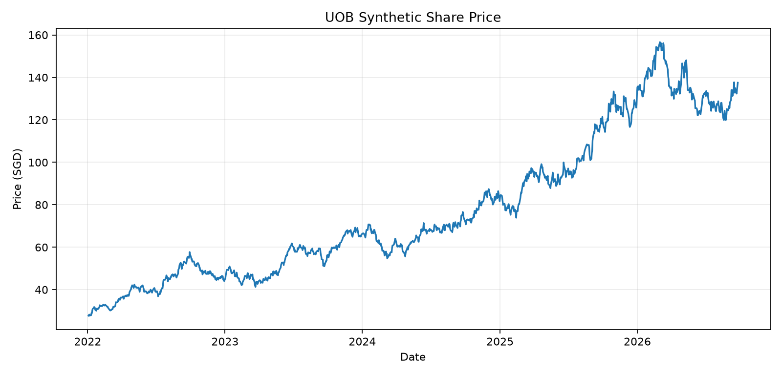
Figure 1. Synthetic share-price history. Source: market.db / daily_prices.

4. Fundamental Trend
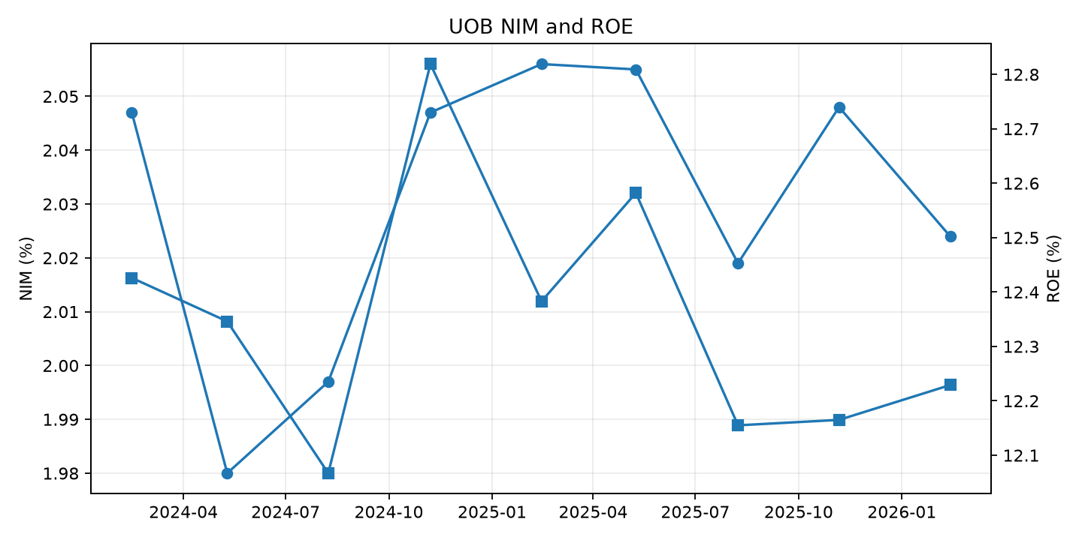
Figure 2. Synthetic NIM and ROE trend. Source: market.db / fundamentals.

5. Event Analysis
The following events are deliberately aligned with market-price shocks and will later appear in other document formats.
Event ID | Date | Description

6. Analyst Questions
- Was the market reaction justified by the earnings trajectory?
- Did valuation change materially around the event?
- Did volume confirm unusual investor activity?
- How does the company compare with its sector peers?
- What additional evidence should the research agent retrieve?

7. Provenance
Evidence | Location
Prices | market.db / daily_prices
Volume | market.db / daily_volume
Fundamentals | market.db / fundamentals
Events | data/reference/events.json
Dataset status | Synthetic

