Singapore Banks
Synthetic Sector Investment Committee Note
DBS Group | OCBC | UOB
SYNTHETIC DATASET — FOR AI PROTOTYPE TESTING ONLY.

1. Sector Comparison
Company | NIM | ROE | CET1 | NPL | P/E | P/B
DBS Group | 2.23% | 14.34% | 17.17% | 1.10% | 10.42x | 1.34x
OCBC | 2.17% | 12.78% | 15.64% | 1.17% | 9.56x | 1.39x
UOB | 2.02% | 12.23% | 16.11% | 1.30% | 9.64x | 1.15x

2. Relative Performance
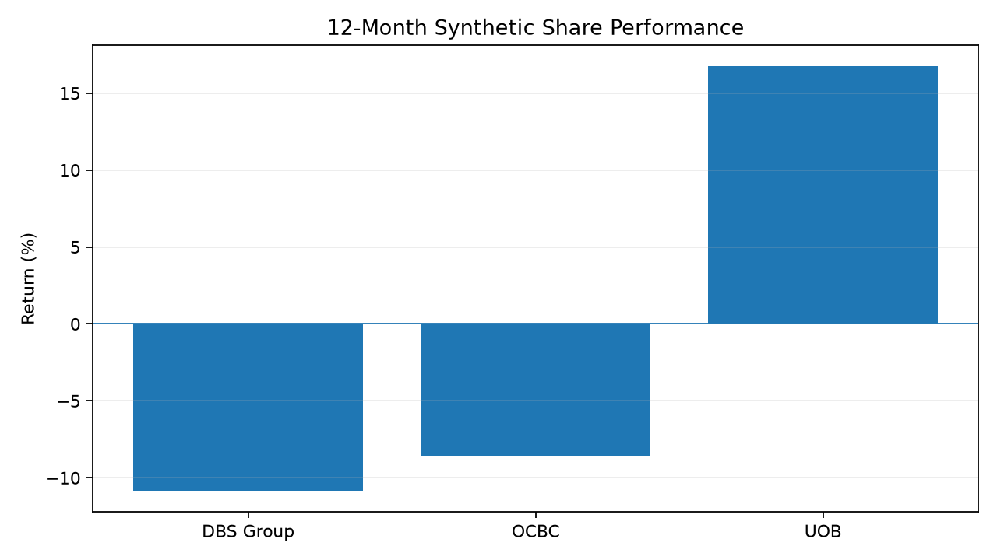
Figure 1. Synthetic 12-month share-price comparison.

3. Research Framework
- Profitability versus valuation
- Capital strength versus growth
- Credit quality versus returns
- Event-driven share-price reaction
- Sector versus company-specific effects

