Name: Niharika Bolledla

SID:700734351

Problem 1

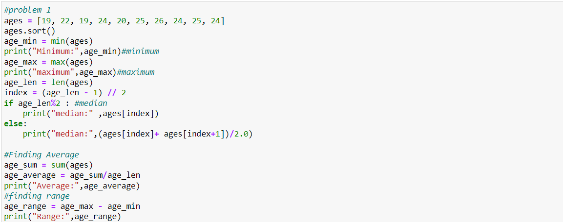

Output:

Output:

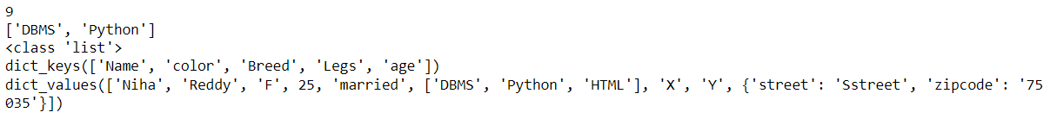

Problem 3:

Output:



Problem 4:

Output:

Problem 5:

Output:

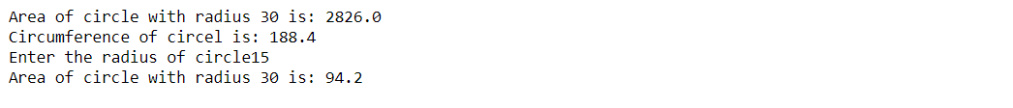

Problem 6:

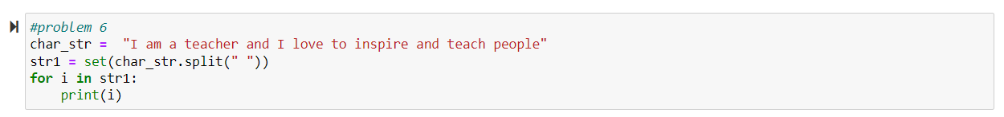

Output:

Problem 7:

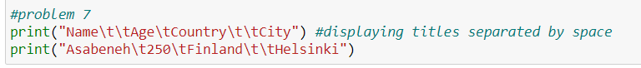

Output:



Problem 8:

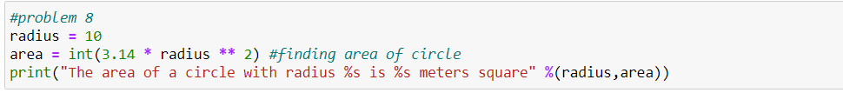

Output:



Output:

