Project Report

On

"Website/Project name"

# Submitted to Punjab Technical University, Jalandhar

**In partial fulfillment of the requirements**

**For the degree of**

# B.Tech Computer Science & Engineering

# (Session 2021-2022)



**Submitted To:**

Aditi Sharma

**Submitted By:**

Ms. Neha Sharma

**PCTE INSTITUTE OF ENGINEERING & TECHNOLOGY, LUDHIANA**

**Declaration**

I swore that the work being presented by me in the dissertation titled "Kickz World” in partial requirements for the fulfillment of degree of B. Tech Computer Science and Engineering to be submitted in **PCTE INSTITUTE OF ENGINEERING AND TECHNOLOGY, LUDHIANA** affiliated to **PTU, Jalandhar** is authentic record of my own work carried out by me under the supervision of **"**Ms. Neha Sharma**".**

**Acknowledgement**

**On the very outset I would like to thank the almighty GOD for showering his blessing & providing me with the courage, motivation & strength to complete my project.**

**Every Project work demands a lot of hard work, time, patience and concentration. While working on this seminar, apart from these aspects, I have developed necessary skills and attitude, which are always required in a professional field. I am thankful to all those who helped me in completing this project.**

**I express my deep sense of gratitude & indebtness towards my respected Project In-charge "**Ms. NehaSharma**", and faculty members of PCTE Institute of Engineering and Technology from whom I have learnt the technical skills for completion of this Project. Without their guidance, I would have found it really difficult to undertake the project work. I would like to thank them for their ever available, unconditional help & guidance that they made available throughout the project work.**

**I would also like to acknowledge the encouraging attitude of my friends & other staff members of P.C.T.E family that helped me to complete the project work.**

**Certificate from Organization**

This is to certify that format and quality of presentation of project report submitted by

As one of the requirements for the degree of

**B. Tech Computer Science and Engineering**

is acceptable to

**Department of Computer Science and Engineering,**

**PCTE, Ludhiana**

**Head of Dept.**

**(_**Dr. Kapil Prashar)

**PCTE Institute of Engineering and Technology, Ludhiana**

**Certificate from Internal Guide**

This is to certify that the project title “**Kickz World**” submitted for the degree of **B.Tech Computer Science and Engineering** in the project of **PCTE Institute of Engineering and Technology, Ludhiana** affiliated to **PTU, Jalandhar** is a benefited research which is carried out by **me** under my supervision and no part of this project has been for any other degree. They have worked very hard and sincerely during this project.

**Project Supervisor**

Ms. Neha Sharma

**(Faculty, PCTE)**

**Ludhiana**

**Contents**

* Introduction to project
* Study of Existing System
* Study of Proposed System
* Software and Hardware Requirements at time of development
* Objectives of Project
* Features of Project
* Site Map
* Module wise description
* Project Design (forms)
* Project Plan
* Development tool

**INTRODUCTION**

**INTRODUCTION TO PROJECT**

This project is about a website displaying huge collection of shoes. This Project has the following main functionality

1. To provide best quality footwear brands at one place.
2. Improving the online shopping experience of the users by keeping the site very simple and easy to understand.

**PURPOSE OF THE PROJECT**

This project is developed to create an e-commerce website on footwears. An E-commerce(electronic commerce) website is an online store where you can buy or sell products online. With the evolution of technology and the wave of digitalization, more and more businesses are adapting to tech evolutions. You will find the digital payment options with the grocery sellers & street-side vendors as well. The ultimate purpose behind this evolution is to make shopping a hassle-free experience for everyone.

1. Capability to create a unique user shopping profile or by End users after registering themselves
2. Capability for End users to login into the system using a browser
3. Capability for logged in users to buy product/services
4. Add their products to cart to check out later

**PROBLEM IN EXISTING SYSTEM**

* Cannot Upload and Download the latest updates.
* Risk of mismanagement and of data when the project is under development.
* Less Security.
* No proper coordination between different Applications and Users.
* Fewer Users - Friendly.
* Manual system need man power a lot.
* Limited option of products available

**SOLUTION OF THESE PROBLEMS**

The development of the new system contains the following activities, which try to automate the entire process keeping in view of the database integration approach.

1. User friendliness is provided in the application with various controls.
2. The system makes the overall project management much easier and flexible.
3. Readily upload the latest updates, allows user to download the alerts by clicking the URL.
4. There is no risk of data mismanagement at any level while the project development is under process.

It provides high level of security with different level of authentication

**STUDY OF THE SYSTEM**

**Number of Modules**

The system after careful analysis has been identified to be presented with the following modules:

**The modules involved are:**

1. **Home Module:**

* By using this module, users can access the navigation bar and can scroll below to login/register into their accounts.

1. **About Module:**

* This module is made to provide a basic knowledge about the company and the types of products and services they offer to the users.

1. **Collection Module:**

* This module is made is provide security features to the application.

1. **Contact Us Module:**

* This module is designed to help users to contact the company or to locate their showroom

1. **FAQ Module:**

* User can solve their all product and services related queries through visiting this module.

**PURPOSE OF THE SYSTEM**

This project is developed to create an e-commerce website to buy/sell products and services. Our website Kickz world will help the users to find the best footwear collection online for men, women and kids. It will help you to complete your outfit with India's most trusted footwear brand. Stay cool stylish with our wide variety of colors, sizes and style in our shoes collection. This type of application needs to manage mails send by registered users.

Kickz World’s Main Features

* Capability to create a unique user shopping profile or by End users after registering themselves
* Capability for End users to login into the system using a browser
* Capability for logged in users to buy product/services
* Add their products to cart to check out later

**PROBLEMS IN THE EXISTING SYSTEM:**

* The existing system is manual system. Needs to be converted into automated system.
* Risk of mismanagement of data.
* Less Security.
* No proper coordination between different Applications and Users.
* Fewer Users - Friendly.
* Accuracy not guaranteed.
* Not in reach of distant users.

**SOLUTION OF THESE PROBLEMS**

The development of the new system contains the following activities, which try to automate the entire process keeping in view of the database integration approach.

1. User friendliness is provided in the application with various controls.
2. The system makes the overall project management much easier and flexible.
3. There is no risk of data mismanagement at any level while the project development is under process.
4. It provides high level of security with different level of authentication.
5. Users from any part of the world can make use of the system.
6. New system will process accurate results.
7. New system will be much better in performance as compared to existing one.

**PROPOSED SYSTEM**

To debug the existing system, remove procedures those cause data redundancy, make navigational sequence proper. To provide information about audits on different level and also to reflect the current work status depending on organization/auditor or date. To build strong password mechanism.

**NEED FOR COMPUTERIZATION**

We all know the importance of computerization. The world is moving ahead at lightning speed and everyone is running short of time. One always wants to get the information and perform a task he/she/they desire(s) within a short period of time and too with amount of efficiency and accuracy. The application areas for the computerization have been selected on the basis of following factors:

* Minimizing the manual records kept at different locations.
* There will be more data integrity.
* Facilitating desired information display, very quickly, by retrieving information from users.
* Facilitating various statistical information which helps in decision-making?
* To reduce manual efforts in activities that involved repetitive work.
* Updating and deletion of such a huge amount of data will become easier.

**FUNCTIONAL FEATURES OF THE MODEL**

As far as the project is developed the functionality is simple, the objective of the proposal is to strengthen the functioning of Audit Status Monitoring and make them effective and better. The entire scope has been classified into five streams knows as Coordinator Level, management Level, Auditor Level, User Level and State Web Coordinator Level. The proposed software will cover the information needs with respect to each request of the user group viz. accepting the request, providing vulnerability document report and the current status of the audit.

**INPUT AND OUTPUT**

The main inputs, outputs and major functions of the system are as follows.

Inputs:

Member Registration details:

Registration module is responsible for member registration and login. While registration, member will be prompted for his 1) login account details (username, password, hint question, answer), 2) his personal details, and 3) his contact address

At time of sign in, Member has to provide username and password.

In Message compose box, Member has to provide Message to send with Email-ID (to whom message has to be sent.).

**Outputs:**

* On successful registration, member will be provided confirmation mail.
* On successful signing in, member will be placed to My Account page.

**PROCESS MODELS USED WITH JUSTIFICATION**

**ACCESS CONTROL FOR DATA WHICH REQUIRE USER AUTHENTICATION**

The following commands specify access control identifiers and they are typically used to authorize and authenticate the user (command codes are shown in parentheses)

**USER NAME (USER)**

The user identification is that which is required by the server for access to its file system. This command will normally be the first command transmitted by the user after the control connections are made (some servers may require this).

**PASSWORD (PASS)**

This command must be immediately preceded by the user name command, and, for some sites, completes the user's identification for access control. Since password information is quite sensitive, it is desirable in general to "mask" it or suppress type out.

**Mail Client**

Development of a feature-rich web based Mail Service

1. **Title of the project:** **Mail Client**
2. **Domain:** Open Industry
3. **Sub Domain:** Mail Client
4. **Project Architecture**: N-Tire Architecture
5. **Abstract of the project:**

This project is about developing a web based mail client connecting to windows Server running a Mail Server. This Project has the following main functionality

1. Receiving/Sending/organizing mails.
2. Sending mail using send mail.
3. Performing Admin functions like managing new user, resetting passwords etc.

The software is fully integrated with **CRM** (Customer Relationship Management) as well as **CMS** (Content Management System) solution and developed in a manner that is easily manageable, time saving and relieving one from manual works.

**Functional components of the project:** Following is a list of functionalities of the system:-

1. Capability to create user Email Accounts by an Administrator or by End users after registering themselves
2. Administrator functionality to Delete User Accounts, Change passwords
3. Capability for End users to login into the system using a browser
4. Capability for logged in users to send/receive/forward/reply/delete mails
5. Invalidate user login on inactive for more than 10mts
6. Address book capability
7. Mark mails as Junk
8. Apply Label to Mail
9. Organize mails in Logical Folders

**6. EXISTING SYSTEM:**

* Cannot Upload and Download the latest updates.
* No use of Web Services and Remoting.
* Risk of mismanagement and of data when the project is under development.
* Less Security.
* No proper coordination between different Applications and Users.
* Fewer Users - Friendly.
* Manual system need man power a lot.
* Communication between Patient and administration is a tuff job.
* Difficult to maintain each and patient information in form of files.

**7. PROPOSED SYSTEM:**

The development of the new system contains the following activities, which try to automate the entire process keeping in view of the database integration approach.

* User friendliness is provided in the application with various controls.
* The system makes the overall project management much easier and flexible.
* Readily upload the latest updates, allows user to download the alerts by clicking the URL.
* There is no risk of data mismanagement at any level while the project development is under process.
* It provides high level of security with different level of authentication.

**8. MODULES:**

* Member Registration Module:
* Sending and Receiving mails:
* Integrated Security Module:
* Admin Module:
* Login/Logout Date & Time Tracking Module
* Address book Maintenance
* CMS (content Management System) Integration

**9. Keywords:**

* **Generic Technology Keywords:** Databases, User Interface, Programming
* **Specific Technology Keywords:** ASP.Net, C#.Net, MS SQL Server
* **Project Type Keywords:** Analysis, Design, Implementation, Testing
* **SDLC Keywords**: Presentation, Business, Data Access Layers

**10. Environment:**

* **Servers:**

**Operating System Server: -** Microsoft Windows 2007

* **Clients:** Microsoft Internet Explorer,
* **Tools:** Microsoft Visual Studio .Net

**11. Requirements:**

* **Hardware requirements:**

|  |  |
| --- | --- |
| **Number** | **Description** |
| 1 | PC with 2 GB hard-disk  and 256 MB RAM |

* **Software requirements:**

|  |  |
| --- | --- |
| **Number** | **Description** |
| 1 | Windows 2000/ XP/ or Higher with MS-office |
|  |  |
| 3. | MS-Visual Studio .Net 2022 |
| 4. | MS-Internet Explorer |

**Objectives of Project**

* Quality Services
* Easy Management
* Easy Updating
* Save Time
* Improve Efficiency
* Easy Search and Report Generation

**Features of Project**

1. **Easy Interface :**

Management Softwareis made of very simple interfaces. Any end user with a minimum knowledge of operating the Computer can easily familiar with this software.

1. **Security :**

Management Software is password-protected software. Unauthorized user cannot log on to this software.

1. **Reliability :**

Management Software is reliable software. One can rely on the result produced by this software. We try to remove all the errors from it and make it error free but it can be error prone.

1. **Compact Coding :**

Management Software is compact and efficient coded software. It is developed with keeping in mind memory space and speed. It uses less memory space and work on increasing speed.

1. **Security:**

It secures the databases through the personal logins and their reserved passwords.

1. **No extra skills require:**

Person needs not to be computer professional. If user with little knowledge of computer can operate this project.

1. **Large capacity: -**

The storage capacity is very large and database is centralized.

1. **User Friendly:** -

We develop software which is very user friendly.

**Site Map**

1. Home
2. About
3. Collection
4. Contact Us
5. FAQ

**Module wise description with screen shots**

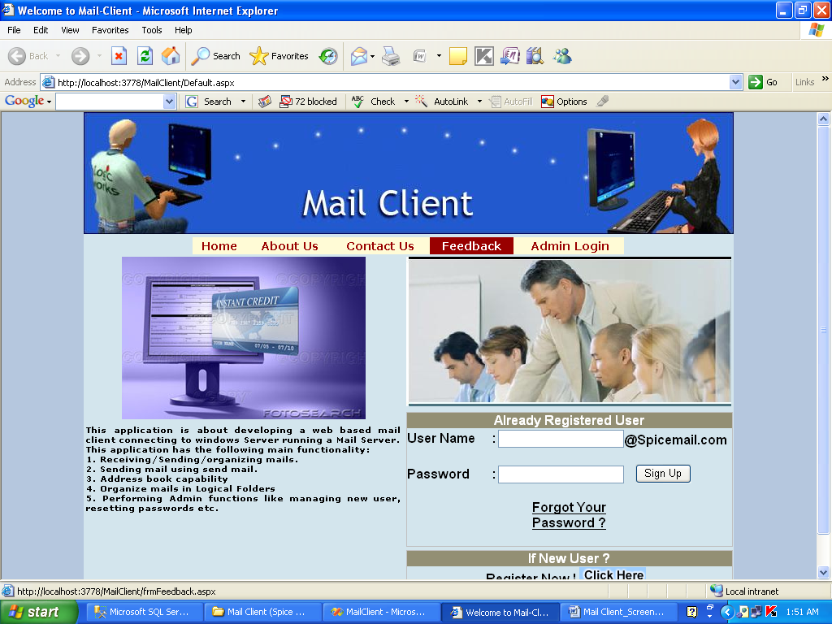

Page name: Home page

Fields: User name, password, forget your password, sign up

Process: Users have to enter login details

Stored procedure: yes

Remarks: if new users have to sign up

Error: no

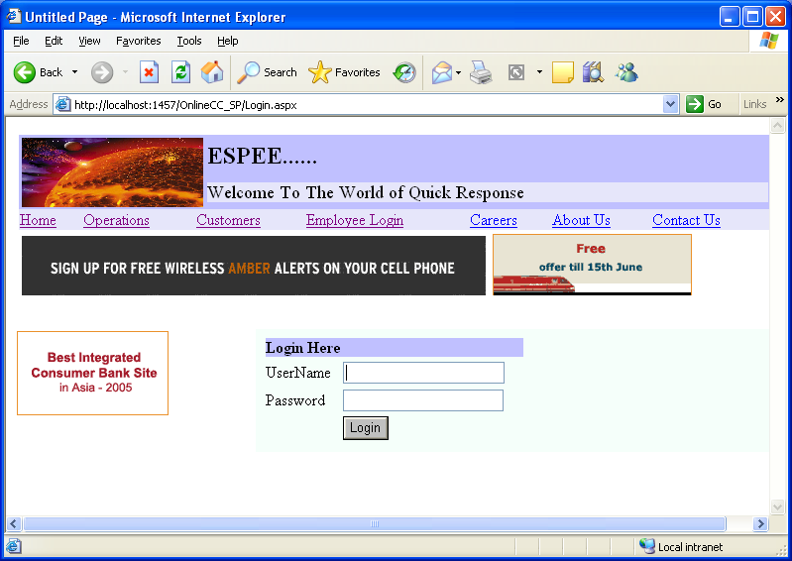

Page name: emp login

Fields: user name, password, login

Process: enter login details

Table: login

Remarks: login

Error: no

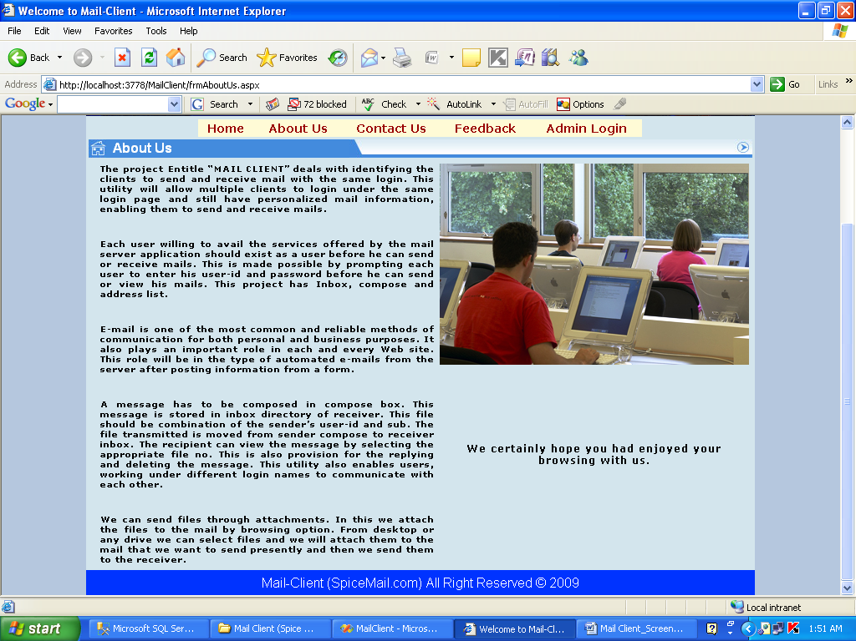

Page name: About Us

Fields: no

Process: static page

Table: no

Stored procedure: no

Remarks: static

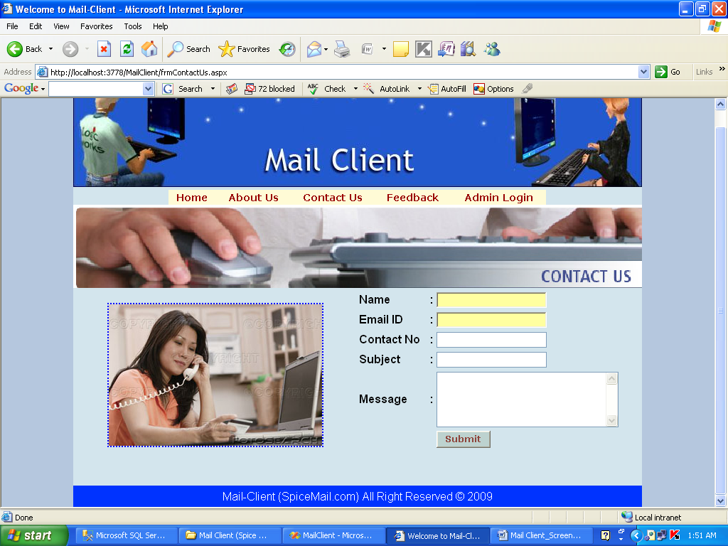

Page name: contact us

Fields: name, email id, contact no, subject, message

Process: enter contact details

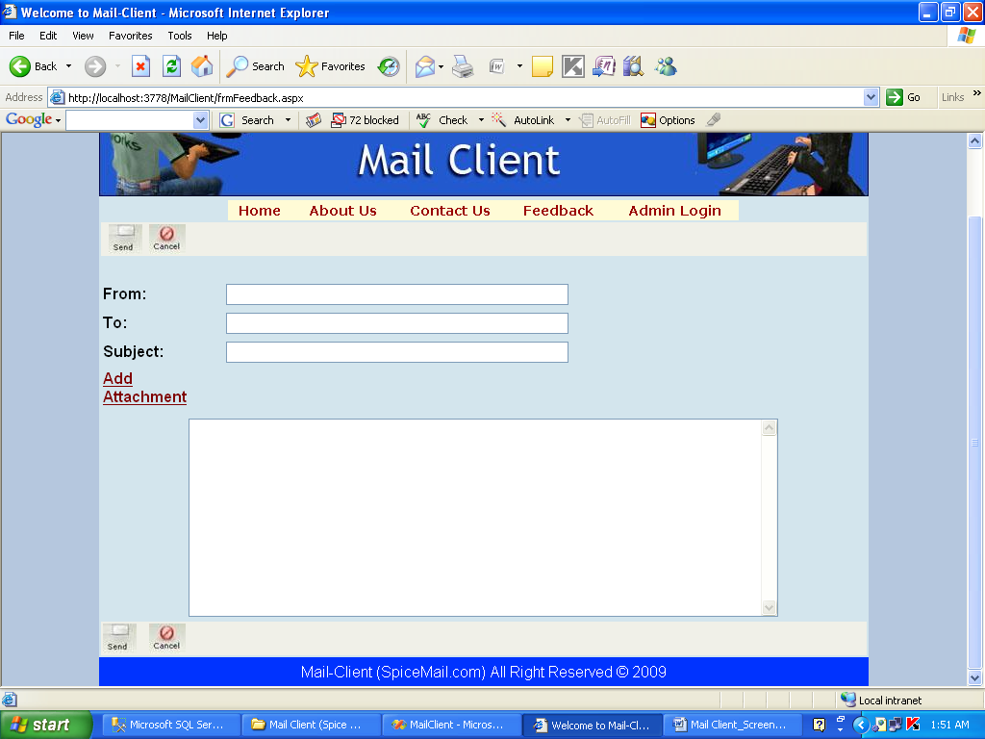

Page name: mail

Fields: from, to, subject, add attachment, body, send, cancel

Process: enter respective details

Table: mail

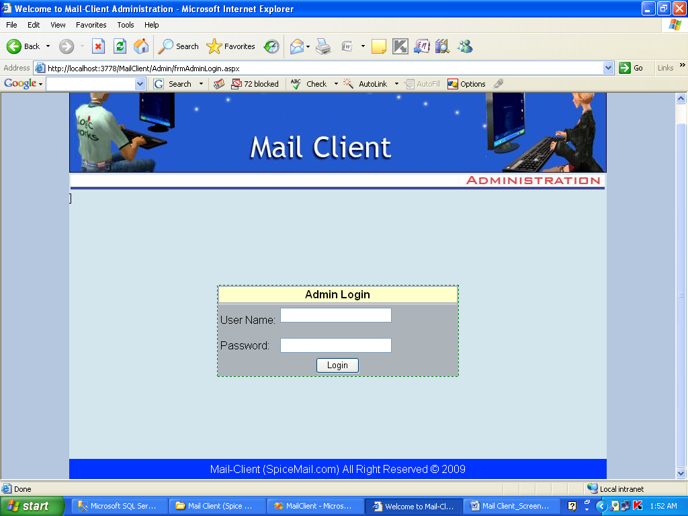

Page name: admin

Fields: username, password

Process: enter admin credentials

Table: admin

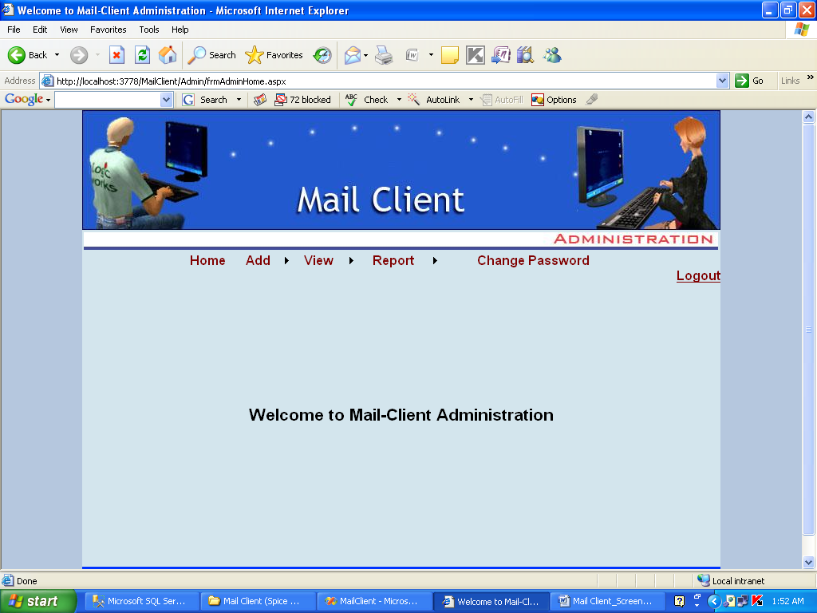

Page name: admin home

Fields: logout

Process: home page

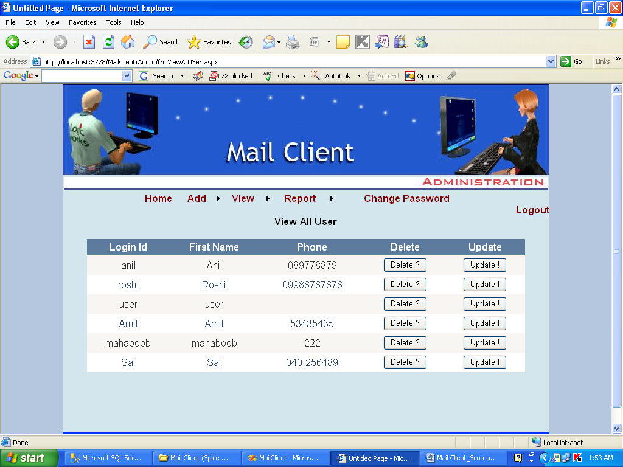

Page name: view all user

Fields: grid view

Process: show user

Table: user details

Stored procedure:

Remarks: user details

Error: no

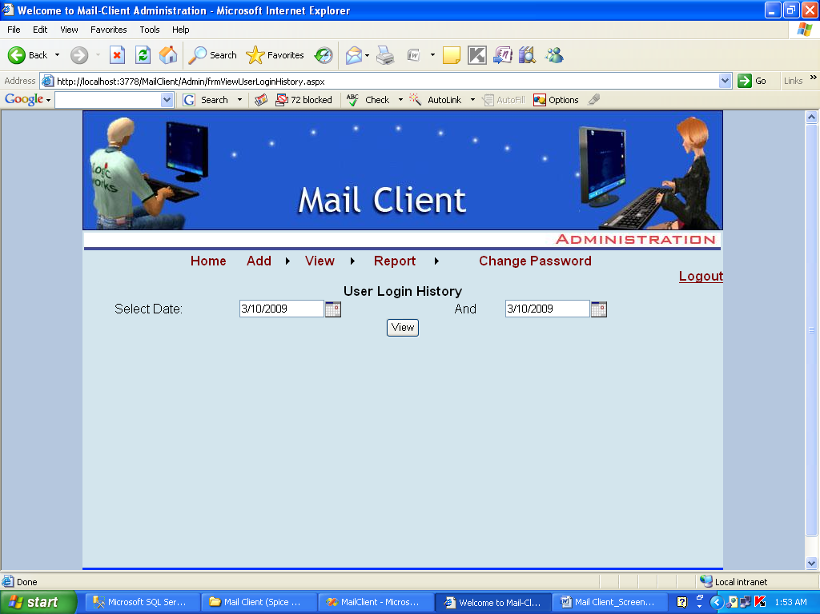

Page name: user login history

Fields: date

Process: show that are login

Table: user login

Stored procedure:

Remarks: show that are login

Error: no

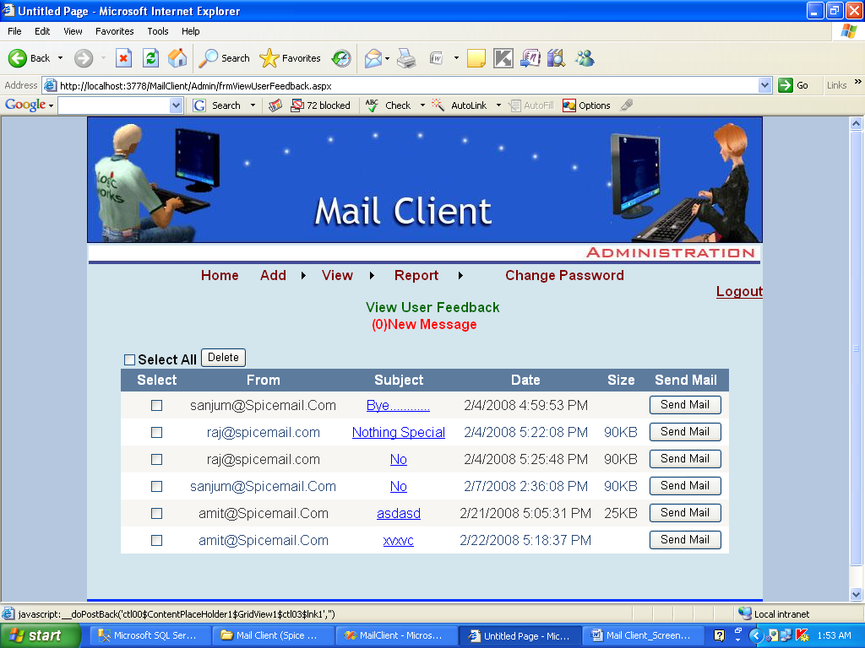

Page name: user feed back

Fields: delete

Process: feedback of user

Table: feed back

Remarks:

Error: no

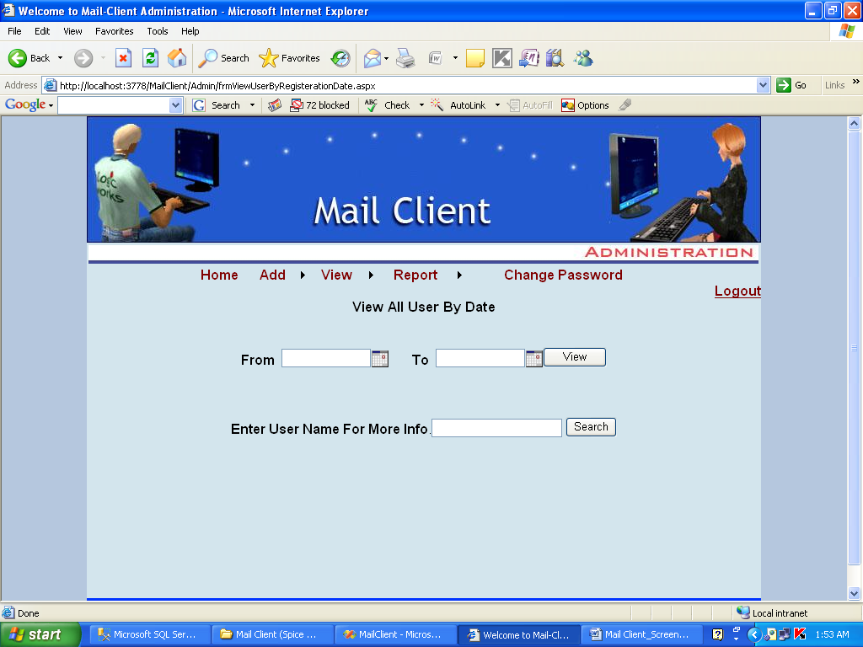

Page name: view all user by date

Fields: from, to, user name

Process: enter fields

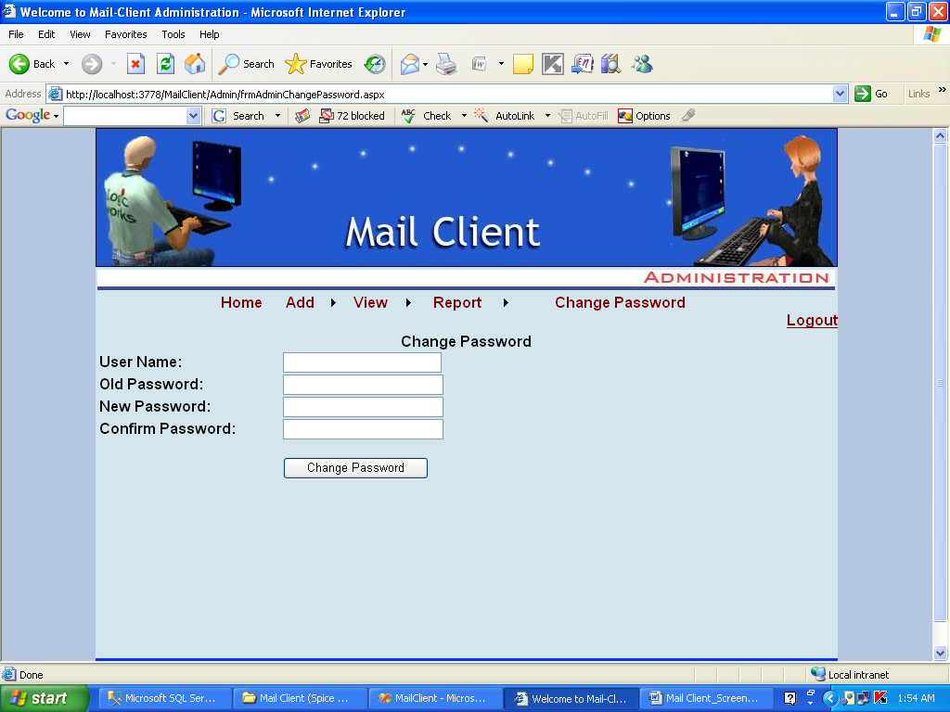

Page name: change password

Fields: user name, old password, new password, confirm password

Process: changes password

Table: password

Remarks: new password

Error: no

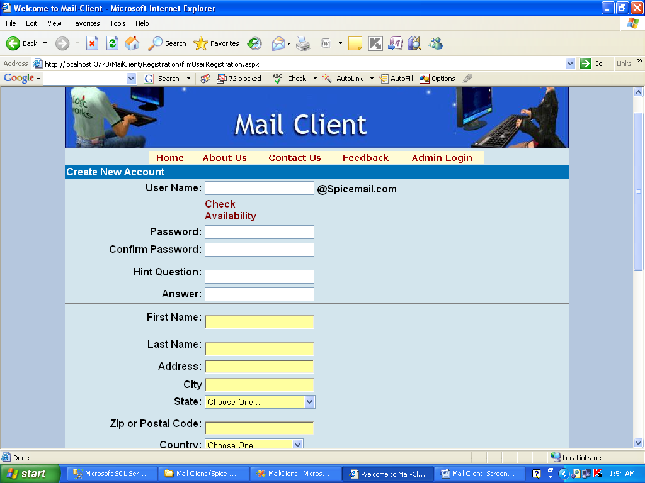

Page name: create new account

Fields:pwd. hint qus, ans, name. last name, address, city, state, code, country

Process: register

Table: register

Remarks: create an account

Error: no

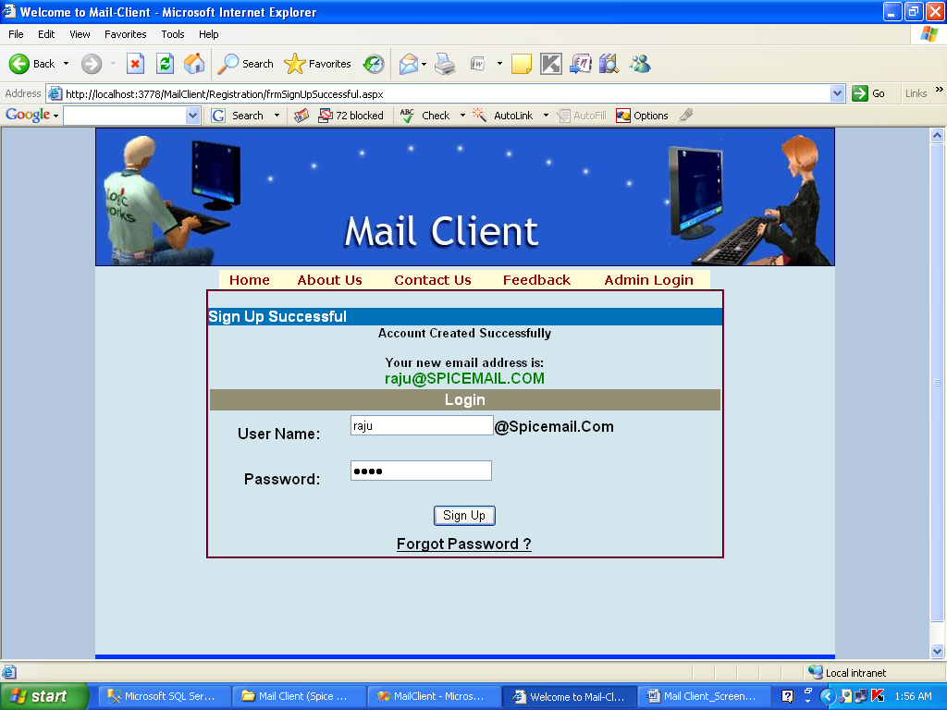

Page name: after registration

Fields: user name, password

Process: after login

Remarks: after login this will come

Error: no