Question 1:

Draw your Home network topology and explain how you are accessing the RPS lab environment.

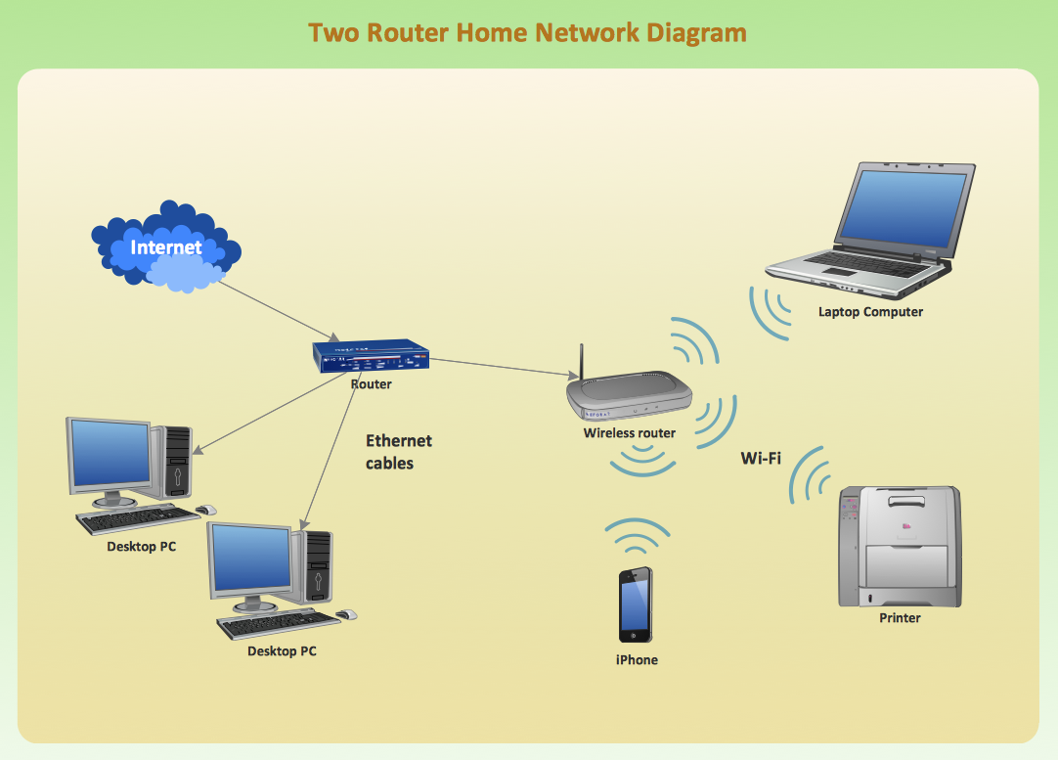

Accessing RPS Lab Environment:
To access a remote lab environment like RPS from my home network, I would typically follow these steps:
- Connect to the Internet: Ensure that my home network is connected to the Internet through my ISP (Internet Service Provider), usually via a modem.
- Connect to the Router: Devices within my home network connect to a router either wired (via Ethernet cables) or wirelessly (Wi-Fi). The router manages local network traffic and assigns IP addresses to devices.
- Connect to the RPS Lab Environment: Access to the RPS lab environment might be provided through a VPN (Virtual Private Network) connection or through a web-based interface.
a. VPN Connection: If the RPS lab requires a VPN connection, I would first connect to the VPN provided by the lab using VPN client software installed on my device. Once connected, my device would be assigned a virtual IP address within the lab's network, allowing me to access resources within the lab environment securely.
b. Web-based Interface: Alternatively, the RPS lab might offer access through a web-based interface. In this case, I would simply open a web browser on my device, navigate to the provided URL, and log in with the necessary credentials to access the lab environment remotely.
- Interact with RPS Lab Resources: Once connected to the RPS lab environment, I can interact with the lab resources, which could include virtual machines, physical hardware, simulation software, or other tools depending on the purpose of the lab.

Question 2:

Identify a real-world application for both parallel computing and networked systems.Explain how these technologies are used and why there are important in that context.

Answer:

One real-world application that utilises both parallel computing and networking systems is distibuted computing for scientific research,such as simulating climate models and particle physics experiments conducted at facilities like CERN.

In rhis ,parallel computing enables researchers to divide massive datasets into smaller chunks and process them simultaneously acreoss multiple computing nodes. Each node performs computations independently ,utilizing parallel processing techniques to speed up data analysis.

Networked systems play a crucial role in distributing these computing tasks across geographically distibuted resources.High-speed networkd connect computing clusters located at different research institutions worldwide,allowing for efficient data exchange and collaboration among researchers.

These technologies are essential in scientific research because they ennable the analysis of vast amounts of experimental data generated by particle accelerators and dectectors.Prallel computing accelerates data processing ,reducing,the time required for analysis and enabling scientists to extract valuable insights from complex datasets.Networked systems facilitate collaboration and resource sharing among researchers,leading to advancements in fundamental science and our understanding of the universe.

