**Assignment (04-10-2024)**

Niharika NG

***Question1:- A Shop which sells products***

**Tables are as followed: -**

### **Supplier**

|  |  |  |  |
| --- | --- | --- | --- |
| Supplier ID | Company Name | Contact Name | Phone |
| 101 | La Pino's | Tanya Chanani | 9710446575 |
| 102 | Haldiram | Disha Gupta | 8710446575 |
| 103 | Bikenarwala | Niharika Garg | 9777442575 |
| 104 | Donalds | Saurabh Gupta | 8334446575 |
| 105 | Pizza Hut | Rajeev Jain | 7810446575 |

### **Product**

|  |  |  |  |
| --- | --- | --- | --- |
| ProductID | Name | Price | Quantity |
| 1001 | Pizza | 250 | 100 |
| 1002 | Pastry | 300 | 100 |
| 1003 | Burger | 100 | 100 |
| 1004 | Cake | 230 | 100 |
| 1005 | Chips | 50 | 100 |

### **Product Supplied**

|  |  |  |  |  |  |
| --- | --- | --- | --- | --- | --- |
| PO_Number | ProductID (FK) | SupplierID (FK) | DateOfSupply | Quantity | Price |
| 11 | 1001 | 101 | 09-10-2024 | 100 | 250 |
| 12 | 1002 | 102 | 03-10-2024 | 100 | 300 |
| 13 | 1003 | 103 | 04-03-2024 | 100 | 100 |
| 14 | 1004 | 104 | 03-09-2024 | 100 | 230 |
| 15 | 1005 | 105 | 04-09-2024 | 100 | 50 |

### **Customer**

|  |  |  |  |
| --- | --- | --- | --- |
| ID | Name | Phone | Age |
| 112 | Nia | 9710446575 | 22 |
| 113 | Sarika | 8710446575 | 34 |
| 114 | Riya | 9777442575 | 21 |
| 115 | Ashu | 8334446575 | 23 |

### **Order**

|  |  |  |  |  |
| --- | --- | --- | --- | --- |
| OrderID | Bill Number (FK) | CustomerID (FK) | Date of Purchase | Total Bill Amount |
| 1011 | 1011 | 112 | 03-10-2024 | 500 |
| 1012 | 1012 | 113 | 04-10-2024 | 300 |
| 1023 | 1023 | 114 | 05-10-2024 | 100 |
| 1022 | 1022 | 115 | 06-10-2024 | 150 |

### **Bill Details**

|  |  |  |  |  |
| --- | --- | --- | --- | --- |
| Bill Number (FK) | ProductID (FK) | Quantity | Price | Discount |
| 1011 | 1002 | 2 | 500 | 0 |
| 1012 | 1003 | 1 | 300 | 0 |
| 1023 | 1004 | 1 | 100 | 0 |
| 1022 | 1005 | 3 | 150 | 0 |

**Relationship is as followed:-**

* **Product – ProductSupplied** (Many-to-One)

Many products can be supplied by a specific supplier in the ProductSupplied entity, but each product supply record refers to only one product.

* **Supplier – ProductSupplied** (One-to-Many)

A supplier can supply many products over time, but each supply entry in ProductSupplied is linked to only one supplier.

* **Customer – Order** (One-to-Many)

A customer can place many orders, but each order is tied to only one customer.

* **Order – BillDetails** (One-to-Many)

An order can have multiple entries in BillDetails, but each bill detail record corresponds to a single order.

* **BillDetails – Product** (Many-to-One)

Many bill detail records can reference the same product, but each bill detail is linked to only one product.

**ER-DIAGRAM:-**

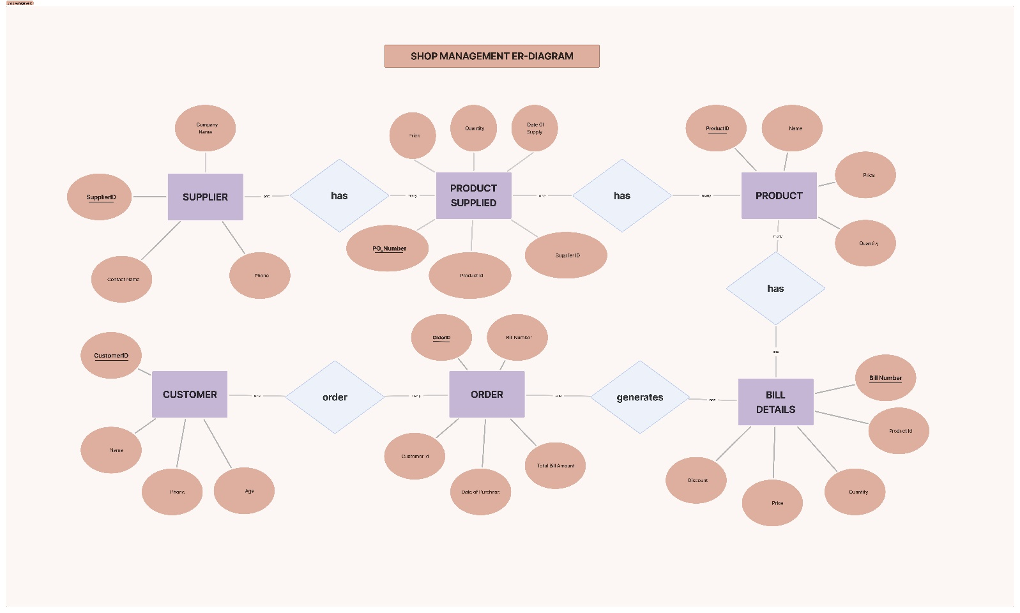

***Question2: A Video Rental Store***

**Tables are as followed: -**

### **Movie**

|  |  |  |  |  |
| --- | --- | --- | --- | --- |
| **Movie_Number** | **Title** | **Format** | **Category** | **StoreID (FK)** |
| 11 | Inception | Blu-ray | Sci-Fi | 101 |
| 12 | Avengers | DVD | Action | 102 |
| 13 | Frozen | DVD | Animation | 103 |

### **Video Store**

|  |  |  |  |
| --- | --- | --- | --- |
| **StoreID** | **StoreName** | **ContactNumber** | **Location** |
| 101 | MX Cinema | 9265786903 | Ghaziabad |
| 102 | MAM Cinema | 9265786103 | Lucknow |
| 103 | NG Cinema | 8165786903 | Delhi |

### **Member**

|  |  |  |  |  |  |
| --- | --- | --- | --- | --- | --- |
| **MemberID** | **Name** | **Number** | **Category** | **Type** | **Card**  **Number** |
| 1 | John Doe | 9234567890 | Gold | Individual | N456 |
| 2 | Jane Smith | 9234567891 | Silver | Family | N457 |

### **Dependent**

|  |  |  |  |
| --- | --- | --- | --- |
| Dependent ID | MemberID (FK) | Name | Number |
| 101 | 2 | Tim Smith | 9234567892 |
| 102 | 2 | Sara Smith | 9234567893 |

### **MovieRental**

|  |  |  |  |  |  |
| --- | --- | --- | --- | --- | --- |
| Rental  ID | MovieID (FK) | RentalDate | ReturnDate | MemberID (FK) | DependantID (FK) |
| 1011 | 11 | 2024-10-01 | 2024-10-05 | 1 | NULL |
| 1012 | 12 | 2024-10-02 | 2024-10-06 | 2 | 101 |
| 1013 | 13 | 2024-10-03 | 2024-10-07 | 2 | 102 |

**Relationship is as followed: -**

* **Video Store – Movie** (One-to-Many)

A store can have multiple movies available for rental, but each movie is associated with only one store.

* **Movie – Movie Rental** (One-to-Many)

A movie can have multiple rentals over time, but each rental is associated with one specific movie.

* **Member – Movie Rental** (One-to-Many)

A member can rent multiple movies, but each rental is linked to only one member.

* **Member – Dependent** (One-to-Many)

A member can have multiple dependents, but each dependent is linked to one specific member.

* **Dependent – Movie Rental** ( Many -to-One)

A dependent can rent movies using the member's account. A rental can be associated with either a member or a dependent.

**ER-DIAGRAM: -**

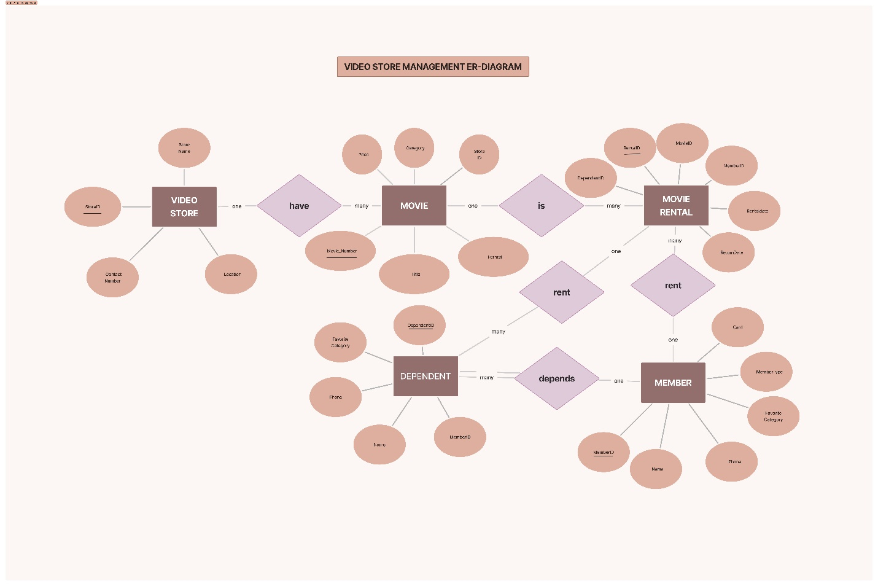

***Question3 : Student Management***

**Tables are as followed: -**

**Student**

|  |  |  |  |  |
| --- | --- | --- | --- | --- |
| Id (PK) | Name | Phone | Email | DateEnroll |
| 1 | Alice Smith | 9712345678 | alice.smith@gmail.com | 2024-01-10 |
| 2 | Bob Brown | 9812345678 | bob.brown@gmail.com | 2024-01-12 |
| 3 | Clara Jones | 9912345678 | clara.jones@gmail.com | 2024-02-01 |
| 4 | David White | 9612345678 | david.white@gmail.com | 2024-02-10 |

**Instructor**

|  |  |  |  |  |
| --- | --- | --- | --- | --- |
| ID (PK) | Name | Number (Phone) | Email | Department |
| 101 | Dr. John Doe | 9712348765 | john.doe@university.com | CS |
| 102 | Dr. Jane Adams | 9812348765 | jane.adams@university.com | Math |
| 103 | Dr. Emily Turner | 9612348765 | emily.turner@university.com | Physics |
| 104 | Dr. Mark Stevens | 9912348765 | mark.stevens@university.com | CS |

**Course**

|  |  |  |  |  |  |
| --- | --- | --- | --- | --- | --- |
| CourseID (PK) | InstructorID (FK) | ScheduleID (FK) | Name | Credits | Description |
| 201 | 101 | 301 | Object-Oriented Programming | 4 | Introduction |
| 202 | 102 | 302 | Calculus II | 3 | Advanced topics |
| 203 | 103 | 303 | Classical Mechanics | 4 | forces and motion |
| 204 | 104 | 304 | Data Structures | 4 | data management |

**Schedule**

|  |  |  |  |
| --- | --- | --- | --- |
| ID (PK) | Location | TimeStart | TimeEnd |
| 301 | Room 101 | 09:00 AM | 10:30 AM |
| 302 | Room 202 | 10:45 AM | 12:15 PM |
| 303 | Room 303 | 01:00 PM | 02:30 PM |
| 304 | Room 404 | 02:45 PM | 04:15 PM |

**StudentInstructor**

|  |  |
| --- | --- |
| StudentID (FK) | InstructorID (FK) |
| 1 | 101 |
| 2 | 102 |
| 3 | 103 |
| 1 | 102 |
| 3 | 101 |

**Relationship is as followed: -**

* **Student – StudentInstructor** (One-to-Many)

A student can be linked to multiple instructors over time through the StudentInstructor table, but each record in the StudentInstructor table references one student.

* **Instructor – StudentInstructor** (One-to-Many)

An instructor can be linked to multiple students through the StudentInstructor table, but each record in StudentInstructor references one instructor.

* **Instructor – Course** (One-to-Many)

An instructor can teach multiple courses, but each course is assigned to only one instructor.

* **Schedule – Course** (One-to-Many)

A schedule can be associated with multiple courses, but each course follows only one schedule.

* **Course – Student** (One-to-Many)

A course can have many students enrolled in it, but a student joins only one Course.

**ER-DIAGRAM: -**

