Bhartendu Awasthi

DiSCO Squad 4

Installation instructions -Drop frequency optimizer

STEPS :

1. Installation of python programming language in the PC
2. Installing necessary python libraries
3. Downloading the tool folders
4. Configuring the excel front end of the tool

STEP A :

Installation of python programming language in the PC

1. Install python programming language. Its very lightweight software. Please visit the below page:  
   [Python Release Python 3.8.8 | Python.org](https://www.python.org/downloads/release/python-388/)  
   Scroll down towards the file section, and download the “Windows installer (64-bit)”. This will download the .exe file. File would be named like: “python-3.8.8-amd64.exe”

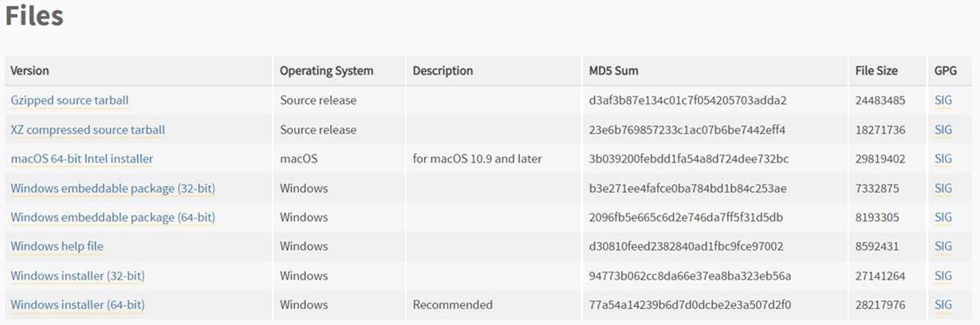

1. After downloading the .exe file from step 1, please open it, and run it. You should see a screen like below:

a ) Please note the selection highlighted below. Pls uncheck the “Install launcher for all users“ and pls check the box “Add Python 3.8 to Path” (exact the same way in the below screen shot)

b) After making the selection above, please press “Install Now” button. It should install python

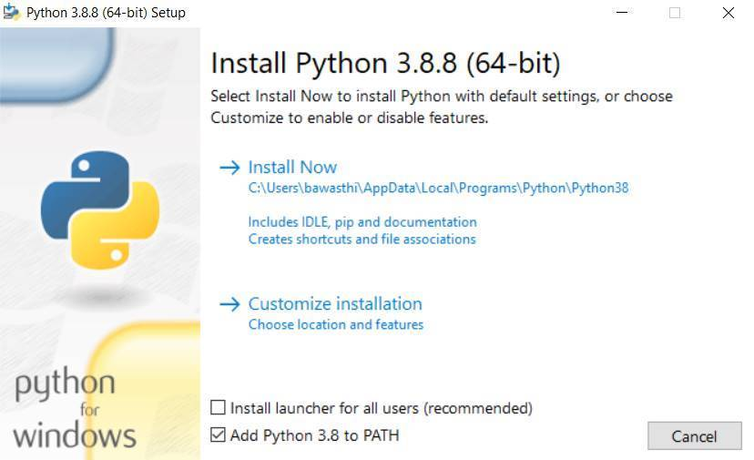

1. Please check the python is installed. Please open the command prompt. To find command prompt, please look at the bottom left 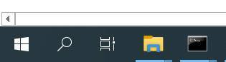 windows button, press it and type “command prompt”, and then open it. You should see a black window 😊 getting opened  Please type python and press enter key from keyboard. You should see something like below (except it should be python 3.8.8). If you see something like below, installation is successful. You can close the command prompt window by clicking top right close button.

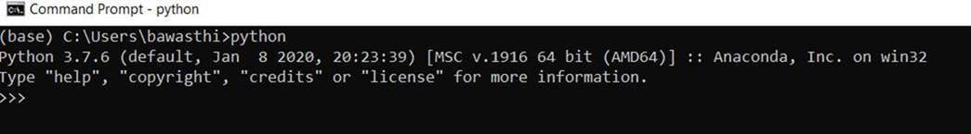

----------------------------------------------------

****** STEP A COMPLETED ******

----------------------------------------------------

STEP B :

Installing necessary python libraries

Important: For step 1 and step 2, please **disconnect from Big IP**. For step 3, it does not matter. Eventually, the tool will run irrespective of the fact that you are on Big Ip or not

1. Open command prompt. Pls write python and press enter. You should see something like below. This is exact same step we performed in STEP A, instruction 3)

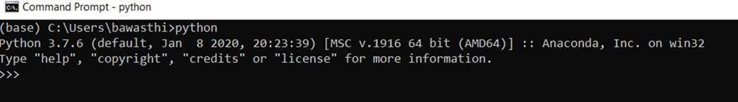

1. Please copy the below snippet and enter above. I think you might need to enter key 2 times. This will start installing the packages. Please ensure you are disconnected from BIG IP, and are connected to open (home) Wi-Fi network

import subprocess  
import sys  
  
packages = ['numpy', 'pandas', 'requests', 'xlwings==0.24.3', 'ortools', 'xlrd', 'openpyxl', 'pytest']  
  
for pckg in packages:  
    subprocess.check_call([sys.executable, "-m", "pip", "install", pckg])

After running the above commands, you should see something like below :

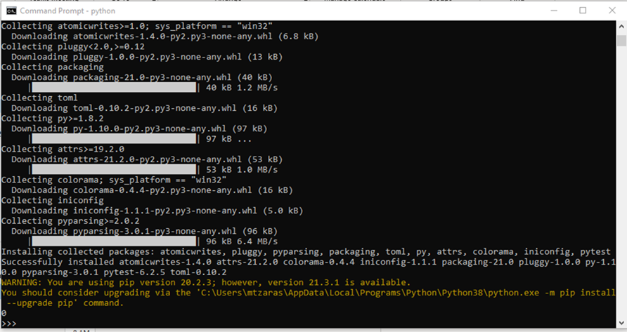

Python installing required packages. When we see “>>>” prompt on the above window it signifies that all the packages were installed.

1. CLOSE the above command prompt window. And open a new command prompt window. Please again write python, and press enter. Now copy and paste below:

import numpy  
import pandas  
import requests  
import xlwings  
import ortools  
import xlrd  
import openpyxl  
import pytest

Each line should run without any errors. Like below: (please note you would have to   
 press enter when you will see “import pytest”)

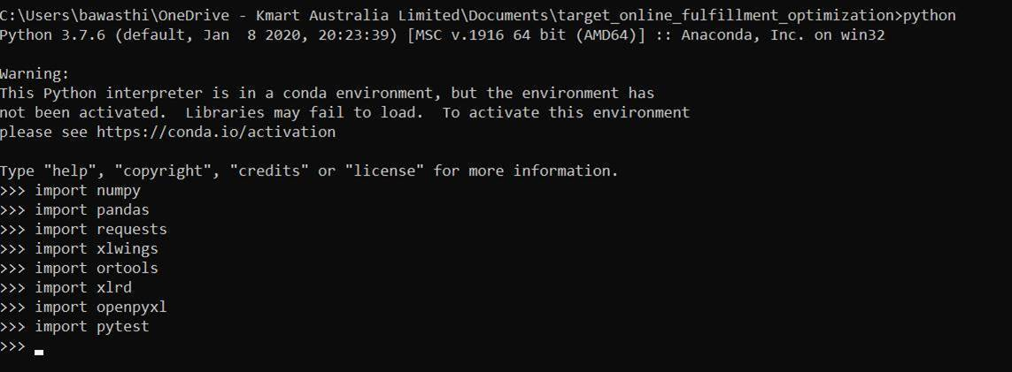

----------------------------------------------------

****** STEP B COMPLETED ******

----------------------------------------------------

STEP C:  
Downloading the tool folders

The link to the shared folder where the tool resides is [here](https://teams.microsoft.com/_#/files/General?threadId=19%3A64b236bfd739493bb5d7b201f6faacb0%40thread.tacv2&ctx=channel&context=Drop%2520frequency%2520optimization%2520tool&rootfolder=%252Fteams%252FT-DISCODemand-drivenInventoryBuffering%252FShared%2520Documents%252FGeneral%252FDrop%2520frequency%2520optimization%2520tool) Please navigate to the folder named “drop_frequency_optimization_tool”. Please download the folder and place a copy of it in “H:\”  
Please ensure that the folder is unzipped, if it gets downloaded in zipped format, please unzip it first. Please ensure that the name of the folder should be “drop_frequency_optimization_tool”, please don’t make any changes to the folder name

----------------------------------------------------

****** STEP C COMPLETED ******

----------------------------------------------------

STEP D:

Configuring the excel front end of the tool

1. Please navigate to the following folder: . /drop_frequency_optimization_tool/results (after completing step C)  
   Please open the workbook: “optimal_drop_schedule.xlsm”
2. Please make a note of the below 2 paths:  
   C:\Users\<username>\AppData\Local\Programs\Python\Python38\python.exe  
   C:\Users\<username>\AppData\Local\Programs\Python\Python38\Lib\site-packages\xlwings\addin  
   H:\drop_frequency_optimization_tool

Please replace <username> with your username

1. Click on “File” which is on top left corner, like below. And then click on Options  
   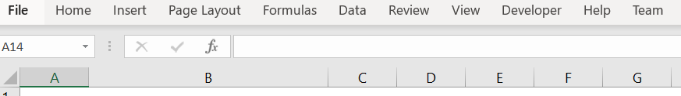

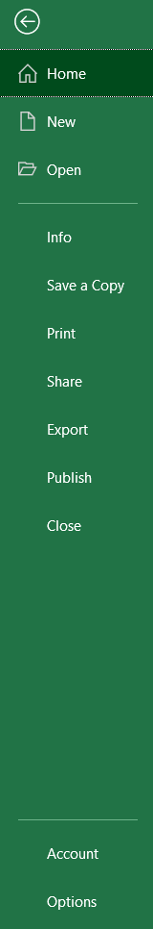

1. Click on “Add-ins”, and then move to right screen and toward the bottom click on “Go” button  
   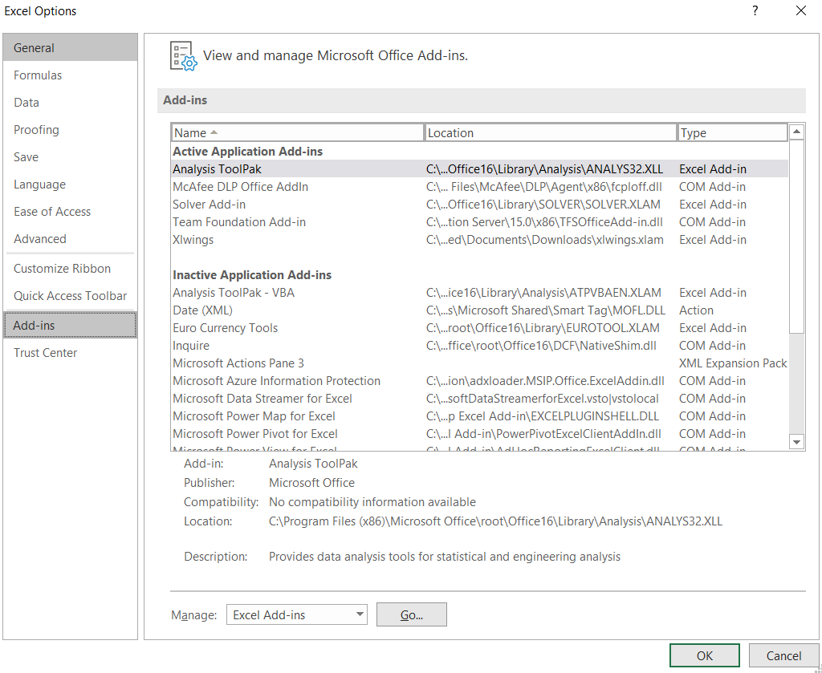
2. Click on Browse

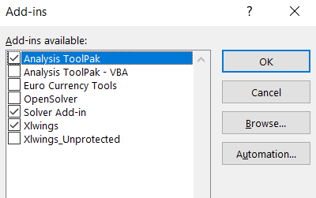

1. Paste the path noted in point 2:   
   C:\Users\<username>\AppData\Local\Programs\Python\Python38\Lib\site-packages\xlwings\addin   
   under File name, and then click OK

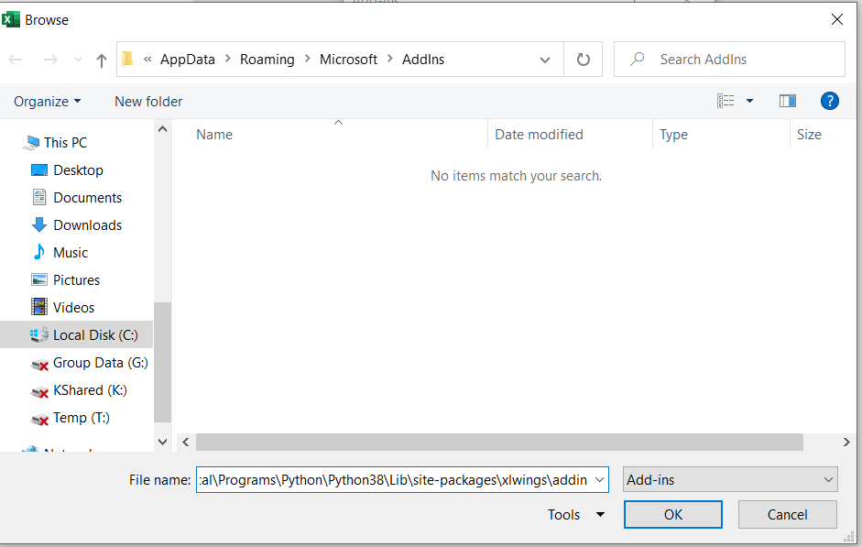

1. Now, select “xlwings” and press OK  
   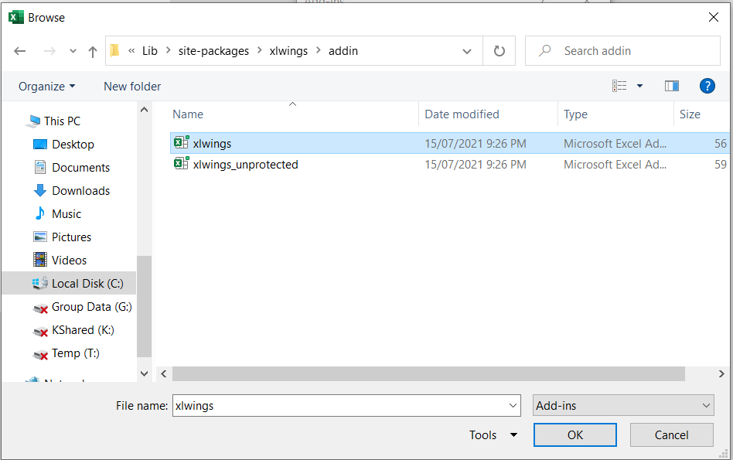
2. Double click on “xlwings” icon in the excel file  
     
   Under “Interpreter”, paste the path you noted in point 2:  
   C:\Users\<username>\AppData\Local\Programs\Python\Python38\python.exe  
     
   Under “PYTHONPATH”, paste the path you noted in point 2:  
   H:\drop_frequency_optimization_tool  
     
   And finally check the box against “Show Console”  
     
   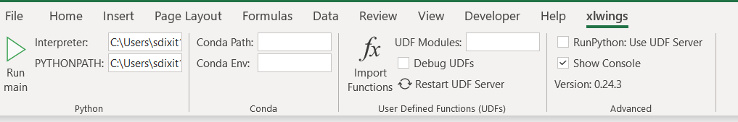

----------------------------------------------------

****** STEP D COMPLETED ******

----------------------------------------------------